# Scaffold

**Initial Vision Document**  
By Daniel Patterson, June 24, 2020

The purpose of this document is to provide the initial statement for the project along with the needs of the user community that can lead to the focused development of a base application with an original set of features and components. The results of any existing observations and research on standards are additionally included in this document to provide a full picture from as many perspectives as possible.

## The Need for a Fully Featured Instructional Design System

At the time of this document, there are a few large and mature e-learning authoring tools in the commercial market that produce courseware output suitable for Learning Management Systems (LMSs). Aside from having many of the advantages you would expect of professional grade software, most of the systems are each generally perceived to have one or more of the following disadvantages.

* High bar of entry. All of the known commercial versions require a form of payment to get started in earnest. A trial period is typically provided, but at least one of the systems severely degrades quality of the media output on the demo version.
* Questionable Return On Investment (ROI). The common pricing model of mature systems seems to be that of an ongoing subscription. When the user stops paying the monthly or yearly fee, as the case may be, the software becomes non-functional. To warrant keeping this software installed on your system, you will have to constantly be using it to create courses that directly generate revenue. To a freelance professional receiving perhaps one or two significant assignments per year, the yearly cost of the software makes a non-repetitive assignment hardly worth the effort.
* Limited vision in the industry.
  + Multiple people are expressing their desire to work with non-linear decks. It is clear to this contributor that the designer of the course should be able to create courses that are non-linearly adaptive to the learner.
  + Even after responsive design has been a practical reality in the web industry for several years, e-learning authoring systems offer little in terms of smooth user interface across devices.
  + There is a complete lack of attention to universally transferable learner transcripts.

The intention of this project is to provide, as closely as possible, the same functionality found in commercial e-learning authoring tools without introducing any of the disadvantages they currently present, then to fill in the gaps the existing commercial systems are not addressing.

## Vernacular Of This Project

A number of specialized terms are used in this project.

* **Control**. A user input or display element that can be placed on a page or within another parent control. See Curriculum Hierarchy.
* **Course**. The entire curriculum of a single course, which consists of at least one module (see Curriculum Hierarchy). A default module might or might not be defined by the designer, and if not, a default shadow module is used implicitly by the system.
* **Designer**. The individual or team creating the content in the project.
* **Element**. In this application, every object having a place in the user's object model is an element. For example, all of the following items are elements.
  + Button.
  + Control.
  + Course.
  + Event.
  + Module.
  + Panel.
  + Page.
  + Trigger.
  + Unit.
* **Event**. In a tangible sense, an event is typically something that happened. In this application, the event element is more specialized than that and is the handler and/or repeater for something that has happened. This system also has a type of element, known as a trigger, that is responsible for the the signals that cause the events. Events might be triggered directly from system events such as clicking or moving the mouse, or by trigger elements defined by the designer. Any event can have multiple trigger inputs, and any event can also repeat its trigger signal to multiple other elements capable of receiving trigger signals, either before or after the local handling of the event in question has been completed.
* **Learner**. The individual or group receiving the instruction.
* **Module**. A single instructional module within the course (see Curriculum Hierarchy). In certain authoring applications, this is the outermost level of the project.
* **Page**. Often referred to in the e-learning authoring tool industry as a *slide*, a more appropriate curriculative term might be a unit of *content*, but for now, this contributor is going to use *page* as the reference to a single slide to start getting away from the slideshow type of association traditional authoring tools share. See Curriculum Hierarchy.
* **Project**. The file container for the course and its elements.
* **Trigger**. An element representing the signal coming from the system or other element that can be handled by an *event* element. In most general scenarios, an event is something that happened, and the trigger of the event is the stimulus that caused it. In this application, the trigger represents a specialized signal, while the event represents the place where a signal of that type is handled or forwarded to other handlers.
* **Unit**. A single instructional unit within a module (see Curriculum Hierarchy). Sometimes referred to as a *deck* in the industry, this application chooses the name *unit* for establishing a direct curriculative reference. One unit can contain zero or more pages.

Figure - Initial UI Concept for Scaffold

## Overview of Project Goals

Scaffold is an open source e-learning authoring tool meant to meet the following goals.

* Operate as a desktop application based upon the Electron framework, to promote platform independence, and maintain 100% operational compatibility with Windows, Linux, or Mac.
* Allow any element to work with any trigger / timeline combination under singular or cyclical conditions.
* Allow the timeline of any element to be based upon global, course, module, page, or element timers, or in reference to a trigger.
* Publish themed, responsive, accessible, interactive, animated, media-rich courseware presentation with touchscreen gesture support to learners on any device over any network, website, learning management system, or stand-alone pre-loaded offline file.
* Provide methods by which learners on the system are able to transfer their transcripts from one system to another, without having access to modify their results or scores, such as might be implemented with the help of blockchain. For example, one learner works at a bank, which is heavily regulated, and requires several channels of continuous online training, depending upon their role. Upon moving to another bank completely unaffiliated with the first one, that learner needs to have a record of course history at the new bank. Otherwise, that learner will be required to retake a number of similar courses from a different LMS provider to become recertified to perform the job.
* Provide methods by which a team of instructional designers can seamlessly collaborate with formal incremental, reversible change tracking during the development of a course through direct compatibility with the most widely accepted version management system.
* Present enough of the user interface and functionality elements of any of the commercial systems that the user is intuitively familiar with the design environment on first use.
* Provide a big-picture outline view that can be used to navigate to any part of the project from course to individual element.
* Allow any element of the project to be selected, moved, copied, pasted, edited, or deleted from the outline view.
* Provide a unique interactive wireframe or node-based sketching system by which designers can create the official storyboard for each course module that itself actively aids in the construction of the target course, thereby resulting in an extreme productivity gain over that possible in commercial systems.
* Support any type of trigger on any object, leading to any type of defined reaction.
* Support drag and drop and instant design activation of any object in the gallery.
* Provide full support for linear and non-linear navigation with dynamic, adaptive behavior.
* Provide onboard screen casting capability to allow designers to communicate and teach about the platform itself.
* Support segments and groups of material that can be mixed and matched among multiple projects.
* Support every modern type of image, audio, and video format, converting them to optimized web formats upon preview or publication.
* Provide a wide variety of question types and assessment styles.
* Allow activities and assessments to be randomized or adaptively progressive.
* Support positive and negative scoring to discourage learner guessing.
* Provide multiple application and document options for stakeholder routing, sign-off, and final approval / disproval on pages, modules, and courses.
* Allow for synchronized, multi-language localization of all media types on every element.
* Provide support for skipping / indexing in any direction at any location.
* Provide support for community-based sharable library of theme templates, characters, images, vector art, icons, audio effects, and videos.
* Provide support for in-course section navigation by name or number, and controllable by options.
* Allow the designer to copy formatting elements of one or more objects to other elements.
* Provide a wide variety of animation capabilities, including multiple point paths with Bezier curve characteristics.
* Allow animations to occur on any trigger, including entrance, exit, and timer.
* Allow the specifications of one animation to be reused by applying them to other objects. Allow the specification to occur in the form of a link to the original or a separate customizable copy.
* Provide support for visual and audio transitions, controlled by triggers and timers.
* Allow the properties of any element to be changed by a specified amount to, or to a specific value, as the result of a trigger or timer.
* Allow a group of images, audios, or videos to be activated or controlled by definable set of triggers or timers.
* Provide navigations to keyframes or scoped times based upon triggers or timers.
* Provide support for triggers on object collision, drag start, drag end, and a number of other common movements.
* Provide support for triggers at successful completion of page, module, and course.
* Provide support for user-defined variables that can be used anywhere in a scope and can fire triggers at predefined settings.
* Provide complete support for a scripting language such as JavaScript for creating advanced behaviors.
* Provide direct support for at least the following standards.
  + AICC.
  + cmi5.
  + SCORM.
  + Tin Can API 1.0.
  + WCAG.

A number of interactive element types can be supported on each page. In the first version of the application, the following types should be supported.

* Buttons.
* Checkboxes.
* Embedded pages.
* Hot spots.
* Info boxes.
* Mouse effects.
* Panels.
* Radio buttons.
* Text labels.
* Textboxes.

## Curriculum Hierarchy

The application follows a curriculum sensitive hierarchy with the intention of allowing the project structure to fit accepted training methodologies as closely as possible.

In the first version, the project will be capable of modeling a single full course with child elements that are modular enough to be shared among multiple courses.

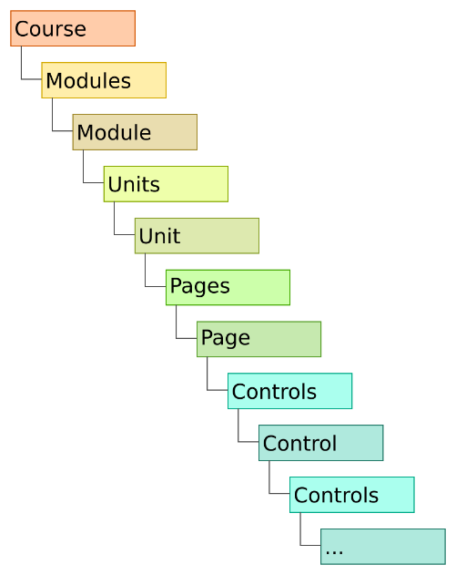

Figure - Curriculum hierarchy base object model

Notice in the above figure that the Course object is the only one not represented by a collection/member pair. For example, the modules collection contains zero or more module objects and so on.

## Component and Feature Enumeration

The following set of initial required components and features expands upon the general goals described above.

### Application Environment - Desktop Application

When working with creative material, the clear favorite for workspace environment tends to be desktop application - even if that same application happens to be available as an app for mobile devices. This contributor also feels strongly in favor of that sentiment.

What's more is that although there will need to be plenty of attention to seamless collaborative capabilities within teams, the application itself should not be cloud-based, and should not rely on an internet connection for any part of its operation other than transporting discrete project updates to established team members, and providing optional access to shared community assets and plug-ins.

Applications that rely fully on cloud operation, commonly referred to as Software As a Service (SAS), suffer from the following issues, among others.

* Because of traceable visitor accesses to the projects and files, the SAS provider can gain direct access to basic contact information for your customer and can contact them directly in a competitive move.
* With your entire projects stored in the SAS database, the provider has direct access to all of the creative content being produced, and can use slightly modified parts of that content to assure their own success in manners that compete directly in different segments of your own market.
* When an unsuccessful software change is activated at the SAS data center, all of the users of the software are affected immediately and adversely. In many cases, even basic functionality is lost until the change is either rolled-back, or a solution to the new problem is found.
* General activities like clicking on an object, changing a property value, or updating a view often have a tangible lagging user response, instead of the sharp, instantaneous response that is possible in well-written locally installed applications.
* When your internet connection is slow, intermittent, or out of service, nobody in the office can do any work at all. When the software is being used directly in the service of live customers, all of the customers in queue also have to wait until the connection is restored, if ever.

Cross-platform functionality could also be a huge advantage to users.

A platform independent desktop platform like Electron is currently looking like the clear preference, given that it doesn't ever have to be repeatedly recompiled for use on Windows, Linux, or Mac.

The change Apple is making to adopt their own microprocessors in the coming year will cause the differences between PC and Mac to be more pronounced than they have been since the 1980s and no matter what the quality level of your C compiler, differences always exist for applications compiled directly to dissimilar hardware platforms.

Raising the code base to a universal UI level would alleviate all hardware considerations for a type of software like this that needs no hardware support other than accurate timers. The real challenge in this elevation is to find code base that still provides exceptional performance when running at such an abstracted level.

This is context in which the first experimental exercises for this project will be conducted.

### Events, Triggers, Timelines, Keyframes, And Elements

In this software, the term element is used to imply any thing that will be present in the course, including a background, sprite, button, and even the timer used to keep the pace on another element.

A trigger is a signal that something has occurred, where an event represents an implementation of behaviors or actions serving as the response to something. A trigger is an input to one or more stimulus, and an event can be set to react to one or more separate triggers, as well as repeating the signal to other events. Triggers can be set to fire once or every time the related stimulus occurs. A limited single, infinite cyclical, or numbered sequence can be achieved through the use of a timer control in the trigger chain. The timer control can generate single shot, repeating, and counted triggers from a local delay or from its own input trigger. See more about the timer control later in this document.

The timeline is a singular universal concept representing the stream of general time. All things occur along the same timeline, but the scope of use can be focused at any level, from the time an element was shown to the time the student has spent on all modules since the beginning of the course. Keyframes are cue points that can be defined on any scope of the timeline to annotate important milestones, synchronize content, or trigger events.

### Universal Element Theming

A separated master theming configuration is preferred that allows the designer to predefine or redefine all of the parts that would be traditionally referred to as the master page. Unlike the concept of the master page, however, the idea of cascading style sheets is added to allow certain elements to have multiple different styles that each come into play in different relations to the elements around them and how they are being used.

The designer should also be given the freedom to define elements as having freely assignable format classes, where a class is defined as a preset list of formatting styles like font size, color, and border width, for example.

The designer should be able to change any style or the entire theme without having to alter any of the underlying course content.

### Responsive Design

It is expected that without any great effort on behalf of the designer, all content should smoothly and consistently readjust to any screen size or resolution.

A multiple resolution previewer should be implemented at the earliest version possible, to allow interactive adjustment of how certain individual elements might resize relative to display size, but other elements on the same page might reposition or reorganize.

### Accessible Content For People With Disabilities

Assure that any content being published is not only fully compliant with the Americans with Disabilities Act, but that whenever practical, additional steps can easily be taken to provide additional accessibility.

### Interactive, Animated, Media-Rich Design

The application should allow the designer to easily and intuitively create highly interactive scenes that convey any meaning intended by that individual. Multiple videos, audios, animated sprites, and input-driven objects should be supported, and timed as appropriate.

The design screen should be as capable as possible of rendering the real-time result while the design is in progress, as well as displaying the elements in a static state at any time of the associated timeline scope.

### Multiple Publishing Choices

The designer should be able to have a wide range of publishing choices. Everything from completely driven by the latest learning management system to self-contained in a single file that can be run locally on an Android device, and every possibility in between.

The stand-alone single file variation should contain the ability to report the results of any onboard assessments to a waiting LMS.

### Universal Transcript Support

In as early a version as is possible, adoption of Universal Transcripts, as proposed by The National Laboratory for Education Transformation will be implemented, unless a more suitable system is found in the meantime.

As described at their website <http://nlet.org/universal-transcript/>, Universal Transcript is a blockchain-based, student-managed, independently verified transformation tool for both education and the workforce.

The fact that the information is embedded in blockchain makes it nearly impossible to modify after being duly recorded, yet the same information remains permanently usable by anyone who wishes to reference it.

The potential disadvantage with the noted source is that it appears to be in a conceptual stage with a long way to go before production and does not yet appear to have fully working parts. If that is the case, we could follow one of these pathways to implementation.

* Find another blockchain-based universal transcript group that is already operational.
* Work with the NLET to get a usable version running if the current designs are sufficient.
* Design and implement a universal transcript service from scratch.

### Offline Version Control

Although the application is designed to specifically avoid operating in the cloud, distributed version control does make use of the cloud to provide interpersonal collaboration by any number of individuals on a team and any number of teams in a division.

At the present time, this will be accomplished through the use of GIT.

In outgoing changes, new, modified, and deleted files can update the version control repository from inside the application, through the selection of individual files or an update all function.

When it comes to incoming changes, the designer will be able to check for external updates, adopt some or all of them, or ignore them until later.

Whenever possible, designers should try to avoid making overlapping changes on the same page, because those can lead to conflicts that need to be resolved through a series of sequential steps. However, with that said, GIT is remarkably good at tracking separate changes made within the same document.

### Familiar User Interface

The user interface employs a combination of familiar layout methodology and industry accepted terms to maximize the possibility that all design tasks can be carried out as quickly and intuitively as possible.

### Global Element Outline

Any element in the entire project can be navigated to in the global outline control, following this consistent hierarchy.

* **Course**.
  + Formatting.
  + Keyframes.
  + Triggers.
  + Events.
  + **Modules**.
    - **Module**.
      * Formatting.
      * Keyframes.
      * Triggers.
      * Events.
      * **Units**.
        + **Unit**.

Formatting.

Keyframes.

Triggers.

Events.

**Pages**.

**Page**.

Formatting.

Keyframes.

Triggers.

Events.

**Controls**.

**Control**.

Formatting.

Keyframes.

Triggers.

Events.

**Controls**.

...

Any element of a similar or compatible type can be copied, cut, deleted, duplicated, or pasted from the outline, as appropriate for the control.

### Node-Based Expression, Evaluation, and Chaining

Using generally purposed boxes with specialized property values and interface nodes to describe a series of conditions or events has proven both intuitive to a large audience and successful in definition of functionality over the past few years.

In the following illustration, a custom event named Button 1 Click is visually created using a combination of the actual click event from Button 1 and timer that expires every 10 seconds. The result of this chain is an event that happens every 10 seconds in addition to any direct click by the learner.

Not shown here, Button 1 Click can be used to set the properties for anything, or to be set as a trigger for any other event.

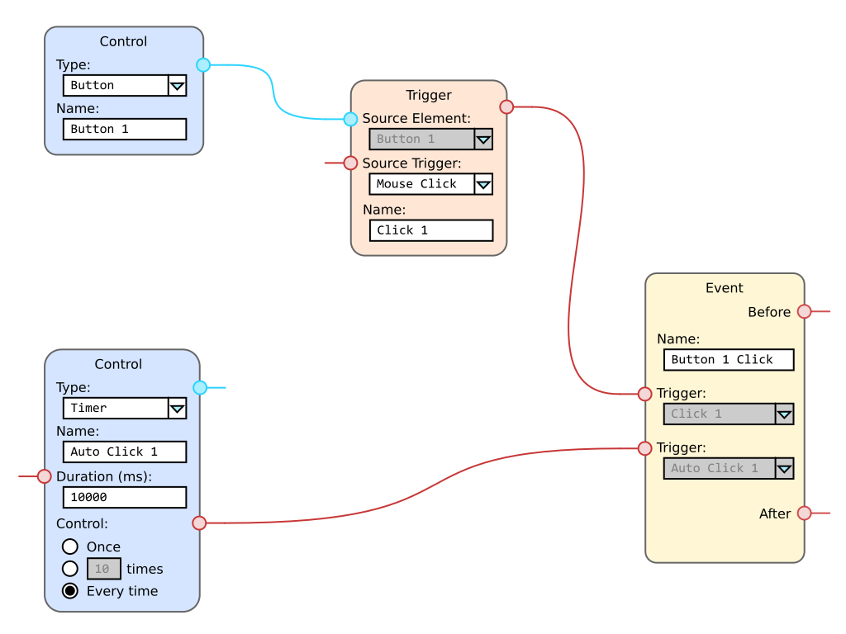

Figure - Node-based expressions

### Drag And Drop Design

The designer is allowed to drag any element onto the page, then to move that item around using drag and drop actions. The specific positioning of the item can be set through a properties grid when the item is selected on the page or in the outline.

### Drag And Drop Learning Activities

The learner can be allowed to drag any element on the page and drop it anywhere else. The extent of this functionality and the events processed by the activity are determined solely by the designer.

### Linear And Non-Linear Activities

The designer can define whether the learner must follow a linear process or whether non-linear progression is allowed.

More specifically, the following flow characteristics can be set.

* Linear progression. In linear progression mode, the learner is required to visit each page. In this mode, the designer has control over whether each assessment can be skipped, whether the learner must at least attempt the assessment a defined number of times, or whether an inline assessment must be successfully completed before moving on to each new section.
* Page skipping. This mode allows a page to be skipped if is has the skip attribute set.
* Learner-driven navigation to any page. This mode allows the learner to navigate to each individual page. Preconditions for navigation to any page can be set on the properties of that page.
* Adaptive positive and negative progression. This mode can't be guaranteed to be in the first version but should be given a higher than normal priority for implementation. Each time the learner is proving to be more advanced than normal, he or she can be shifted to a later stage in the course or shown more advanced materials. Similarly, if the learner is somewhat average, the main course can be shown. At the very slowest level, if the learner is demonstrating to have less than average previous knowledge of the subject, remedial content can be displayed with the intention of helping that learner get up to speed as much as possible.
* Random selection of page, activity, or inline assessment. The content displayed on any page can be set to randomly selectable from within a group of eligible targets.

### Screen Casting Functionality

To allow Scaffold users of all types to demonstrate their techniques in the form of video tutorials for the general community, basic screen casting functionality will be built into the first version.

If possible and practical, there will also be an option to display the keystrokes pressed during recording.

Video output will be standard compressed MP4 in a low enough resolution to be appropriate for download from the web.

### Sharable Asset Groups

All of your themes, per-element styles, style classes, page layouts, images, videos, audios, and individual elements can be grouped into separate groups that can be shared in the community.

### Universal Media Support

Every modern type of image, video, and audio format is supported.

Each project supports multiple publishing profiles, each of which allow you to define whether the input media should be converted to specific formats or left in their original formats.

### Question Types and Assessment Styles

The following question types can be used in any order, on any final or inline assessment.

#### Graded Questions

* True or false.
* Multiple choice by radio button.
* Unique placement of multiple questions by radio button.
* Multiple choice by drop-down list.
* Multiple choice by image.
* Multiple selection by checkbox.
* Multiple selection by list.
* Multiple selection by image.
* Text fill in the blank.
* Numeric fill in the blank.
* Word container.
* Matching drag and drop.
* Drag and drop in sequence.
* Drop-down list in sequence.
* Hotspot click.

#### Non-Graded Questions

Any graded question can be used in a non-graded context. There are also a few additional types available for this use.

* Essay answer.

Multiple assessment styles are suggested.

* Formative assessment. Informs the expansion of course based upon student learning.
* Summative assessment. Explores how well the student has been able to learn the material in the course and how easily that information can be applied.
* Confirmative assessment. The long-term review of summative assessment.
* Norm-referenced assessment. Comparison of the individual learner's performance with the average normal.
* Criterion-referenced assessment. Comparison of the learner's current performance with a predetermined set of standards.
* Ipsative assessment. Comparison of the individual learner's current performance with their previous performance on related material.

### Spelling and Grammar

A basic spelling dictionary and grammar analyzer will be present from the first version of Scaffold. Both the dictionary and grammar rules references will be maintained by the development team, and maintainable by the community.

The grammar engine will start with the following rules, among others.

* Avoiding terms like *always* and *never*.
* Avoid using double-negatives.
* State the question positively instead of negatively.
* Provide four or five answer options.
* Passive voice.
* Lexical illusion.
* *So* at the beginning of a sentence.
* *There is* or *There are* at the beginning of a sentence.
* Weasel words. Words or statements that are intentionally ambiguous.
* Weakening adverbs like really, very, extremely, etc.
* Wordy phrases and unnecessary words.
* Common clichés.
* Optional E-Prime for the elimination of all forms of "to-be". <https://en.wikipedia.org/wiki/E-Prime>

#### Libraries

At the time of this document, the following libraries are selected for providing spelling and grammar services.

* electron-spellchecker. <https://www.npmjs.com/package/electron-spellchecker>
* Proofreader. <https://github.com/kdzwinel/Proofreader>

### Stakeholder Routing

Routing options for stakeholders and team members will be supported.

The following activities can be implemented as simple file changes within the built-in version control system.

* Team member task assignment.
* Team member task completion.
* Team member sign-off.
* Peer review testing started.
* Peer review testing halted.
* Peer review testing completed.
* Project manager approved.
* Project manager vetoed.

The project can be set to automatically advance to the next status when all required reviews have been completed.

### Project and Page Status

The project as a whole can be in one status while individual pages can each have their own states. This allows the team to track progress with a great deal of detail.

### Multi-Language Localization

International localization of every element is possible from the first version.

When setting up the project, US-EN is the default language. As you add additional languages to the project languages list, you will be able to complete checklists for providing naming maps for each of the elements used in the project.

### Animation Support

Scaffold will have complete support for animating elements under timeline / keyframe, timer, and trigger control.

The general style of animation is 2D sprite.

Animations are defined in modular specifications that can be reused in other parts of the same project, or different projects altogether. They can also be shared on the community library.

When reusing animation specifications from the same project, a link mode can be specified that allows the original specification to be used as the master, updating all linked animation behaviors when the master is changed.

### Visual and Audio Transitions

Transitions are defined as animations that can be initiated, like any other animation, by triggers and timers.

### Object Collision and Adjacency

Detection of objects that have just touched, lined up, moved away from one another, or a number of similar subtle relations is used in conjunction with drag and drop to fire events that handle whether the learner is moving objects to the correct areas on the screen, in addition to a number of other possible animation uses in gamified courses.

### User-Defined Variables

The designer can define an unlimited number of unique variables that can be used alone or in mathematical expressions to control the flow of the course.

User-defined variables can be referenced within expression controlled contexts, as well as for generating triggers, setting timers, and numerous other duties.

### Native JavaScript Support

The behavior of any event, element, or animation can be expressed directly in JavaScript.

### System Triggers

There are a number of event triggers built into the application that can be used to define actions on their own or can be used to initiate other timers and triggers.

Following is a non-exhaustive list of the built-in events. All of them occur at the page and control levels.

| Name | Description |
| --- | --- |
| Activate | Fired whenever the object is activated. |
| Animation Start | Fired when animation is started on an object. |
| Animation Stop | Fired when animation is stopped on an object. |
| Background Color Change | Fired when the background color of an object is changed. |
| Background Image Change | Fired when the background image of an object is changed. |
| Background Layout Change | Fired when some part of the background layout of an object is changed. |
| Binding Context Change | Fired when the binding context of an object has been changed. |
| Causes Validation Change | Fired when the condition of validation has been changed on the object. |
| Click | Fired when the object is clicked. |
| Control Add | Fired when a control is added to the object. |
| Control Remove | Fired when a control is removed from the object. |
| Cursor Change | Fired when the cursor symbol has changed for an object. |
| Deactivate | Fired when the object is deactivated. |
| Dock Change | Fired when the docking style of the object has been changed. |
| Double Click | Fired when the object is double-clicked. |
| Drag Drop | Fired when a drag and drop operation has been completed. |
| Drag Enter | Fired when the mouse drags an object into the client area for this control. |
| Drag Leave | Fired when an object is dragged out of this control's bounds. |
| Drag Over | Fired when an object is dragged over this control's bounds. |
| Enabled Change | Fired when the enabled state of this object is changed. |
| Enter | Fired when the object has received the user input focus. |
| Font Change | Fired when the font of this object has been changed. |
| Fore Color Change | Fired when the foreground color of this object has been changed. |
| Give Feedback | Fired when the mouse drags an object. |
| Help Button Click | Fired when the assigned help button is clicked. |
| Help Request | Fired when the learner is invoking help. |
| Input Language Changed | Fired when the language used for input has been changed. |
| Input Language Changing | Fired when the system is requesting that the input language be changed. The request can be declined. |
| Key Down | Fired when a key is depressed. |
| Key Press | Fired when the control has focus, and when the learner has depressed and released the key. |
| Key Up | Fired when a key is released. |
| Keyframe | Fired when a cue point on the timeline has been reached for the assigned scope. |
| Layout | Fired when the control is about to layout its contents. |
| Leave | Fired when the object has lost the user input focus. |
| Load | Fired when the object has been loaded and is ready to display for the first time. |
| Location Change | Fired when the location of the object has been changed. |
| Mouse Down | Fired when the mouse is above the object and the mouse button has been depressed. |
| Mouse Enter | Fired when the mouse enters the area above this object's visible region. |
| Mouse Hover | Fired when the mouse remains stationary above this object for a period of time determined to be idle. |
| Mouse Leave | Fired when the mouse leaves the visible part of the object. |
| Mouse Move | Fired when the mouse is moved while over this object. |
| Mouse Up | Fired when the mouse button is released while the mouse is positioned over this object. |
| Move | Fired when an object is moved. |
| Page Closed | Fired after the learner closes the page. |
| Page Closing | Fired before the learner closes the page. |
| Parent Change | Fired when an object has been moved from one parent to another. |
| Preview Key Down | Fired before the Key Down trigger, and while focus is on this control. |
| Query Continue Drag | Fired when the mouse drags an object. The system is requesting whether the drag and drop operation should be continued. |
| Resized | Fired when an object's size has been changed. |
| Resizing | Fired before an object's size is changed. The resize operation can be canceled. |
| Scroll | Fired when the learner scrolls the scrollable object. |
| Shown | Fired when the object is first shown. |
| Style Change | Fired when one or more styles of the object have been changed. |
| Text Change | Fired when the text value of the object has been changed. |
| Validated | Fired when the content of the object has been validated. |
| Validating | Fired when the content of the object is going to be validated. The validated event can be canceled. |
| Visible Change | Fired when the visibility of the object has been changed. |
| UI Cues Change | Fired when keyboard and hotspot cues are being changed. |

## Functional Dependencies

As described in this document, the application is currently expected to have the following external dependencies.

|  |  |  |  |
| --- | --- | --- | --- |
| Name | Local Use | Description | Source |
| GIT | Peer to peer distributed version collaboration. | The most widely adopted version control system. | <https://git-scm.com/downloads> |
| jQuery | Quick and reliable control of user interface elements. | HTML and JavaScript high capability and AJAX functionality library. | <https://jquery.com/> |
| jQuery UI | Ornamentation of user interface elements. | Consistent formatting and control components from HTML user interface elements. | <https://jqueryui.com/> |
| jQuery UI Layout Plug-in | Docking windows. | Docking window theme add-on for jQuery UI. | <http://layout.jquery-dev.com/> |
| Universal Transcript | In-course, independent transcript access for course completion. | Blockchain-based transcript for students in learning specializations of all types. | <http://nlet.org/universal-transcript/> |