Visual-DB
Ascent Group

Copyright © 2010 Ascent Group
Table of Contents
1. Introduction. 3
1.1. Welcome to Visual-DB! 3
1.2. About Visual-DB project. 3
1.3. Installation. 3
1.3.1. Windows. 3
1.3.2. Unix/Linux. 3
2. Establishing connection. 4
2.1. Database location and credentials. 4
2.2. Proxy. 4
3. Exploring Database. 5
3.1. Objects tree. 5
3.2. Scene. 6
3.3. Object description. 7
3.3.1. Schema. 7
3.3.2. Table. 7
3.3.3. View. 8
3.3.4. Role. 8
3.3.5. Index. 8
3.3.6. Trigger. 8
3.3.7. Procedure. 8
3.4. SQL runner. 8
4. Troubleshooting. 8

Introduction.

Welcome to Visual-DB!
Welcome to Visual-DB developed by Ascent Group. The latest version of this document is always available from the project's web site .
The idea of Visual-DB bases on our desire to have a universal (and available for everyone) database tool. We want it to be easy to use, powerful and support most known database management systems. It might look like some kind of utopia, but nevertheless Visual-DB team believes that this is possible. That's why this project has started and Visual-DB doing its best in achieving these goals.

About Visual-DB project.
Visual-DB is an opensource software distributed under BSD license. At this point PostgreSQL is the only DBMS supported by this tool. One of the reasons for this is that Visual-DB project has started not so long ago and its development team is small.
If you have any question or suggestions feel free to contact any person on our team.
- karataev@users.sourceforge.net
- lyuts@users.sourceforge.net

Installation.
In general, the software is distributed as a tar.bz2/tar.gz archive with the source code for Unix/Linux and a package with binaries for Windows. They can be found in the download section on the project’s site.

Windows.
To get Visual-DB working on Windows it should be enough to download prebuilt application archive, unpack it and just run it. All its dependencies are shipped with the application.

Unix/Linux.
Before compiling Visual-DB the following dependency should be installed:
- Qt >= 4.4 (at least 4.5 is preferable).
- PostgresSQL plugin for Qt.

- Download an appropriate archive from here.
- $ tar xfvj visual-db_vX.Y.tar.bz2
- $ mkdir build
- $ cd build
- $ qmake ../visual-db_vX.Y/visual-db.pro
- $ make


Establishing connection.
To create a new connection, click the the connection button ( ). This will bring up a connection dialog which asks you to set the connection parameters of the database and proxy (if applicable).
Note: At this point, Visual-DB has a limitation, it cannot connect via unix domain socket.

Database location and credentials.
The illustration below shows the part of a connection dialog that refers to database parameters.
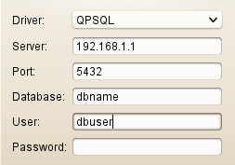Illustration 1: Database parameters

Proxy.
The illustration below shows the proxy parameters part of the connection dialog. The proxy types that are supported are completely identical to those supported by Qt.

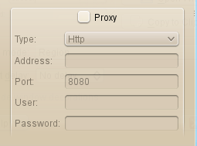Illustration 2: Proxy parameters

Exploring Database.
After the new connection has been established the names of database objects are read from the specified database. The complete description of objects are not read until the moment when they are actually needed. Both user defined objects and RDBMS system objects are read.

Objects tree.
The database object tree is a tree that holds the names of objects grouping them by their types. Here is a sample tree of test database.
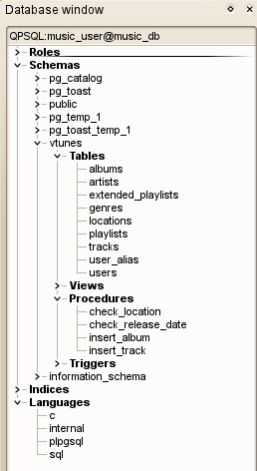Illustration 3: Objects tree

Scene.
The area located to the right of database object tree is a scene. This is the area where you can put tables and views and see the relations between them. The scene control widget is in the top right corner and it provides basic controlling functionality, such as moving, zooming and browsing.
There are several ways to display the desired objects on the scene:
- To display all available objects in the database on the scene, just press “Draw full scheme”

button ( ).

- To display a specific table or a set of table, select them in the object tree and then drag and drop them on the scene (the same result can be achieved by selecting “Add” item in the context menu).
- To display all tables and views from a specific schema, select it in the object tree and drag and drop it on the scene (the same result can be achieved by selecting “Add” item in the context menu).

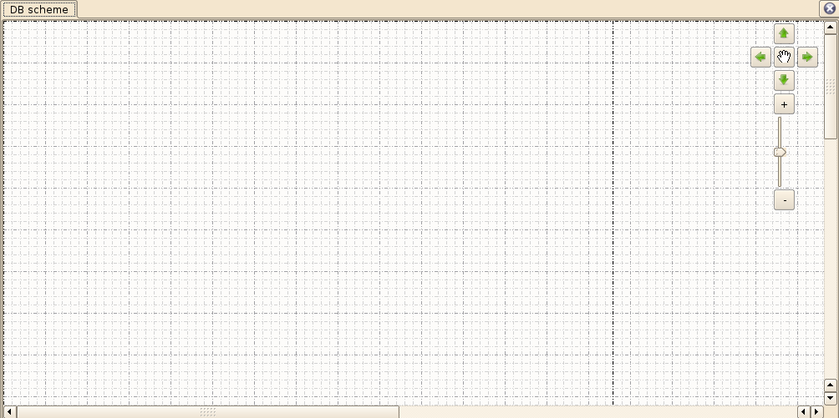Illustration 4: Scene
There is a context menu of the scene, which allows you to:
- Show/hide scene grid;
- Enable/disable aligning of items to scene grid;
- Divide the scene into pages;
- Show/hide scene legend;
- Show/hide control widget;
- Colorize items on scene according to the schema these items belong to.

The items that are displayed on the scene have their own context menu which controls the way they are displayed and how they behave, i.e.:
- Show/hide types of table's fields;
- Show/hide table's indices;
- Change color;
- Adjust size;
- Group/ungroup tables and/or views;
- Select all items of the given schema;
- Enable/disable anchor, which means the item will be restricted to its current position and will not be able to move.

Object description.
To get the description of a database object, just select it in the database object tree and select “Describe” item in its context menu. This will open a new tab with a complete description of the selected object. Additionally, a query for object creation is generated (if applicable).

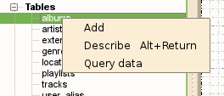Illustration 5: Describe request

SQL runner.
SQL runner allows you to write and execute your queries for a selected table or view. By default, it reads the results portion by portion. The size of portion is 30 records (in new version this setting will be configurable). There is also a check for safe queries which forbids execution of queries that modify data, i.e. queries that contain SQL keywords such as DELETE, INSERT, UPDATE (in new versions the user will be able to specify his own safe query rules).

Troubleshooting.
If you haven’t found the answer for your question or if you have spotted a bug you can email us or submit a bug report here.

Q: There is no driver in drivers combo box in the connection dialog.
A: The Qt plugin for your RDBMS is not found, i.e. it hasn’t been installed, or the application doesn’t know where to look for it.

