**Assignment 5 Report**

**12032373徐浩翔**

**1.2** Maps are plotted from script and saved as jpeg file in the same directory.

**1.3** I don’t think a specific threshold is meaningful here. Because we can pick up places that has relative higher wind speed instead of setting up somehow certain wind speed limit for determination. Judging windfarms only by simply a threshold is not that significant. According to the result map, two place are selected that suitable for windfarms construction: mid-northern Inner Mongolia and northern Tibet. Those places are flat in topography (one is grasslands and the other is highland). And the human activities there are quite natural respect to developed areas. For regions like western Taiwan and northern Qinghai, mountains (Taiwan Central Range and Qilian Mountain) may increase the construction difficult and cost. For coastal regions, most of them are already urban or industry regions.

**1.4** Mid-eastern Sichuan would be an appropriate place to construct photovoltaics (PV) farms. I don’t choose middle of this province is because mega city Chengdu is there. In addition, precipitation result shows this is a low precipitation place, which mean rainy days might be lower if simply due to precipitation amount. Based on its location, this PV farms is able to supply a large places due to this is nearly middle of China.

**2.1**

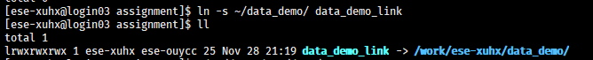

**2.2**

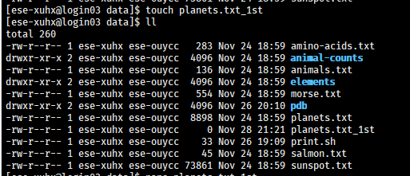

**2.3**



**2.4**



**2.5**



**2.6**

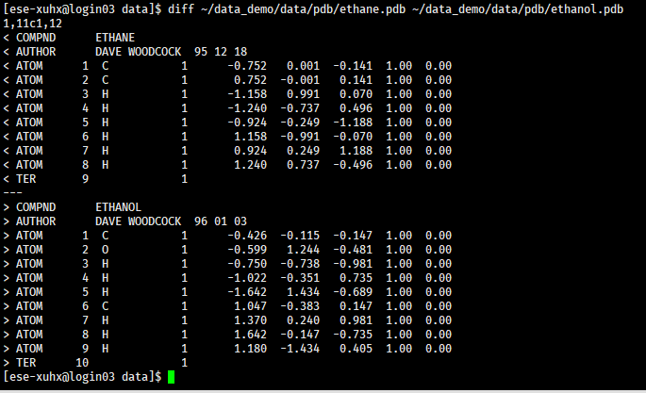

**2.7**



**2.8**

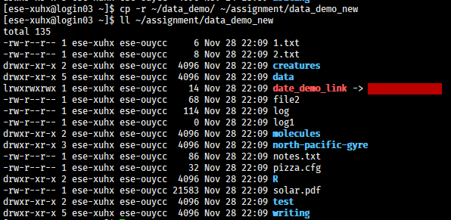

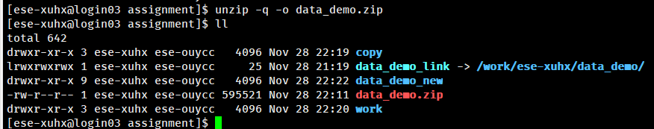

**2.9**

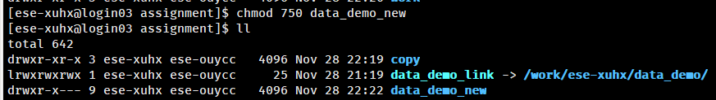

**2.10**

