

**CSC 431**  
  
**College Social App**  
  
  
System Architecture Specification (SAS)

**Team 14**

|  |  |
| --- | --- |
| Austin Schladant | Scrum Master |
| Kyle Riley | Scrum Development Team Member |
| Bo Fei Wang | Scrum Development Team Member |

**Version History**

|  |  |  |  |
| --- | --- | --- | --- |
| Version | Date | Author(s) | Change Comments |
| 3.0 | 5/5/21 | Austin Schladant, Kyle Riley, Bofei Wang | Final |
| 2.0 | 4/13/21 | Austin Schladant, Kyle Riley | Final Draft |
| 1.0 | 4/1/21 | Austin Schladant, Kyle Riley, BoFei Wang | First Draft |

**Table of Contents**

**System Analysis** **6**

System Overview 6

System Diagram 6

Actor Identification 7

Design Rationale 7

Architectural Style 7

Design Pattern(s) 7

Framework 8

**Functional Design** **9**

Sequence Diagram 9

**Structural Design** **11**

Class Diagram 11

**Table of Figures**

Figure 1. Application System Diagram 6

Figure 2. Chatroom System Diagram 7

Figure 3: Login Sequence Diagram 9

Figure 4: Sequence Diagram 9

Figure 5: Chat Room Sequence Diagram 10

Figure 6. Sign In Class Diagram 11

Figure 7. Chatroom Class Diagram 11

Figure 8. Topic and Room Selection Class Diagram 12

### System Analysis

#### System Overview

The system will consist of two main parts: the chatroom selection and the chatroom itself. The chatroom selection will allow the user to view all the chat rooms that are stored using firebase. While the chatroom will allow users to actively send messages to the chatroom and read any incoming messages from other users.

The pipeline of the application is: (1) the user logs in, or signs up if an account isn’t made, (2) the user edits their profile if they need to change password or update/add profile picture (3) the user explores chat rooms depending on what subject they select, (4) the user enters a chat room, (5) the user sends and reads messages in the chat room, (6) the user saves the chat room if they want.

The chatroom will be designed using a Model-View Controller architecture, while the navigation of the application will be designed using an Event-Driven architecture. Using a Model-View-Controller architecture will allow us to implement that functionality of sending messages, saving the messages onto the database, and then showing the messages in the chatrooms, and an Event-Driven architecture will allow us to easily program navigation through the application.

#### System Diagram

The follow diagram is a component diagram for the application:

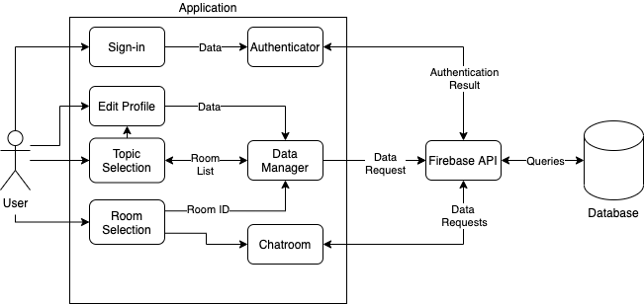Figure 1. Application System Diagram

The following diagram is a component diagram for the chatrooms:

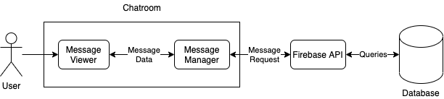

###### Figure 2. Chatroom System Diagram

#### Actor Identification

There are two types of human actors - those that have an account, and those that don’t. Those that do not have an account can only access the account creation and login functionality of the app, while those that have an account have those functions and all other functions of the app, such as sending and receiving messages from various group chats. Additionally, there is a non-human actor, which is the database where the user information and chatroom messages will be saved.

#### Design Rationale

##### Architectural Style

In this application, the user will navigate themselves through various topics in order to find a chatroom that they want to join. Since the main functionality of the other states in our application are to navigate the application in order to find a chatroom, we decided that using an **event-driven architecture** to design these states would be best. Depending on the event caused by the user, i.e., the user pressing a button, the application will then act accordingly. For example, the user will select a topic by pressing a button, this will trigger the application to display the rooms pertaining to the topic, then once the user selects a room, the application will enter the chatroom selected.

The chatroom will have a **model-view-controller (MVC) architecture**. In this architecture, the controller represents the text field where the user inputs their message, the model represents the database where the messages are stored, which is firebase, and the view represents the text box where the messages show up in the chat room. The flow of this architecture is: the user inputs a message into the controller, the controller then handles this message and sends it to the model, then the model saves the message, and finally, the view grabs the message and displays it in the chatroom.

##### Design Pattern(s)

We anticipate that we are going to use the following design patterns:

1. The chatrooms are going to be designed using the **mediator pattern**. This object is going to encapsulate the User object and the Database base and add functionality between the two.
2. The functionality to choose a chatroom is going to be designed using the **factory method**. After choosing a topic, the user will then interact with the Chatroom Selection Object, which contains a list of different chat rooms, to choose a chat room. This object always has the structure of a list, no matter the topic selected. The factory method allows us to implement the structure for a Chatroom Selection Object, then depending on the user input, the application will implement an interface of this object. For example, if the user selects the “Academics” topic, the Academic Chatroom Selection Object will be instantiated.

##### Framework

This application is going to be using the Flutter UI toolkit and the Firebase API. Using Flutter and Dart will allow the program to interact with Firebase storage to allow users to message each other in chat rooms.

### Functional Design

#### Sequence Diagram

The following sequence diagram shows the process of a user signing in:

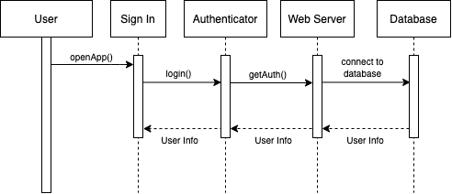

###### Figure 3: Login Sequence Diagram

The following sequence diagram shows the process of a user, after logging in, navigating the app, and selecting a chatroom:

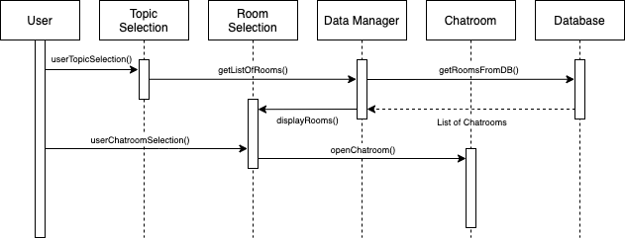

###### Figure 4: Sequence Diagram

The following sequence diagram shows the process of a user receiving and sending messages after they’ve selected a chatroom:

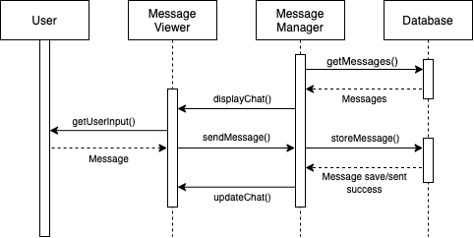

###### Figure 5: Chat Room Sequence Diagram

* When the user logs in, their email and password are authenticated using the Firebase API.
* After the user logs in, they have the option to select a topic, and once they do that, the Chatroom Selection then communicates with a Data Manager that accesses Firebase to get the list of chatrooms under that topic and displays it to the user.
* The user then has the option to select any of the chatrooms that are displayed. Once selected, the Chatroom object is called, and the Chatroom interacts with Firebase through a Message Manager and displays the chatroom and its messages.
* The Chatroom object then waits for the user input. When the user inputs a message, the Chatroom object then tells the Message Manager to store the message in Firebase and updates the chat.

### Structural Design

#### Class Diagram

The following diagram shows the classes for the process of a user signing in:

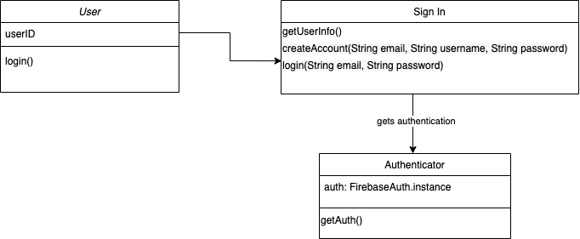

###### Figure 6. Sign in Class Diagram

The following diagram shows the classes for the using the chat rooms:

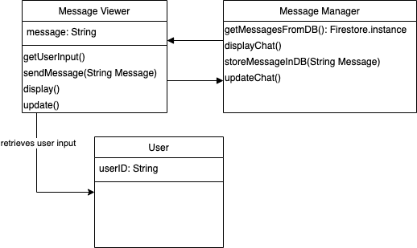

###### Figure 7. Chatroom Class Diagram

The following diagram shows the classes for the process of a user selecting a topic and/or a room:

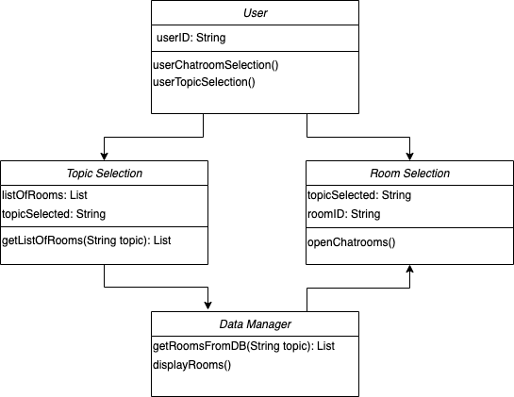

###### Figure 8. Topic and Room Selection Class Diagram