

**CSC 431**

**College Social App**

**Software Requirements Specification (SRS)**

**Team 14**

|  |  |
| --- | --- |
| Austin Schladant | Scrum Master |
| Kyle Riley | Team Member |
| Bofei Wang | Team Member |

**Version History**

|  |  |  |  |
| --- | --- | --- | --- |
| Version | Date | Author(s) | Change Comments |
| 3.0 | May 5, 2021 | Austin Schladant, Kyle Riley, Bofei Wang | Final |
| 2.3 | March 9, 2021 | Kyle Riley, Bofei Wang | Added Evolutionary Requirements |
| 2.2 | March 6, 2021 | Austin Schladant | Added use-case diagram and System constraints. |
| 2.1 | March 4, 2021 | Austin Schladant | Fixed functional requirements |
| 1 | Feb. 24, 2021 | Austin Schladant, Kyle Riley, Bofei Wang | First Draft |

**Table of Contents**

1. System Requirements **7**

1.1. Functional Requirements 7

1.1.1. Login 7

1.1.2. Sign-up 7

1.1.3. Section Selection 7

1.1.4. Room Selection 8

1.1.5. View Current Rooms 8

1.1.6. Change Settings 8

1.1.7. Send and Receive Message 9

1.1.8. Recover Password 9

1.2. Non Functional Requirements 10

1.2.1. Rapid Message Sending 10

1.2.2. Fast Message Loading 10

1.2.3. Quickly Recover and Update Password 10

1.2.4. Fast Chat Room List Loading 10

2. System Constraints **12**

2.1. Tool Constraints 12

2.1.1. Firebase Platform 12

2.2. Language Constraints 12

2.2.1. Dart Language Constraint 12

2.3. Platform Constraints 12

2.3.1. Android and iOS Constraint 12

2.4. Hardware Constraints 12

2.4.1. Firebase Cloud Storage Constraint 12

2.5. Deployment Constraints 13

2.5.1. University Authorization 13

2.5.2. Google Play and Apple App Store Authorization 13

2.6. Budget & Schedule Constraints 13

2.6.1. Project Due Date 13

2.7. Miscellaneous Constraints 13

2.7.1. Limit Application to Students Only 13

3. Requirements Modeling **14**

3.1. Functional Requirements Use Case 14

4. Evolutionary Requirements **15**

4.1. Functional Requirements 15

4.1.1. Add Friends 15

4.1.2. Private Message Chat Room 15

4.1.3. Find Friends 15

4.2. Non-Functional Requirements 16

4.2.1. Message Encryption 16

**Table of Tables**

1.1.1. Login 8

1.1.2. Sign-up 8

1.1.3. Section Selection 8

1.1.4. Room Selection 9

1.1.5. View Current Rooms 9

1.1.6. Change Settings 9

1.1.7. Send and Receive Message 10

1.1.8. Recover Password 10

1.2.1. Rapid Message Sending 11

1.2.2. Fast Message Loading 11

1.2.3. Quickly Recover and Update Password 11

1.2.4. Fast Chat Room List Loading 11

2.1.1. Firebase Platform 13

2.2.1. Dart Language Constraint 13

2.3.1. Android and iOS Constraint 13

2.4.1. Firebase Cloud Storage Constraint 13

2.6.1. University Authorization 14

2.6.2. Google Play and Apple App Store Authorization 14

2.7.1. Project Due Date 14

2.8.1. Limit Application to Students Only 14

4.1.1. Add Friends 16

4.1.2. Private Message Chat Room 16

4.1.3. Find Friends 16

4.2.1. Message Encryption 17

**Table of Figures**

# 1. System Requirements

## 1.1. Functional Requirements

### 1.1.1. Login

|  |  |
| --- | --- |
| Title | Login |
| Description | Users input their email and password which allows them to enter the app and use its functions.  Or users can choose to create an account. |
| Priority | 1 |
| Precondition(s) | The user needs to already have an account to pass this page. or clicked login from Sign-Up Page. |
| Basic Flow | If user has no account, press “Create an account” button, and is sent to the Sign-Up Page  The user enters email and password, and is directed to the main page of the app that has the section selection, room selection, current chat rooms  If the user has forgotten the password, “Forgot password” is clicked where a change password link is sent to their email |
| Postconditions(s) | User gains access to rest of app’s functions (chat rooms) |
| Use Case Diagram | 3.1: Functional Requirements Use Case |

### 1.1.2. Sign-up

|  |  |
| --- | --- |
| Title | Sign-up |
| Description | Allows students to make a profile using their school email. |
| Priority | 1 |
| Precondition(s) | User needs to press the “Create an account” button in the Login Page. |
| Basic Flow | User enters email.  User enters a new password.  User reenters that same password.  Users enter in a unique username to be displayed in chat rooms.  User selects “Create account” |
| Postconditions(s) | Depending on the domain name of the user's email, the user is put into corresponding school selection rooms. |
| Use Case Diagram | 3.1: Functional Requirements Use Case |

### 1.1.3. Section Selection

|  |  |
| --- | --- |
| Title | Select a Section |
| Description | Allows users to display chat rooms related to the topic they select. |
| Priority | 0 |
| Precondition(s) | Users must be logged in with an active account. |
| Basic Flow | Once the user is on the section selection screen, the user will be able to select what specific section of rooms they would like to choose from by touching the section name.  Sections will be clubs, entertainment, and academics.  Once a section is touched, a list of related rooms will appear. |
| Postconditions(s) | The user is taken to the room selection screen for the specific section that was chosen. |
| Use Case Diagram | 3.1: Functional Requirements Use Case |

##### 

### 1.1.4. Room Selection

|  |  |
| --- | --- |
| Title | Clubs, Entertainment, or Academic Room Selection |
| Description | Allows users to select a chatroom from a shown list of rooms that are available to join based on section selected in Section Selection |
| Priority | 0 |
| Precondition(s) | User must be logged in  The club, entertainment, or academic room must be selected. |
| Basic Flow | Depending on what section the user selects from Section Selection, a list of available rooms regarding that topic will show.  The user can select a room to go to. |
| Postconditions(s) | The user will be taken to the selected room. |
| Use Case Diagram | 3.1: Functional Requirements Use Case |

##### 

### 1.1.5. View Current Rooms

|  |  |
| --- | --- |
| Title | Current Room |
| Description | Allows user to select a previously saved chat room. |
| Priority | 0 |
| Precondition(s) | User is logged in.  User selects “Current Room” |
| Basic Flow | User needs to login or sign up.  User needs to select “Current Room” |
| Postconditions(s) | The user will be able to see and select rooms that they have currently saved.  The user can select any of the rooms and be taken to the specified room. |
| Use Case Diagram | 3.1: Functional Requirements Use Case |

##### 

### 1.1.6. Change Settings

|  |  |
| --- | --- |
| Title | Change Settings |
| Description | Allows users to see and change their profile picture and login information. |
| Priority | 2 |
| Precondition(s) | User needs to have been made an account and entered the app through the login page |
| Basic Flow | User selects the Settings tab  User can click on their profile picture for editing, where a button is shown on the screen to choose a new picture from gallery or take one  User can click on their login information to change password, where the old password is entered and an email is sent with a link to change their password  App makes any changes |
| Postconditions(s) | User can have changed profile picture  User can have changed password |
| Use Case Diagram | 3.1: Functional Requirements Use Case |

##### 

### 1.1.7. Send and Receive Message

|  |  |
| --- | --- |
| Title | Send and Receive Message |
| Description | Allows users to have conversations via messages about specific topics depending on what room they selected. |
| Priority | 0 |
| Precondition(s) | User is logged in.  User selects “Section Selection” or “Current Rooms”  User selects the room they want to go to. |
| Basic Flow | After a user logs in or signs up, they can either go to the section or to their current rooms.  In either “section selection” or “current rooms,” a user can select from a number of chat rooms depending on what they want to talk about.  Users can save the chat room to be able to come back to it from “current rooms” page |
| Postconditions(s) | Users can send messages to the chat room.  Users read other user messages.  Users can save the current room for later access. |
| Use Case Diagram | 3.1: Functional Requirements Use Case |

### 1.1.8. Recover Password

|  |  |
| --- | --- |
| Title | Recover |
| Description | Allows users to recover password after choosing the Recover Password function |
| Priority | 1 |
| Precondition(s) | User is logged in.  User selects “Recover Password” |
| Basic Flow | After a user has an account, they can choose to change the password after they have forgotten by selecting “Recover Password” in either the login page or the settings page. |
| Postconditions(s) | User has a different password to login  User has to re-login with the new password |
| Use Case Diagram | 3.1: Functional Requirements Use Case |

## 1.2. Non Functional Requirements

### 1.2.1. Rapid Message Sending

|  |  |
| --- | --- |
| Title | Message Send Time |
| Description | Implement an efficient algorithm to filter and send messages to the database to ensure that when a user is using a device with a fast internet connection that the messages should be sent and received within 5 seconds. |
| Priority | 1 |
| Applicable FR(s) | Chat Room |

##### 

### 1.2.2. Fast Message Loading

|  |  |
| --- | --- |
| Title | Fast Message Loading |
| Description | Algorithm for opening chat rooms and loading messages should be efficient enough so that all messages load for the user to view within 10 seconds |
| Priority | 2 |
| Applicable FR(s) | Chat Room |

##### 

### 1.2.3. Quickly Recover and Update Password

|  |  |
| --- | --- |
| Title | Quickly Recover and Update Password |
| Description | The password recovery email should send to the user within 30 seconds of the user attempting to change their password  Once the password is changed, the system should update the user’s password and allow the user to login with the new password within 5 seconds |
| Priority | 1 |
| Applicable FR(s) | Login page / settings |

### 1.2.4. Fast Chat Room List Loading

|  |  |
| --- | --- |
| Title | Fast Chat Room List Loading |
| Description | Algorithm for displaying list of chat rooms after topic selection should be efficient enough so that list is ready for the user to view and select from within 3 seconds |
| Priority | 3 |
| Applicable FR(s) | Topic Selection/ Chat Rooms |

# 2. System Constraints

## 2.1. Tool Constraints

### 2.1.1. Firebase Platform

|  |  |
| --- | --- |
| Title | Firebase Platform Constraint |
| Description | The application will use Firebase as a tool to store user information, such as email, password, username, and profile picture. |
| Priority | 4 |

## 2.2. Language Constraints

### 2.2.1. Dart Language Constraint

|  |  |
| --- | --- |
| Title | Dart Language Constraint |
| Description | We will program the application using Dart so the program is compatible with both iOS and Android. |
| Priority | 2 |

## 2.3. Platform Constraints

### 2.3.1. Android and iOS Constraint

|  |  |
| --- | --- |
| Title | Android and iOS Constraint |
| Description | The application will only be available on Android and iOS operating systems. |
| Priority | 3 |

## 2.4. Hardware Constraints

### 2.4.1. Firebase Cloud Storage Constraint

|  |  |
| --- | --- |
| Title | Storage Constraint |
| Description | Storing chat room information and user information is limited to Firebase Spark plan. |
| Priority | 4 |

## 2.5. Deployment Constraints

### 2.5.1. University Authorization

|  |  |
| --- | --- |
| Title | University Authorization |
| Description | For the application to be used as a tool by students from a specific university, the university needs to approve of the application. We can use the student email domain name as a means of verification to ensure that users are students of a specific university. |
| Priority | 1 |

### 2.5.2. Google Play and Apple App Store Authorization

|  |  |
| --- | --- |
| Title | Google Play and Apple App Store Deployment |
| Description | In order to launch the application on the Google Play Store and Apple App Store, any policies/requirements needed must be met. |
| Priority | 0 |

## 2.6. Budget & Schedule Constraints

### 2.6.1. Project Due Date

|  |  |
| --- | --- |
| Title | Project Due Date |
| Description | Everything other than implementation of the application should be completed by May 1st, 2021. |
| Priority | 0 |

## 2.7. Miscellaneous Constraints

### 2.7.1. Limit Application to Students Only

|  |  |
| --- | --- |
| Title | Student Only Application |
| Description | Application use should be limited to students of the specified university. Faculty and other people outside of the university shouldn’t be able to read/write in the chat rooms. |
| Priority | 1 |

##### 

# 3. Requirements Modeling

## 3.1. Functional Requirements Use Case

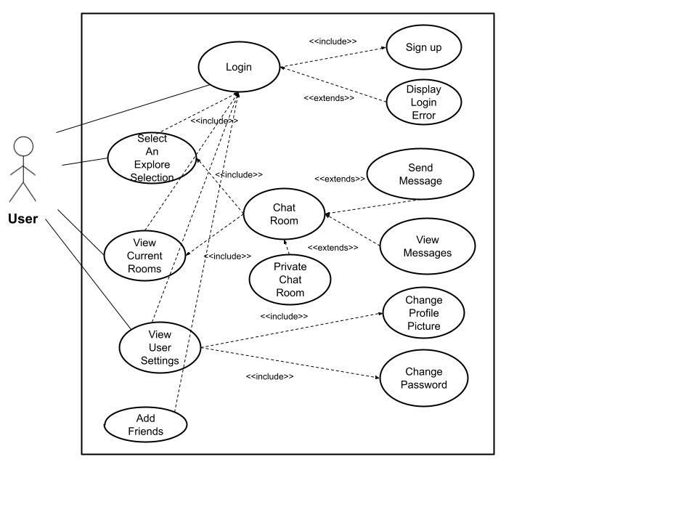

# 4. Evolutionary Requirements

## 4.1. Functional Requirements

### 4.1.1. Add Friends

|  |  |
| --- | --- |
| Title | Add Friends |
| Description | Allows users to request to add friends to their friends list , and also the ability to accept/decline friend requests.  Users also have the ability to block and mute individual users because of reasons such as spam and inappropriate messages |
| Priority | 3 |
| Precondition(s) | User needs to have an account |
| Postconditions(s) | User has friends on their friends list and notifications of friend requests |
| Use Case Diagram | 3.1 Functional Requirements Use Case |

### 4.1.2. Private Message Chat Room

|  |  |
| --- | --- |
| Title | Private Message Chat Room |
| Description | Allows users to message individual people |
| Priority | 3 |
| Precondition(s) | Users can open a private chat room with another user if they are friends.  Users can send a message to another user before they are friends, but the receiving user may choose to decline the message and thus not open the private chat room. |
| Postconditions(s) | Private chat room is opened between two users |
| Use Case Diagram | 3.1 Functional Requirements Use Case |

### 4.1.3. Find Friends

|  |  |
| --- | --- |
| Title | Find Friends |
| Description | Users will be able to find other users by searching for a name or being presented with suggestions based on interests and app usage. |
| Priority | 3 |
| Precondition(s) | Users must be logged in. In order to find other users by suggestion, at least one room must be selected. |
| Postconditions(s) | Users will be presented with a list of names that either closely match the search query or that were suggested based on room selection. |
| Use Case Diagram | 3.1 Functional Requirements Use Case |

## 

## 4.2. Non-Functional Requirements

### 4.2.1. Message Encryption

|  |  |
| --- | --- |
| Title | Message Encryption |
| Description | Message Encryption prevents others from accessing the data in the messages and adds a level of security |
| Priority | 2 |
| Applicable FR(s) | Private Chat Room, Chat Rooms |

#### 