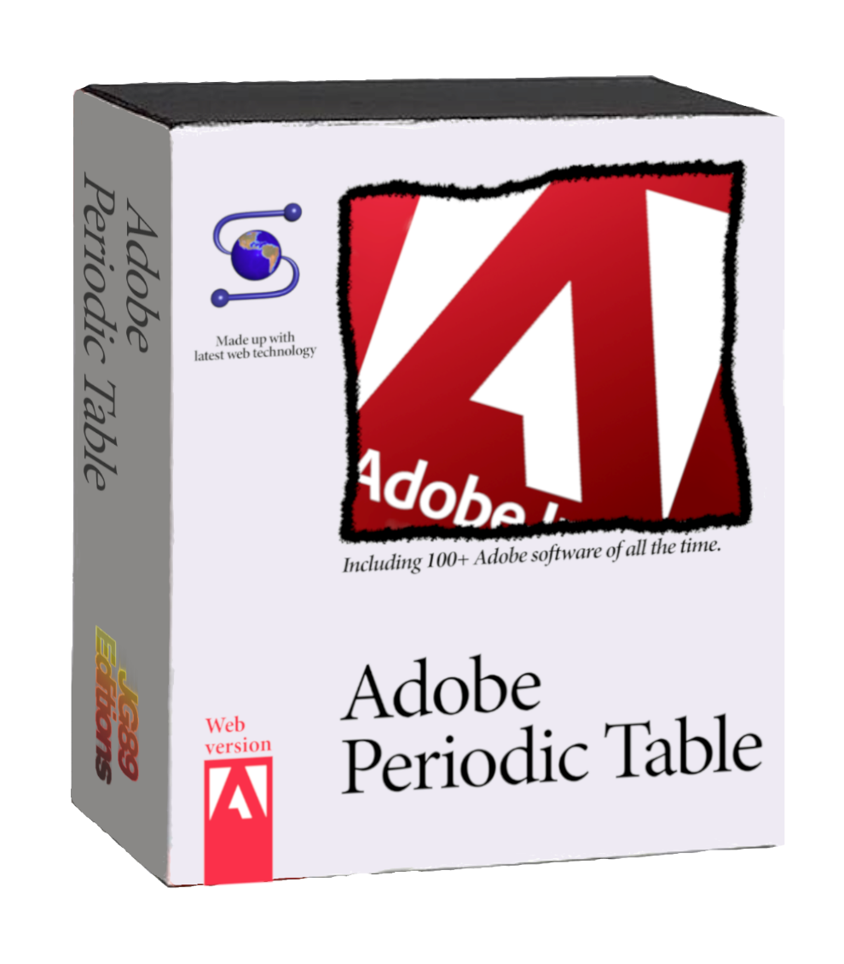

Adobe Periodic Table User Guide

***Documentation***

***Thank you for downloading Adobe Periodic Table software on your PC.***

For this whole project, I’ve used these Adobe brand fonts: Minion Pro and Adobe Clean. *Minion Pro* is the font used by Adobe in the 90s and 20s, then they replaced it with the new design of the *Adobe Clean* font around 2008 and 09. Both fonts were designed by internal Adobe employees.

I also tried getting as much logotypes from Adobe products as possible, since before 2005, Adobe didn’t used any logotype for their products, and there are some extremely rare and unheard programs which don’t have a logotype, screenshots, or they quality is just terrible. For those I couldn’t find, I have already taken care of making an ‘Unknown program’ logo, imitating the usual Adobe logo design, that looks like the right picture:

There isn’t really a specific reason to make this project. I was just one day looking by curiosity how many programs there were in the Adobe CS, and after looking at all of them, I told myself: “Holy crap this company has got programs for everything, it’d be fun to see a **periodic table** of all this”, and that’s how it was born. I decided to challenge myself doing this as I knew it wouldn’t be easy, more like a very tedious and organized task. This is how I structured the work:

* Doing a list with all the programs.
* Transforming it into a table, adding more programs, and more info like: own categories and supported platforms (*programs-list.txt*).
* Doing the cell layout (*GIMP cells work*).
* Filling and exporting a cell for each program.
* Doing the periodic table layout and adding every cell.
* Doing the website which you might have downloaded this PDF from.

Software data table

Before making anything of graphic assets or whatever, I’ve done a table with all the Adobe’s products, and some quick info like the platform where you can run that software and one or more categories. The table can be found by the file name of “programs-list.txt” in the complete download package available on the website.

The software list contains all the programs included in the final periodic table, or at least in its initial release, as I may plan some updates as Adobe keeps changing their products and services offer.

There are some things that may be cleared out for a better understanding and comprehension of the table:

* The “mobile” device tag remains to all modern mobile devices, such as Android devices, Apple’s and Blackberry’s.
* The “Linux” device tag includes both Linux and Unix compatibility.
* The Apple icon, which represents availability for MacOS computers, includes Classic MacOS and OS X (every Mac operating system that has ever existed).
* Even if the supported devices are “all” and there is a parenthesis saying “cross-platform” or just “cross”, there still may be some other cross-platform apps that haven’t been marked with this tag.
* The “~notav~” device tag stands for Not Available, which means any information related to its compatibility with any device couldn’t be fetched.

It is important to know that the table is very possible to be outdated. Not outdated in terms of information dates, which could also be, but instead there could be some missing programs, that appear on the table but not on this list. This is mostly caused due to this list was completed on July 2021, and the project was resumed to be finished on August 2022, meaning some programs were discontinued, and some others less known were finally visible on the Internet, and the information update has been directly done to the periodic table cells to save time and effort writing programs that will be already on the table. Therefore, I recommend you get based on the information written in the software cells rather than the data found on the table.

Distribution/classification list

This list is where you can find all the program names classified like in the periodic table. This was a draft of how the programs would be classified into the final table, because, you know, it’s a periodic table.

At the beginning, a classification system based on the tags written in the program cells was though, but soon I realized that had no sense, as I wasn’t a true Adobe-ist. I soon noticed that had to be arranged by suites and own Adobe categories. Before having some suites, Adobe categorized their programs by tags based on their functionality, like I did at first, but without inventing it. Old tags system has been used with programs that weren’t part of a suite or were previous to 2005 approximately.

Program cell

This is the design and layout of a single program cell, each program will have a cell with its own info, like the title, its original authors/companies, a short and clear description, active development years, its continued status and supported platforms and OS.

The cell background colour has an opacity of 80% for a simulated glass effect in the table, basically to look cooler😎.

The logotype of each product is what will have visual importance, so you can take a fast look and recognize the product you want to read about.

The cell has been made using GIMP 2.10. You can download the project file (.xcf) from the complete download package, on the website. For doing and exporting your own cells, make sure to select the PNG format, otherwise the transparency effect will be lost.

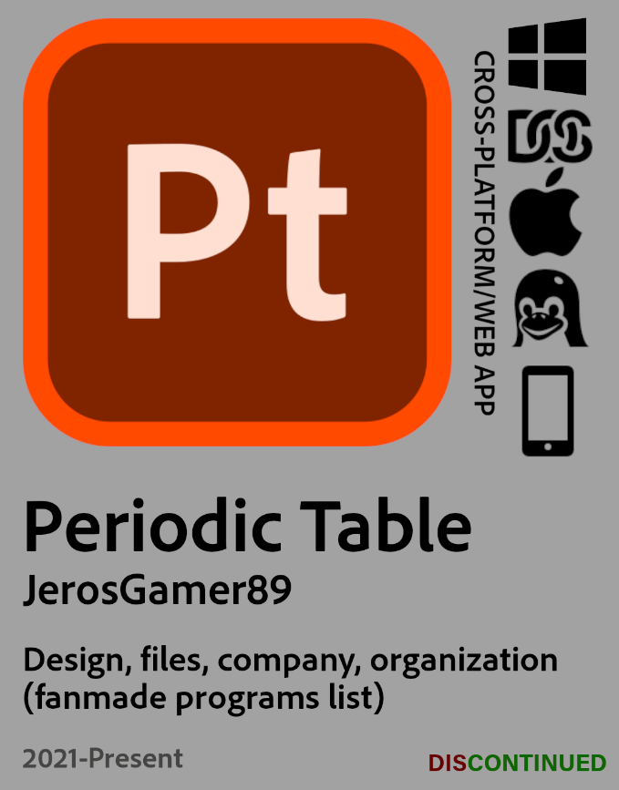Some programs might have a little gold star at the bottom right of its logotype. This means, as you may guess, that it is a really popular product of the company, such as Flash, Photoshop and Premiere Pro.

Some programs aren’t just programs, but services provided by Adobe. This can be understood with almost all the marketing and business products, such as Experience Manager and Adobe Sensei, just as examples. They cannot be put the platforms that they are available at, so it usually will appear the “Information not available” tag at the right side of the logotype.

Company cell

On these cells are gathered all the notable companies bought by Adobe throughout time. Especially the ones that provided Adobe a strong technology base for products they even still have on sold. There are other companies which Adobe’s purpose after the buyout was just getting its technology and applying it to their products. Which may seem an intelligent and logic move, if you just don’t want to generate competence and are a complete lazy company wanting to the best overall lol.

Business aside, they really bought pretty solid and strong companies that gave them the best (in some cases almost the best) technology to continue as a world-leading company in many different areas. They can be found in the table on a section under the name of *“Acquisitions”*.

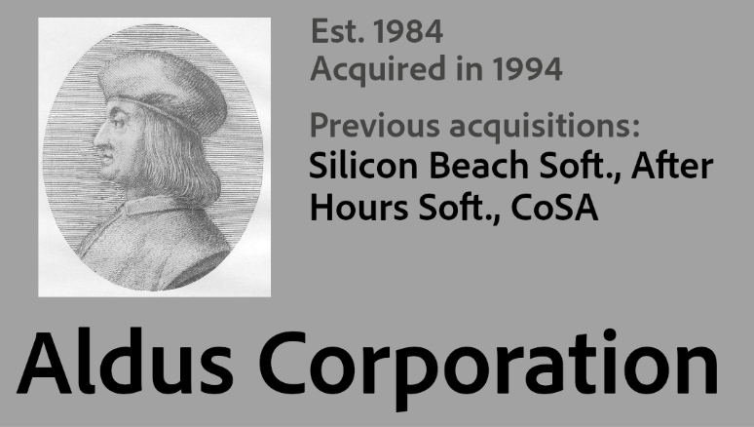The cell is similar to the programs one in some details, like the background, fonts and visual stuff, except for the layout and type of information in most cases. Including brief but enough information about those companies, like the establishment year (founded/created on 0123, sometimes isn’t determined due to lack of information or even motivation lol), the year it was acquired, all the programs/companies it acquired before Adobe bought them, a nice pic of the company logotype, and its name.

I already though on including the programs that merged onto Adobe’s list, but that would have been useless as the original authors of each program are listed on their respective program cell. It may result easier for you to know them at a glance, but come on, just take a look at the table and you’ll quickly know it.

Table composition

The table sections have been arranged and selected by suites. The original Adobe suites that were publicly available on their website not that much time ago, now it’s a little bit harder to find them, but they are also available on the Wikipedia. These sections with different coloured backgrounds were made on Inkscape, a program that works like Illustrator.

These sections were exported as PNGs, and then finally organised and decorated on GIMP.

The final table image contains the table with all the sections, the title with my logotype, the adobe box in the background and an example cell with indicators describing what means each element of the cell.

Questions

If you have got any questions or doubts that you want to solve, get in touch with me. By [clicking here](https://ascript89.github.io/#contact) you’ll see all the possible ways.

Legal disclosure/statement

This project is not affiliated in any way to Adobe Incorporated or any of its partners. This is a project freely done by me, in my free time, without any type of support or sponsorship.

The font families “Adobe Clean” and “Minion Pro” are made and copyrighted by Adobe Inc. All rights belong to this company.

Icons of Adobe’s software has been obtained thanks to public sources on the Internet. They haven’t been modified or created manually, always respecting their brand design guidelines. Icons have been designed by internal staff of Adobe Inc., and all rights belong to them.

Shown multiple times in many files of the project, the Adobe software box (background image at the first page) is a mock-up of the real 80s software boxes that were distributed in local stores. There was not any intention of copying, or imitating Adobe software boxes or any similar.

This project (the table, the desktop application and the cells) is licensed under a Creative Commons BY-NC-ND 4.0 license, more information about this license by [clicking here](https://creativecommons.org/licenses/by-nc-nd/4.0/legalcode).

Credits

All of this has been done by JerosGamer89. More information about him on his [portfolio website](https://ascript89.github.io/). Done from July 2021 to August 2021 and July 2022 to September 2022. Software used: GIMP, Inkscape, Microsoft Word for the documentation, Windows Notepad as editor for text files.

Information and icon sources: Wikipedia, Adobe Wiki Fandom, Logopedia Fandom, Adobe.com, The Internet Archive and some Adobe YouTube videos.