**Carbon Footprint monitoring tool**

**Business Problem**: In today's world, there is a growing concern about environmental sustainability and the need to reduce carbon emissions. Many organizations are recognizing the importance of measuring and reducing their carbon footprints to contribute to a greener and more sustainable future. However, without a proper monitoring tool, businesses face challenges in accurately assessing their carbon emissions and implementing effective strategies to reduce them.

Importance of Solving the Problem:

1. **Clients**: The organization's clients are the primary stakeholders who will benefit from the development of a Carbon Footprint monitoring tool. By having access to such a tool, clients can measure their carbon emissions across various aspects of their operations, such as energy consumption, transportation, waste management, and more. This information is crucial for clients to understand their environmental impact and make data-driven decisions to reduce their carbon footprints. The tool's ability to generate reports and provide suggestions for carbon reduction strategies empowers clients to take proactive steps towards sustainability.
2. **Environment**: The development of a Carbon Footprint monitoring tool has a significant impact on the environment as a whole. By providing organizations with the means to measure and track their carbon emissions, the tool encourages them to adopt eco-friendly practices and reduce their environmental impact. This, in turn, contributes to the larger goal of mitigating climate change and preserving the planet for future generations.
3. **Organization**: As a data analytics consultancy, developing a Carbon Footprint monitoring tool positions the organization as a leader in environmental sustainability solutions. By offering this tool to their clients, the organization can attract environmentally conscious businesses, build long-term partnerships, and establish a reputation for providing innovative and effective data-driven solutions. Additionally, the tool can generate revenue through licensing or subscription models, creating a new source of income for the organization.

To help clients and stakeholders to monitor and fast calculation we develop following console application with report generating and data validation functions.

The importance of developing this Carbon Footprint monitoring tool can be understood by considering the following stakeholders:

1. Organization's Clients: The tool aims to assist the organization's clients in monitoring and reducing their carbon footprints. Clients will benefit from the tool by being able to input their data related to energy consumption, waste generation, and business travel. The tool calculates the carbon footprint based on the provided data and provides valuable insights and suggestions for reducing it. This empowers clients to take informed actions towards sustainability and demonstrate their commitment to environmental responsibility.
2. Environment: By enabling organizations to measure and track their carbon footprints, the tool contributes to environmental preservation. It encourages clients to adopt sustainable practices, such as reducing energy consumption, improving waste management, and promoting greener business travel. Ultimately, this collective effort aids in mitigating climate change, minimizing carbon emissions, and protecting the environment for future generations.
3. Data Analytics Consultancy: Developing the Carbon Footprint monitoring tool enhances the reputation and credibility of the data analytics consultancy. By offering an innovative and effective solution to measure and reduce carbon footprints, the consultancy establishes itself as a leader in sustainability consulting. This can attract environmentally conscious clients, foster long-term partnerships, and create new business opportunities. Additionally, the tool can serve as a revenue stream through licensing or subscription models, contributing to the consultancy's financial growth and sustainability.

**Code samples and documentation:**

Project consists of several classes and files.

Structure of project:

* 1. baseFunc.py
     1. class topics
     2. class validation
     3. def getTopicResults
  2. console.py

a. **baseFunc.py** file represents a topic list and related validation functions for a Carbon Footprint monitoring tool. It includes three topic classes: "Energy Us," "Waste," and "Business Travel." Each topic class has attributes for name, values, questions, and a method for calculating the carbon footprint result. Additionally, there is a validations class that contains functions for data validation.

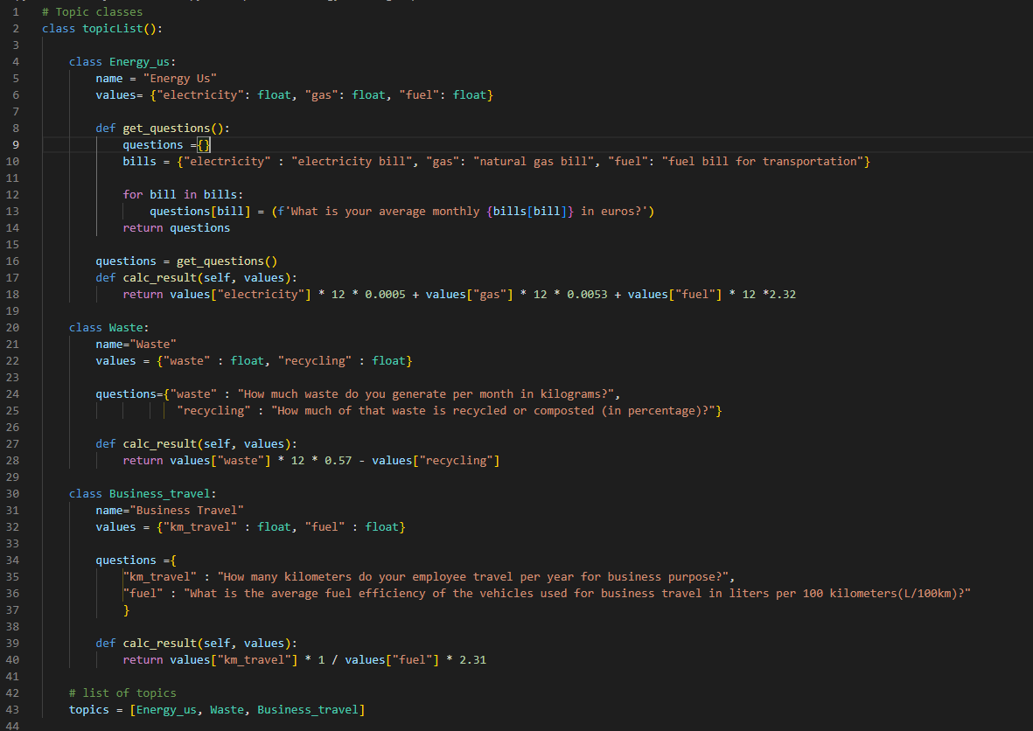

Application a class structure for a topic list in a Carbon Footprint monitoring tool. The code includes three nested classes representing different topics: "Energy Us," "Waste," and "Business Travel." Each topic class has attributes for name, values, questions, and a method for calculating the carbon footprint result.

Extra topic can be added or removed from class, which will not effect the work of monitoring tool

**Validations class.**

Code includes a validations class that contains validation functions and error messages for data input. These functions can be used to validate various types of data, such as floats, integers, and numeric ranges.

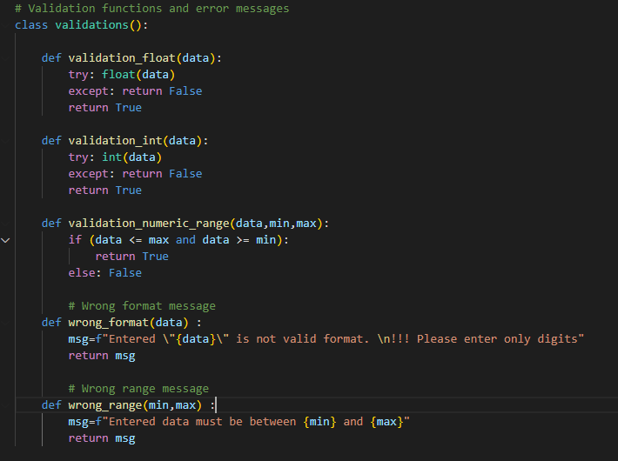

The code includes a **getTopicResult** function that validates user inputs and calculates the carbon footprint result for a selected topic. This function utilizes the validation functions and error messages from the validations class.

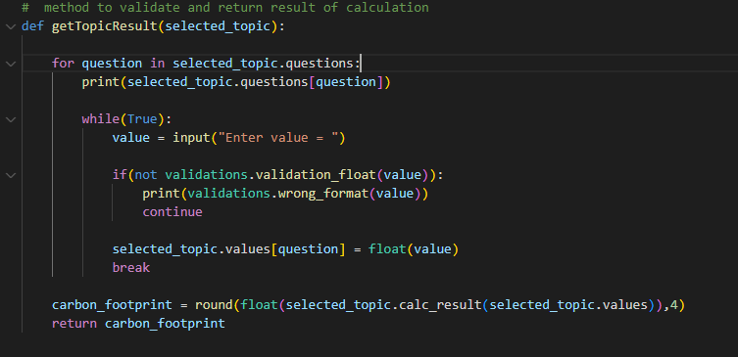

**Console.py**

The file code flow for selecting and calculating the carbon footprint for different topics. The program prompts the user to choose a topic, validates the input, and calculates the carbon footprint result using the getTopicResult function. The program repeats this process until all topics are covered, and then displays the results.

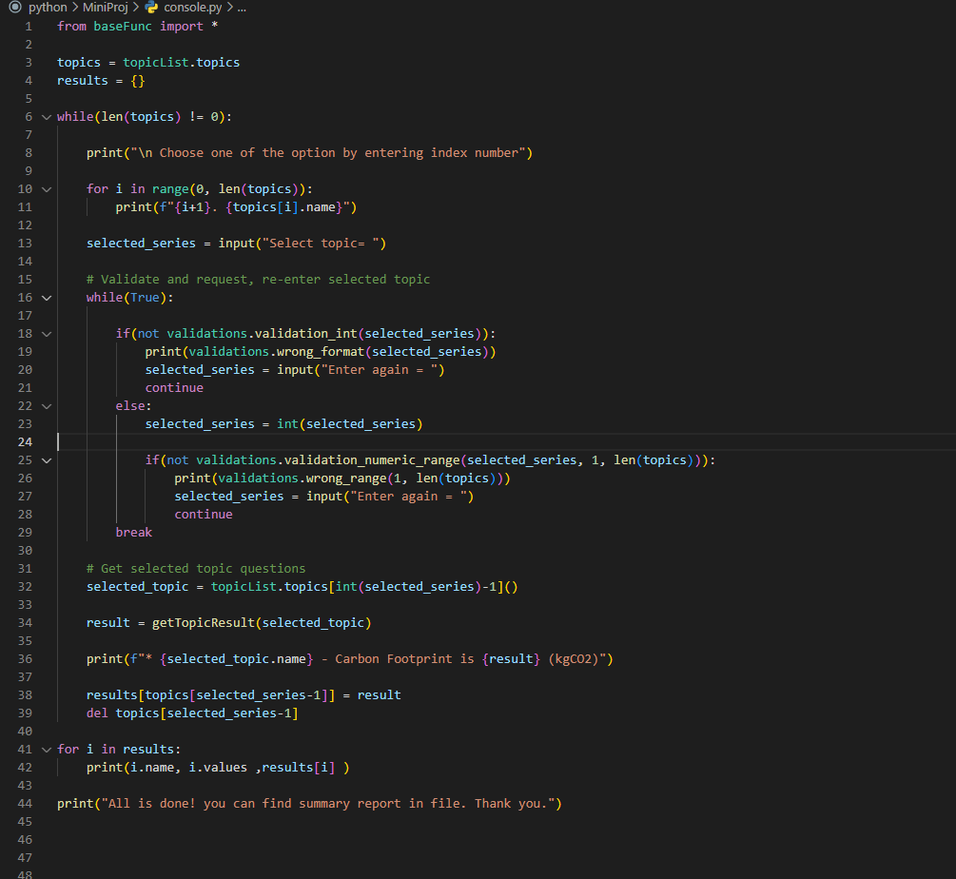

**Conclusion:**

In conclusion, developing a Carbon Footprint monitoring tool benefits clients, the environment, and the data analytics consultancy. It provides clients with the necessary tools and insights to reduce their carbon footprints, contributes to environmental preservation, and positions the consultancy as a leader in sustainability consulting.