Course Withdrawal System

Project Documentation

1. Project Context
The Course Withdrawal System is a web-based application designed to streamline and digitize the process of student course withdrawal requests in educational institutions. Traditional course withdrawal processes often involve paper-based forms, manual approvals, and time-consuming administrative tasks. This system addresses these challenges by providing an automated, transparent, and efficient platform for managing withdrawal requests.
The system serves three main user roles: - Students - Submit withdrawal requests with reasons - Teachers/Administrators - Review and process withdrawal requests - System Administrators - Manage system data (courses, sections, users)
The application is built using modern web technologies: - Frontend: HTML5, CSS3, JavaScript - Backend: PHP 8.x - Database: MySQL/MariaDB - Email Service: PHPMailer with SMTP

2. General Objective
To develop a comprehensive web-based Course Withdrawal System that automates and streamlines the course withdrawal request process, enabling efficient communication between students and administrators while maintaining proper documentation and tracking of all withdrawal transactions.

3. Specific Objectives
- User Authentication & Authorization
  - Implement secure login system with role-based access control
  - Provide separate interfaces for students and administrators
  - Ensure password security through hashing
- Withdrawal Request Management
  - Enable students to submit withdrawal requests with detailed reasons
  - Allow administrators to review, approve, or reject requests
  - Support admin remarks for feedback to students
- Course & Section Management
  - Provide CRUD operations for courses and sections
  - Allow assignment of teachers to specific course-section combinations
- User Management
  - Manage student and teacher/admin accounts
  - Assign students to sections and teachers
- Notification System
  - Implement in-app notifications for request updates
  - Send email notifications for status changes
- Reporting
  - Generate reports on withdrawal requests
  - Filter reports by status, date range, and other criteria
  - Export functionality for data analysis

4. Scope and Limitations

Scope
The system covers the following functionalities:
Module | Features
Authentication | Login, logout, session management
Student Portal | Submit requests, view history, receive notifications
Admin Dashboard | Statistics overview, pending requests count
Request Review | Approve/reject requests, add remarks
Course Management | Add, edit, delete courses
Section Management | Add, edit, delete sections
Teacher Assignment | Assign teachers to course-section pairs
User Management | Manage students and admin accounts
Notifications | In-app and email notifications
Reports | Filterable reports with export options

Limitations
- Single Institution - Designed for one educational institution
- No Mobile App - Web-based only (responsive design)
- No Payment Integration - Does not handle refunds or financial transactions
- No Academic Calendar Integration - Manual date management
- English Language Only - No multi-language support
- Manual Password Reset - No automated forgot password functionality
- No Course Prerequisites - Does not validate course dependencies

5. System Features

5.1 Login Page
The login page provides secure authentication for all users (students and administrators).
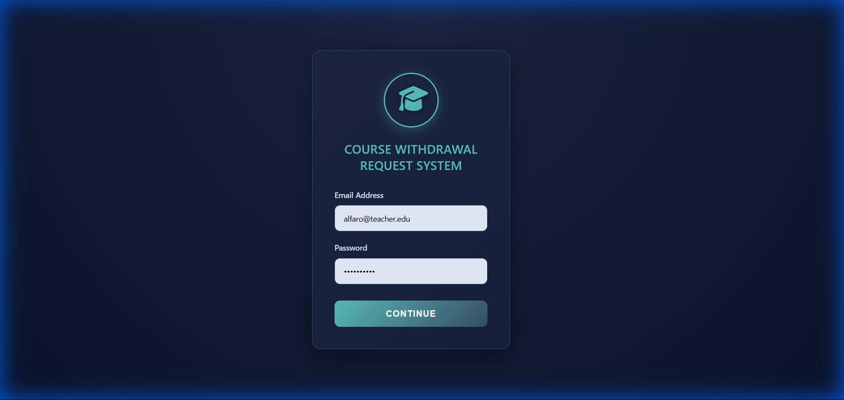
Login Page
Features: - Email and password authentication - Role-based redirection (Admin → Dashboard, Student → Student Portal) - Session management with secure cookies - Password verification using bcrypt hashing

STUDENT FEATURES

5.2 Student Dashboard
The student dashboard provides students with an overview of their withdrawal request activities.
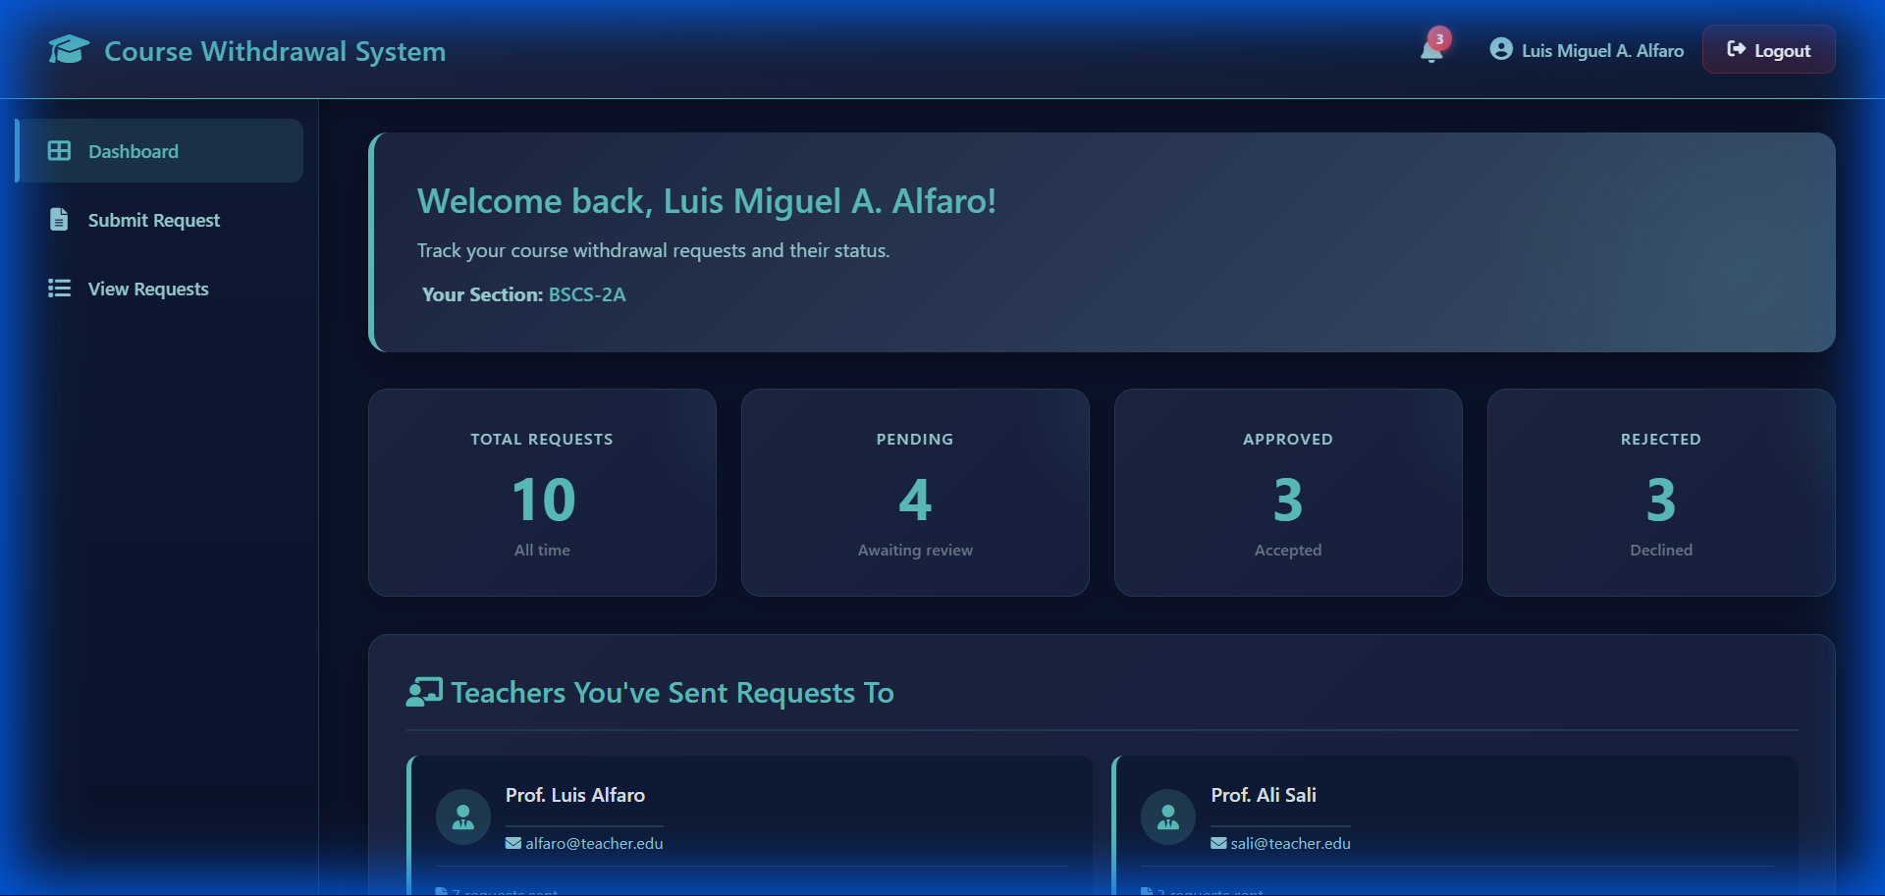
Student Dashboard
Features: - Quick overview of request statistics - Navigation to submit new requests - View pending and completed requests - Access to notifications

5.3 Submit Withdrawal Request
Students can submit withdrawal requests for their enrolled courses.
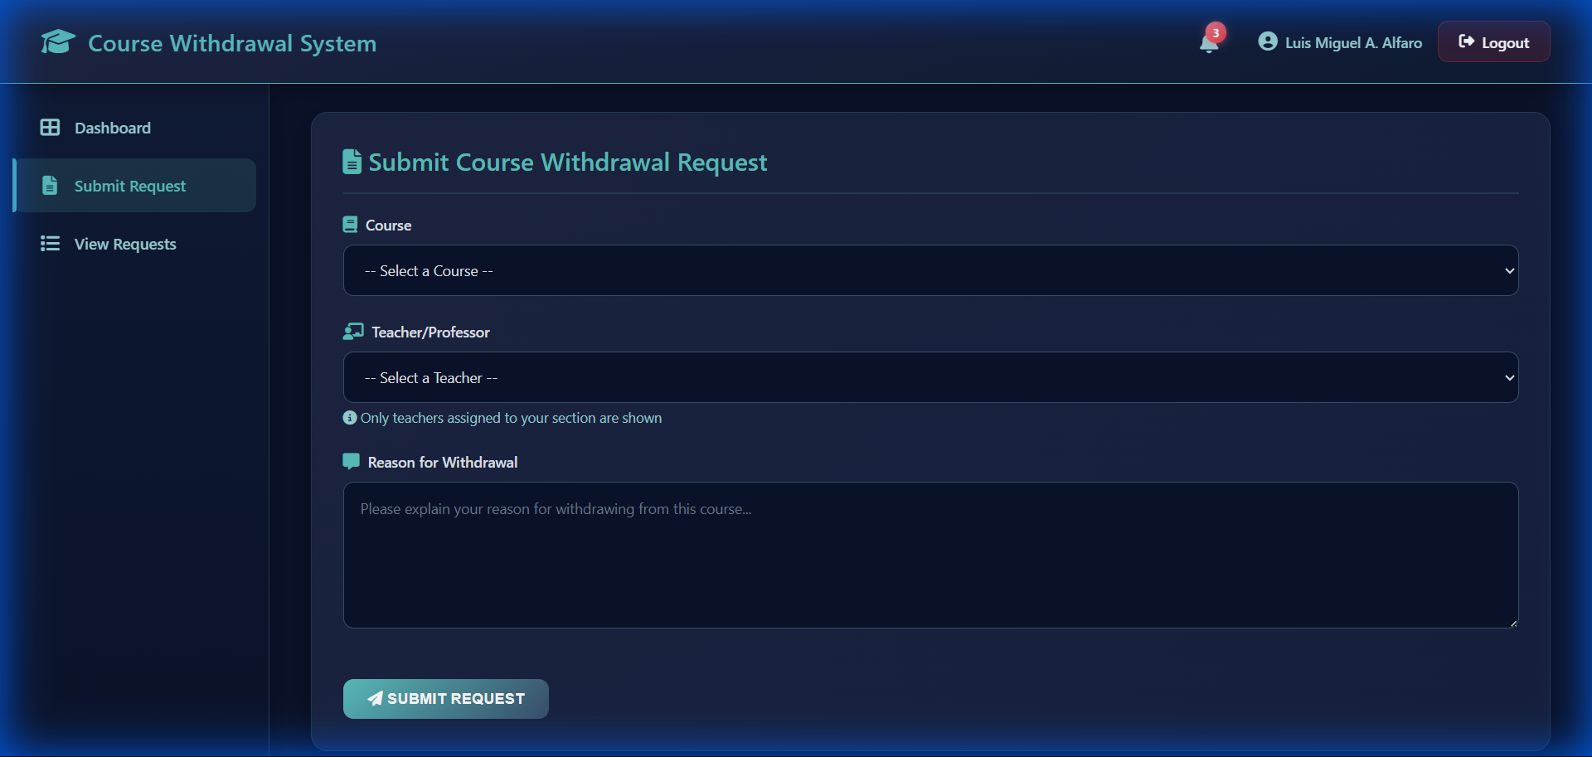
Submit Request Form
Features: - Select course to withdraw from - Provide detailed reason for withdrawal - Automatic teacher assignment based on course-section - Email notification sent to assigned teacher - In-app notification confirmation

5.4 View My Requests (Request History)
Students can track all their withdrawal requests and their statuses.
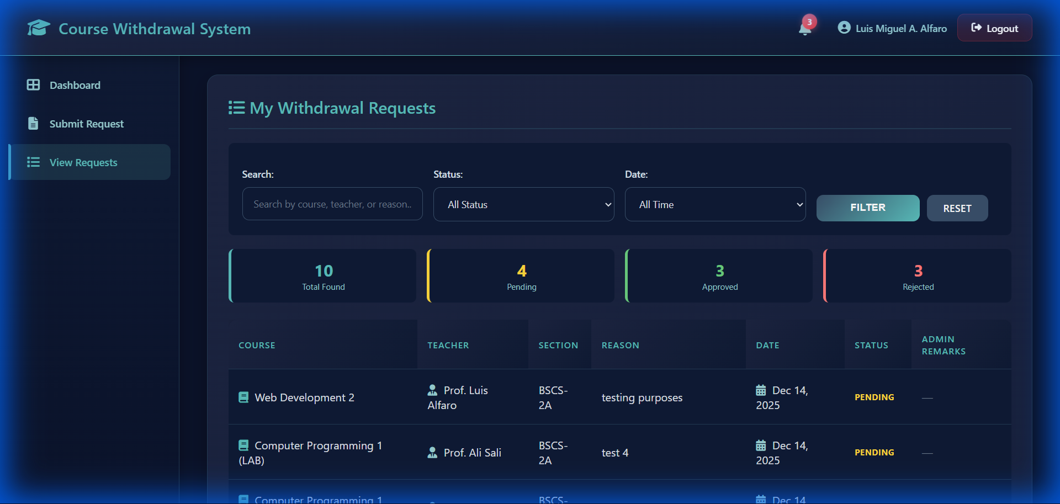
My Requests
Features: - View all submitted requests - Track request status (Pending, Approved, Rejected) - See admin remarks and feedback - Request date and course details - Color-coded status indicators

5.5 Student Notifications
Students receive notifications about their request status updates.
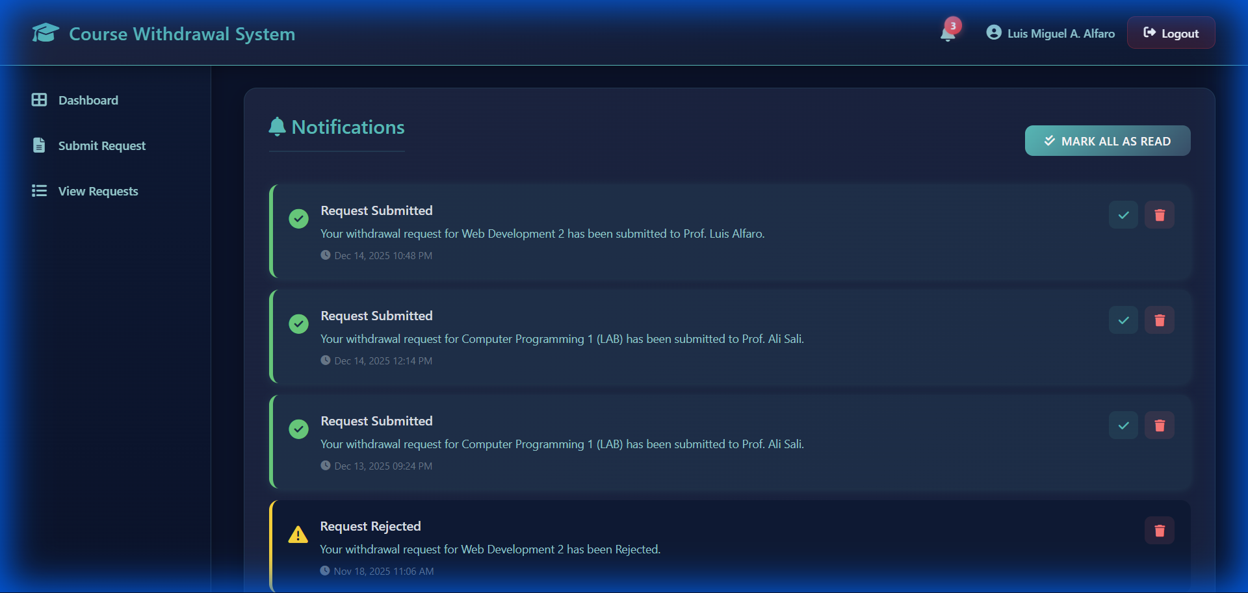
Student Notifications
Features: - In-app notification center - Notification types (info, success, warning, error) - Mark notifications as read - Real-time updates on request status - Notification bell with unread count

ADMIN FEATURES

5.6 Admin Dashboard
The main dashboard provides administrators with an overview of system statistics.
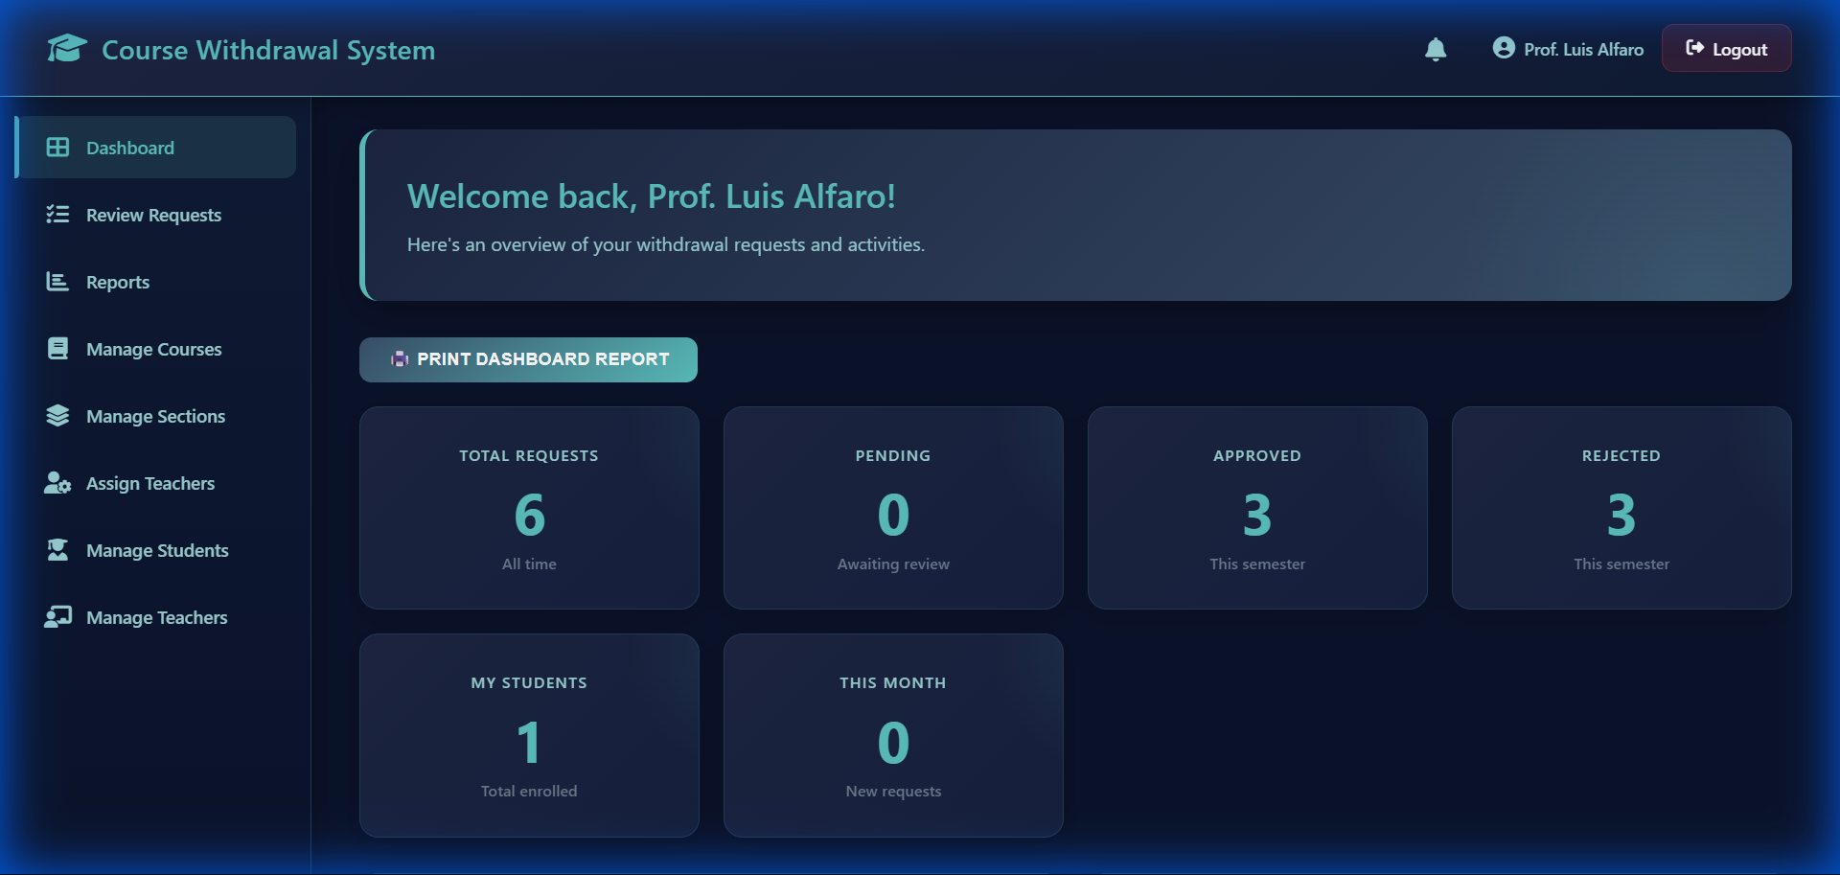
Admin Dashboard
Features: - Real-time statistics (total requests, pending, approved, rejected) - Quick access navigation sidebar - User information display - Notification bell with unread count

5.7 Review Requests
Administrators can review and process student withdrawal requests.
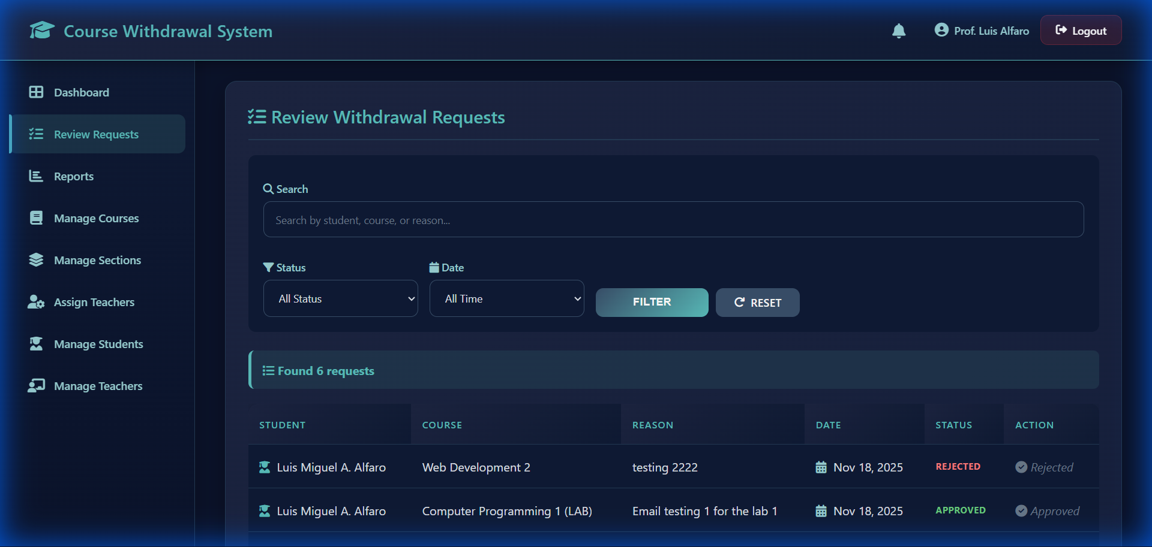
Review Requests
Features: - View all pending requests - Filter by status, section, and search term - Approve or reject requests with modal confirmation - Add admin remarks for student feedback - Status-based color coding

5.8 Reports
Generate and export reports on withdrawal requests.
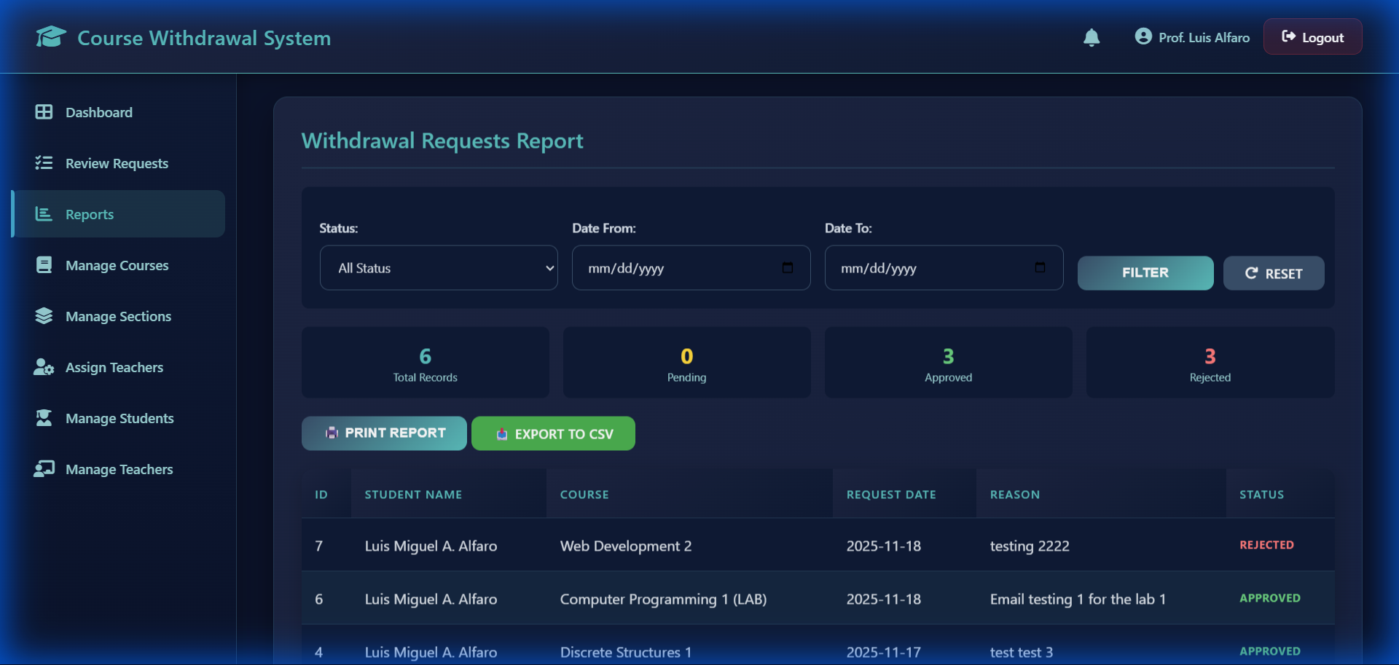
Reports
Features: - Filter by status (Pending, Approved, Rejected) - Date range filtering - Summary statistics display - Print and CSV export options - Detailed request table

5.9 Manage Courses
CRUD operations for managing courses in the system.
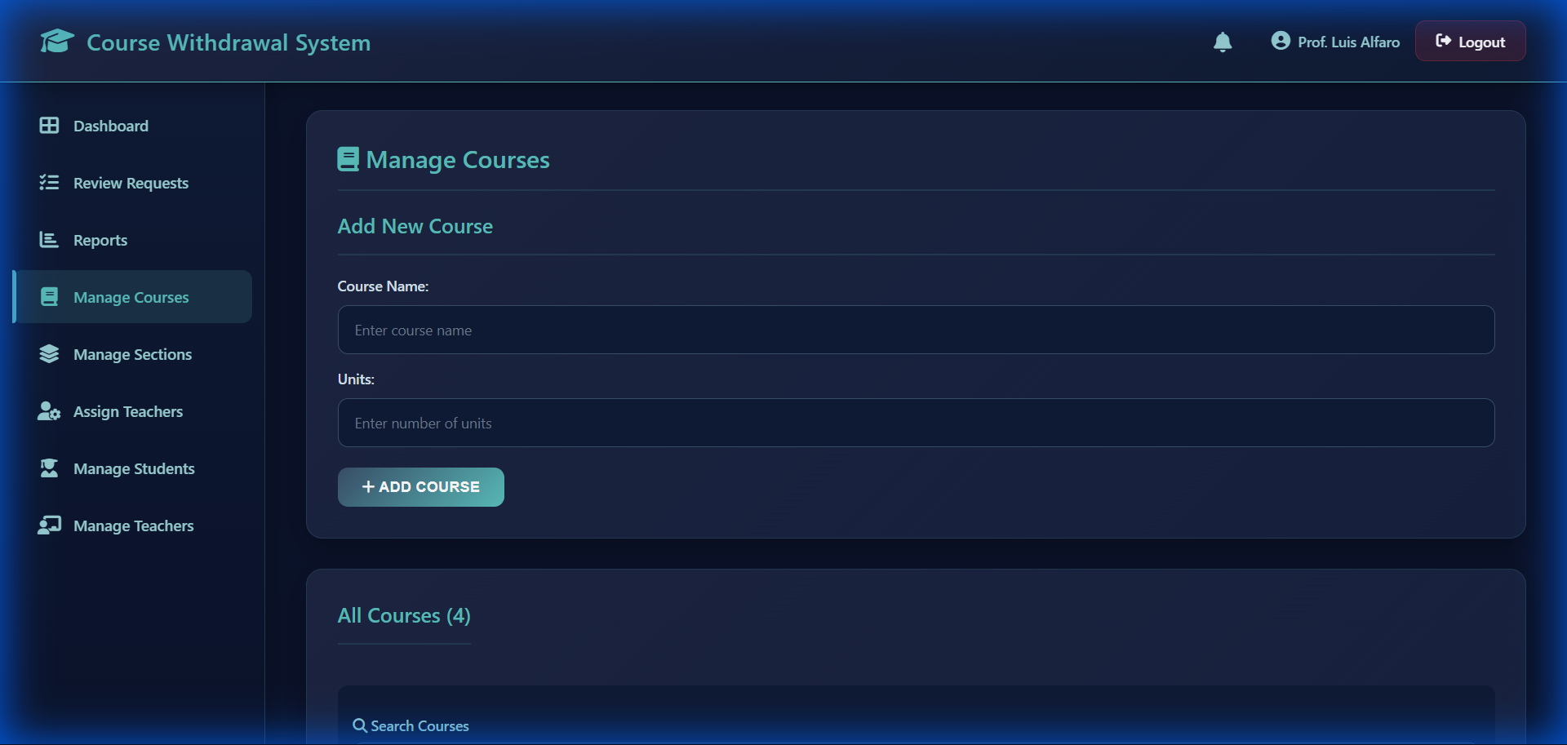
Manage Courses
Features: - Add new courses with name and units - Edit existing course details - Delete courses - Search functionality - Validation for duplicate course names

5.10 Manage Sections
CRUD operations for managing class sections.
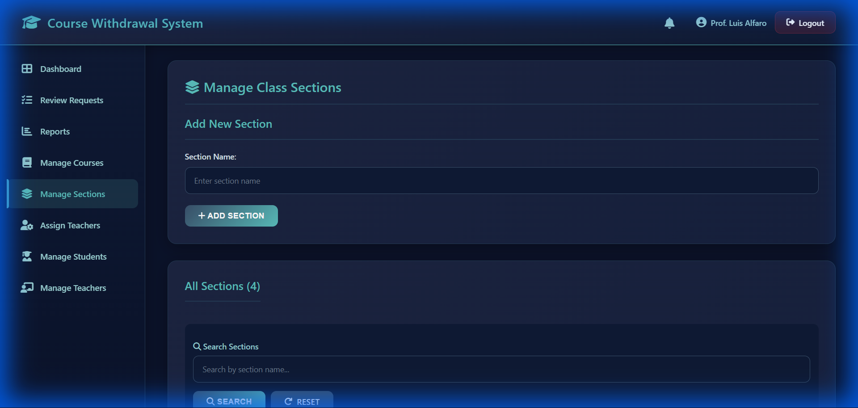
Manage Sections
Features: - Add new sections - Edit section names - Delete sections - Search functionality - Unique section name validation

5.11 Assign Teachers
Assign teachers/admins to course-section combinations.
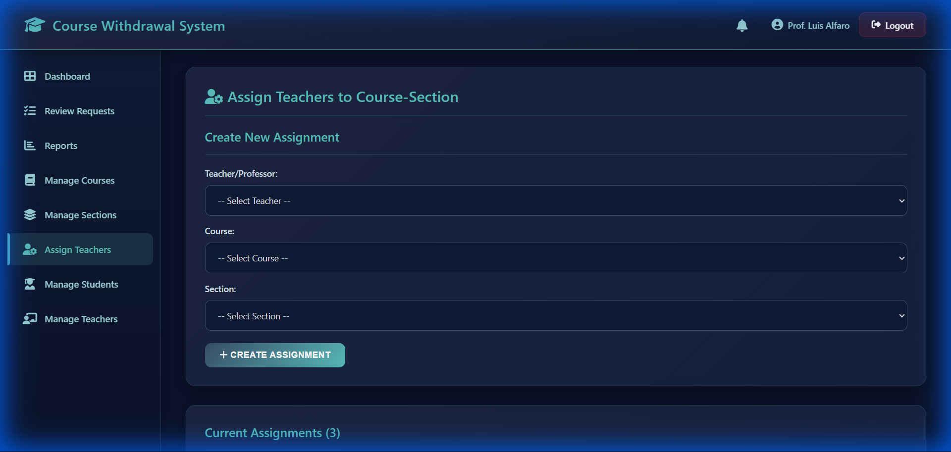
Assign Teachers
Features: - Create teacher-course-section assignments - Edit existing assignments - Delete assignments - Search by teacher, course, or section - Prevent duplicate assignments

5.12 Manage Students
Manage student accounts in the system.
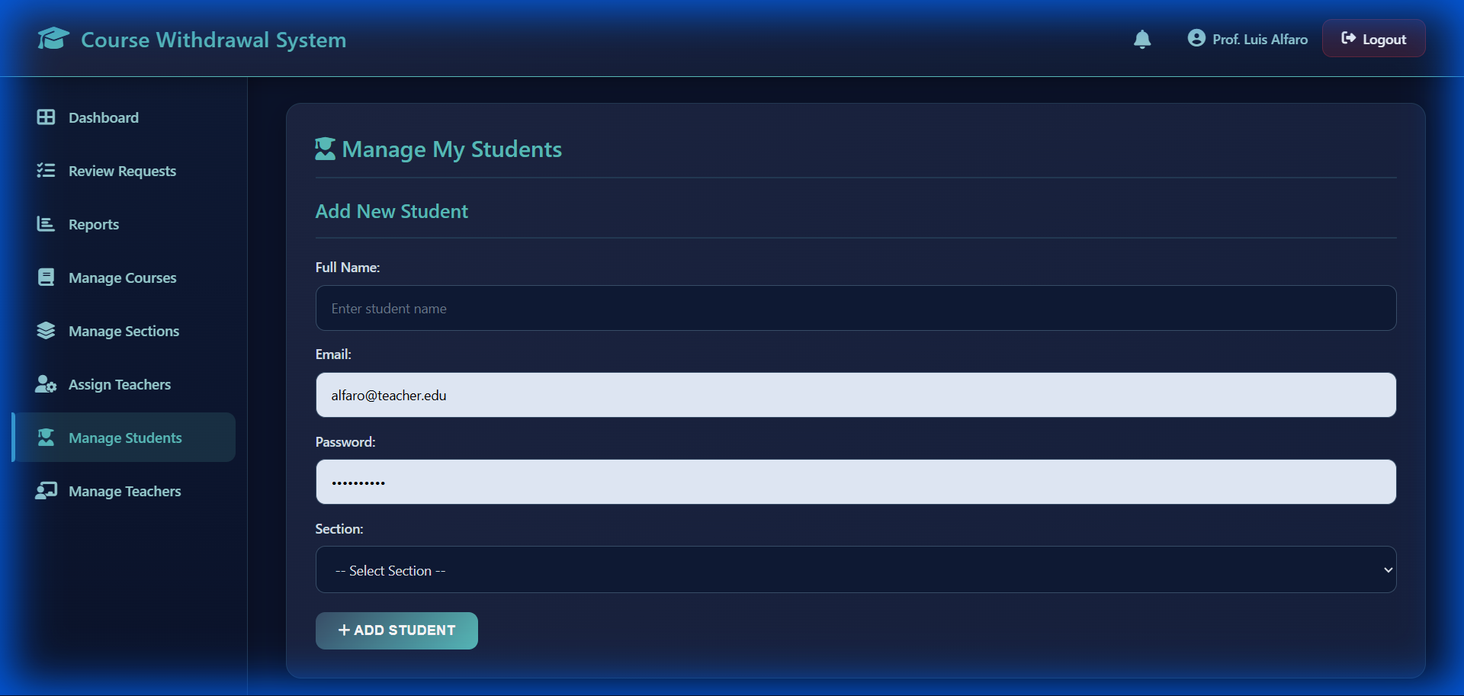
Manage Students
Features: - Add new student accounts - Assign students to teachers and sections - Edit student information - Delete student accounts - Search and filter functionality - Secure password hashing

5.13 Manage Teachers/Admins
Manage teacher and administrator accounts.
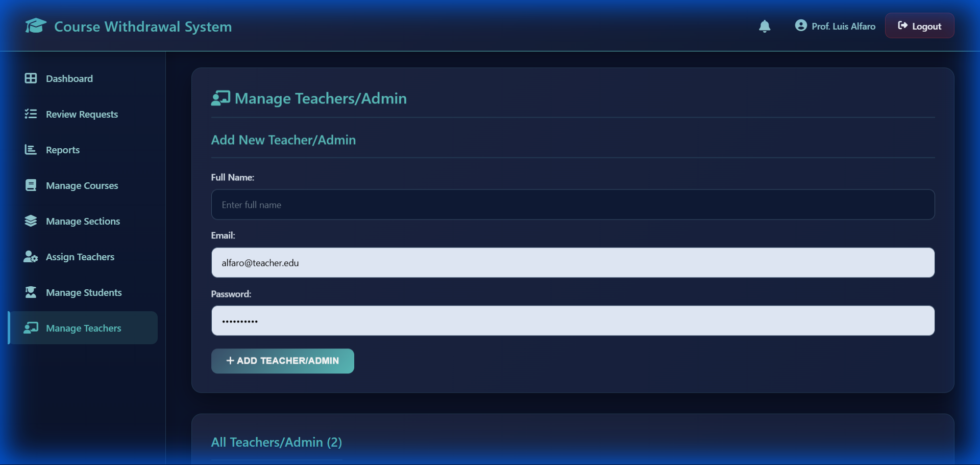
Manage Teachers
Features: - Add new admin/teacher accounts - Edit account information - Delete accounts - Search functionality - Secure password management

6. System Analysis and Design

6.1 Entity-Relationship (ER) Model
┌─────────────┐ ┌─────────────────────────┐ ┌─────────────┐
│ USER │ │ WITHDRAWAL_REQUEST │ │ COURSE │
├─────────────┤ ├─────────────────────────┤ ├─────────────┤
│ UserID (PK) │──┐ │ RequestID (PK) │ ┌──│ CourseID(PK)│
│ FullName │ │ │ UserID (FK) │────┘ │ CourseName │
│ Email │ └────│ CourseID (FK) │ │ Units │
│ Password │ │ TeacherID (FK) │ └─────────────┘
│ Role │ │ SectionID (FK) │
│ TeacherID │───────│ RequestDate │ ┌─────────────┐
│ SectionID │ │ Reason │ ┌──│ SECTION │
└─────────────┘ │ Status │ │ ├─────────────┤
│ │ AdminRemarks │────┘ │ SectionID │
│ └─────────────────────────┘ │ SectionName │
│ │ CreatedAt │
│ ┌─────────────────────────┐ └─────────────┘
│ │ TEACHER_COURSE_SECTION │ │
└───────────────│ ID (PK) │ │
│ TeacherID (FK) │──────────────┘
│ CourseID (FK) │
│ SectionID (FK) │
│ CreatedAt │
└─────────────────────────┘
┌─────────────────────────┐
│ NOTIFICATION │
├─────────────────────────┤
│ NotificationID (PK) │
│ UserID (FK) │
│ Title │
│ Message │
│ Type │
│ IsRead │
│ CreatedAt │
└─────────────────────────┘

6.2 Logical Model

Entity Descriptions
Entity | Description
USER | Stores all user accounts (students and admins) with role-based access
COURSE | Contains course information including name and credit units
SECTION | Represents class sections (e.g., BSCS-2A, BSIT-3A)
WITHDRAWAL_REQUEST | Core transaction table for withdrawal requests
TEACHER_COURSE_SECTION | Junction table for teacher-course-section assignments
NOTIFICATION | Stores in-app notifications for users

Relationships
Relationship | Type | Description
User → Withdrawal_Request | 1:N | A user can have many withdrawal requests
Course → Withdrawal_Request | 1:N | A course can have many withdrawal requests
User (Teacher) → Withdrawal_Request | 1:N | A teacher processes many requests
User → Section | N:1 | Many students belong to one section
User → User (Teacher) | N:1 | Many students assigned to one teacher
Teacher ↔ Course ↔ Section | M:N:M | Many-to-many through junction table
User → Notification | 1:N | A user can have many notifications

6.3 Physical Database (SQL Script)
-- =====================================================
-- COURSE WITHDRAWAL SYSTEM DATABASE SCHEMA
-- =====================================================
-- Create database
CREATE DATABASE IF NOT EXISTS course_withdrawal_system
CHARACTER SET utf8mb4 COLLATE utf8mb4_general_ci;
USE course_withdrawal_system;
-- =====================================================
-- TABLE: user
-- Stores all user accounts (students and administrators)
-- =====================================================
CREATE TABLE `user` (
`UserID` int(11) NOT NULL AUTO_INCREMENT,
`FullName` varchar(100) NOT NULL,
`Email` varchar(100) NOT NULL UNIQUE,
`Password` varchar(255) NOT NULL,
`Role` enum('Student','Admin') NOT NULL DEFAULT 'Student',
`TeacherID` int(11) DEFAULT NULL,
`SectionID` int(11) DEFAULT NULL,
PRIMARY KEY (`UserID`),
KEY `idx_teacher` (`TeacherID`),
KEY `SectionID` (`SectionID`)
) ENGINE=InnoDB DEFAULT CHARSET=utf8mb4 COLLATE=utf8mb4_general_ci;
-- =====================================================
-- TABLE: section
-- Stores class sections
-- =====================================================
CREATE TABLE `section` (
`SectionID` int(11) NOT NULL AUTO_INCREMENT,
`SectionName` varchar(100) NOT NULL UNIQUE,
`CreatedAt` timestamp NOT NULL DEFAULT current_timestamp(),
PRIMARY KEY (`SectionID`)
) ENGINE=InnoDB DEFAULT CHARSET=utf8mb4 COLLATE=utf8mb4_general_ci;
-- =====================================================
-- TABLE: course
-- Stores course information
-- =====================================================
CREATE TABLE `course` (
`CourseID` int(11) NOT NULL AUTO_INCREMENT,
`CourseName` varchar(100) NOT NULL,
`Units` int(11) NOT NULL CHECK (`Units` > 0),
PRIMARY KEY (`CourseID`)
) ENGINE=InnoDB DEFAULT CHARSET=utf8mb4 COLLATE=utf8mb4_general_ci;
-- =====================================================
-- TABLE: teacher_course_section
-- Junction table for teacher-course-section assignments
-- =====================================================
CREATE TABLE `teacher_course_section` (
`ID` int(11) NOT NULL AUTO_INCREMENT,
`TeacherID` int(11) NOT NULL,
`CourseID` int(11) NOT NULL,
`SectionID` int(11) NOT NULL,
`CreatedAt` timestamp NOT NULL DEFAULT current_timestamp(),
PRIMARY KEY (`ID`),
UNIQUE KEY `unique_assignment` (`TeacherID`,`CourseID`,`SectionID`),
FOREIGN KEY (`TeacherID`) REFERENCES `user` (`UserID`) ON DELETE CASCADE,
FOREIGN KEY (`CourseID`) REFERENCES `course` (`CourseID`) ON DELETE CASCADE,
FOREIGN KEY (`SectionID`) REFERENCES `section` (`SectionID`) ON DELETE CASCADE
) ENGINE=InnoDB DEFAULT CHARSET=utf8mb4 COLLATE=utf8mb4_general_ci;
-- =====================================================
-- TABLE: withdrawal_request
-- Core table for withdrawal request transactions
-- =====================================================
CREATE TABLE `withdrawal_request` (
`RequestID` int(11) NOT NULL AUTO_INCREMENT,
`UserID` int(11) NOT NULL,
`CourseID` int(11) NOT NULL,
`TeacherID` int(11) NOT NULL,
`RequestDate` date DEFAULT curdate(),
`Reason` varchar(255) DEFAULT NULL,
`Status` enum('Pending','Approved','Rejected') DEFAULT 'Pending',
`SectionID` int(11) DEFAULT NULL,
`AdminRemarks` text DEFAULT NULL,
PRIMARY KEY (`RequestID`),
FOREIGN KEY (`UserID`) REFERENCES `user` (`UserID`) ON DELETE CASCADE,
FOREIGN KEY (`CourseID`) REFERENCES `course` (`CourseID`) ON DELETE CASCADE,
FOREIGN KEY (`TeacherID`) REFERENCES `user` (`UserID`) ON DELETE CASCADE,
FOREIGN KEY (`SectionID`) REFERENCES `section` (`SectionID`) ON DELETE SET NULL
) ENGINE=InnoDB DEFAULT CHARSET=utf8mb4 COLLATE=utf8mb4_general_ci;
-- =====================================================
-- TABLE: notification
-- In-app notification system
-- =====================================================
CREATE TABLE `notification` (
`NotificationID` int(11) NOT NULL AUTO_INCREMENT,
`UserID` int(11) NOT NULL,
`Title` varchar(255) NOT NULL,
`Message` text NOT NULL,
`Type` enum('info','success','warning','error') DEFAULT 'info',
`IsRead` tinyint(1) DEFAULT 0,
`CreatedAt` timestamp NOT NULL DEFAULT current_timestamp(),
PRIMARY KEY (`NotificationID`),
KEY `idx_user_notification` (`UserID`,`IsRead`),
FOREIGN KEY (`UserID`) REFERENCES `user` (`UserID`) ON DELETE CASCADE
) ENGINE=InnoDB DEFAULT CHARSET=utf8mb4 COLLATE=utf8mb4_general_ci;
-- =====================================================
-- Add foreign key constraints to user table
-- =====================================================
ALTER TABLE `user`
ADD CONSTRAINT `fk_teacher` FOREIGN KEY (`TeacherID`)
REFERENCES `user` (`UserID`) ON DELETE SET NULL ON UPDATE CASCADE,
ADD CONSTRAINT `user_ibfk_1` FOREIGN KEY (`SectionID`)
REFERENCES `section` (`SectionID`) ON DELETE SET NULL;

7. Technology Stack
Component | Technology
Frontend | HTML5, CSS3, JavaScript
Backend | PHP 8.x
Database | MySQL 8.0 / MariaDB 10.4
Web Server | Apache (XAMPP)
Email | PHPMailer with SMTP
Icons | Font Awesome 6.x
Hosting | Hostinger (Production)

8. Security Features
Feature | Implementation
Password Hashing | bcrypt via password_hash()
SQL Injection Prevention | PDO Prepared Statements
XSS Prevention | htmlspecialchars() output encoding
Session Management | PHP Sessions with secure cookies
Access Control | Role-based authentication
Error Handling | Production-safe error messages
File Protection | .htaccess security rules

