**Description of the project**

It is a project which helps scientists to simulate the importance of social distance. In the program, the simulator will generate N users to walk randomly in a certain area. There are various variables allowing scientists to input including Boundary (X), total number of users (N) , virus transmit distance(C) , contagious users (R) , vaccinated user (V), user who wear mask (M), walking speed of user (S), transmit chance (Tnn, Tnm, Tmm) which is normal people to normal people, normal people to people who wear a mask and people who wear a mask to people who wear a mask respectively.

**Structure & Design of Program**

This C++ program is divided into 3 parts User, Simulator, and Main. In User, there are five local variables (Speed, coordinate-x, coordinate-y, contagious, vaccinated, wearMask)

In User, I would like to introduce the most important function – walk(). In the walk() function, the User may walk randomly choose a direction and walk at a certain speed. However, there is some chance that the two or more users overlap together or even left the area. To avoid it, the program will estimate the next coordinate of the user and check whether there is another user already or is the boundary. If yes, the user will stand in situ.

In Simulator, the simulator will collect all the values inputted by the scientist and draw a graph to represent the situation of the simulation. Scientists can see that there are various colors appear on the screen.

Red -> contagious user

Blue -> vaccinated user

Green -> user who wears the mask

Purple -> contagious user who wears the mask

In this program, the most eye-catching function should be checkInfect(). Because there is allowing scientists to input the probability of infecting the virus. For example, the probability of normal people to normal people between people who wear the mask to people who wear the mask should be different in the reality. Thus, this program would let scientists input the chance to transmit the virus depending on different cases. Also, this program applies Euclidean distance instead of square distance. Furthermore, we used a double-pointer to store all the values. The detail is an array containing an array containing user data.

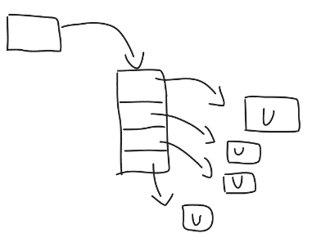

In the main, we collect the variables of values and pass it all to the simulator to simulate.

Finally, the simulator will print out the status of the users using for loop.

**Special things in this Program**

here are the libraries that I have used in this program. <time.h> is used for random code as this program required that a random experiment. If the srand() code is the same, the result of experiment would be the same. Thus <time.h> is used.

Also, <math.h> is used as Euclidean distance need the function of power pow() and square root sqrt().

In addition, the #define is used to change the color of the word printed out. In this program, I used a string function to check the status of the user and return the corresponding color to each “U”.

**Implementation**

It is a user-friendly program. Program Users just need to answer several questions and the simulator will be printed the situation of the simulation.

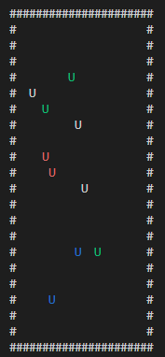For example, if the user input is updated 3 times.

The result has been shown below.