Computer Science And Engineering Department  Academic Year 1447- 1448 / 2025- 2026  Second Semester | Project 1  CS381  Web Application Development

Date: | 5/20/2026 | Time Allowed: | 0 0 Hours: 00 Minutes

Student Name 1: |  | Aseel Azoni | ID Number: | 441500260
Student Name 2: |  | Hanan Alanazi | ID Number: | 441500457
Teacher’s Name: | Ms.mai |  | Section: | 1

Please read the following instructions carefully:
- Write your name, I.D. number and section number in the space provided above.
- Read each question carefully before answering.
- Answer all questions.
- Support materials are not allowed in the examination Hall except those provided by instructor.
- Do not use digital or printed dictionary.
- Do not use pencils for answering except for drawing.
For Instructor Use Only
CLO. |  | Mark Assigned |  | Mark Attained
1.3 |  | 5
2.1 |  | 5
3.1 |  | 5
3.2 |  | 5
 |  |  | Total:

Marked by: | Mr. Muhammad Rafiq | Signature:

Signature:
Dr. Mai Nabeel

Student Feedback System
Yanbu Industrial College
Computer Science and Engineering Department
Academic Year 1447-1448 / 2025-2026
Second Semester
Project 1 – CS381 Web Application Development
Students:
Hanan Alanazi — 441500457
Aseel Azoni — 441500260
Instructor:
Mr. Muhammad Rafiq and Ms. Mai

Table of Contents
1. Problem Description
2. Description of System
3. Updated ER Diagram
4. System Architecture
5. File Structure
6. Frontend Development (Phase 2)
7. Backend Development (Phase 3)
8. Security Implementation (Phase 4)
9. System Features
10. System Output
11. Testing Section
12. Screenshots
13. AI Disclosure
14. Challenges
15. Future Improvements
16. Conclusion
17. References

1. Problem Description
Many students face difficulties when trying to submit academic or service-related feedback inside the college. Traditional feedback methods are often unorganized, difficult to track, and may lead to delayed responses from administrators. Students may not know whether their feedback has been reviewed, while administrators may struggle to manage large amounts of feedback manually.
The Student Feedback System was developed to solve this problem by providing a centralized web-based platform where students can submit feedback securely and efficiently. The system allows administrators to review, manage, and update feedback records in one organized system.

2. Description of System
The Student Feedback System is a web application developed using HTML, CSS, JavaScript, PHP, MySQL, and PDO.
Student Role:
• Register new accounts
• Login/logout
• Submit feedback
• View feedback
• Edit feedback
• Delete feedback
• Track feedback status
Admin Role:
• Login securely
• View all submitted feedback
• Manage feedback records
• Update feedback status
• Delete records
• View dashboard statistics

3. Updated ER Diagram
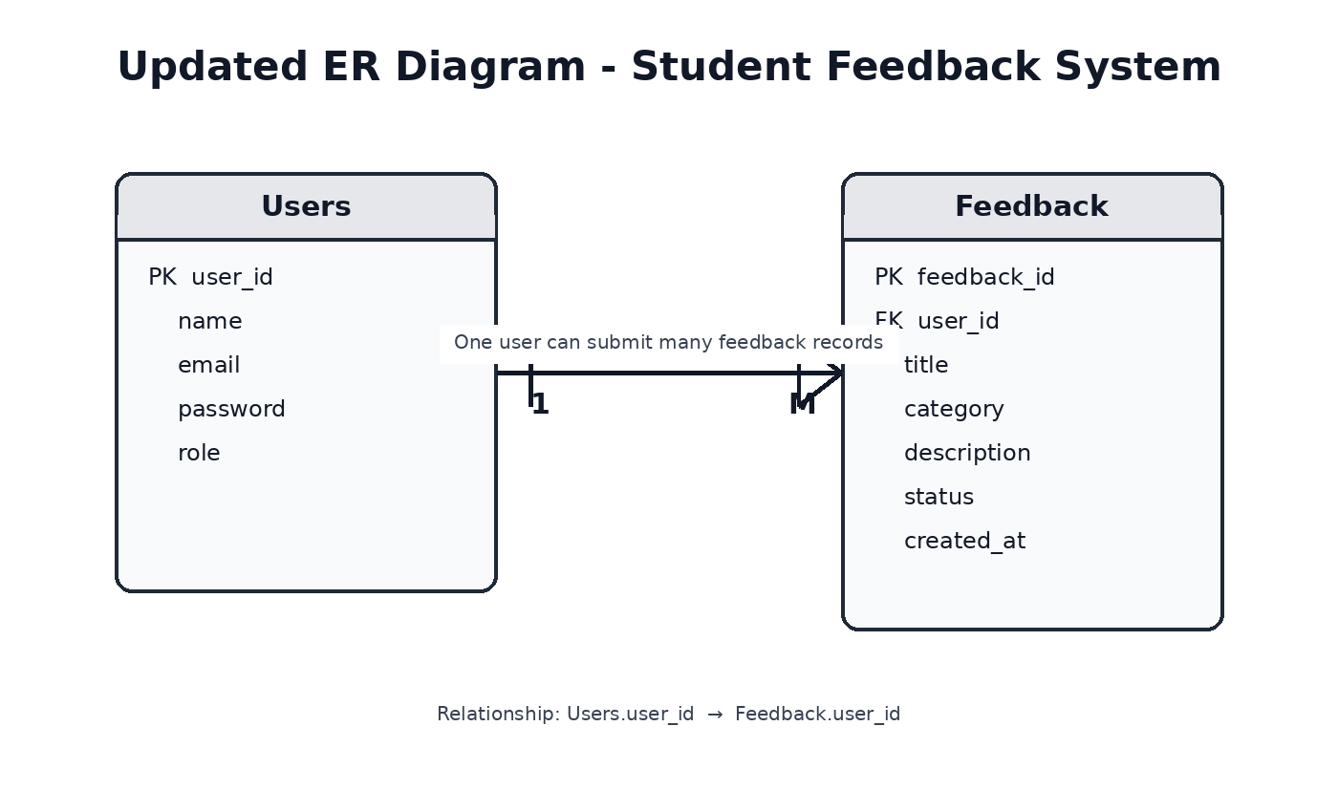
The database contains two main tables:
• Users Table
• Feedback Table
Relationship:
• One user can submit multiple feedback records.
• Each feedback record belongs to one user.

4. System Architecture
The system architecture follows a simple client-server structure where:
• Frontend handles user interaction.
• PHP processes backend requests.
• MySQL stores application data securely.
[ User ]
↓
[ Frontend ]
HTML / CSS / JavaScript
↓
[ PHP Backend ]
↓
[ MySQL Database ]

5. File Structure
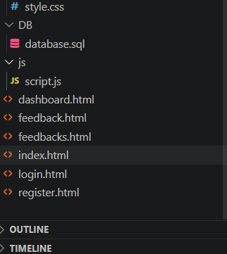
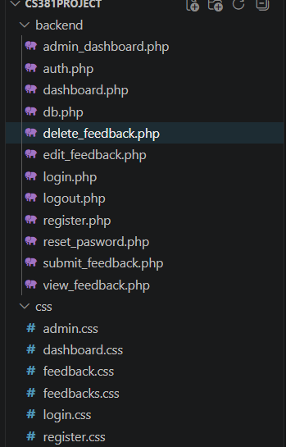
Main project folders:
• css/
• js/
• includes/
• database/
• screenshots/
• uploads/

6. Frontend Development (Phase 2)
The frontend was developed using semantic HTML5, responsive CSS3, and JavaScript.
Developed Pages:
• Home Page
• Login Page
• Register Page
• Dashboard
• Submit Feedback Page
Responsive design was implemented using media queries to support desktop, tablet, and mobile devices.
JavaScript was used for:
• Form validation
• Input checking
• Interactive navigation

7. Backend Development (Phase 3)
The backend phase focused on CRUD operations and database integration using PHP and MySQL.
Implemented Features:
• Registration system
• Login/logout system
• Session management
• CRUD operations
• PDO prepared statements
• Role-based access control
Example PDO Connection:
$pdo = new PDO(
"mysql:host=$host;dbname=$dbname",
$username,
$password
);

8. Security Implementation (Phase 4)
Several security techniques were implemented:
• Input Validation
• PDO Prepared Statements
• Password Hashing
• Session Authentication
• Role-Based Access Control
• XSS Prevention
• CSRF Protection
Example Password Hashing:
$passwordHash = password_hash($password, PASSWORD_DEFAULT);
Example Login Verification:
if(password_verify($password, $user['password'])) {
$_SESSION['user_id'] = $user['id'];
}

9. System Features
Student Features:
• Register account
• Login/logout
• Submit feedback
• View own feedback
• Edit feedback
• Delete feedback
• Track feedback status
Admin Features:
• Login as admin
• View all feedback
• Update feedback status
• Delete feedback
• Dashboard statistics

10. System Output
The final system includes:
• Home Page
• Login Page
• Register Page
• Student Dashboard
• Submit Feedback Page
• My Feedback Page
• Admin Dashboard
• Database Tables
Each page was tested successfully and connected to the database.

11. Testing Section
Test Cases:
• User Registration → Account created successfully
• User Login → Redirected to dashboard
• Submit Feedback → Saved in database
• Edit Feedback → Updated successfully
• Delete Feedback → Deleted successfully
• Admin Login → Dashboard displayed
• Logout → Session terminated successfully

12. Screenshots
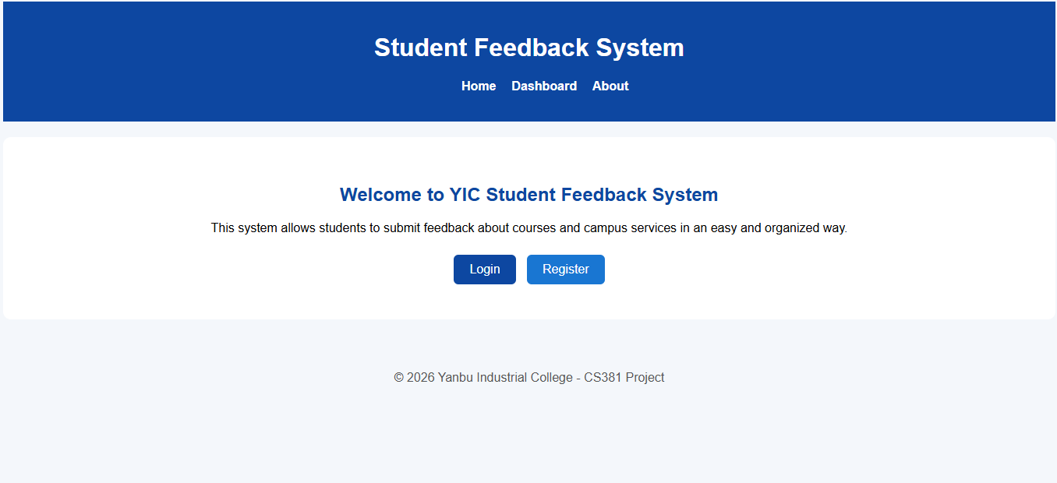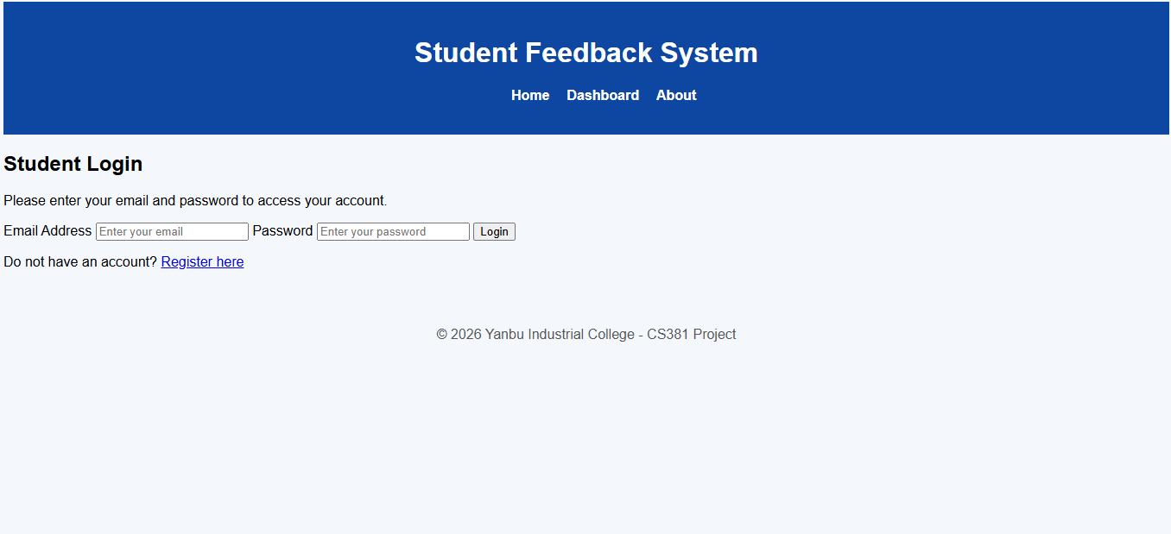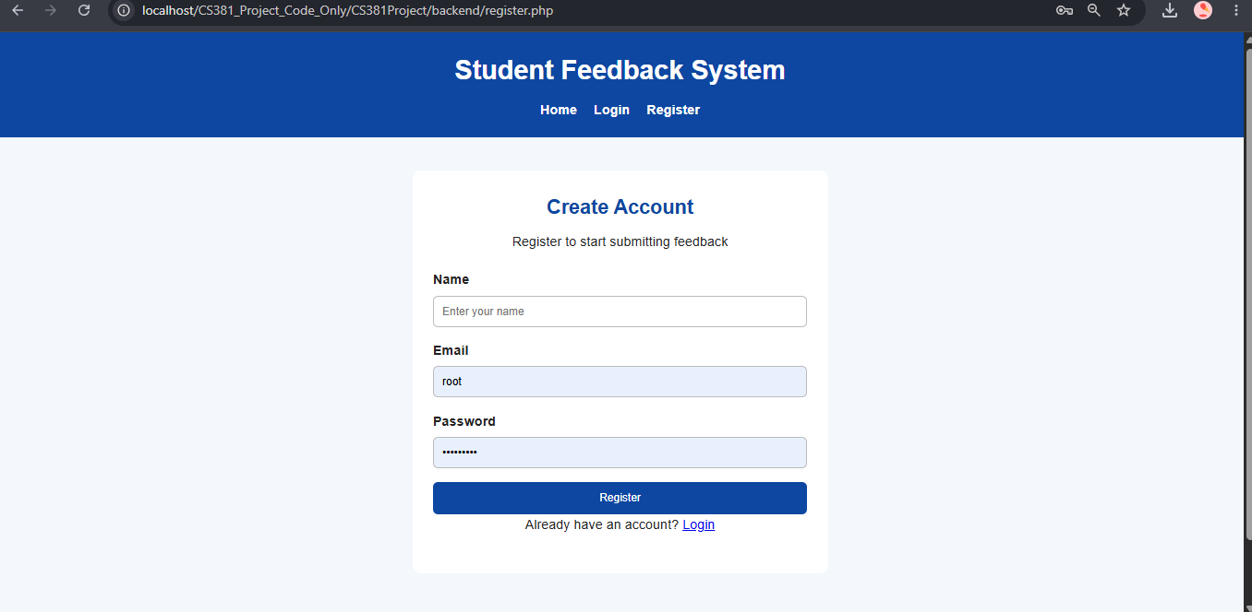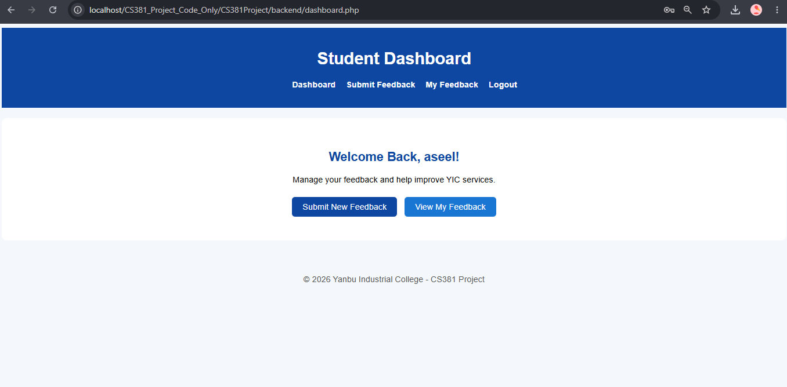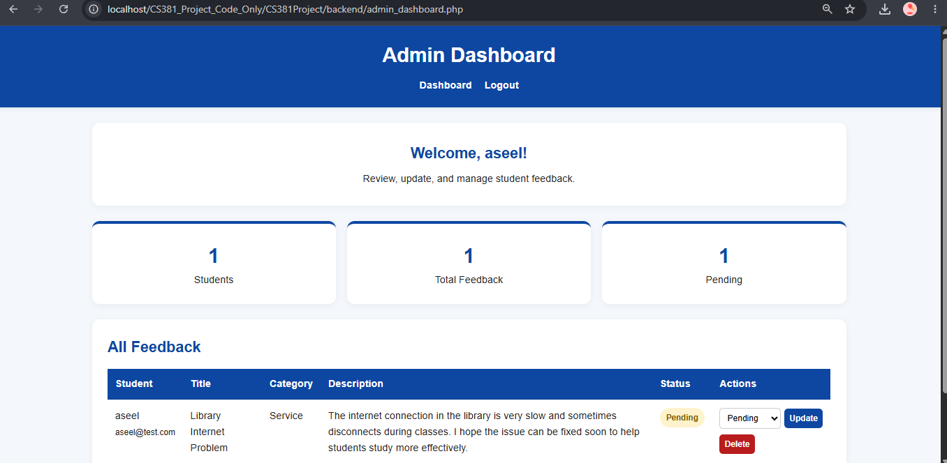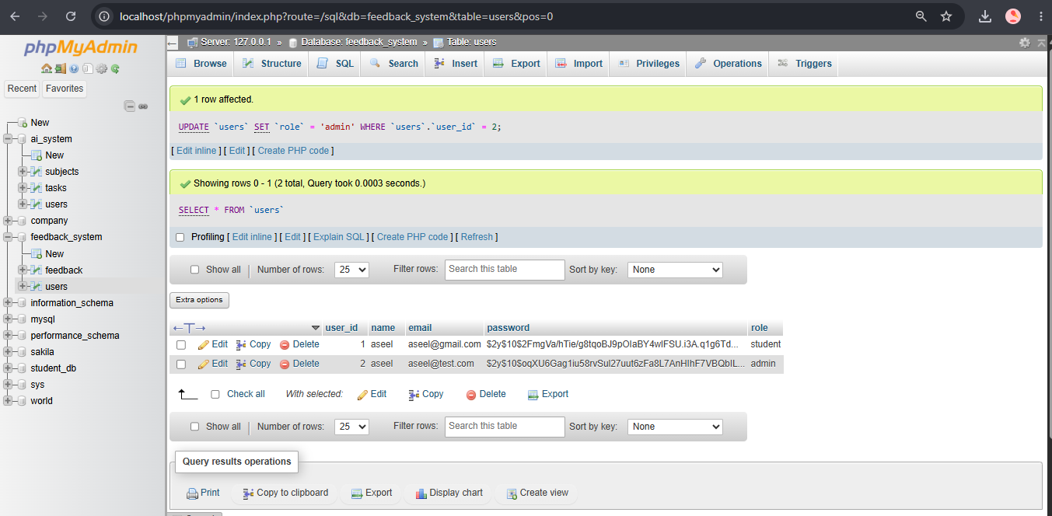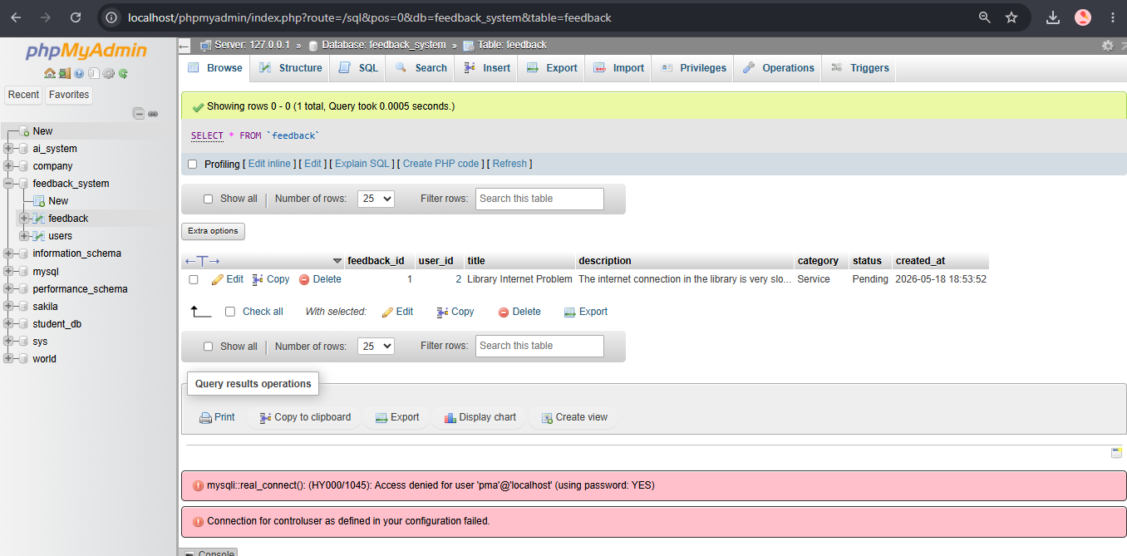

13. AI Disclosure
Artificial Intelligence tools were used to:
• Explain PHP and PDO concepts
• Help debug errors
• Improve report formatting
• Suggest frontend layouts
• Explain security concepts
All generated suggestions and code were reviewed, modified, and tested manually by the students.

14. Challenges
Challenges faced during development:
• Connecting frontend with backend
• Managing user roles
• Session handling
• CRUD operations
• Preventing unauthorized access
• Fixing login and database errors

15. Future Improvements
Future improvements may include:
• Email notifications
• Search and filtering
• Better dashboard analytics
• Pagination support
• Improved UI/UX
• Advanced reporting system

16. Conclusion
The Student Feedback System successfully integrates frontend development, backend logic, database management, authentication, CRUD operations, and security implementation into one complete web application.
The project demonstrates practical web development skills using PHP and MySQL and satisfies all project requirements.

17. References
1. W3Schools PHP Tutorial – https://www.w3schools.com/php/
2. W3Schools SQL Tutorial – https://www.w3schools.com/sql/
3. PHP Official Documentation – https://www.php.net/docs.php
4. PHP Manual PDO – https://www.php.net/manual/en/book.pdo.php
5. MySQL Documentation – https://dev.mysql.com/doc/
6. MDN Web Docs – https://developer.mozilla.org/
7. Font Awesome Documentation – https://fontawesome.com/
8. HTML5 Documentation – https://html.spec.whatwg.org/

