Yanbu Industrial College
Computer Science and Engineering Department
Academic Year 1447-1448 / 2025-2026
Second Semester
Project 1 - CS381 Web Application Development
Project Title: Student Feedback System
Student Name: _Aseel Azoni ___________
Student ID: ___441500260_________
Student Name 2: __Hanan Alanazi__________
Student ID 2: ___441500457_________
Instructor: Mr. Muhammad Rafiq and MS. Mai

Problem Description
Students lack a structured system to submit feedback, causing delays and poor tracking.

System Objective
Develop a system for submitting, tracking, and managing feedback efficiently.

Description of System
The system is a web-based platform allowing students to submit categorized feedback and track responses while admins manage and resolve issues.

Features
Student: Register, login, submit feedback, track status, edit/delete.
Admin: Manage feedback, respond, update status, generate reports.

User Roles
Student and Admin with different permissions.

User Stories
As a student, I want to register so I can access the system.
As a student, I want to login so I can submit feedback.
As a student, I want to submit feedback so I can report issues.
As a student, I want to track feedback status.
As a student, I want to edit/delete feedback.
As an admin, I want to view all feedback.
As an admin, I want to respond to feedback.
As an admin, I want to update status.

System Architecture
[Client] → [Frontend] → [Server] → [Database]
[Database] → [Server] → [Client]
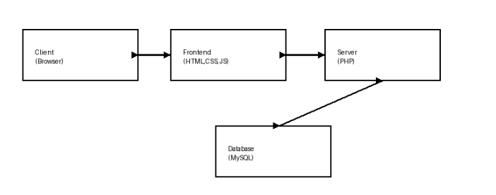

File Structure
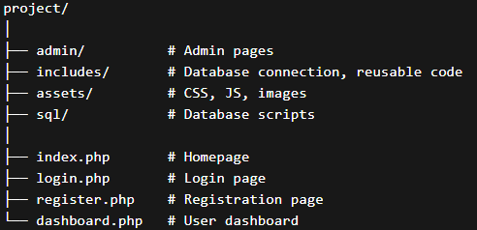

Database Design (ERD)
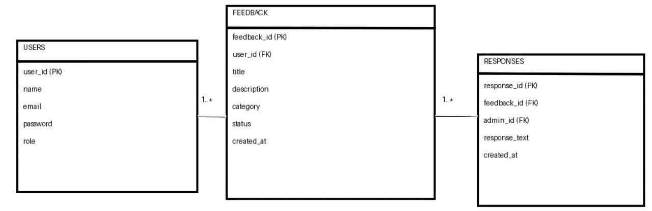

Page Flow Diagram
Student: Home → Login → Dashboard → Submit → View
Admin: Login → Dashboard → Manage → Respond
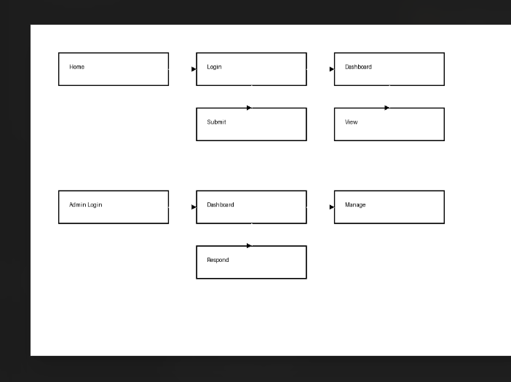

Wireframes
1.
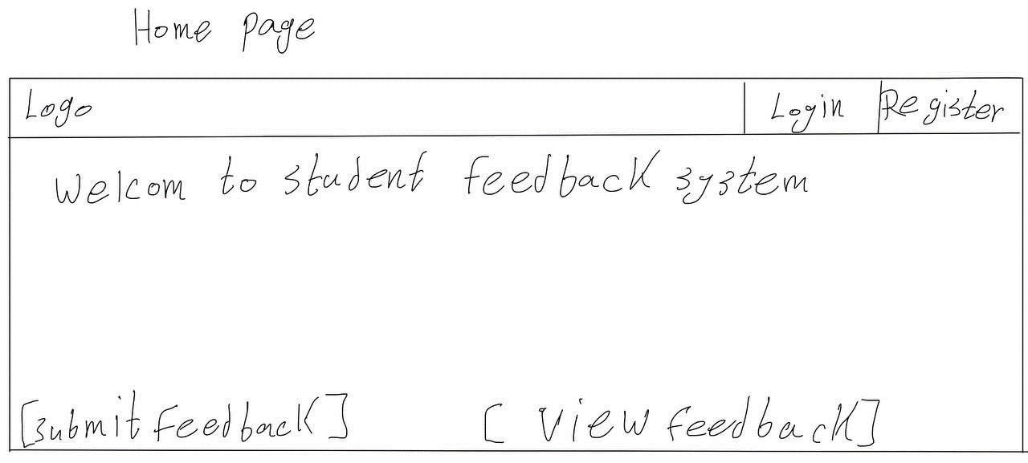
2.
3.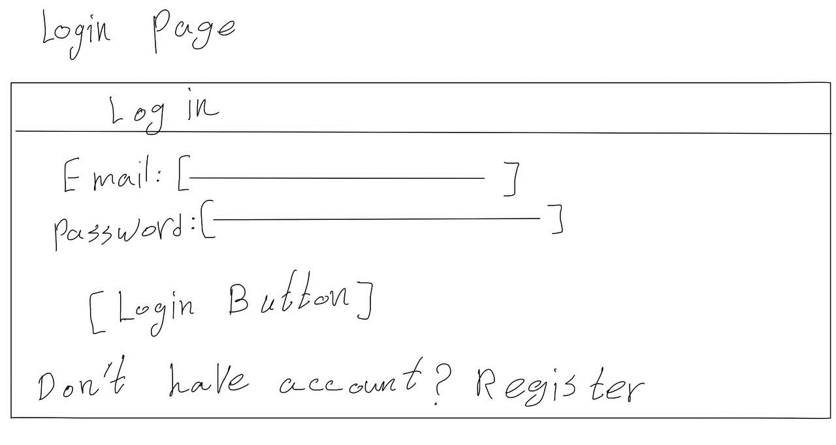
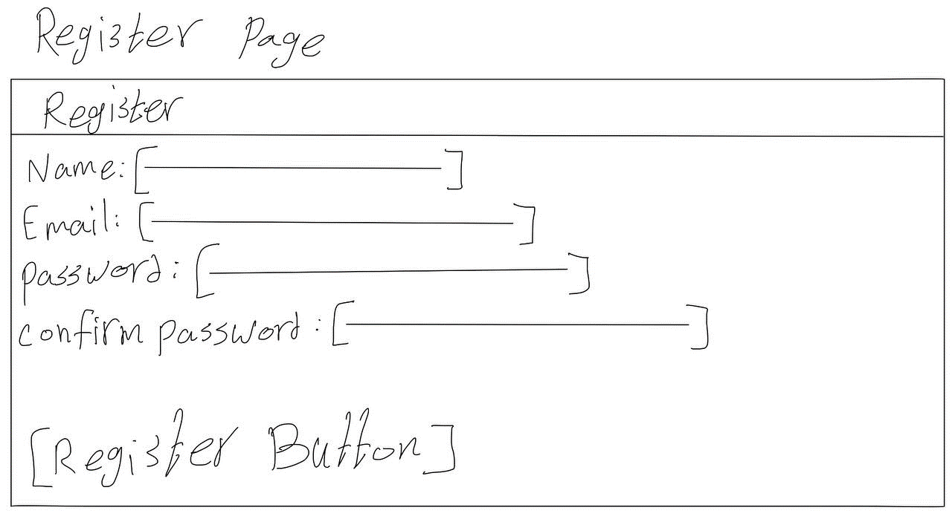

4.
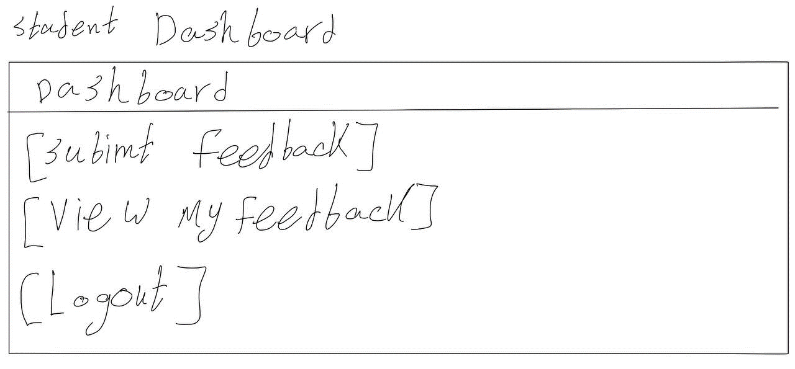
5.
