
Department of Electrical & Computer Engineering
ENCS5337 Chip Design Verification
HW #4

Name: Aseel Dar Assi

ID: 1211974

Section: 1

Instructor: Dr.Elias Khalil

Date: 5/3/2026

GitHub Repository Link for HW4-SystemVerilog:

Aseel-DarAssi/HW4-SystemVerilog

- Linux Path to the source code folder:

Path: "/home/st88/HW4/"

- Waveform screenshot showing at least 10 values addition:

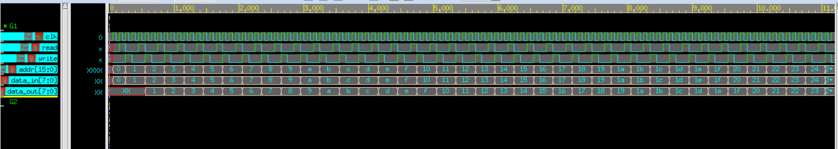

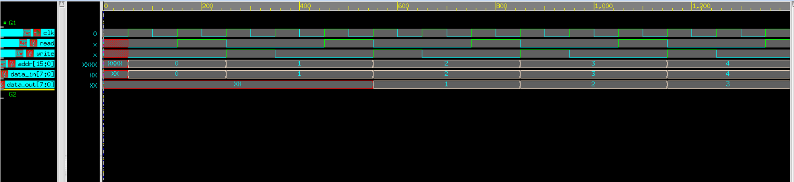

- log files :

HW4-SystemVerilog/verdiLog at master · Aseel-DarAssi/HW4-SystemVerilog

