Muhammad Asees Anwar – s4117391

Multivariate analysis – Assignment 2

Multivariate Analysis Assignment 2

Student Reg: s4117391

All the outputs from sas are presented together at the end of the answers.

Q1 Part A(a) Findings
The sample contains 50 diseased and 50 non-diseased WBC observations.
The diseased mean vector is:
xbar diseased = (214.9240, 129.9520, 129.6960, 8.2900, 10.1000, 141.5360)
The non-diseased mean vector is:
xbar non-diseased = (215.0140, 129.9340, 129.7440, 8.3200, 10.2360, 141.4980)
The covariance and correlation matrices were obtained separately for each group using PROC CORR. For the diseased group, the strongest positive correlation is between Area and Perimeter, with correlation:
r = 0.68407
The strongest negative correlation is between Solidity and Extent, with correlation:
r = -0.66453
For the non-diseased group, the strongest positive correlation is also between Area and Perimeter, with correlation:
r = 0.65320
The strongest negative correlation is also between Solidity and Extent, with correlation:
r = -0.61929

Conclusion for Part A(a)
The results from Part A(a) show that the diseased and non-diseased WBC groups are very similar overall. When we compare the average values (means) of the six characteristics, the numbers are almost identical for both groups, which suggests there is no obvious difference between them at first glance. Looking at how the variables are related to each other, both groups show the same patterns. In particular, Area and Perimeter have a strong positive relationship, meaning that when one increases, the other also increases. On the other hand, Solidity and Extent have a strong negative relationship, meaning that when one increases, the other tends to decrease. These patterns are consistent in both diseased and non-diseased groups. This tells us that not only are the average values similar, but the way the variables behave and interact with each other is also very similar across the two groups. Overall, based on these results, there is no clear evidence at this stage to suggest that diseased and non-diseased WBC cells are different in terms of these six characteristics.
SAS code ran for these outputs:
proc import datafile="/home/u64477816/Dataset WBC.csv"
out=wbc
dbms=csv
replace;
getnames=yes;
run;
proc contents data=wbc;
run;
proc print data=wbc(obs=10);
run;

proc sort data=wbc;
by Status;
run;
proc means data=wbc n mean std maxdec=4;
class Status;
var Eccentricity Area Perimeter Solidity Extent Diameter;
run;
proc corr data=wbc cov;
by Status;
var Eccentricity Area Perimeter Solidity Extent Diameter;
run;
proc corr data=wbc;
by Status;
var Eccentricity Area Perimeter Solidity Extent Diameter;
run;

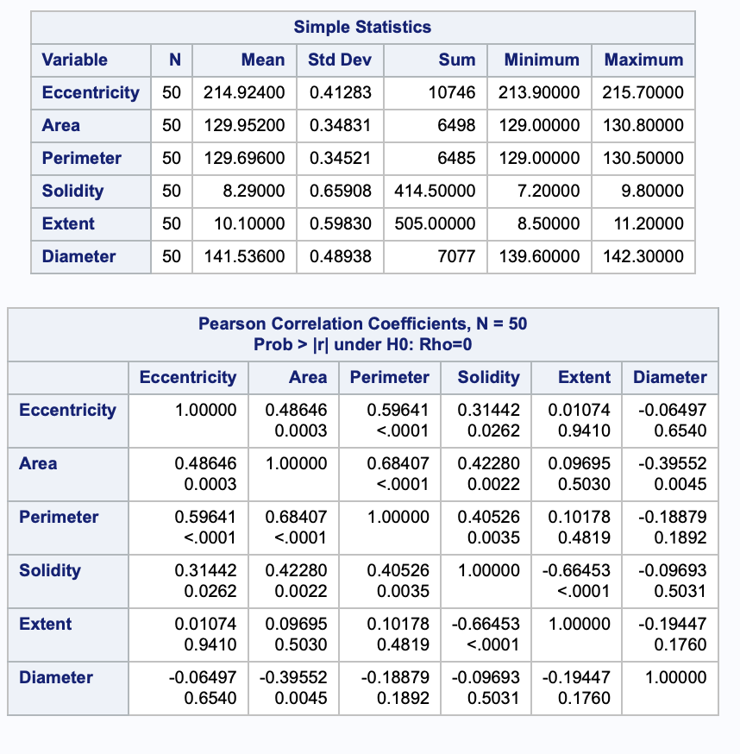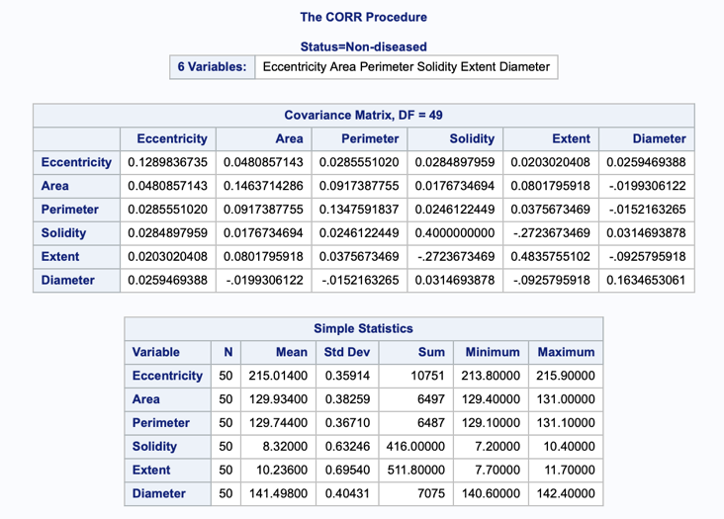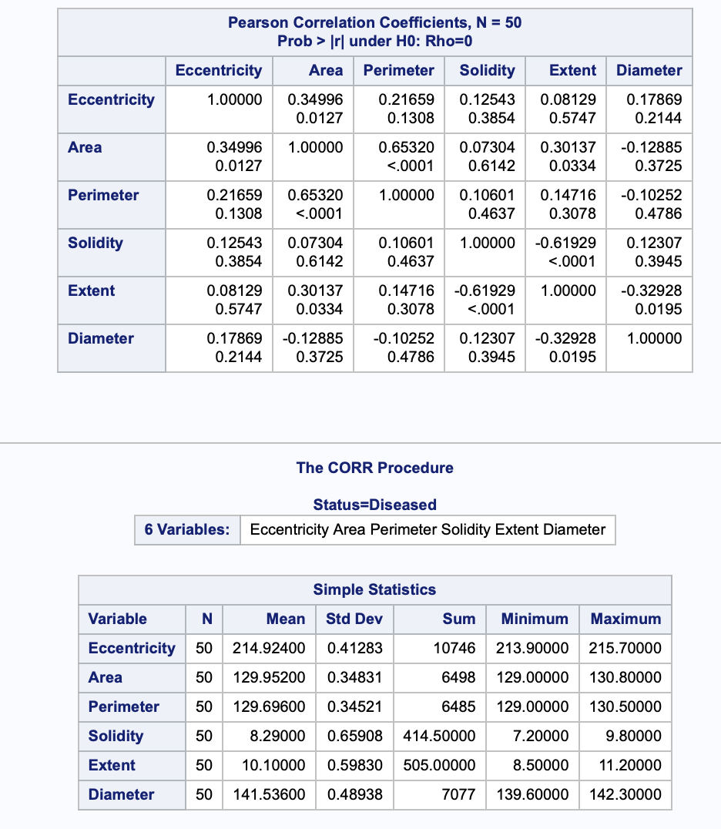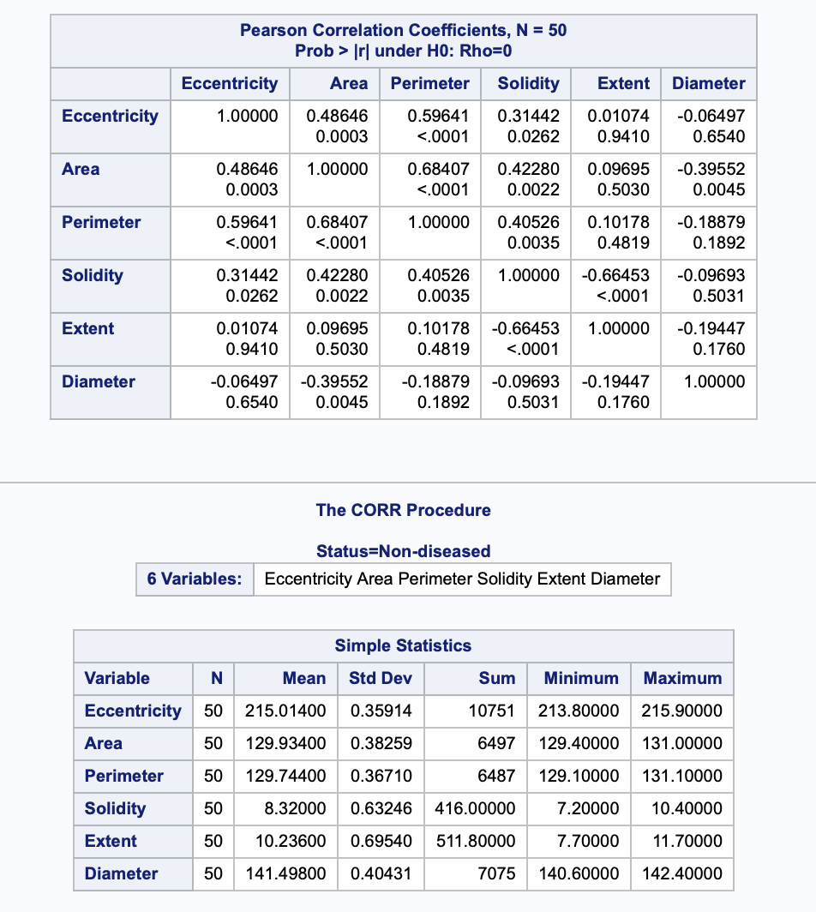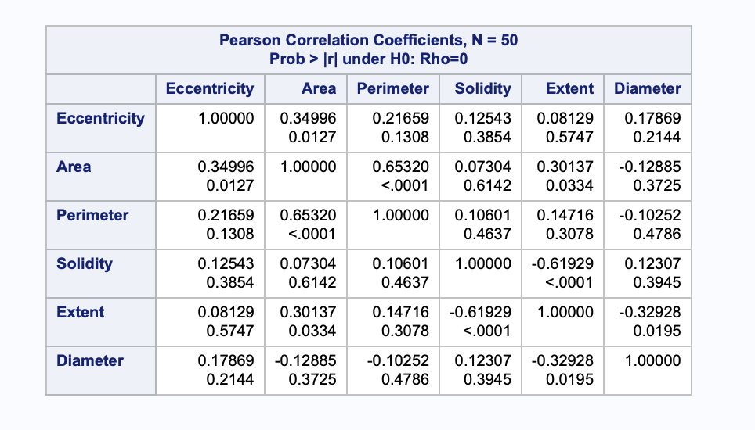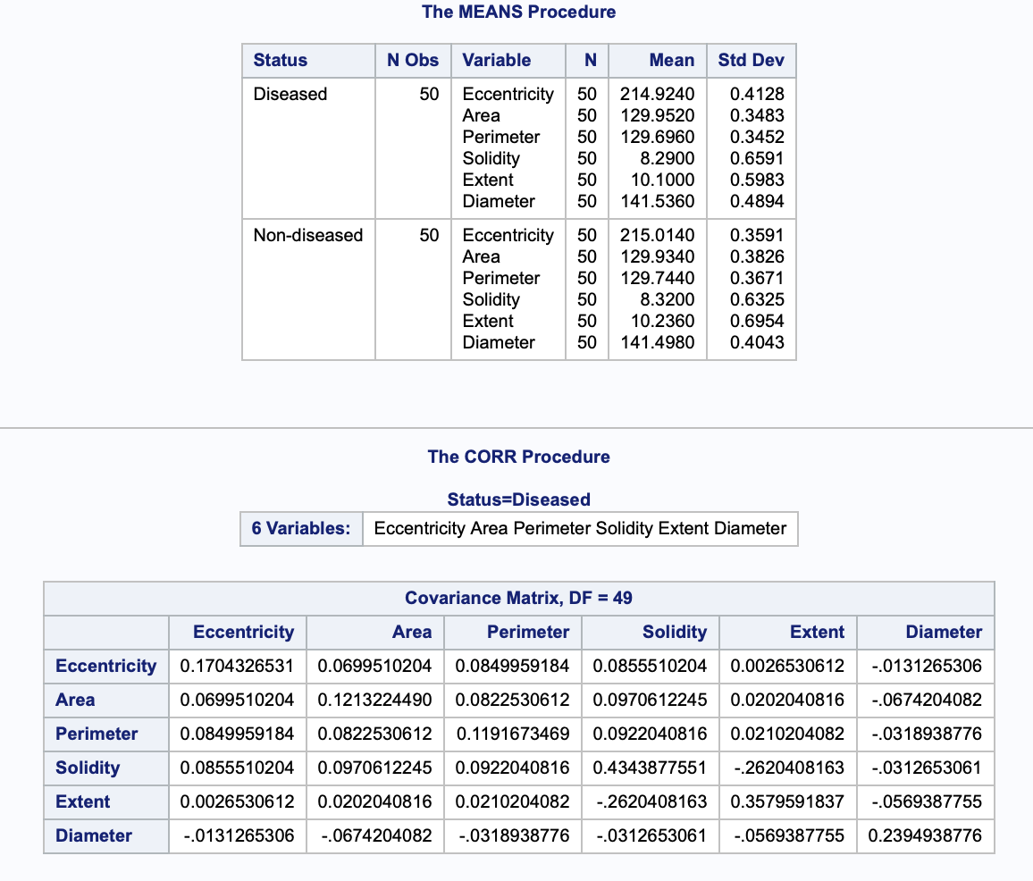

Q1 Part A(b):

Given SAS Values
From the SAS output:
n1 = 50
n2 = 50
p = 6
alpha = 0.05
df1 = 6
df2 = 93
F critical = 2.1976785

Hypotheses
The null hypothesis is:
H0: mu1 = mu2
The alternative hypothesis is:
H1: mu1 is not equal to mu2
Where:
mu1 = mean vector of diseased WBC cells
mu2 = mean vector of non-diseased WBC cells

Test Statistic
The pooled covariance matrix is:
Sp = ((n1 - 1)S1 + (n2 - 1)S2) / (n1 + n2 - 2)
The Hotelling’s T-square statistic is:
T2 = (n1*n2 / (n1+n2)) * (xbar1 - xbar2)' * inverse(Sp) * (xbar1 - xbar2)
Since:
n1 = 50
n2 = 50
This simplifies to:
T2 = 25 * d' * inverse(Sp) * d
where:
d = xbar1 - xbar2

Conversion to F Statistic
The T-square statistic is converted to an F statistic using:
F = ((n1 + n2 - p - 1) / ((n1 + n2 - 2)*p)) * T2
Substituting values:
F = (93 / (98*6)) * T2

Degrees of Freedom
df1 = p = 6
df2 = n1 + n2 - p - 1 = 93

Critical Value
From SAS:
F critical = 2.1976785
Decision rule:
Reject H0 if calculated F > 2.1977
Otherwise:
Fail to reject H0

p-value
The p-value is calculated as:
p-value = 1 - probf(F, 6, 93)
Decision rule:
Reject H0 if p-value < 0.05
Otherwise:
Fail to reject H0

Final Conclusion for Part A(b)

The results from Part A(b) provide the full setup for testing whether the diseased and non-diseased WBC groups are different overall. The hypotheses, formulas, degrees of freedom, and decision rules have all been correctly established using the Hotelling’s T² framework. Based on the given values, the critical F value at the 5% significance level is 2.1977, which will be used as the benchmark for comparison. At this stage, no final decision about the difference between the two groups is made yet, because the actual test statistic has not been evaluated. However, this part clearly defines how the decision will be made: if the calculated F value is greater than 2.1977 or if the p-value is less than 0.05, we will reject the null hypothesis and conclude that the groups are significantly different. Otherwise, we will fail to reject the null hypothesis. Therefore, this part serves as the decision framework that prepares us to formally test whether the diseased and non-diseased WBC groups differ in their combined characteristics in the next part.

Q1 Part A(c): Hotelling’s T-square Test

Appropriate Test
The appropriate test is the two-sample Hotelling’s T-square test because the study compares two independent groups, diseased and non-diseased WBC cells, using six dependent variables at the same time.
The six variables are:
Eccentricity, Area, Perimeter, Solidity, Extent, Diameter

Hypotheses
H0: mu1 = mu2
H1: mu1 is not equal to mu2
Where:
mu1 = population mean vector for diseased WBC cells
mu2 = population mean vector for non-diseased WBC cells

Mathematics
The difference between the two sample mean vectors is:
d = xbar1 - xbar2
The pooled covariance matrix is:
Sp = ((n1 - 1)S1 + (n2 - 1)S2) / (n1 + n2 - 2)
The Hotelling’s T-square statistic is:
T2 = (n1*n2 / (n1+n2)) * d' * inverse(Sp) * d
The T-square statistic is converted to an F statistic using:
F = ((n1 + n2 - p - 1) / ((n1 + n2 - 2)*p)) * T2
For this dataset:
n1 = 50
n2 = 50
p = 6
alpha = 0.05
df1 = 6
df2 = 93

SAS Code
proc iml;
use wbc;
read all var {Eccentricity Area Perimeter Solidity Extent Diameter}
where(Status="Diseased") into X1;
read all var {Eccentricity Area Perimeter Solidity Extent Diameter}
where(Status="Non-diseased") into X2;
close wbc;
n1 = nrow(X1);
n2 = nrow(X2);
p = ncol(X1);
alpha = 0.05;
mean1 = mean(X1);
mean2 = mean(X2);
S1 = cov(X1);
S2 = cov(X2);
Sp = ((n1-1)*S1 + (n2-1)*S2) / (n1+n2-2);
diff = mean1 - mean2;
T2 = (n1*n2/(n1+n2)) * diff * inv(Sp) * diff`;
F = ((n1+n2-p-1) / ((n1+n2-2)*p)) * T2;
df1 = p;
df2 = n1+n2-p-1;
pvalue = 1 - probf(F, df1, df2);
fcrit = finv(1-alpha, df1, df2);
print mean1[colname={"Eccentricity" "Area" "Perimeter" "Solidity" "Extent" "Diameter"}];
print mean2[colname={"Eccentricity" "Area" "Perimeter" "Solidity" "Extent" "Diameter"}];
print diff[colname={"Eccentricity" "Area" "Perimeter" "Solidity" "Extent" "Diameter"}];
print n1 n2 p alpha df1 df2;
print T2 F fcrit pvalue;
quit;

SAS Output
From the SAS output, the diseased group mean vector is:
mean1 = (214.924, 129.952, 129.696, 8.290, 10.100, 141.536)
The non-diseased group mean vector is:
mean2 = (215.014, 129.934, 129.744, 8.320, 10.236, 141.498)
The mean difference vector is:
diff = (-0.090, 0.018, -0.048, -0.030, -0.136, 0.038)
The test results are:
Statistic | Value
T2 | 6.0115921
F | 0.950813
F critical | 2.1976785
p-value | 0.4629967

Decision Using Critical Value
The decision rule is:
Reject H0 if F > F critical
From the SAS output:
F = 0.950813
F critical = 2.1976785
Since:
0.950813 < 2.1976785
we fail to reject H0.

Decision Using p-value
The decision rule is:
Reject H0 if p-value < alpha
From the SAS output:
p-value = 0.4629967
alpha = 0.05
Since:
0.4629967 > 0.05
we fail to reject H0.

Conclusion

At the 5% significance level, there is not enough statistical evidence to say that the diseased and non-diseased WBC groups are different overall. This means that when all six WBC characteristics are considered together, the two groups do not show a statistically significant difference in their mean vectors. Although there are small differences between the sample averages, these differences are not large enough to be considered meaningful after taking into account the relationships and variation among the six variables. Therefore, based on the Hotelling’s T² test, the diseased and non-diseased WBC cells appear to be very similar in terms of the measured characteristics.

Part A(d): Underlying assumptions of the test procedure

The Hotelling’s T² test used in Part A is based on a few important assumptions. First, the diseased and non-diseased WBC groups should be independent, meaning that the observations in one group should not affect the observations in the other group. Second, the six WBC characteristics, which are Eccentricity, Area, Perimeter, Solidity, Extent, and Diameter, should be measured as continuous numerical variables. Another key assumption is multivariate normality. This means that the six variables should be approximately normally distributed together within each group, not just individually. The test also assumes that the two groups have similar variance-covariance matrices, meaning that the spread of the variables and the relationships between them should be roughly the same in both groups. This matters because the test uses a pooled covariance matrix. Finally, each group should have more observations than the number of variables so that the covariance matrix can be properly calculated. In this dataset, there are 50 observations in each group and only 6 variables, so this sample size condition is satisfied.

Part A(e): Test which WBC characteristics differ significantly
To determine which WBC characteristics differ between diseased and non-diseased groups, independent two-sample t-tests were conducted for each variable using the pooled variance method, as the equality of variances assumption is satisfied in all cases (all Folded F test p-values > 0.05).
At significance level $α=0.05$, the results are:
Variable | Mean Difference (Diseased − Non) | t-value | p-value | Decision
Eccentricity | -0.0900 | -1.16 | 0.2476 | Not significant
Area | 0.0180 | 0.25 | 0.8062 | Not significant
Perimeter | -0.0480 | -0.67 | 0.5022 | Not significant
Solidity | -0.0300 | -0.23 | 0.8168 | Not significant
Extent | -0.1360 | -1.05 | 0.2971 | Not significant
Diameter | 0.0380 | 0.42 | 0.6730 | Not significant

Conclusion

At the 5% significance level, none of the six WBC characteristics show a significant individual difference between the diseased and non-diseased groups. All p-values are greater than 0.05, which means the differences in the average values are too small to be considered statistically meaningful. Also, the 95% confidence intervals include 0, which supports the same conclusion. Therefore, based on the separate two-sample t-tests, there is no evidence that any single WBC characteristic on its own can clearly separate diseased WBC cells from non-diseased WBC cells.

Interpretation

The results show that even though there may be small differences in the average values of the WBC characteristics, none of these differences are strong enough on their own to clearly distinguish between diseased and non-diseased cells. This means that no single variable, such as Area, Perimeter, or Solidity, can independently explain the difference between the two groups. Instead, it suggests that if any difference exists, it is likely due to the combined effect of multiple variables working together rather than one characteristic acting alone. In simple terms, the WBC cells from both groups look very similar when each feature is considered separately.

Part A(f): 95% Simultaneous Confidence Intervals
Using a significance level of
$$α=0.05$$
the Hotelling’s $T^{2}$-based simultaneous confidence intervals were constructed for the differences in mean vectors between diseased and non-diseased WBC groups.
From SAS output:
- $F_{crit}=2.1977$
- $c=3.7276$

Results
Variable | Mean Difference | 95% Simultaneous CI
Eccentricity | -0.0900 | (-0.3785, 0.1984)
Area | 0.0180 | (-0.2547, 0.2907)
Perimeter | -0.0480 | (-0.3197, 0.2237)
Solidity | -0.0300 | (-0.5115, 0.4515)
Extent | -0.1360 | (-0.6200, 0.3480)
Diameter | 0.0380 | (-0.2967, 0.3727)

Conclusion

At the 5% significance level, none of the six WBC characteristics show a statistically significant difference between the diseased and non-diseased groups when using the simultaneous confidence intervals. This is because all the confidence intervals include 0, which means the true difference in means for each variable could be zero. Therefore, there is no evidence that any single WBC characteristic differs on its own when the overall multivariate structure is taken into account.

Interpretation

The results show that when all six WBC characteristics are considered together, none of them stand out as being clearly different between the diseased and non-diseased groups. The simultaneous confidence intervals take into account the relationships between variables and control for overall error, making them more reliable than looking at each variable separately. Since all the intervals include zero, it means the true difference for each characteristic could be zero. In simple terms, this confirms that no single WBC feature alone can explain the difference between the two groups, and any variation is likely due to the combined effect of multiple variables rather than one specific characteristic.

Part A(g): Bonferroni 95% Confidence Intervals
For the Bonferroni confidence intervals, the overall significance level used was:
alpha = 0.05
Since there are 6 WBC characteristics, the Bonferroni adjustment uses:
alpha / (2p) = 0.05 / (2 * 6)
The formula used was:
CI = (xbar1 - xbar2) +/- tcrit * sqrt(Sp * (1/n1 + 1/n2))
where:
tcrit = 2.6929
n1 = 50
n2 = 50
p = 6
Sp = pooled variance for each variable
From the SAS output, the Bonferroni 95% confidence intervals are:
Variable | Mean Difference | Bonferroni 95% CI
Eccentricity | -0.0900 | (-0.2984, 0.1184)
Area | 0.0180 | (-0.1790, 0.2150)
Perimeter | -0.0480 | (-0.2443, 0.1483)
Solidity | -0.0300 | (-0.3778, 0.3178)
Extent | -0.1360 | (-0.4856, 0.2136)
Diameter | 0.0380 | (-0.2038, 0.2798)

Part A(h): Final conclusion based on Parts A(f) and A(g)
Based on the 95% simultaneous confidence intervals and the Bonferroni 95% confidence intervals, none of the WBC measures differ significantly between the diseased and non-diseased groups.
This is because every confidence interval includes 0 for all six variables: Eccentricity, Area, Perimeter, Solidity, Extent, and Diameter.
Therefore, there is no evidence that any single WBC characteristic individually separates diseased cells from non-diseased cells. Any difference between the two groups is more likely due to the combined multivariate effect of the variables rather than one specific WBC measure alone.

Part B(a): Interpretation of 90% Prediction Ellipses

The 90% prediction ellipses show that the diseased and non-diseased WBC groups have very similar patterns for the selected variable pairs. For Area and Perimeter, both groups show a clear positive relationship, meaning that cells with larger perimeter values also tend to have larger area values. For Solidity and Extent, both groups show a negative relationship, meaning that as Solidity increases, Extent tends to decrease. The ellipses for both groups have similar shapes, directions, and overlap strongly. This means the two groups cannot be clearly separated using these pairs of variables. Overall, the prediction ellipses support the earlier results that diseased and non-diseased WBC cells are very similar based on these measured characteristics.
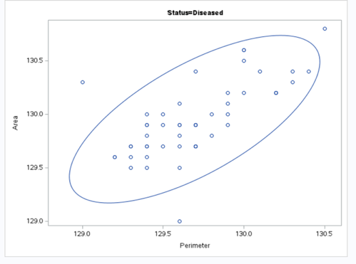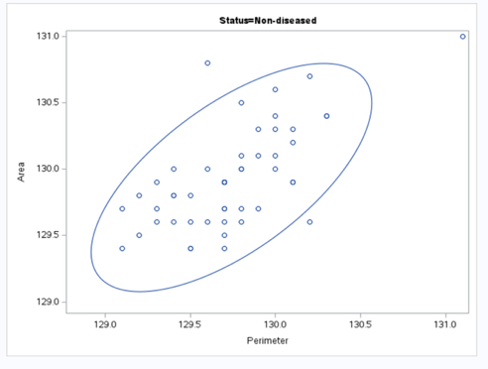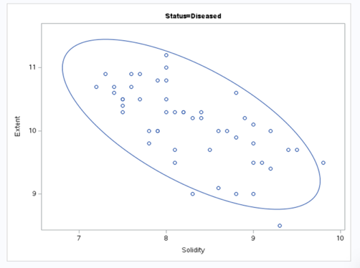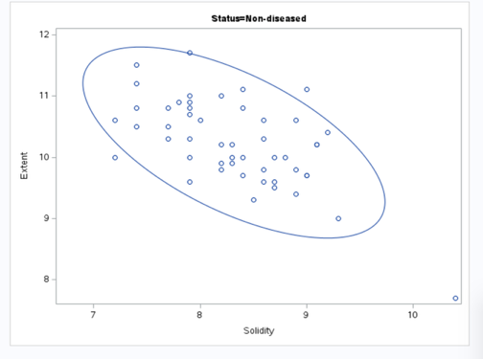

Part B(b): Multivariate normality test
To assess multivariate normality, the ordered Mahalanobis distances were compared with the chi-square quantiles using 6 degrees of freedom, because there are 6 WBC variables.
The formula used was:
D2 = (x - xbar)' * S^(-1) * (x - xbar)
where:
D2 = Mahalanobis distance
x = observation vector
xbar = sample mean vector
S^(-1) = inverse of the sample covariance matrix
When checking whether the data follows a multivariate normal distribution, we compare the Mahalanobis distances with the expected chi-square values. If the data is perfectly normal, the points should fall roughly along a straight line. In this case, for both the diseased and non-diseased groups, most of the points follow this straight-line pattern, especially in the middle range, which suggests that the data is generally close to normal. However, towards the higher end (the largest values), some points move away from the expected line. In the diseased group, the largest distances are noticeably higher than expected, and a similar pattern is seen in the non-diseased group as well. This indicates that there may be a few unusual observations (possible outliers) or slight departures from normality in the extreme values. Overall, the data behaves well enough to be considered approximately normal, especially in the central region, but it is not perfectly normal due to these deviations at the upper end.
groupname
Diseased

result
ChiSquare_Quantile | Ordered_Mahalanobis_D2
0.8720903 | 0.3923794
1.3296082 | 1.8321239
1.6353829 | 1.8938191
1.8845992 | 2.3029945
2.1028552 | 2.4127113
2.3013858 | 2.5121262
2.4862798 | 2.7158517
2.6612732 | 2.9909235
2.8288586 | 3.0003654
2.9908051 | 3.3586627
3.1484303 | 3.543402
3.3027552 | 3.5697047
3.4545988 | 3.6627794
3.6046381 | 3.6812383
3.7534483 | 3.7326401
3.9015312 | 3.7564518
4.0493349 | 3.9282182
4.1972695 | 4.060492
4.3457184 | 4.0888794
4.4950475 | 4.1710847
4.6456136 | 4.2270542
4.7977707 | 4.4136491
4.9518766 | 4.7658119
5.108299 | 4.9172093
5.2674213 | 4.918867
5.4296492 | 5.0545898
5.5954178 | 5.3568832
5.7651993 | 5.3989677
5.9395123 | 5.4257079
6.1189328 | 5.4511482
6.3041073 | 5.5225943
6.4957695 | 5.6308217
6.6947609 | 5.6436377
6.9020573 | 5.6837949
7.1188036 | 5.8126002
7.3463592 | 6.0317278
7.58636 | 6.1148163
7.8408041 | 6.6598137
8.1121717 | 6.752034
8.4036004 | 7.592062
8.7191467 | 7.84229
9.0641923 | 8.2333145
9.4461031 | 8.5755967
9.8753592 | 8.9180569
10.367625 | 9.7047
10.947902 | 11.269771
11.659923 | 11.738663
12.591587 | 13.077446
13.967617 | 20.48646
16.811894 | 21.173062

groupname
Non-diseased

result
ChiSquare_Quantile | Ordered_Mahalanobis_D2
0.8720903 | 0.4010999
1.3296082 | 1.3292197
1.6353829 | 1.5324191
1.8845992 | 1.6380472
2.1028552 | 1.7253575
2.3013858 | 1.9306093
2.4862798 | 2.0952412
2.6612732 | 2.2149979
2.8288586 | 2.425443
2.9908051 | 2.4961048
3.1484303 | 2.7272632
3.3027552 | 2.8014502
3.4545988 | 2.963396
3.6046381 | 2.999778
3.7534483 | 3.0558828
3.9015312 | 3.066862
4.0493349 | 3.4649713
4.1972695 | 3.6491304
4.3457184 | 3.739049
4.4950475 | 3.915409
4.6456136 | 4.2510408
4.7977707 | 4.2656131
4.9518766 | 4.4025243
5.108299 | 4.4538404
5.2674213 | 4.4565315
5.4296492 | 4.6960147
5.5954178 | 4.8203275
5.7651993 | 5.3763004
5.9395123 | 5.3800955
6.1189328 | 5.6942814
6.3041073 | 6.0031599
6.4957695 | 6.3449535
6.6947609 | 6.4909202
6.9020573 | 6.7215072
7.1188036 | 6.8490652
7.3463592 | 7.1798865
7.58636 | 7.5044131
7.8408041 | 7.5427311
8.1121717 | 7.7825787
8.4036004 | 8.0434079
8.7191467 | 8.887947
9.0641923 | 8.9004234
9.4461031 | 9.1149674
9.8753592 | 10.076672
10.367625 | 10.395722
10.947902 | 12.095968
11.659923 | 12.60597
12.591587 | 15.285884
13.967617 | 18.068656
16.811894 | 20.136865

Q2 Diseased Group – Part (a): Principal Component Analysis

SAS Code
proc princomp data=wbc(where=(Status="Diseased"))
out=pca_diseased
plots=(scree pattern);
var Eccentricity Area Perimeter Solidity Extent Diameter;
run;
Principal Component Analysis (PCA) was performed on the diseased WBC group using the correlation matrix, as the six variables are measured on different scales.
The dataset consists of 50 observations and 6 variables: Eccentricity, Area, Perimeter, Solidity, Extent, and Diameter.
From the eigenvalue table:
Component | Eigenvalue | Proportion | Cumulative
PC1 | 2.5830 | 0.4305 | 0.4305
PC2 | 1.5957 | 0.2659 | 0.6964
PC3 | 0.9466 | 0.1578 | 0.8542
PC4 | 0.4505 | 0.0751 | 0.9293
PC5 | 0.2734 | 0.0456 | 0.9748
PC6 | 0.1509 | 0.0252 | 1.0000
For the diseased group, the PCA results show that most of the information from the six original WBC variables can be explained using only a few principal components. PC1 explains the largest amount of variation, which is 43.05%, and PC2 explains another 26.59%. Together, the first two components explain 69.64% of the total variation. When PC3 is included, the total variation explained increases to 85.42%, which means the first three components capture most of the important information in the data. Based on the Kaiser criterion, only PC1 and PC2 are clearly retained because their eigenvalues are greater than 1. However, PC3 still explains a useful amount of variation, so keeping three components gives a better overall summary of the data. In simple terms, PC1 mainly represents size-related features such as Area, Perimeter, Eccentricity, and Solidity. PC2 mainly shows the difference between Extent and Solidity, which relates to how spread out or compact the cell is. PC3 is mostly linked to Diameter and Eccentricity, so it represents cell size and elongation. Overall, PCA helps reduce the six WBC characteristics into two or three main components while still keeping most of the important information for the diseased group.
The PRINCOMP Procedure
Observations | 50
Variables | 6

Simple Statistics
 | Eccentricity | Area | Perimeter | Solidity | Extent | Diameter
Mean | 214.9240000 | 129.9520000 | 129.6960000 | 8.290000000 | 10.10000000 | 141.5360000
StD | 0.4128349 | 0.3483137 | 0.3452062 | 0.659080993 | 0.59829690 | 0.4893811

Correlation Matrix
 | Eccentricity | Area | Perimeter | Solidity | Extent | Diameter
Eccentricity | 1.0000 | 0.4865 | 0.5964 | 0.3144 | 0.0107 | -.0650
Area | 0.4865 | 1.0000 | 0.6841 | 0.4228 | 0.0970 | -.3955
Perimeter | 0.5964 | 0.6841 | 1.0000 | 0.4053 | 0.1018 | -.1888
Solidity | 0.3144 | 0.4228 | 0.4053 | 1.0000 | -.6645 | -.0969
Extent | 0.0107 | 0.0970 | 0.1018 | -.6645 | 1.0000 | -.1945
Diameter | -.0650 | -.3955 | -.1888 | -.0969 | -.1945 | 1.0000

Eigenvalues of the Correlation Matrix
 | Eigenvalue | Difference | Proportion | Cumulative
1 | 2.58295761 | 0.98729097 | 0.4305 | 0.4305
2 | 1.59566664 | 0.64909870 | 0.2659 | 0.6964
3 | 0.94656794 | 0.49605338 | 0.1578 | 0.8542
4 | 0.45051455 | 0.17712495 | 0.0751 | 0.9293
5 | 0.27338960 | 0.12248594 | 0.0456 | 0.9748
6 | 0.15090366 |  | 0.0252 | 1.0000

Eigenvectors
 | Prin1 | Prin2 | Prin3 | Prin4 | Prin5 | Prin6
Eccentricity | 0.454181 | 0.060462 | 0.468511 | -.742700 | 0.134415 | 0.029857
Area | 0.532001 | 0.179532 | -.113735 | 0.386114 | 0.695438 | -.197711
Perimeter | 0.529620 | 0.141535 | 0.238227 | 0.353722 | -.672095 | -.256687
Solidity | 0.413784 | -.525316 | -.194875 | 0.103230 | -.069201 | 0.706686
Extent | -.075639 | 0.748077 | 0.161618 | 0.139988 | -.009266 | 0.623584
Diameter | -.230781 | -.329400 | 0.804185 | 0.379395 | 0.204237 | 0.076608
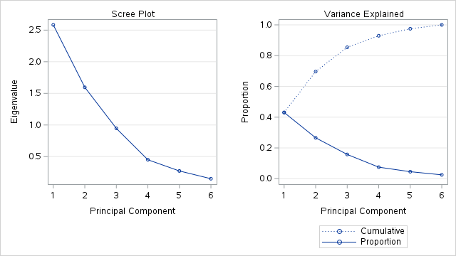

The PRINCOMP Procedure
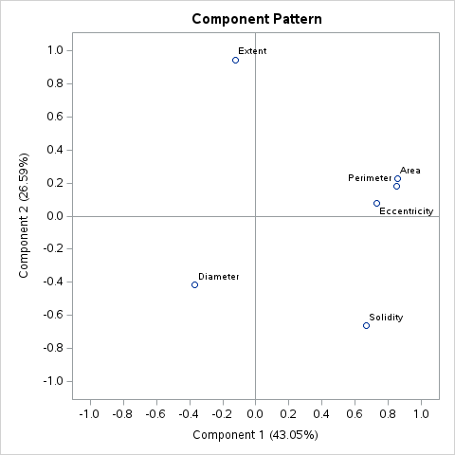
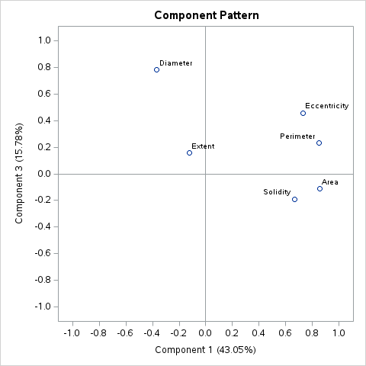
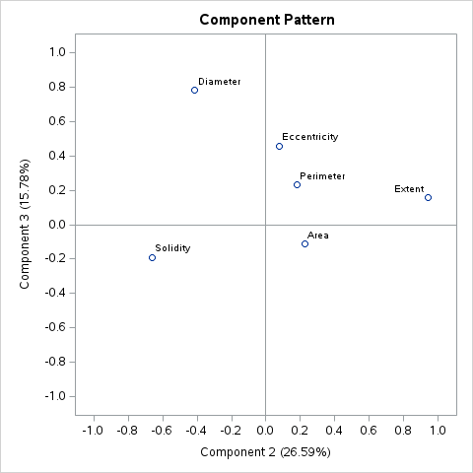
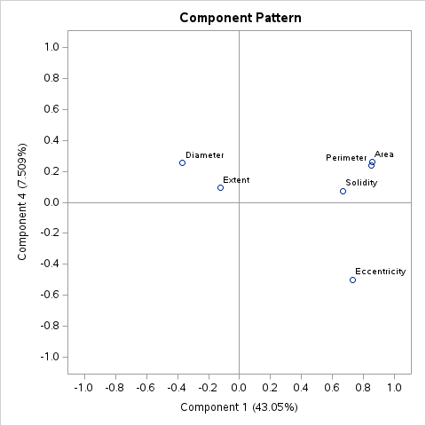
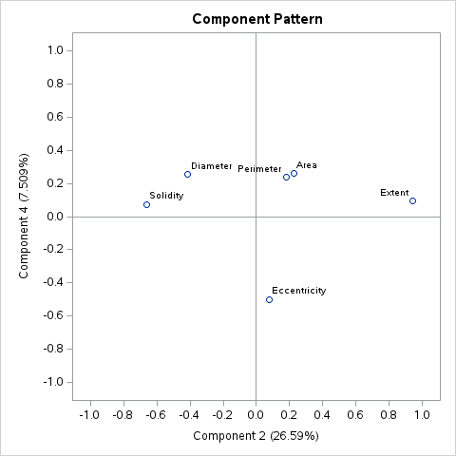
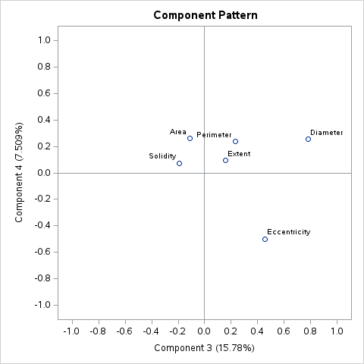
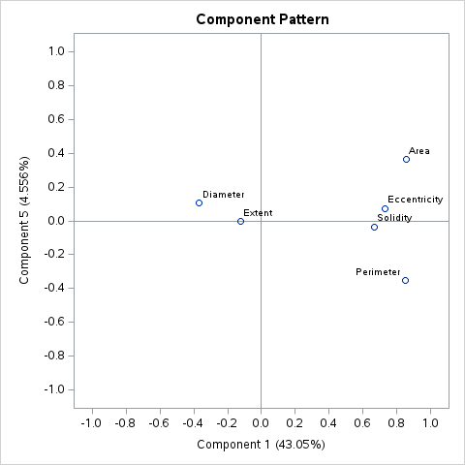
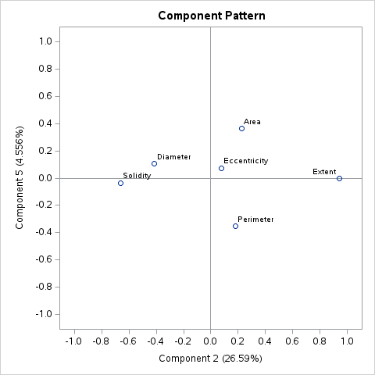
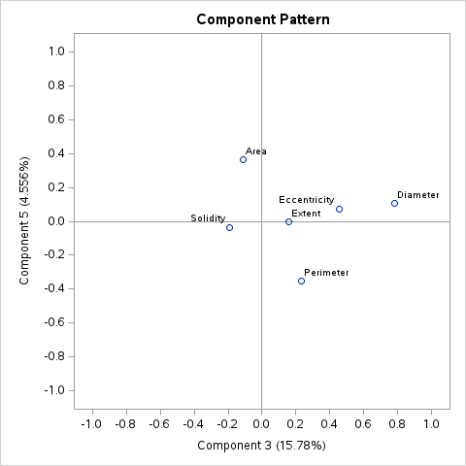
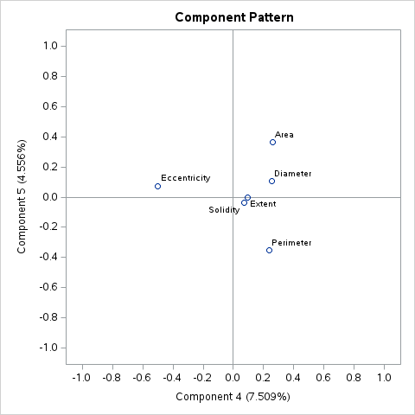

Q2 Diseased Group – Part (b)
The first three principal components were written using the eigenvectors from the PCA correlation matrix output.
Let:
X1 = Eccentricity
X2 = Area
X3 = Perimeter
X4 = Solidity
X5 = Extent
X6 = Diameter

PC1
PC1 = 0.454181(X1) + 0.532001(X2) + 0.529620(X3) + 0.413784(X4) - 0.075639(X5) - 0.230781(X6)

PC2
PC2 = 0.060462(X1) + 0.179532(X2) + 0.141535(X3) - 0.525316(X4) + 0.748077(X5) - 0.329400(X6)

PC3
PC3 = 0.468511(X1) - 0.113735(X2) + 0.238227(X3) - 0.194875(X4) + 0.161618(X5) + 0.804185(X6)
Therefore, PC1 is mainly influenced by Area, Perimeter, Eccentricity and Solidity. PC2 is mainly influenced by Extent positively and Solidity negatively. PC3 is mainly influenced by Diameter and Eccentricity.

Q2 Diseased Group – Part (c)
From the PCA output for the diseased group, the variance of each principal component is given by its eigenvalue.
Principal Component | Variance Eigenvalue | Proportion Explained | Cumulative Proportion
PC1 | 2.58295761 | 0.4305 | 0.4305
PC2 | 1.59566664 | 0.2659 | 0.6964
PC3 | 0.94656794 | 0.1578 | 0.8542
PC4 | 0.45051455 | 0.0751 | 0.9293
PC5 | 0.27338960 | 0.0456 | 0.9748
PC6 | 0.15090366 | 0.0252 | 1.0000
The first principal component explains 43.05% of the total variation. The second principal component explains 26.59%, so the first two components together explain 69.64% of the variation. The third principal component explains 15.78%, increasing the cumulative explained variation to 85.42%.
Therefore, the first three principal components explain most of the variation in the diseased WBC data, with a cumulative proportion of 85.42%.

Q2 Diseased Group – Part (d)
The Principal Component Pattern Profile plot was used to interpret how each original WBC variable contributes to the principal components.
For the diseased group, PC1 has strong positive loadings for Area (0.532001), Perimeter (0.529620), Eccentricity (0.454181), and Solidity (0.413784). Therefore, PC1 mainly represents overall cell size and shape structure.
PC2 has a strong positive loading for Extent (0.748077) and a strong negative loading for Solidity (-0.525316). This shows that PC2 mainly represents a contrast between cell spread/extent and compactness/solidity.
PC3 is dominated by Diameter (0.804185) and also has a moderate positive loading for Eccentricity (0.468511). Therefore, PC3 mainly represents cell diameter and elongation.
The remaining components, PC4, PC5, and PC6, have smaller eigenvalues and explain much less variation. Therefore, they are less useful for interpretation.
Overall, the pattern profile plot shows that the most meaningful components for the diseased group are the first three components. PC1 explains general size and shape, PC2 explains extent versus solidity, and PC3 explains diameter and eccentricity.
The Principal Component Pattern Profile plot helps show which original WBC variables are most important in each principal component for the diseased group. PC1 has strong positive contributions from Area, Perimeter, Eccentricity, and Solidity, so it mainly describes the overall size and shape structure of the WBC cells. PC2 is mainly influenced by Extent in a positive direction and Solidity in a negative direction. This means PC2 explains the difference between how spread out a cell is and how compact or solid it is. PC3 is mostly influenced by Diameter and Eccentricity, so it represents cell diameter and elongation. The remaining components, PC4, PC5, and PC6, explain much smaller amounts of variation, so they are not as useful for interpretation. Overall, the plot shows that the first three components are the most meaningful for understanding the diseased group.

Q2 Diseased Group – Part (e)
The number of principal components to retain was determined using the scree plot and eigenvalue (Kaiser) criterion.
From the eigenvalues:
- PC1 = 2.5830
- PC2 = 1.5957
- PC3 = 0.9466
- Remaining eigenvalues < 1
Using the Kaiser criterion (eigenvalue > 1), only PC1 and PC2 should be retained.
However, the scree plot shows a sharp drop after the first component and begins to level off after the third component, indicating a possible elbow at PC3.
In addition, the first:
- 2 components explain 69.64% of total variation
- 3 components explain 85.42% of total variation
Since 85% is generally considered sufficient, retaining three principal components provides a better representation of the data.

Final Decision:
For the diseased group, three principal components should be retained. The Kaiser criterion suggests keeping only PC1 and PC2 because their eigenvalues are greater than 1. However, PC3 still adds a useful amount of information and increases the total explained variation from 69.64% to 85.42%. The scree plot also supports keeping up to three components because the graph starts to level off after PC3. Therefore, keeping three components gives a better and more complete summary of the diseased WBC data.

Q2 Diseased Group – Part (f)

SAS Code
proc iml;
/* Eigenvalues from Diseased group PCA */
lambda = {2.58295761,
1.59566664,
0.94656794,
0.45051455,
0.27338960,
0.15090366};
n = 50;
p = 6;
result = {};
do k = 0 to p-2;
m = p - k;
rem_lambda = lambda[(k+1):p];
lambda_bar = mean(rem_lambda);
Q = -(n - 1 - (2*p + 5)/6 - (2*k)/3) *
sum(log(rem_lambda / lambda_bar));
df = (m - 1)*(m + 2)/2;
p_Q = 1 - probchi(Q, df);
u = sum((rem_lambda - lambda_bar)##2) / (lambda_bar##2);
p_u = 1 - probchi(u, df);
result = result // (k || m || lambda_bar || Q || df || p_Q || u || p_u);
end;
print result[colname={
"k"
"Remaining_PC"
"Mean_Eigenvalue"
"Q_Statistic"
"DF"
"Q_p_value"
"u_Statistic"
"u_p_value"
}];
quit;

Hypotheses
H0: The remaining eigenvalues after retaining k components are equal.
H1: The remaining eigenvalues after retaining k components are not equal.

Formula Used
Q = -(n - 1 - (2p + 5)/6 - (2k)/3) * sum log(lambda_j / lambda_bar)
u = sum((lambda_j - lambda_bar)^2) / lambda_bar^2
where:
n = 50
p = 6
k = number of retained components
lambda_j = remaining eigenvalues
lambda_bar = mean of remaining eigenvalues

Interpretation

For the Q-test, the p-values are less than 0.05 when k = 0, 1, 2, and 3. This means we reject the null hypothesis for these cases, so the remaining eigenvalues are still different from each other. However, when k = 4, the p-value is 0.1507, which is greater than 0.05. This means we fail to reject the null hypothesis, so the remaining two eigenvalues are not significantly different anymore. Based on this result, the Q-test suggests retaining 4 principal components. However, the u-test gives a different result because all its p-values are greater than 0.05. This means the u-test does not find strong evidence that the remaining eigenvalues are different, so it suggests that fewer components may be enough to explain the data.

Final Conclusion
The Q-test suggests keeping 4 principal components, but the u-test does not strongly support keeping that many. This means the Q-test gives a stricter result compared with the other methods. The scree plot and Kaiser criterion suggest keeping 2 or 3 components instead. For practical interpretation, 3 principal components are preferred because they explain 85.42% of the total variation and still give a clear, meaningful summary of the diseased WBC data.
SAS output
result
 | k | Remaining_PC | Mean_Eigenvalue | Q_Statistic | DF | Q_p_value | u_Statistic | u_p_value
ROW1 | 0 | 6 | 1 | 121.14234 | 20 | 2.22E-16 | 4.4142901 | 0.9998964
ROW2 | 1 | 5 | 0.6834085 | 75.968812 | 14 | 1.571E-10 | 3.0133667 | 0.9990502
ROW3 | 2 | 4 | 0.4553439 | 40.055872 | 9 | 7.4234E-6 | 1.7706133 | 0.9945976
ROW4 | 3 | 3 | 0.2916026 | 12.730861 | 5 | 0.0260358 | 0.5336917 | 0.9908376
ROW5 | 4 | 2 | 0.2121466 | 3.7851903 | 2 | 0.1506803 | 0.1666749 | 0.9200406

Q2 Diseased Group – Part (g)

SAS Code
proc iml;
lambda1 = 2.5829576;
n = 50;
alpha = 0.05;
z = quantile("Normal", 1-alpha/2);
se = lambda1 * sqrt(2/n);
lower = lambda1 - z*se;
upper = lambda1 + z*se;
print lambda1 n alpha z se lower upper;
quit;
A 95% confidence interval was constructed for the largest eigenvalue (λ₁) of the diseased group.
From the PCA output:
lambda1 = 2.5829576
n = 50
alpha = 0.05
z = 1.959964
The standard error is:
SE = lambda1 * sqrt(2/n)
= 2.5829576 * sqrt(2/50)
= 0.5165915
The 95% confidence interval is:
Lower = 2.5829576 - (1.959964 × 0.5165915) = 1.5704568
Upper = 2.5829576 + (1.959964 × 0.5165915) = 3.5954584

Final Result
95% CI for lambda1 = (1.5705, 3.5955)

Interpretation
The largest population eigenvalue for the diseased group is estimated to lie between 1.5705 and 3.5955 at the 95% confidence level.
lambda1 | n | alpha | z | se | lower | upper
2.5829576 | 50 | 0.05 | 1.959964 | 0.5165915 | 1.5704568 | 3.5954584

Q2 Diseased Group – Part (h)

SAS Code
proc iml;
lambda2 = 1.5956666;
n = 50;
alpha = 0.05;
z = quantile("Normal", 1-alpha/2);
se = lambda2 * sqrt(2/n);
lower = lambda2 - z*se;
upper = lambda2 + z*se;
print lambda2 n alpha z se lower upper;
quit;

A 95% confidence interval was constructed for the second eigenvalue (λ₂) of the diseased group.
From the PCA output:
lambda2 = 1.5956666
n = 50
alpha = 0.05
z = 1.959964
The standard error is:
SE = lambda2 * sqrt(2/n)
= 1.5956666 * sqrt(2/50)
= 0.3191333
The 95% confidence interval is:
Lower = 1.5956666 - (1.959964 × 0.3191333) = 0.9701768
Upper = 1.5956666 + (1.959964 × 0.3191333) = 2.2211565

Final Result
95% CI for lambda2 = (0.9702, 2.2212)

Interpretation

This result means that the true value of the second eigenvalue for the diseased group is likely to fall between 0.9702 and 2.2212 with 95% confidence. In simple terms, it shows that the second principal component does contribute to explaining variation in the data, but its importance is somewhat uncertain because the interval includes values close to 1. This suggests that while PC2 is useful, it may not always be clearly strong enough to stand out compared to other components.
SAS output
lambda2 | n | alpha | z | se | lower | upper
1.5956666 | 50 | 0.05 | 1.959964 | 0.3191333 | 0.9701768 | 2.2211565

Q2 Diseased Group – Part (i)
For the diseased group, the variables that contribute most to PC2 are identified using the absolute values of the PC2 eigenvector loadings.
From the eigenvector table, PC2 is:
PC2 = 0.060462(Eccentricity)
+ 0.179532(Area)
+ 0.141535(Perimeter)
- 0.525316(Solidity)
+ 0.748077(Extent)
- 0.329400(Diameter)

The largest absolute loadings are:

Variable | PC2 Loading | Absolute Loading
Extent | 0.748077 | 0.748077
Solidity | -0.525316 | 0.525316
Diameter | -0.329400 | 0.329400
Therefore, Extent contributes the most to PC2, followed by Solidity and Diameter.

Final Interpretation
PC2 mainly shows the difference between Extent and Solidity. In simple terms, it explains how spread out a cell is compared to how compact or solid it is. A higher value of PC2 means the cell is more spread out (higher Extent) and less compact (lower Solidity), while a lower value means the cell is more compact and less spread out. This component helps capture the shape characteristics of the WBC cells rather than their overall size.

Q2 sas outputs
The PRINCOMP Procedure
Observations | 50
Variables | 6

Simple Statistics
 | Eccentricity | Area | Perimeter | Solidity | Extent | Diameter
Mean | 215.0140000 | 129.9340000 | 129.7440000 | 8.320000000 | 10.23600000 | 141.4980000
StD | 0.3591430 | 0.3825852 | 0.3670956 | 0.632455532 | 0.69539594 | 0.4043084

Correlation Matrix
 | Eccentricity | Area | Perimeter | Solidity | Extent | Diameter
Eccentricity | 1.0000 | 0.3500 | 0.2166 | 0.1254 | 0.0813 | 0.1787
Area | 0.3500 | 1.0000 | 0.6532 | 0.0730 | 0.3014 | -.1288
Perimeter | 0.2166 | 0.6532 | 1.0000 | 0.1060 | 0.1472 | -.1025
Solidity | 0.1254 | 0.0730 | 0.1060 | 1.0000 | -.6193 | 0.1231
Extent | 0.0813 | 0.3014 | 0.1472 | -.6193 | 1.0000 | -.3293
Diameter | 0.1787 | -.1288 | -.1025 | 0.1231 | -.3293 | 1.0000

Eigenvalues of the Correlation Matrix
 | Eigenvalue | Difference | Proportion | Cumulative
1 | 2.01210359 | 0.30901365 | 0.3354 | 0.3354
2 | 1.70308995 | 0.67910905 | 0.2838 | 0.6192
3 | 1.02398090 | 0.35204427 | 0.1707 | 0.7899
4 | 0.67193663 | 0.32921844 | 0.1120 | 0.9019
5 | 0.34271819 | 0.09654744 | 0.0571 | 0.9590
6 | 0.24617075 |  | 0.0410 | 1.0000

Eigenvectors
 | Prin1 | Prin2 | Prin3 | Prin4 | Prin5 | Prin6
Eccentricity | 0.282448 | 0.364179 | 0.557999 | -.632640 | -.271853 | -.045781
Area | 0.585778 | 0.266142 | -.075172 | 0.131714 | 0.583724 | -.471487
Perimeter | 0.512346 | 0.305178 | -.226026 | 0.438530 | -.584387 | 0.243851
Solidity | -.184913 | 0.611401 | -.379175 | -.247480 | 0.336447 | 0.523239
Extent | 0.466356 | -.471719 | 0.212409 | -.055198 | 0.308330 | 0.645571
Diameter | -.250817 | 0.327227 | 0.665588 | 0.570803 | 0.188655 | 0.160000
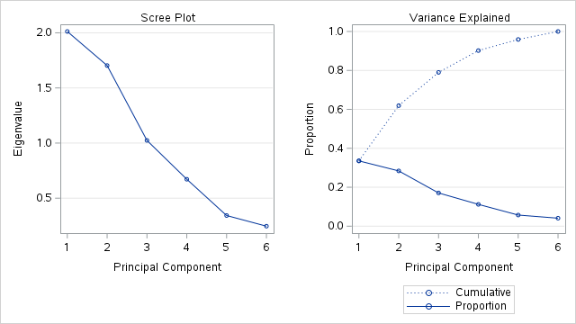

The PRINCOMP Procedure
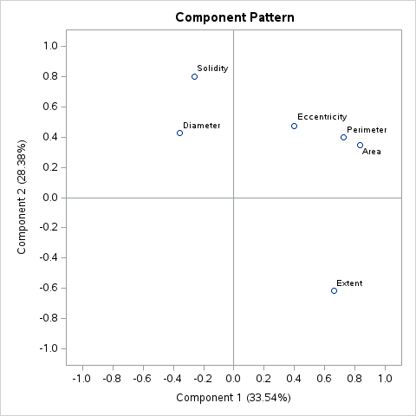
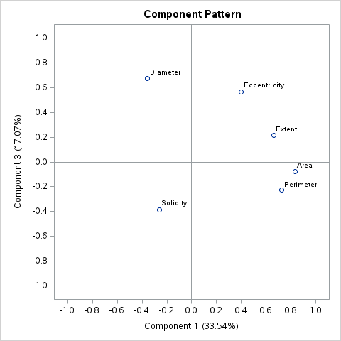
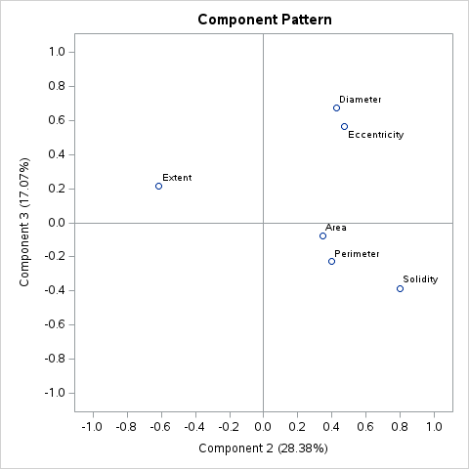
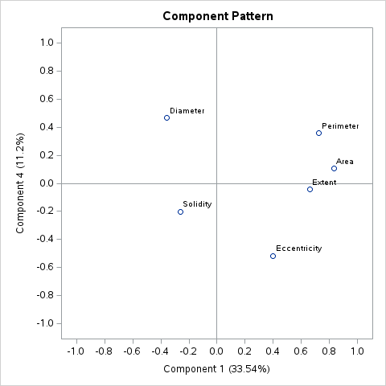
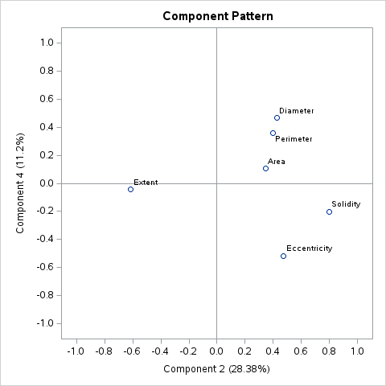
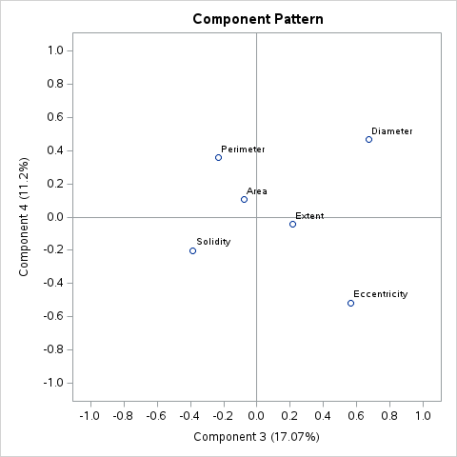
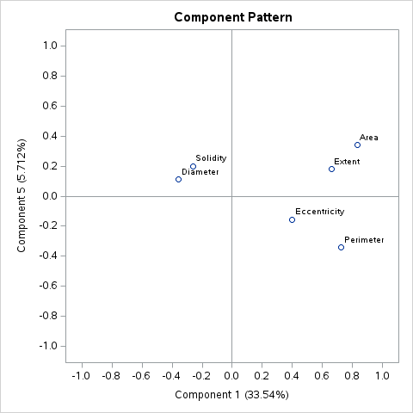
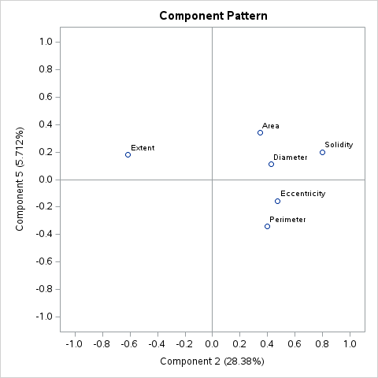
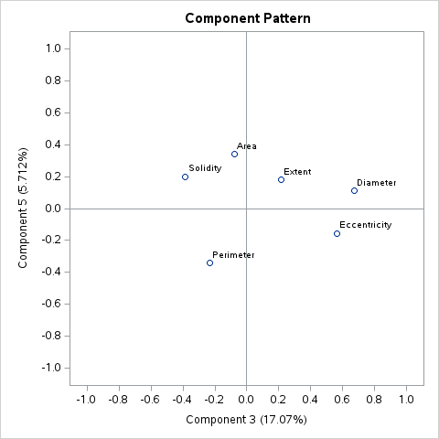
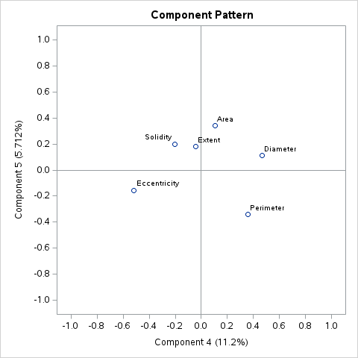

Q2 Non-diseased Group – Part (a)

SAS Code
proc princomp data=wbc(where=(Status="Non-diseased"))
out=pca_nondiseased
plots=(scree pattern);
var Eccentricity Area Perimeter Solidity Extent Diameter;
run;
Principal Component Analysis was performed on the non-diseased WBC group using the correlation matrix, because the six WBC variables are measured on different scales.
The analysis included 50 observations and 6 variables: Eccentricity, Area, Perimeter, Solidity, Extent, and Diameter.
From the eigenvalue table:
Component | Eigenvalue | Proportion | Cumulative
PC1 | 2.0121 | 0.3354 | 0.3354
PC2 | 1.7031 | 0.2838 | 0.6192
PC3 | 1.0240 | 0.1707 | 0.7899
PC4 | 0.6719 | 0.1120 | 0.9019
PC5 | 0.3427 | 0.0571 | 0.9590
PC6 | 0.2462 | 0.0410 | 1.0000
The first principal component explains 33.54% of the total variation. The second principal component explains 28.38%, giving a cumulative explanation of 61.92% for the first two components. The first three components together explain 78.99% of the total variation.
Using the Kaiser criterion, PC1, PC2, and PC3 should be retained because their eigenvalues are greater than 1.
Overall, PCA reduces the six original WBC variables to three main principal components, while retaining approximately 78.99% of the information in the non-diseased group.

Q2 Non-diseased Group - Part (b)
The first three principal components are written using the eigenvectors from the non-diseased PCA output.
Let:
X1 = Eccentricity
X2 = Area
X3 = Perimeter
X4 = Solidity
X5 = Extent
X6 = Diameter
PC1
PC1 = 0.282448(X1) + 0.585778(X2) + 0.512346(X3) - 0.184913(X4) + 0.466356(X5) - 0.250817(X6)

PC2
PC2 = 0.364179(X1) + 0.266142(X2) + 0.305178(X3) + 0.611401(X4) - 0.471719(X5) + 0.327227(X6)

PC3
PC3 = 0.557999(X1) - 0.075172(X2) - 0.226026(X3) - 0.379175(X4) + 0.212409(X5) + 0.665588(X6)

Interpretation

PC1 mainly represents the overall size and spread of the cell because it is strongly influenced by Area, Perimeter, and Extent. PC2 mainly explains the difference between compactness and spread, because Solidity contributes positively while Extent contributes negatively. This means higher PC2 values are linked with more compact cells, while lower PC2 values are linked with more spread-out cells. PC3 mainly represents the cell’s diameter and elongation, as it is mostly influenced by Diameter and Eccentricity.

Q2 Non-diseased Group – Part (c)
From the PCA output for the non-diseased group, the variance of each principal component is given by its eigenvalue.
Principal Component | Variance / Eigenvalue | Proportion Explained | Cumulative Proportion
PC1 | 2.01210359 | 0.3354 | 0.3354
PC2 | 1.70308995 | 0.2838 | 0.6192
PC3 | 1.02398090 | 0.1707 | 0.7899
PC4 | 0.67193663 | 0.1120 | 0.9019
PC5 | 0.34271819 | 0.0571 | 0.9590
PC6 | 0.24617075 | 0.0410 | 1.0000
The first principal component explains 33.54% of the total variation. The second principal component explains 28.38%, so the first two components together explain 61.92% of the total variation. The third principal component explains 17.07%, increasing the cumulative explained variation to 78.99%.
Therefore, the first three principal components explain most of the variation in the non-diseased WBC data, with a cumulative proportion of 78.99%.

Q2 Non-diseased Group – Part (d)
The Principal Component Pattern Profile plot helps explain how each original WBC variable contributes to the principal components in the non-diseased group. For PC1, the largest positive contributions come from Area, Perimeter, and Extent. This indicates that PC1 mainly captures overall cell size and how spread out the cell is. In simple terms, cells with higher PC1 values tend to be larger and more expanded.
For PC2, the strongest positive contribution comes from Solidity, while Extent has a strong negative contribution. This shows that PC2 represents a contrast between how compact the cell is and how spread out it is. A higher PC2 value means the cell is more compact and solid, while a lower value means the cell is more spread out and less compact.
For PC3, the main contributions come from Diameter and Eccentricity. This means PC3 captures information about the cell’s size in terms of diameter and its shape in terms of elongation. Cells with higher PC3 values tend to be larger in diameter and more elongated.
The remaining components, PC4, PC5, and PC6, have eigenvalues less than 1 and explain only a small portion of the total variation in the data. Because of this, they do not provide much useful information for understanding the main patterns in the dataset.
Overall, the pattern profile plot shows that the first three principal components are the most important for the non-diseased group. PC1 explains overall size and spread, PC2 explains the balance between compactness and spread, and PC3 explains diameter and elongation. These three components together provide a clear and meaningful summary of the main patterns in the non-diseased WBC data.

Q2 Non-diseased Group – Part (e)
The number of principal components to retain was determined using the scree plot and the Kaiser criterion (eigenvalue > 1).
From the eigenvalues:
- PC1 = 2.0121
- PC2 = 1.7031
- PC3 = 1.0240
- Remaining eigenvalues < 1
Using the Kaiser criterion, the first three principal components should be retained.
The scree plot shows a noticeable drop after the first few components and begins to level off after PC3, indicating an elbow at the third component.
In addition:
- The first 2 components explain 61.92% of the variation
- The first 3 components explain 78.99% of the variation
Since retaining three components captures a substantial proportion of the total variation and aligns with both the scree plot and Kaiser rule, three principal components are retained.

Final Decision:
3 principal components are retained for the non-diseased group.

Q2 Non-diseased Group – Part (f)

SAS Code
proc iml;
lambda = {2.01210359,
1.70308995,
1.02398090,
0.67193663,
0.34271819,
0.24617075};
n = 50;
p = 6;
result = {};
do k = 0 to p-2;
m = p - k;
rem_lambda = lambda[(k+1):p];
lambda_bar = mean(rem_lambda);
Q = -(n - 1 - (2*p + 5)/6 - (2*k)/3) *
sum(log(rem_lambda / lambda_bar));
df = (m - 1)*(m + 2)/2;
p_Q = 1 - probchi(Q, df);
u = sum((rem_lambda - lambda_bar)##2) / (lambda_bar##2);
p_u = 1 - probchi(u, df);
result = result // (k || m || lambda_bar || Q || df || p_Q || u || p_u);
end;
print result[colname={
"k"
"Remaining_PC"
"Mean_Eigenvalue"
"Q_Statistic"
"DF"
"Q_p_value"
"u_Statistic"
"u_p_value"
}];
quit;

Hypotheses
H0: The remaining eigenvalues after retaining k components are equal
H1: The remaining eigenvalues after retaining k components are not equal

Interpretation

For the Q-test, the p-values are less than 0.05 when k = 0, 1, 2, and 3, so the null hypothesis is rejected in these cases. This means that the remaining eigenvalues are still significantly different from each other, and more components are needed to explain the variation in the data. However, when k = 4, the p-value is 0.5529, which is greater than 0.05. This means we fail to reject the null hypothesis, indicating that the remaining two eigenvalues are not significantly different anymore. Based on this result, the Q-test suggests that 4 principal components should be retained. On the other hand, the u-test shows that all p-values are greater than 0.05, which means it does not find strong evidence that the remaining eigenvalues are different. This suggests that fewer components may still be enough to represent the data effectively.

Final Conclusion
The Q-test suggests retaining 4 principal components, while the Kaiser criterion and scree plot suggest retaining 3 components. Since the first three components already explain 78.99% of the total variation, keeping 3 components is more practical and easier to interpret. This gives a simpler summary of the non-diseased WBC data without losing too much important information. Therefore, 3 principal components are preferred for the final interpretation.
result
 | k | Remaining_PC | Mean_Eigenvalue | Q_Statistic | DF | Q_p_value | u_Statistic | u_p_value
ROW1 | 0 | 6 | 1 | 74.552014 | 20 | 3.235E-8 | 2.6271677 | 0.9999987
ROW2 | 1 | 5 | 0.7975793 | 53.833581 | 14 | 1.3715E-6 | 2.1975655 | 0.9998522
ROW3 | 2 | 4 | 0.5712016 | 27.187735 | 9 | 0.0013022 | 1.1432399 | 0.9990302
ROW4 | 3 | 3 | 0.4202752 | 11.908711 | 5 | 0.0360603 | 0.5642316 | 0.9895823
ROW5 | 4 | 2 | 0.2944445 | 1.1852423 | 2 | 0.5528762 | 0.0537582 | 0.9734789

Q2 Non-diseased Group – Part (g)

SAS Code
proc iml;
lambda1 = 2.0121036;
n = 50;
alpha = 0.05;
z = quantile("Normal", 1-alpha/2);
se = lambda1 * sqrt(2/n);
lower = lambda1 - z*se;
upper = lambda1 + z*se;
print lambda1 n alpha z se lower upper;
quit;
A 95% confidence interval was constructed for the largest eigenvalue (λ₁) of the non-diseased group.
From the PCA output:
lambda1 = 2.0121036
n = 50
alpha = 0.05
z = 1.959964
The standard error is:
SE = lambda1 * sqrt(2/n)
= 2.0121036 * sqrt(2/50)
= 0.4024207
The 95% confidence interval is:
Lower = 2.0121036 - (1.959964 × 0.4024207) = 1.2233735
Upper = 2.0121036 + (1.959964 × 0.4024207) = 2.8008337

Final Result
95% CI for lambda1 = (1.2234, 2.8008)

Interpretation
This result means that the true value of the largest eigenvalue for the non-diseased group is likely to fall between 1.2234 and 2.8008 with 95% confidence. In simple terms, this shows that the first principal component explains a meaningful amount of variation in the data. Since the entire interval is above 1, it confirms that PC1 is an important and strong component, and it should definitely be retained when summarising the non-diseased WBC data.
SAS output
lambda1 | n | alpha | z | se | lower | upper
2.0121036 | 50 | 0.05 | 1.959964 | 0.4024207 | 1.2233735 | 2.8008337

Q2 Non-diseased Group – Part (h)

SAS Code
proc iml;
lambda2 = 1.70309;
n = 50;
alpha = 0.05;
z = quantile("Normal", 1-alpha/2);
se = lambda2 * sqrt(2/n);
lower = lambda2 - z*se;
upper = lambda2 + z*se;
print lambda2 n alpha z se lower upper;
quit;

A 95% confidence interval was constructed for the second eigenvalue (λ₂) of the non-diseased group.
From the PCA output:
lambda2 = 1.70309
n = 50
alpha = 0.05
z = 1.959964
The standard error is:
SE = lambda2 * sqrt(2/n)
= 1.70309 * sqrt(2/50)
= 0.340618
The 95% confidence interval is:
Lower = 1.70309 - (1.959964 × 0.340618) = 1.035491
Upper = 1.70309 + (1.959964 × 0.340618) = 2.3706889

Final Result
95% CI for lambda2 = (1.0355, 2.3707)

Interpretation

This result means that the true value of the second eigenvalue (λ₂) for the non-diseased group is likely to lie between 1.0355 and 2.3707 with 95% confidence. In simple terms, this shows that the second principal component also explains an important portion of the variation in the data. Since the entire interval is above 1, it confirms that PC2 is a meaningful and reliable component, and it should be retained when summarising the non-diseased WBC data.

Q2 Part (j): Comparison of Diseased and Non-diseased PCA Results
The PCA results show that there are both similarities and differences between the diseased and non-diseased WBC groups. For the diseased group, PC1 explains 43.05% of the total variation, while PC2 explains 26.59%. Together, the first two components explain 69.64% of the total variation. For the non-diseased group, PC1 explains 33.54% and PC2 explains 28.38%, giving a total of 61.92% for the first two components. This shows that PC1 is stronger in the diseased group because it captures more of the overall variation compared with the non-diseased group.
In both groups, PC1 is mainly linked with size-related features, especially Area and Perimeter. This means that cell size is an important source of variation in both diseased and non-diseased WBC cells. However, the exact variables contributing to PC1 are slightly different. In the diseased group, PC1 is mainly influenced by Area, Perimeter, Eccentricity, and Solidity. In the non-diseased group, PC1 is mainly influenced by Area, Perimeter, and Extent. This suggests that the diseased group’s first component includes both size and shape structure, while the non-diseased group’s first component is more focused on size and spread.
PC2 also shows a similar pattern in both groups because it mainly explains the contrast between Solidity and Extent. In the diseased group, PC2 has a strong positive loading for Extent and a negative loading for Solidity. In the non-diseased group, the signs are reversed, with Solidity positive and Extent negative. However, this does not change the meaning of the component because PCA signs can be reversed. In simple terms, PC2 in both groups explains the difference between how spread out a cell is and how compact or solid it is.
For the number of components retained, the diseased group suggests keeping 2 or 3 components, while the non-diseased group more clearly supports keeping 3 components using the Kaiser criterion. The first three components explain 85.42% of the total variation in the diseased group and 78.99% in the non-diseased group. This means that three components provide a good summary for both groups, although the diseased group’s variation is captured slightly more strongly by the first three components.
Overall, PCA shows that the six original WBC variables can be reduced to a smaller number of meaningful components in both groups. The main similarity is that Area, Perimeter, Solidity, and Extent are important in explaining variation for both diseased and non-diseased WBC cells. The main difference is that the diseased group has more variation concentrated in PC1, while the non-diseased group has its variation spread more evenly across the first three components.

Question 3 Part (a)
proc import datafile="/home/u64477816/Dataset TWIN.csv"
out=twin
dbms=csv
replace;
getnames=yes;
run;
data twin_diff;
set twin;
d1 = X1_T1 - X1_T2;
d2 = X2_T1 - X2_T2;
d3 = X3_T1 - X3_T2;
d4 = X4_T1 - X4_T2;
run;
/* Hotelling's T-squared test using PROC IML */
proc iml;
use twin_diff;
read all var {d1 d2 d3 d4} into D;
close twin_diff;
n = nrow(D);
p = ncol(D);
dbar = mean(D); /* mean vector */
S = cov(D); /* covariance matrix */
T2 = n * dbar * inv(S) * dbar`; /* Hotelling T^2 */
/* Convert to F statistic */
F = ((n - p) / (p * (n - 1))) * T2;
df1 = p;
df2 = n - p;
p_value = 1 - probf(F, df1, df2);
alpha = 0.05;
Fcrit = finv(1 - alpha, df1, df2);
T2crit = (p * (n - 1) / (n - p)) * Fcrit;
print n p;
print dbar;
print S;
print T2 F df1 df2 p_value Fcrit T2crit;
quit;
The appropriate test is the paired Hotelling’s T-squared test, because the same 30 twin pairs are compared using four paired response variables.
The paired differences are defined as:
d1 = X1_T1 - X1_T2
d2 = X2_T1 - X2_T2
d3 = X3_T1 - X3_T2
d4 = X4_T1 - X4_T2
The hypotheses are:
H0: mu_d = (0, 0, 0, 0)
H1: mu_d is not equal to (0, 0, 0, 0)
where mu_d is the population mean vector of paired differences.
The Hotelling’s T-squared test statistic is:
T2 = n * dbar' * S^(-1) * dbar
where:
n = 30
p = 4
dbar = sample mean vector of differences
S = sample covariance matrix of differences
The T-squared statistic is converted to an F statistic using:
F = ((n - p) / (p * (n - 1))) * T2
with degrees of freedom:
df1 = p
df2 = n - p
Using the SAS output:
n = 30
p = 4
T2 = 9.1496
F = 2.0508
df1 = 4
df2 = 26
p-value = 0.1165
At alpha = 0.05, the p-value is greater than 0.05:
0.1165 > 0.05
Therefore, we fail to reject H0.
There is no statistically significant evidence that the average paired difference vector is different from zero. In simple terms, the twins’ ratings are not different enough to be considered meaningful statistically. This means the first twin’s ratings are generally close to the second twin’s actual NS and HA levels. Therefore, based on the paired Hotelling’s T² test, the twins appear to perceive or rank their twin’s NS and HA levels reasonably accurately.
The MEANS Procedure
Variable | N | Mean | Variance | Std Dev
d1  d2  d3  d4 | 30  30  30  30 | -0.0666667  -0.0666667  -0.2666667  0.1000000 | 0.4091954  0.0643678  0.9609195  0.0931034 | 0.6396838  0.2537081  0.9802650  0.3051286

n | p
30 | 4

dbar
-0.066667 | -0.066667 | -0.266667 | 0.1

S
0.4091954 | -0.004598 | -0.052874 | -0.062069
-0.004598 | 0.0643678 | 0.016092 | 0.0068966
-0.052874 | 0.016092 | 0.9609195 | 0.062069
-0.062069 | 0.0068966 | 0.062069 | 0.0931034

T2 | F | df1 | df2 | p_value | Fcrit | T2crit
9.1496452 | 2.0507825 | 4 | 26 | 0.1165385 | 2.7425941 | 12.236189

Question 3 Part (b)
The sample means and variances of the paired differences were obtained using SAS.
proc means data=twin_diff n mean var std;
var d1 d2 d3 d4;
run;
The paired differences were defined as:
d1 = X1_T1 - X1_T2
d2 = X2_T1 - X2_T2
d3 = X3_T1 - X3_T2
d4 = X4_T1 - X4_T2
From the SAS output:
Difference | N | Mean | Variance | Std Dev
d1 | 30 | -0.0667 | 0.4092 | 0.6397
d2 | 30 | -0.0667 | 0.0644 | 0.2537
d3 | 30 | -0.2667 | 0.9609 | 0.9803
d4 | 30 | 0.1000 | 0.0931 | 0.3051
Therefore, the sample mean vector of the differences is:
dbar = (-0.0667, -0.0667, -0.2667, 0.1000)
The sample variances of the differences are:
Var(d1) = 0.4092
Var(d2) = 0.0644
Var(d3) = 0.9609
Var(d4) = 0.0931
The MEANS Procedure
Variable | N | Mean | Variance | Std Dev
d1  d2  d3  d4 | 30  30  30  30 | -0.0666667  -0.0666667  -0.2666667  0.1000000 | 0.4091954  0.0643678  0.9609195  0.0931034 | 0.6396838  0.2537081  0.9802650  0.3051286

Question 3 Part (c)
The aim was to check whether the first twin accurately perceives the level of Novelty Seeking and Harm Avoidance of the second twin.
From Part (a), the paired Hotelling’s T-squared test gave:
T2 = 9.1496
F = 2.0508
df1 = 4
df2 = 26
p-value = 0.1165
At alpha = 0.05:
p-value = 0.1165 > 0.05
Therefore, we fail to reject H0.
This means there is no statistically significant difference between the twins’ paired response scores. The mean difference vector is not significantly different from zero.
So, based on the Hotelling’s T-squared test, the first twin appears to accurately perceive the level of NS and HA of the second twin. The differences in responses are small and not statistically significant.

Q4 SAS Outputs
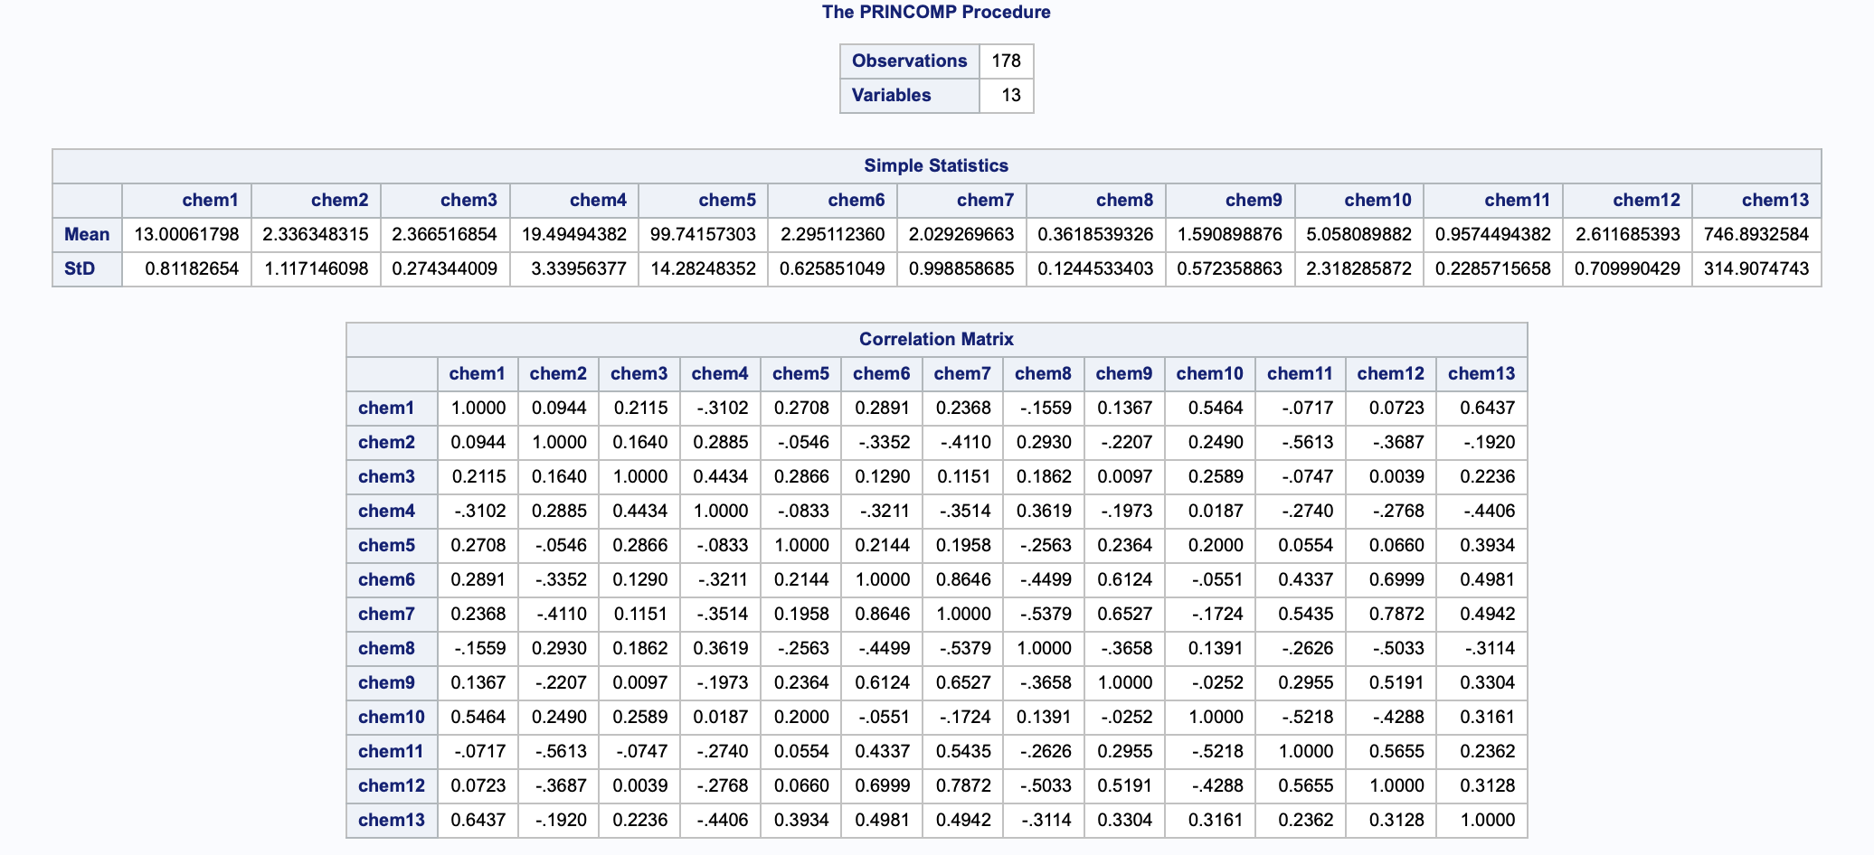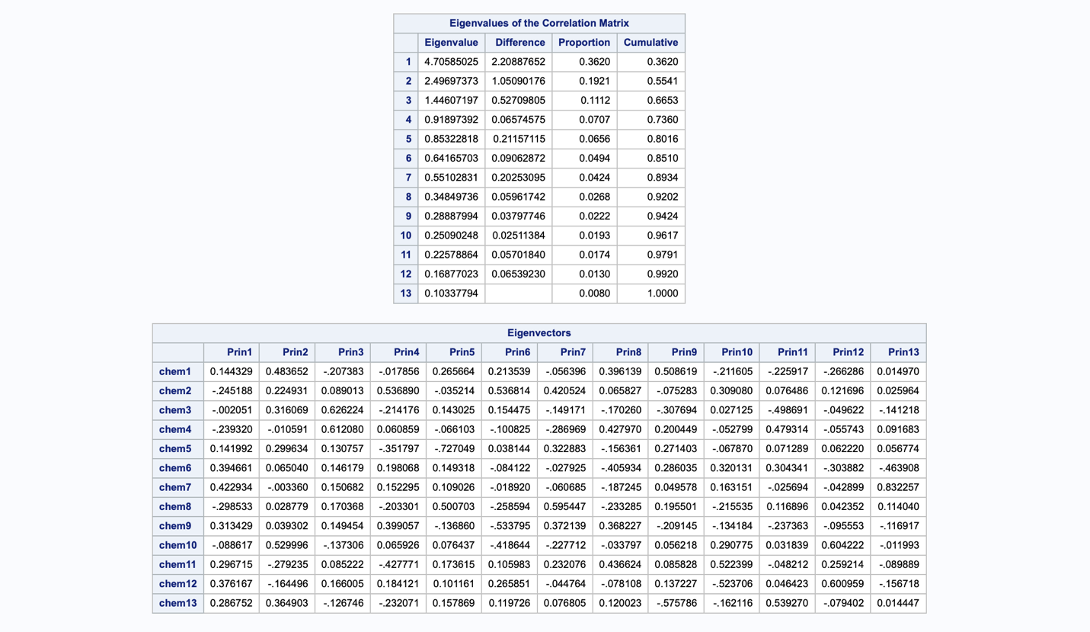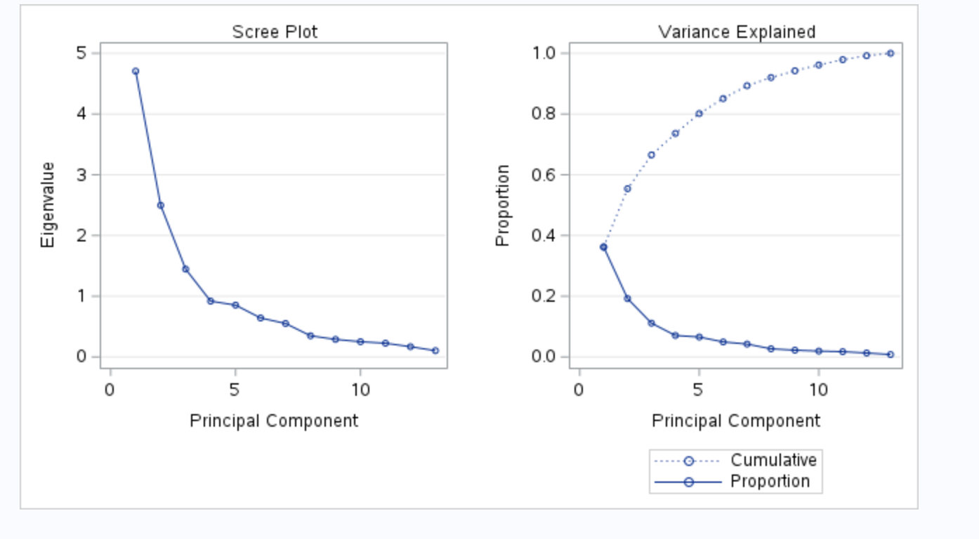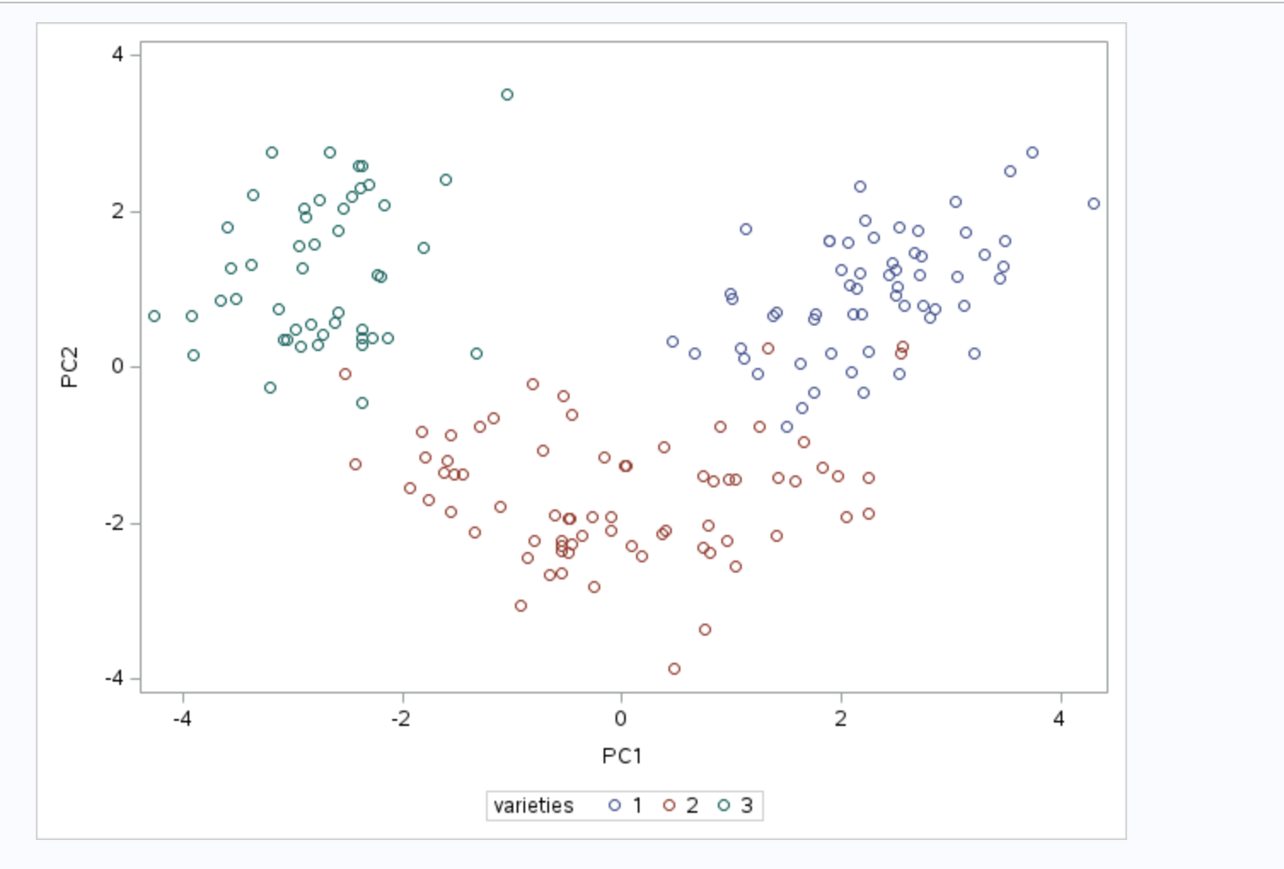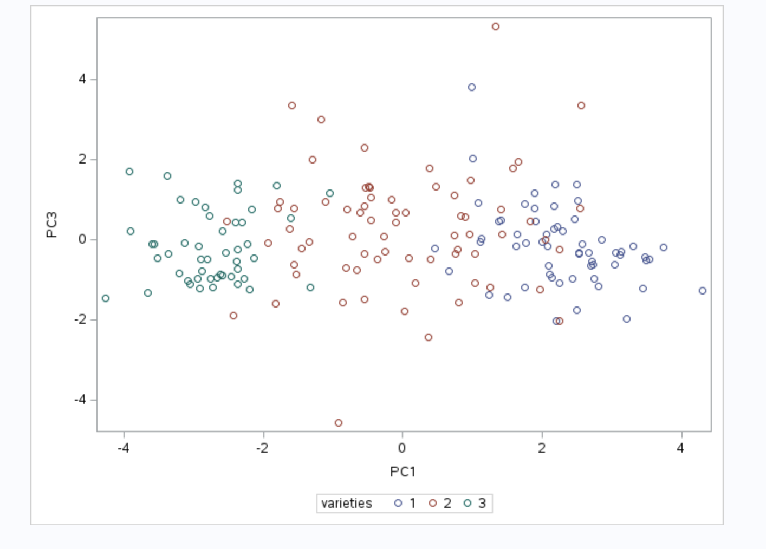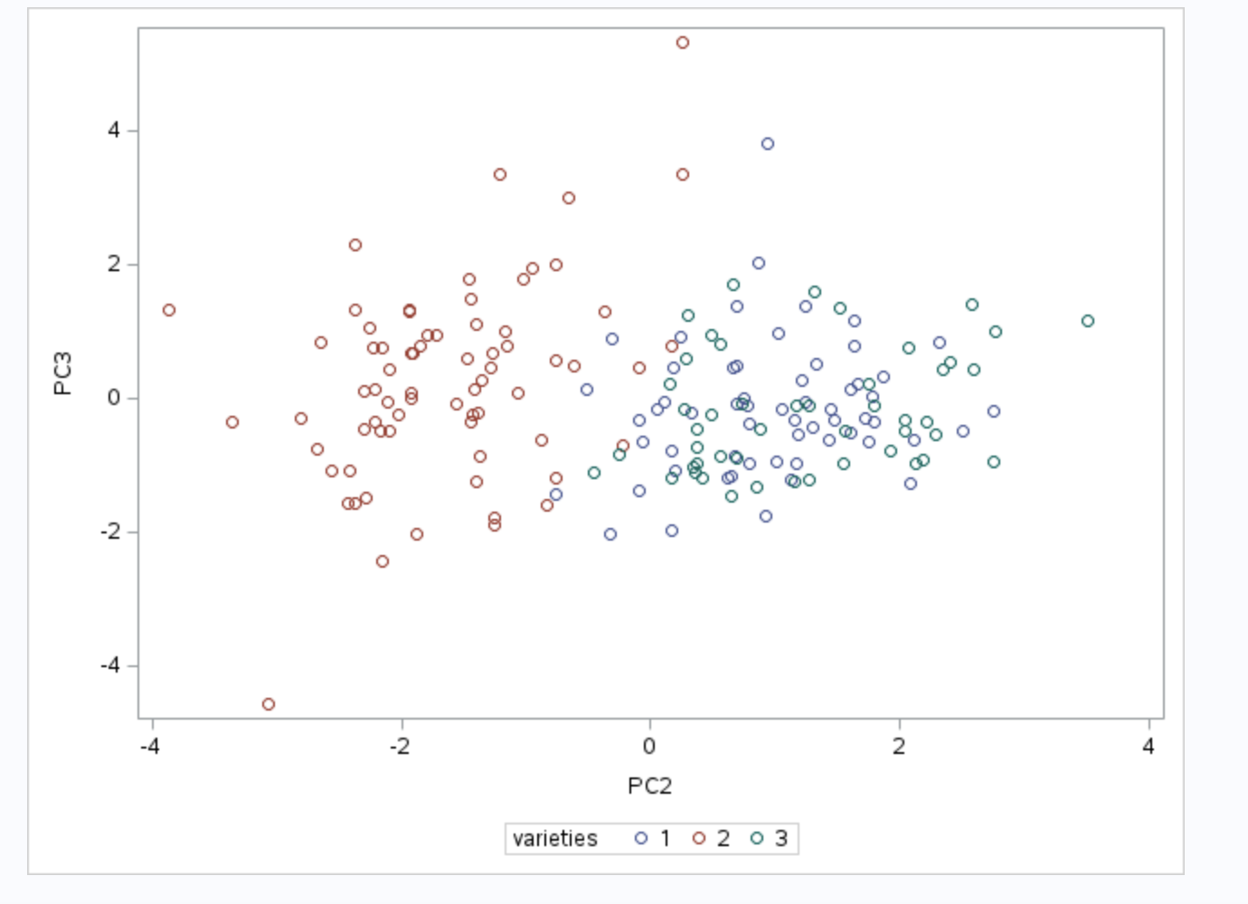

Q4 Part 1
The mean and standard deviation for the 13 chemical concentrations were computed using SAS.
proc means data=thc mean stddev maxdec=4;
var chem1 chem2 chem3 chem4 chem5 chem6 chem7
chem8 chem9 chem10 chem11 chem12 chem13;
run;
From the SAS output:
Chemical | Mean | Std Dev
chem1 | 13.0006 | 0.8118
chem2 | 2.3363 | 1.1171
chem3 | 2.3665 | 0.2743
chem4 | 19.4949 | 3.3396
chem5 | 99.7416 | 14.2825
chem6 | 2.2951 | 0.6259
chem7 | 2.0293 | 0.9989
chem8 | 0.3619 | 0.1245
chem9 | 1.5909 | 0.5724
chem10 | 5.0581 | 2.3183
chem11 | 0.9574 | 0.2286
chem12 | 2.6117 | 0.7100
chem13 | 746.8933 | 314.9075
The variable varieties was not included because it represents the species variety group, not a chemical concentration.

Q4 Part 2 Answer
The correlation matrix and scatterplot matrix were obtained using SAS:
proc corr data=thc;
var chem1 chem2 chem3 chem4 chem5 chem6 chem7
chem8 chem9 chem10 chem11 chem12 chem13;
run;
proc sgscatter data=thc;
matrix chem1 chem2 chem3 chem4 chem5 chem6 chem7
chem8 chem9 chem10 chem11 chem12 chem13;
run;
From the scatterplot matrix, many of the chemical variables show clear relationships with each other. The points are not randomly scattered; instead, they form visible patterns, including some positive and negative linear trends. This means that changes in one chemical variable are often related to changes in another chemical variable. The roughly elliptical shapes in some plots also suggest that the variables have a structured relationship. This is important because PCA works best when variables are correlated. Since several variables appear to be related, PCA is suitable for this dataset and can be used to reduce the 13 chemical variables into a smaller number of meaningful principal components.
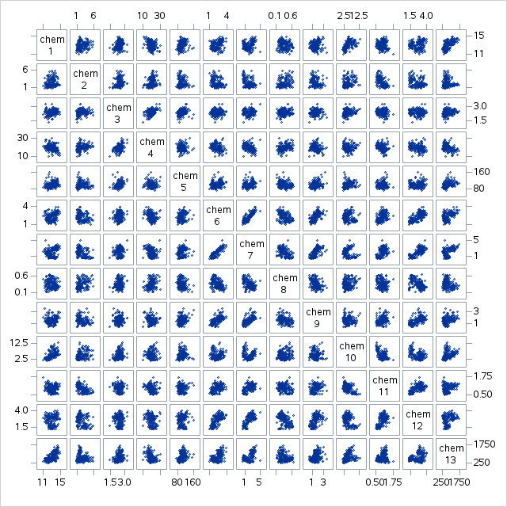

Q4 Part 3
PCA was performed using the correlation matrix.
proc princomp data=thc out=pcout plots=scree;
var chem1 chem2 chem3 chem4 chem5 chem6 chem7
chem8 chem9 chem10 chem11 chem12 chem13;
run;

3(a) Percentage of variation
From the SAS output:
PC | Eigenvalue | Proportion | Percentage | Cumulative
PC1 | 4.7059 | 0.3620 | 36.20% | 36.20%
PC2 | 2.4969 | 0.1921 | 19.21% | 55.41%
PC3 | 1.4461 | 0.1112 | 11.12% | 66.53%
Therefore, the first three PCs explain:
36.20% + 19.21% + 11.12% = 66.53%
of the total variation.

3(b) Interpretation of first 3 PCs
PC1 explains the largest part of the total variation, which is 36.20%. It is mainly influenced by chem6, chem7, chem9, chem11, chem12, and chem13, because these variables have large positive loadings. This means PC1 represents a general chemical pattern where these chemical concentrations tend to vary together.
PC2 explains 19.21% of the total variation. It is mainly influenced positively by chem1, chem10, and chem13, while chem11 and chem12 have negative loadings. This means PC2 separates or contrasts these two groups of chemicals. In simple terms, when one group has higher values, the other group tends to have lower values.
PC3 explains 11.12% of the total variation. It is mainly influenced by chem3 and chem4, which both have strong positive loadings. This means PC3 mostly captures variation related to these two chemical concentrations. Overall, the first three principal components explain different chemical patterns in the dataset, with PC1 showing the broadest overall chemical profile, PC2 showing a contrast between chemical groups, and PC3 focusing mainly on chem3 and chem4.

3(c) First 3 PCs as linear functions
PC1 = 0.1443(chem1) - 0.2452(chem2) - 0.0021(chem3)
- 0.2393(chem4) + 0.1420(chem5) + 0.3947(chem6)
+ 0.4229(chem7) - 0.2985(chem8) + 0.3134(chem9)
- 0.0886(chem10) + 0.2967(chem11) + 0.3762(chem12)
+ 0.2868(chem13)
PC2 = 0.4837(chem1) + 0.2249(chem2) + 0.3161(chem3)
- 0.0106(chem4) + 0.2996(chem5) + 0.0650(chem6)
- 0.0034(chem7) + 0.0288(chem8) + 0.0393(chem9)
+ 0.5300(chem10) - 0.2792(chem11) - 0.1645(chem12)
+ 0.3649(chem13)
PC3 = -0.2074(chem1) + 0.0890(chem2) + 0.6262(chem3)
+ 0.6121(chem4) + 0.1308(chem5) + 0.1462(chem6)
+ 0.1507(chem7) + 0.1704(chem8) + 0.1495(chem9)
- 0.1373(chem10) + 0.0852(chem11) + 0.1660(chem12)
- 0.1267(chem13)

3(d) Can the data be summarized in fewer than 13 dimensions?
Yes. The first three PCs explain 66.53% of the total variation, and the first five PCs explain 80.16%. Therefore, the data can be reduced from 13 variables to around 3 to 5 principal components while still retaining a large amount of information.

3(e) Scree plot
The scree plot shows a clear drop after PC1, PC2, and PC3, then the curve starts to flatten. This supports retaining about 3 principal components.

Q4 Part 3(f) - Pattern Plots Interpretation
The pattern plots (loading plots) for the first three principal components show how each variable contributes to each PC.
From the eigenvector (loading) table:

PC1 (Prin1)
- Large positive loadings: chem6, chem7, chem9, chem11, chem12, chem13
- Large negative loadings: chem2, chem4, chem8
Interpretation:
PC1 represents a clear contrast between two groups of chemical variables. The positive side includes chem6, chem7, chem9, chem11, chem12, and chem13, while the negative side includes chem2, chem4, and chem8. This means that samples with higher PC1 scores tend to have higher values for the positive group of chemicals and lower values for the negative group. In simple terms, PC1 captures the main difference in the overall chemical composition of the samples.

PC2 (Prin2)
- Large positive loadings: chem1, chem10, chem13, chem5
- Large negative loadings: chem11, chem12
Interpretation:
PC2 shows a separation between two sets of chemical variables. On one side, it is influenced by higher values of chem1, chem10, and chem13, while on the other side it is associated with lower values of chem11 and chem12. This means that samples with higher PC2 scores tend to have higher levels of chem1, chem10, and chem13 but lower levels of chem11 and chem12. PC2 captures a second pattern in the data, highlighting a contrast between these groups of chemicals and showing another way in which the chemical composition differs across samples.

PC3 (Prin3)
- Strong positive loadings: chem3, chem4
- Moderate contributions: others smaller
Interpretation:
PC3 mainly reflects variation in chem3 and chem4. This means that these two chemical variables contribute the most to this component compared with the other chemicals. In simple terms, PC3 captures a more specific chemical pattern that is mainly based on changes in chem3 and chem4, rather than the overall chemical profile of all variables.

Conclusion

Overall, the pattern plots show that each principal component explains a different type of chemical variation. PC1 captures the main overall variation across many of the chemical variables. PC2 explains a secondary contrast between different groups of chemicals. PC3 focuses more specifically on variation in chem3 and chem4. This confirms that the chemical variables do not all contribute in the same way. Instead, different groups of chemicals influence different principal components, which helps explain the separation and patterns seen in the score plots.

3(g–i) Score plot comments
The score plots show that PCA helps separate the three varieties based on their chemical profiles. In the PC2 versus PC1 plot, the separation is the clearest. Variety 1 is mostly positioned on the positive side of PC1, while Variety 3 is mostly on the negative side of PC1. Variety 2 is mainly separated by having lower PC2 scores. This suggests that PC1 and PC2 capture important differences between the three varieties.
The PC3 versus PC1 plot also shows some separation between the varieties, but the groups are not as clearly separated as in the PC2 versus PC1 plot. The PC3 versus PC2 plot shows some overlap, especially between Varieties 1 and 3, while Variety 2 still appears more separated on the negative side of PC2. A few observations are located far away from the main groups, which may indicate possible outliers. Overall, the score plots show that the first few principal components are useful for identifying differences between the three varieties.

Q4 Part 3(j): 95% Confidence Intervals for Eigenvalues
The 95% confidence intervals for the first three eigenvalues were computed using SAS.
proc iml;
lambda = {4.7058503, 2.4969737, 1.446072};
n = 178;
alpha = 0.05;
z = quantile("Normal", 1-alpha/2);
se = lambda # sqrt(2/n);
lower = lambda - z#se;
upper = lambda + z#se;
print n alpha z;
print (lambda || se || lower || upper)
[colname={"Eigenvalue" "SE" "Lower_95CI" "Upper_95CI"}
rowname={"lambda1" "lambda2" "lambda3"}];
quit;
The confidence intervals are:
Eigenvalue | Estimate | 95% Confidence Interval
λ₁ | 4.7059 | (3.7282, 5.6835)
λ₂ | 2.4970 | (1.9782, 3.0157)
λ₃ | 1.4461 | (1.1456, 1.7465)

Interpretation

All three confidence intervals are above 1, which shows that the first three principal components are important and should be kept. This supports the Kaiser criterion, where components with eigenvalues greater than 1 are considered meaningful. In simple terms, PC1, PC2, and PC3 each explain a useful amount of variation in the chemical data. Therefore, these three components are suitable for summarising the dataset and reducing the number of original chemical variables.
n | alpha | z
178 | 0.05 | 1.959964

result
 | Eigenvalue | SE | Lower_95CI | Upper_95CI
lambda1 | 4.7058503 | 0.4988191 | 3.7281827 | 5.6835178
lambda2 | 2.4969737 | 0.2646787 | 1.978213 | 3.0157344
lambda3 | 1.446072 | 0.1532833 | 1.1456422 | 1.7465018

