**Configure DHCP by server and using domain name :-**

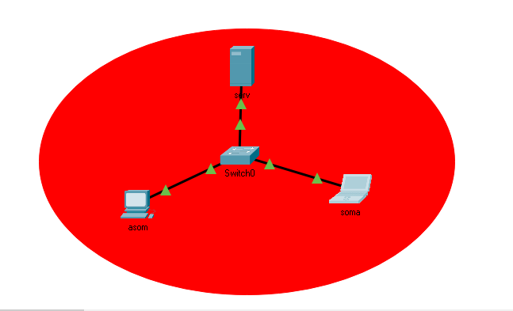

**Step 1:-**

Building that topology .

**Step 2:-**

Go to server >Desktop >Ip configuration

Then putting Ip address and subnetmask

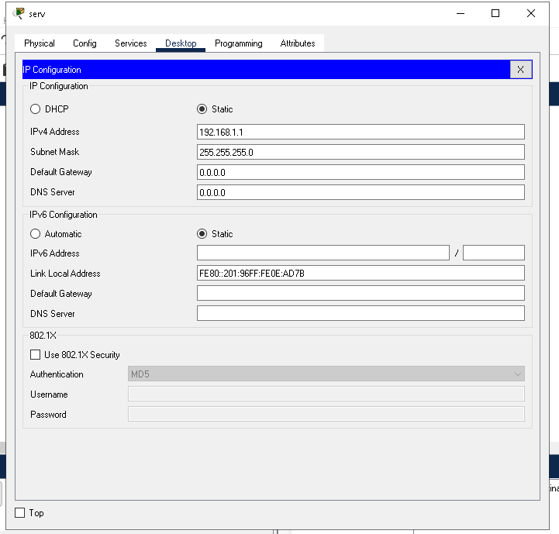

**Step 3:-**

Go to server >services >DHCP > services on

Then putting default gateway and DNS server

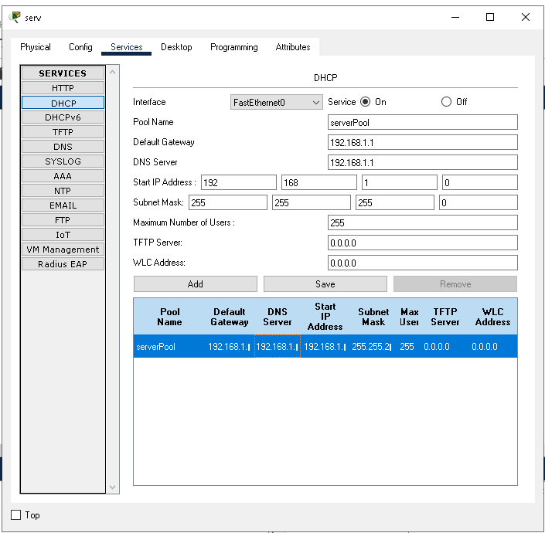

**Step 4:-**

Checking ip address in (asom) and (soma)

asom/soma>Desktop>ip configuration >DHCP (on)

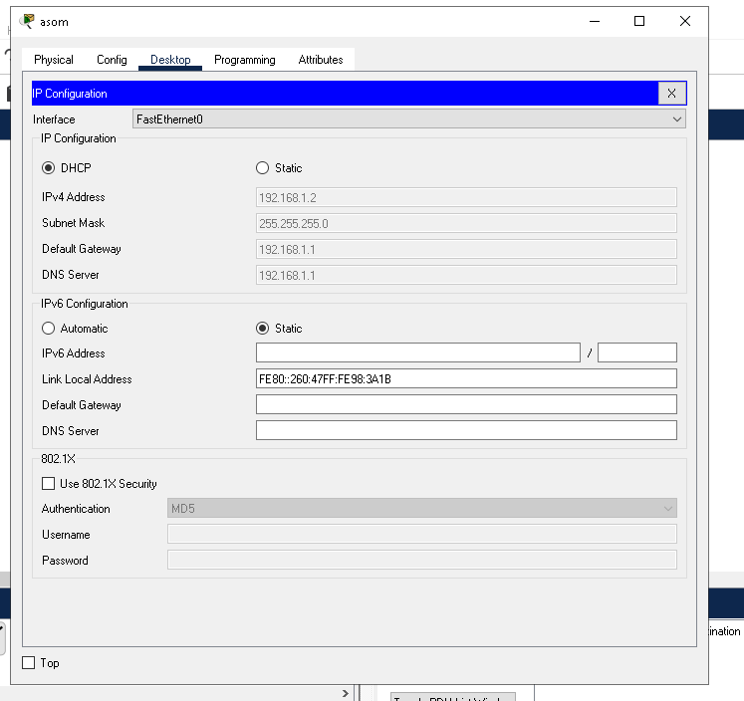

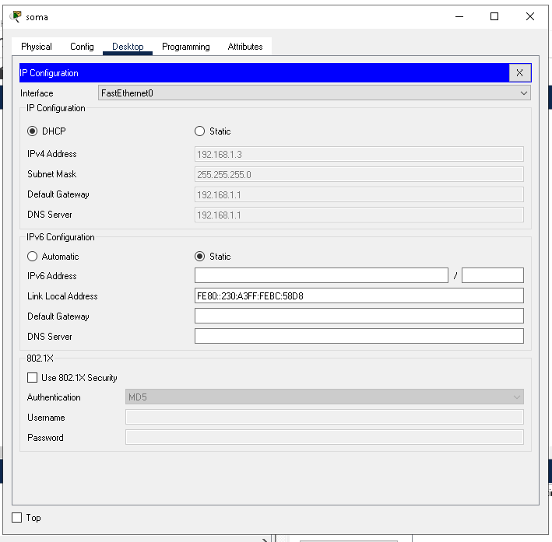

**Step 5:-**

Using domain name by :-

Server >services >DNS > DNS services(on)

Putting name and address of each terminal

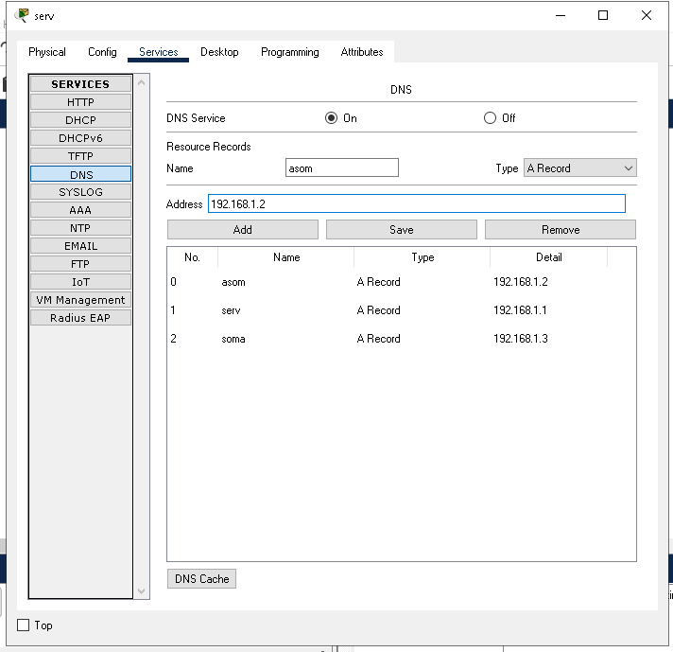

**Step 6:-**

Pinging asom from soma to check connection

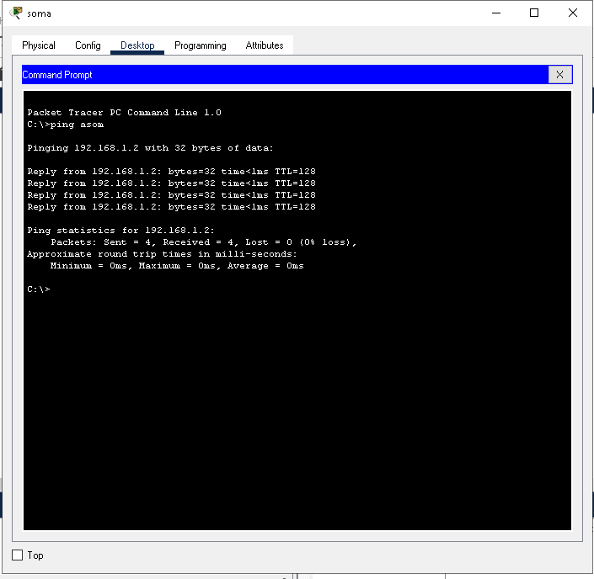

**Good luck**