|  |
| --- |
| 1. **With regard to absorbed doses , which of the following is correct :** |
| 1. A typical absorbed dose for 3 minutes of fluoroscopy screening can be up to 150 mGy.* |
| 1. A typical absorbed dose for a PA chest film is 0.015 mGy. |
| 1. Absorbed doses are normally lower than effective doses |
| 1. The typical absorbed foetal dose of a barium enema in a pregnant patient is higher than the typical absorbed adult dose of AP abdomen. |
| 1. The Typical Absorbed Dose Of A Lateral Lumbar Spine Is 12mGy. |

|  |
| --- |
| 1. **Regarding staff protection, the following is true :** |
| 1. 12 cm of solid brick will provide equivalent protection of 1 mm of lead. |
| 1. An under-couch tube is preferable to an over-couch tube.* |
| 1. Lead aprons generally provide equivalent protection of 2.5–5 mm lead. |
| 1. Lead aprons will provide adequate protection from the primary beam. |
| 1. Minimising exposure time and maximising distance from the x-tube will reduce the dose. |

|  |  |  |
| --- | --- | --- |
| 1. The following contrast medium is not low osmolar non -ionic monomer: | | |
| 1. Iopamidol ( niopam) | | |
| 1. Iomeprol (lomeron) | | |
| 1. Isovist.* | | |
| 1. Iopromide (ultravist) | | |
| 1. Iohexol (0mnipague) | | |
|  | | The following is not a contraindication of barium enema: |
|  | | 1. Melena.* |
|  | | 1. Toxic mega colon |
|  | | 1. Pseudomembranous colitis |
|  | | 1. Recent rectal biopsy |
|  | | 1. Recent barium meal |

|  |
| --- |
| 1. **Regarding CT of the abdomen the following is not true:** |
| 1. The Normal Density Of The Liver Is 60+/- 5HU |
| 1. The spleen commonly enhances heterogeneously |
| 1. Hepatic parenchyma enhances by around 40 HU during arterial portography.* |
| 1. Peak hepatic enhancement is at 50-70 sec after contrast injection into a peripheral vein |
| 1. Peak hepatic enhancement start 40 secs after injection into the superior mesenteric artery. |
| 1. **In CT scan of the thorax the following is not true :** |
| 1. Air is rarely seen in the esophagus.* |
| 1. Scan is performed in suspended respiration |
| 1. Short scanning time is important |
| 1. The oblique fissure may be seen |
| 1. Filling defect in the SVC are seen frequently in normal patients after contrast enhancement |
|  |
| 1. **One of the following does not indent the barium filled esophagus in the thorax**: |
| 1. Aortic arch |
| 1. Left main stem bronchus |
| 1. Left atrium |
| 1. Azygous vein.* |
| 1. Aberrant right subclavian artery. |

|  |
| --- |
| 1. **In arthrography which of the following is true:** |
| 1. Control film are not usually recommended prior to the procedure |
| 1. Joint effusion is a contraindication because of risk of introducing sepsis |
| 1. Negative contrast medium is absorbed from joint within a few hours |
| 1. Delayed films may be useful in the investigation of suspected loose body.* |
| 1. Adrenaline should not be added to contrast medium |
| 1. **Regarding imaging of the breast which of the following is true:** |
| 1. Ductography involve the injection of 5 ml of a water soliable contrast medium into a dilated duct |
| 1. The nipple should be seen in profile in the standard mammographic views of the breast.* |
| 1. The standard mammography film series comprises a cranio-caudal view and straight lateral view of each breast |
| 1. Ultrasound should be performed with a low frequency 3,5 mhz tranducer |
| 1. Compression should not be used during mammography when cysts are suspected. |
| 1. **Regarding angiography the following is not true :** |
| 1. The hole in the vessels wall produced by a 6 french catheter has an area four times larger than that of 3 french catheter |
| 1. Sheath are sized according to the largest sized catheter that they will accommodate |
| 1. Single wall areterial puncture require a two part needle |
| 1. The catheter tip should be positioned about 5-10 cm above the aortic bifurcation in lumber aortography.* |
| 1. The most reliable guide to the position of the common femoral artery for percutaneous puncture is the site of maximal pulsation |

|  |
| --- |
| 1. **Regarding hystrosalpingography (HSG) the following is not true:** |
| 1. It is contraindicated if there is history of untreated salpingitis |
| 1. Pain may persist for up to 1-2weeks after the procedure |
| 1. Venous intravasation can occur |
| 1. Pethidine can be helpful if given as analgesic before the procedure.* |
| 1. It is contraindicated during menses |
| 1. **Maximum density of the nephrogram is dependent on all of the following except :** |
| 1. Degree of dehydration.* |
| 1. Peak plasma level of contrast media |
| 1. Glomerular filtration |
| 1. Renal blood flow |
| 1. Absorption of water and sodium by the proximal tubules |

|  |
| --- |
| 1. **The lordotic view of the chest may be used to demonstrate the following:** |
| 1. The left middle lobe |
| 1. The right middle lobe |
| 1. The left heart border |
| 1. A pericardial effusion |
| 1. The apices of the lungs.* |
| 1. **Regarding barium enema investigation of large bowl the following is not true:** |
| 1. A preliminary abdominal film is never required.* |
| 1. Bowel perforation is more likely if an inflated balloon catheter is used |
| 1. Water intoxication may occur |
| 1. Turning the patient supine with caecum full of barium encourages ileal reflux |
| 1. Over distension of bowel with air may obscure mucosal lesions |

|  |
| --- |
| 1. **The following is true of imaging the pancreas :** |
| 1. Water is an appropriate oral contrast media for CT |
| 1. The pancreas parenchyma enhances maximally during the portal venous phase.* |
| 1. The normal duct measures up to 2mm in diameter in the body of the pancreas on ultrasound |
| 1. The normal duct measure up to 6,5mm at the head of the pancreas at ERCP |
| 1. The number of side branches of the pancreatic duct opacifying at ERCP decreases with age |
| 1. **Regarding Meckel diverticulum radionuclide scan imaging which of the following is true:** |
| 1. Must include stomach |
| 1. The abdomen and pelvis should be imaged |
| 1. A lateral view should be obtained |
| 1. An erect view is helpful.* |
| 1. A post micturition lateral view is the final view. |
| 1. **Which one of the following is not a complication of ERCP :** |
| 1. Allergic reaction |
| 1. Acute pancreatitis |
| 1. Pancreatic pseudocyst.* |
| 1. Rupture of the esophagus |
| 1. Aspiration pneumonitis |

|  |
| --- |
| 1. **The following statement is not true:** |
| 1. In GA 67 scintigraphy uptake within the bowel is often a normal feature |
| 1. Tc 99 tin colloid is taken up in the liver by the hepatocytes.* |
| 1. In colloid scintigraphy focal liver disease may be mimicked by overlying breast tissue |
| 1. In Normal Cholescintagraphy The Gallbladder Should Be Visualized By 1hr |
| 1. Tricyclic antidepressant should be stopped prior to a radionuclide m-iodobenzyl guanidine (MIBG) scan for pheochromocytoma |
| 1. **Generalized convulsions following injection of contrast media can be treated with :** |
| 1. Adrenaline |
| 1. Valium.* |
| 1. Calcium gluonate |
| 1. Buscopan 2. Vitamin D high dose. 3. **W20- Which of the following statements is correct?**   (a) The supraspinatus tendon passes above the acromion process.  (b) The clavicle has a medullary cavity.  (c) The rhomboid fossa marks the site of origin of the costo-clavicular ligament. *  (d) The clavicle is the last bone to ossify.  (e) A distance of more than 5 mm between the humerus and the acromion indicates likely supraspinatus tendon impingement.   1. **Rr21- Regarding the upper limb which of the following statements is false:**   (a) The radial groove is situated in the humerus.  (b) The capitulum articulates with the ulna. *  (c) The ligament of Struthers may compress the median nerve.  (d) The capitulum is the first secondary ossification center to appear in the elbow.  (e) A prominent posterior fat pad in a lateral radiograph of the elbow is seen in cases of joint effusion.     1. **C222- Concerning the wrist and carpus, which of the following statements is false:**   (a) The mid-carpal joint does not communicate with the radiocarpal joint.  (b) On a lateral wrist radiograph the distal radius has a slight volar tilt.  (c) The lunate articulates proximally with the radius and distally with the capitate.  (d) The flexor retinaculum is attached to the pisiform, hook of hamate, scaphoid tubercle and ridge of the trapezium.  (e) Flexor carpi-radialis attaches to the pisiform. *  **23- In skeletal imaging which of the followings is false:**  (a) Phased array surface detection coils greatly improve the signal to noise ratio in MRI of bone joint and soft tissue.  (b) Abnormalities of cortical bone and calcification are usually not detected by MRI.  (c) Meniscal abnormalities of the knee are demonstrated on T2- weighted scans better than T1.  (d) A fat fluid level within the suprapatellar bursa of the knee indicates a fracture.  (e) Bone scans using 99mTc MDP are very specific for pathology. *   1. **In the lower limb, which of the following statements is correct:**   (a) The rectus femoris arises from the anterior superior iliac spine.  (b) Gracilis, sartorius and semitendinosus insert into the medial condyle of the tibia. *  (c) The adductor magnus inserts along the linea aspera, the medial supracondylar line and the adductor tubercle of the lateral femoral condyle.  (d) The adductor hiatus interrupts the distal attachment of the adductor longus muscle  (e) The biceps femoris attaches to the lateral condyle of the femur   1. **In the knee joint, which of the followings is false:**   (a) The synovium lining the joint is extracapsular. *  (b) A Baker’s cyst is an inflamed or swollen medial gastrocnemius – semimembranosus bursa.  (c) The lateral collateral ligament is separated from the capsule by the popliteus tendon.  (d) The anterior cruciate ligament passes from the anterior intercondylar area of the tibia to the medial surface of lateral femoral condyle  (e) The medial collateral ligament is a flattened band that blends posteriorly with the fibrous capsule.   1. **Concerning Electrons, which of the followings is correct:**   a. In the Bohr model of atomic structure electrons orbit the nucleus *  b. The electron has +1 charge  c. The binding energy of the L-shell is higher than the K-shell  d. The K-shell can hold 20 electrons  e. Electrons have a greater mass than protons   1. **Regarding the cathode of the X-ray tube, which of the followings is false:**   a. Is commonly made of tungsten  b. Has a high melting point  c. Has a high resistance  d. Is positively charged in relation to the anode *  e. Can exceed temperatures of 2200°C   1. **Concerning the anode, which of the followings is correct:**   a. It is positively charged relative to the cathode *  b. Molybdenum is used in most X-ray tubes  c. Rhodium is often added to tungsten to reduce pitting and cracking that can be caused by overheating  d. The distance between the cathode and anode affects the quality of the X-rays produced  e. 90% of the energy from the electrons striking the anode is dissipated as heat   1. **Regarding pediatric radiology, which of the followings is false:**   a. Grids with a ratio higher than 1:8 should not be used  b. Immobilization may be required  c. High-attenuation materials such as carbon fiber should be used for table tops *  d. The risk from X-rays to children is greater than in adults  e. Additional filtration may be required   1. **Concerning imaging of the ankle and foot, which of the followings is correct:**   (a) Bohler’s angle is usually about 18° normally.  (b) Congenital tarsal coalitions are best visualized using oblique radiographs with the foot internally rotated.  (c) On ultrasound, tendons are echo poor.  (d) In the AP view of the foot the medial margin of the base of the second metatarsal should be in line with the medial margin of the intermediate cuneiform. *  (e) A fracture through the base of the fifth metatarsal is usually longitudinal to the long axis of the metatarsal.   1. **In the normal wrist: which of the following statements is false.** 2. The scaphoid and the lunate articulate with the distal radius. 3. The scaphoid and the lunate articulate with the head of the capitate. 4. The pisiform articulates with the anterior surface of the triquetrum. 5. The trapezium articulate with the scaphoid. 6. The proximal part of the triquetrum articulates with the trapezium* 7. **Which is the most radiosensitive tissue in adult human”?**   a. Thyroid  b. GI tract.  c. CNS.  d. Gonads *  e. Lung.   1. **Pregnant patient undergoing fluoro. How do you decrease the dose?** 2. take away collimation 3. take away grid * 4. continuous fluoro. 5. Use magnification. 6. Never do fluoro in pregnant. 7. **Which of the followings is responsible for aliasing in ultrasound?**     a) Increased acoustic impedence.  b) Attenuation.  c) Refraction from erythrocytes.  d) Insufficient temporal sampling. *  e) Poor beam focusing.   1. 35- **Regarding the esophagus, which is false:** 2. a. Begins at the level of C6.   b. Receives a blood supply from the inferior thyroid artery.  c. Drains to the left gastric nodes from its abdominal portion.  d. Passes through the diaphragm at the level T10.  e. Is related to the right atrium.*   1. 36- **Regarding the diaphragm, one is true:**   a. Both crura arise from the upper three lumbar vertebrae.  b. The caval hiatus is the lowest and most posterior.  c. The esophageal hiatus transmits the esophagus and vagus nerves only.  d. It arises in part from slips from the lower six costal cartilages.*  e. The blood supply arises solely below the diaphragm.  **37- The abdominal aorta, which is false:**  a. Gives origin to the inferior mesenteric artery at the level of L2.*  b. Lies to left of the cisterna chyli.  c. Gives the celiac artery as an anterior branch.  d. Gives origin to the superior mesenteric artery at the level of L1.  e. Divides into the common iliac arteries at the level of L4.   1. **38- Regarding origin of abdominal arteries, one is correctly matched (branch – origin):**   a. Left gastric artery - hepatic artery.  b. Right gastric artery - coeliac trunk.  c. Left gastroepiploic artery - splenic artery.*  d. Superior pancreaticoduodenal artery - superior mesenteric artery.  e. Middle colic artery - inferior mesenteric artery.   1. 39- **One of the following statements is false:**   a. The median umbilical ligament passes from the bladder to the umbilicus.  b. The lateral umbilical ligaments are the obliterated umbilical arteries.  c. The ligamentum teres is the remains of the left umbilical vein.  d. The quadrate lobe of the liver lies medial to the gallbladder.  e. The ligamentum arteriosum connects the aortic arch to the right pulmonary artery.*  **40- Regarding the peritoneum, which is false:**    a. It is a closed sac in both male and female.*  b. The greater and lesser sacs communicate through the epiploic foramen.  c. The flow of peritoneal fluid is directed in a cephalad direction by the negative intra-abdominal pressure generated in the upper abdomen by respiration.  d. The transverse mesocolon and transverse colon divide the peritoneal cavity.  e. The root of the transverse mesocolon extends from the infra-ampullary segment of the duodenum through the head and along the lower edge of the body and tail of the pancreas.  **41- Regarding the stomach, which is false:**  a. The fundus is the area above the gastro esophageal opening.  b. The “magenstrasse" is a line of gastric rugae running along the greater curve.*  c. Areae gastricae are approximately 2-3 mm nodules seen in the gastric antrum on barium meal examination.  d. The gastric antrum is the area between the incisura and the pylorus.  e. The splenic flexure of the colon forms part of the stomach bed.  **42- Regarding the large intestine, which is false:**  a. The gas-filled large bowel on plain radiographs demonstrates the haustral pattern of incomplete septations.  b. In Chilaiditi syndrome there is hepato-diaphragmatic interposition of the colon.  c. The upper third of the rectum is covered in front and on both sides by peritoneum.  d. The rectum is supplied by branches of the internal iliac artery.  e. There is a portosystemic anastomosis between the middle and inferior rectal veins.*  **43- The followings are entirely retroperitoneal, except:**  a. Duodenum.*  b. Rectum.  c. Abdominal aorta.  d. Descending colon.  e. Kidneys.  **44- Regarding the segments of the liver, which is true:**  a. The caudate lobe is segment IV.  b. Segment V is directly related to the diaphragm.  c. Segment Ill lies to the right of inferior vena cava.  d. Segment Vll receives blood from the right portal vein.*  e. The quadrate lobe corresponds to segment VI.  **45-Regarding the gall bladder, which is false:**  a. The cystic duct passes anterior to the right hepatic artery.  b. On ultrasound, the neck of the gall bladder and the cystic duct are echogenic.  c. The Phrygian cap is the fundus folded back upon the body of the gall bladder.  d. The gall bladder indents the posterior aspect of the first part of the duodenum.*  e. Lymph drainage mainly follows the common bile duct to the liver.  **46- Regarding the pancreas, which is false:**  a. It has the transverse mesocolon attached to its anterior surface.  b. The body slopes upward to the left.  c. It develops from a ventral and dorsal bud.  d. It has peritoneum covering its anterior and posterior surfaces.*  e. The head lies over the inferior vena cava at the level of L2.  **47- Regarding the spleen, which is false:**  a. May normally be identified on a plain abdominal film.  b. Is invested in peritoneum.  c. Is related to the tail of the pancreas.  d. Receives its blood supply via the gastrosplenic ligament.*  e. Lies on the phrenicocolic ligament.  **48- Ring artifacts in CT are most likely caused by:**  a. Beam hardening.  b. Metallic implants.  c. Faulty detectors.*  d. Patient motion.  e. Scattered x-rays.  **49- Stochastic effects of radiation include:**  a. Epilation.  b. Sterility.  c. Carcinogenesis.*  d. Cataracts.  e. Erythema.  **50-Effective dose of PA chest X-ray is:**  a. 0.02 mSv.*  b. 0.7 mSv.  c. 2 mSv.  d. 4 mSv.  e. 7 mSv.  **51- Which one of the followings is a “non-ionic dimer” iso-osmolar iodine-based contrast media:**  a. Diatrizoate (Gastrografin).  b. Ioxaglate (Hexabrix).  c. Iopromide (Ultravist).  d. Iohexol (Omnipaque).  e. Iodixanol (Visipaque).*  **52- Contraindications to barium meal include:**  a. Failed upper gastrointestinal endoscopy.  b. Gastro-oesophageal reflux disease.  c. Partial obstruction.  d. Complete large-bowel obstruction.*  e. Suspected malrotation in young children.  **53- Regarding lung biopsy, pneumothorax rates increase with all of the followings, except:**  a. Inexperienced operators.  b. Fine needle aspiration compared to core biopsy.*  c. The number of passes.  d. Crossing fissures.  e. larger bore needles.   1. **In MRI imaging which of the following is not true about T1 weighted imaging:** 2. **Fat signal is bright** 3. **Fluid signal is dark** 4. **T1 imaging tends to have short TE and short TR times** 5. **Melanin appears dark \*** 6. **Slow flowing blood appears bright** 7. **Which of the following is not true regarding diffusion imaging:** 8. **It should be part of a routine MRI of the brain protocol** 9. **It helps differentiate acute from chronic infarcts** 10. **It helps differentiate epidermoid cyst from arachnoid cyst** 11. **It helps differentiate abscess from necrotic tumors** 12. **The easier water molecules can diffuse in a region the brighter the signal \*** 13. **Regarding Cranial Nerves, which of the following is false:** 14. **The oculomotor (CNIII) and trochlear nerves (CNIV) originate from the midbrain** 15. **The olfactory nerve is originates from the telencephalon and is considered an extension of the CNS** 16. **The Optic nerve originates from the dienephalon and is considered an extension of the CNS** 17. **The trigeminal nerves, facial nerves and vesitiblucochlear nerves are found in the internal auditory canal \*** 18. **The vagus nerve originates from the medulla** 19. **Which of the following is not a branch of the external carotid artery?** 20. **The superior thyroid artery** 21. **The lingual artery** 22. **The middle meningeal artery** 23. **The ophthalmic artery \*** 24. **The posterior auricular artery** 25. **Which of the following is not considered part of the basal ganglia?** 26. **The red nuclei \*** 27. **The caudate nuclei** 28. **The lentiform nuclei** 29. **The subthalamic nuclei** 30. **Globus pallidus** 31. **Which of the following is not an arterial branch of the middle cerebral artery?** 32. **Anterior temporal artery** 33. **Medial lenticulostriate artery** 34. **Orbitofrontal artery** 35. **Ophthalmic artery \*** 36. **Lateral lenticulostriate artery .** 37. **Which statement about the borders of the epiploic foramen is correct?**   a. The second part of the duodenum forms the inferior border.  b. The quadrate process of the liver forms the superior border.  c. The hepatic vein forms the posterior border.  d. The free edge of the greater omentum forms the anterior border.  e. The common bile duct is contained within the anterior border*  **61- Which of these statements about the coeliac trunk is not correct?**  a. It supplies the foregut and its derivatives.  b. It leaves the aorta at the level of L1.*  c. It gives a left gastric branch that supplies the esophagus.  d. It gives a splenic branch.  e. It gives rise to the gastroduodenal artery via its hepatic branch.  **62- Which statement best describes the blood supply of the stomach?**  a. It is derived entirely from the superior mesenteric artery.  b. The gastroepiploic arteries supply the lesser curvature.  c. The right gastric artery is a direct branch of the coeliac axis.  d. The left gastroepiploic artery arises directly from the coeliac trunk.  e. The short gastric arteries arise from the splenic artery.*  **63- Which statement best completes this sentence? The superior mesenteric artery:**  a. Supplies the gut from the pylorus to the terminal ileum.  b. Arises from the aorta at the level of L1.*  c. Runs in front of the body of the pancreas.  d. Crosses the second part of the duodenum.  e. Supplies the appendix via its right colic branch.  **64- Which of the following statements about the duodenum is incorrect?**  a. The second part overlies the right kidney.  b. The transverse mesocolon attaches over the second part.  c. The ampulla of Vater lies in the third part.*  d. The inferior vena cava and aorta lie directly behind the third part.  e. The gall bladder overlies the first part.  **65- Which of these statements regarding Meckel’s diverticulum is correct?**  a. It is found in about 4% of the population.  b. Is always found on the antimesenteric border of the ileum.*  c. Is usually about 2 cm in length.  d. Is usually located about 20 cm from the ileocaecal junction.  e. Is usually attached to the umbilicus.  **66- Which statement about the fascia of the kidney is true?**  a. The suprarenals lie in the same fascial compartment as the kidneys.  b. The renal fascia is continuous with fascia over the inferior vena cava and aorta.*  c. The perinephric fat lies outside the renal fascia.  d. The lienorenal ligament is attached to the right kidney.  e. The perinephric fat lies deep to the true capsule of the kidney.  **67- What is the most dependent space of the abdomen in the supine patient?**  a. Morison pouch.*  b. Pouch of Douglas.  c. Left paracolic gutter.  d. Right paracolic gutter.  e. Lesser sac  **68- What is the most important anatomic in the pediatric upper GI examination?**  a. Gastric fundus.  b. Duodenojejunal junction.*  c. Pyloric channel.  d. Gastric channel.  e. Gastro esophageal junction.  **69- What is the best test for the diagnosis of malrotation?**  a. UGI examination.*  b. Ultrasound  . c. CT.  d. MRI.  E. Abdominal x ray supine and erect.  **70- The left lobe liver includes which segments?**   1. 2, 3, 4.* 2. 1, 2, 3, 4 3. 5, 6, 7, 8 4. 3, 4, 5, 6 5. 1, 2, 7, 8   **71- The venous drainage of the caudate lobe is into which structure?**   1. Left hepatic vein 2. Middle hepatic vein 3. Right hepatic vein 4. Inferior vena cava.* 5. Portal vein   72- **The portal vein is formed from confluence of which veins?**   1. Splenic vein and inferior mesenteric vein 2. Splenic vein and superior mesenteric vein.* 3. Splenic vein and gastric vein 4. Superior mesenteric vein and inferior mesenteric vein 5. Splenic vein and inferior vena cava.   **73- Concerning the hepatic arteries, the following is true:**:  (a) The common hepatic artery usually lies to the left of the common bile duct and posterior to the portal vein.  (b) The right hepatic artery usually crosses the common hepatic duct anteriorly.  (c) The middle hepatic artery supplies the caudate lobe.  (d) The left hepatic artery supplies the left lobe segments.*.  (e) In approximately 25% of individuals the entire hepatic arterial supply arises from the superior mesenteric artery (SMA)    **74- Regarding the blood supply to the pancreas, the following is not true:**  (a) The retroduodenal artery forms an arcade to supply the posterior surface of the entire duodenum and part of the pancreatic head .  (b) The inferior pancreatico-duodenal artery may arise from a proximal jejunal artery  (c) The transverse pancreatic artery may arise from the anterior superior pancreatico-duodenal artery  (d) The blood flow in the arterial tree is usually multidirectional because of numerus anastomosis.  (e) The majority of the blood supply to the pancreas is derived from the dorsal pancreatic artery.*  **75- The superior mesenteric artery (SMA), the following is false:**  (a) arises from the anterior surface of the aorta at about the level of L1.  (b) gives rise to the dorsal pancreatic artery.  (c) gives rise to the middle colic artery inferior to the uncinate process.  (d) gives rise to the right colic artery in a third of individuals.  (e) gives rise to the inferior pancreatico-duodenal artery in the majority of cases.*  **76- Regarding the portal venous system, the following is false:**:  (a) Direct portography may be achieved by a transjugular transhepatic approach.  (b) The splenic and superior mesenteric vein join to form the main portal vein.  (c) The extra hepatic portal vein lies anterior to the common bile duct.*.  (d) The left portal vein supplies the caudate lobe.  (e) The umbilical (distal) portion of the left portal vein supplies the lateral segments 2 and 3 and the inferior portion of segment 4.  **77- Regarding hepatobiliary imaging, the following is false:**:  (a) CT arterio-portography (CTAP) is undertaken by catheterizing the SMA prior to CT scanning  (b) CTAP enables better delineation of metastases than conventional CT.  (c) In magnetic resonance cholangiopancreatography (MRCP) bile has a high signal.  (d) Magnetic resonance cholangiopancreatography uses heavily T2-weighted sequences.  (e) The liver parenchyma exhibits high signal on MRCP sequences.*  **78- Concerning the liver, the following is not true:**:  (a) It is anterior to the upper pole of the right kidney and suprarenal gland.  (b) On ultrasound it has a slightly increased echogenicity compared with kidney.  (c) The walls of the hepatic veins are sonolucent compared with those of the portal vein and its branches.  (d) The intrahepatic bile ducts are usually clearly seen parallel to the portal vein.*  (e) On non-enhanced CT the liver has a higher attenuation than the spleen.  **78- Regarding MRI, one is true**:  a- T1 recovery time is defined as the time it takes for 100% of the longitudinal  magnetization to recover.  b- Using a long TR (time to repletion) allows saturation to occur which enhances contrast.  c- Fat has a short T1 recovery time.*.  d- Water has a short T1 recovery time.  e- In proton density (PD) image, long TR is sed to allow for saturation to occur to enhance  contrast.  **79- Regarding T1-weighted images, all the following are rue except**:  a- Fat appears as a high signal.  b- Slow flowing blood appears as a low signal*  c- Water appears as a low signal.  d- Typical time to echo (TE) is 10-30ms.  e- Typical TR is 300-600ms.  80- **One of the following answers is not correct:**    a- Bicipital insertion.*.  b- Great tuberosity of humerus.  c- Acromion.  d- Acromioclavicular joint.  e- Antero-inferior glenoid rim.  81**- All the following answers are correct except one**: |

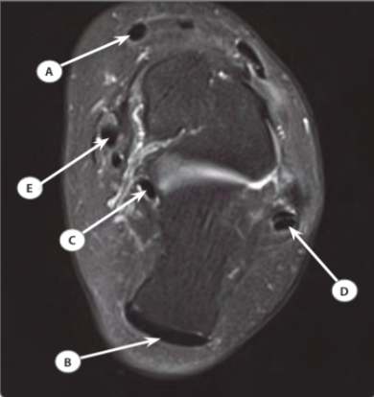

a- Left tibialis anterior tendon.

b- Left Achilles tendon.

c- Left flexor hallucis tendon.

d- Left peroneus previs tendon.*

e- Left tibialis posterior tendon

**82: One of the following answers is false**

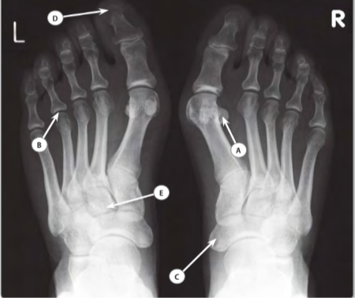

a- Right sesamoid bone.

b- Left fourth metatarsophalangeal joint.

c- Right navicular bone.

d- Tuft of the distal phalanx of the left great toe.

e- Left lateral cuneiform bone.*

**83- One of the following answers is false**

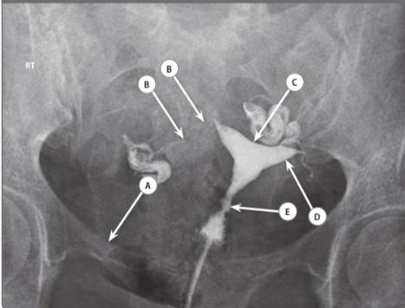

**a- Right inferior pubic ramus.*.**

**b- Isthmus of right Fallopian tube.**

**c- Uterine fundus.**

**d- Left uterine cornu.**

**e- Cervical canal**

**84:** **All the following answers are correct except one**

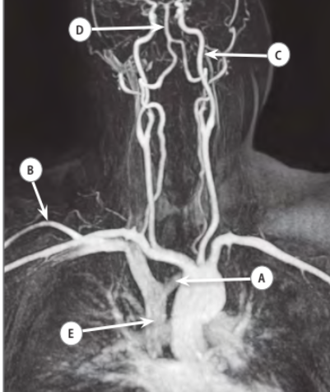

**a- Left sub clavian vein.*.**

**b- Right cephalic vein**

**c- Left internal carotid artery.**

**d- Basilar artery.**

**e- Superior vena cava**

**85-** **One of the following answers is false:**

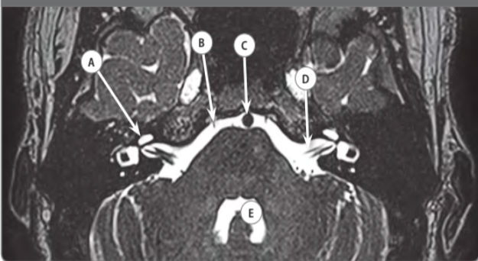

a- Right cochlea

b- Right oculomotor nerve (CN III).*

c- Basilar artery.

d- Left facial nerve (IIV).

e- Fourth ventricle

**86- One of the following answers is false**

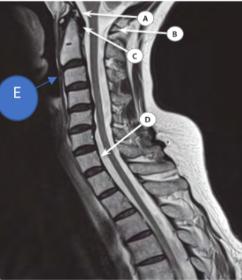

a- Tectorial membrane

b- Posterior arch of C1.

c- Occipito-atlas ligament.*

d- Posterior longitudinal ligament

e- Anterior longitudinal ligament

**87-** **All the following answers are true except one**

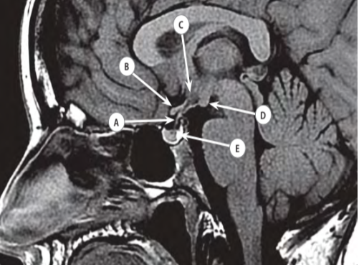

a- Pituitary stalk

b- Optic tract.*

c- Hypothalamus.

d- Mamillary body.

e- Posterior lobe of pituitary gland

**88-** **One of the following answers is false:**

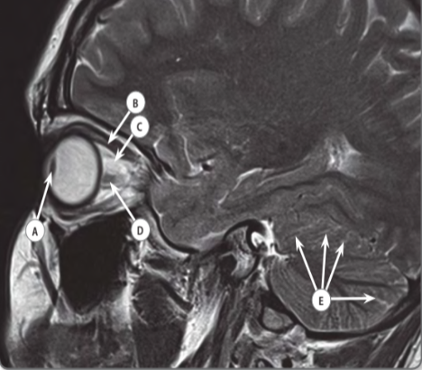

**a- Lens**

**b- Superior rectus muscle**

**c- Superior ophthalmic vein.\***

**d- Optic nerve.**

**e- Cerebellar folia.**

**All the following answers are true except one:89**

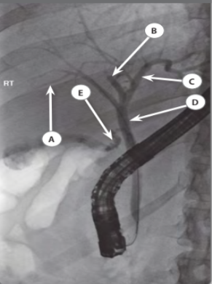

**a**- Right intrahepatic duct

**b**- Right anterior sectorial duct.*

c- Left hepatic duct.

d- Common hepatic duct

e- Cystic duct

**90- One of the following is false**

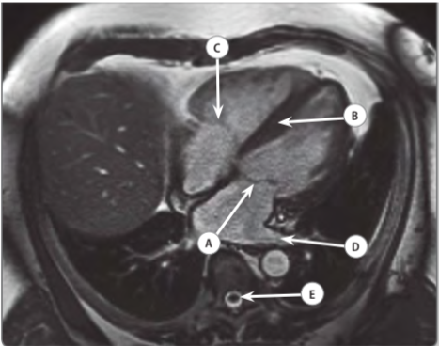

a- Mitral valve (anterior leaflet)

b-. Muscular portion of interventricular septum

c- Tricuspid valve (anterior leaflet)

d- Left superior pulmonary vein.*

e- Spinal cord

**91-** **All the following answers are correct except one**

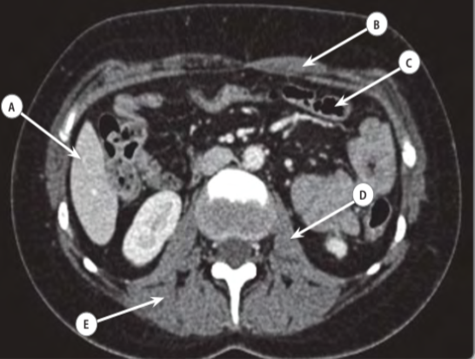

a- Right lobe of liver.

b- Left rectus abdominalis muscle.

c- Transverse colon.

d- Left psoas major muscle.

e- Obturator muscle**.\***

**92-** **59) The following artefacts are manifested as streaks in the image, except one:**

a- Inadequate field of view.

b- Photon starvation.

c- Motion.

d- Cone beam effect.

e- Beam hardening**. \***

**93- In digital subtraction angiography (DSA), one in true**

a- Enhanced vascular structures are seen together with bony and soft tissue structures.

b- The substation is done using a mask image.*.

c- DSA does not require IV contrast administration.

d- The mA used for DSA is the same as that used for normal screening.

e- The main advantage of frame integration is the shorter exposure time

**94- Concerning the Compton effect, one of the following is false**

a- There is interaction between a free electron and a photon.

b- For incident photons of equal energy, more energy is lost from the photon as the scatter

angle increases.

c- High energy radiation undergoes less scattering events than lower energy radiation.*

d- The amount of scattering that occurs depends on the electron’s density of the scattering

material.

e- The larger the angle through which the proton is scattered, the more energy it loses.

**95-Use of a grid normally lead to, except one**

a- The patient gets the same of more scatter due to the higher dose needed when using a

grid.

b- An increase in the exposure latitude of the film screen combination.*

c- An increased to the exposure of patient.

d- A higher mean energy of the beam reaching the film.

e- A reduction of scattered radiation reaching the film

**96-** **Regarding attenuation for an x-ray beam, one of the followings is false**

a- For monochromatic beam attenuation is exponential.

b- The amount of attenuation increases as electron density increases.

c- Throughout the range of 20-100keV a greater proportion of interaction are photoelectric

for soft tissue as compared to bone.*

d- The unit of mass attenuation coefficient is cm (squared) ̸ kg.

e- The half value thickness is the thickness of a substance that well reduce the intensity of the beam by 50%.

**97-** **Regarding ionizing radiation, one of the followings is true:**

a- Beta particles travel through matter in high speeds.*

b- Alpha particles travel through matter at high speeds.

c- Alpha particles are similar o the nucleus of hydrogen.

d- Beta particles are heavier than alpha particles.

e- Alpha particles have useful application in diagnostic radiology.

**98-Regarding the interaction of radiation with the body, one of the following is false**

a- Photons of energy of 40 keV react with soft tissues of the body, predominantly by the

Compton reaction.

b- Bone has a higher effective atomic number than soft tissue for a diagnostic energy range.

c- For given energy and medium in the diagnostic range the actual linear attenuation

coefficient is always higher than Compton linear attenuation coefficient.*

d- The units of the mass energy absorption coefficient are centimeters (squared) ̸ kg.

e- The linear attenuation coefficient is the mass attenuation coefficient divided by the

density.

**99- Stochastic effects of radiation include one of the following**

a- Infertility.

b- Hair loss.

c- Cataract.

d- None of above.

e- Leukemia**.\***

**100- The following are true of signal to noise ratio (SNR) in MRI, one is false**

a- It increases with increasing field strength.

b- The position of receiver coil is important, which must be placed in the transverse plane

perpendicular to the magnet.

c- Increasing TE improves SNR.*.

d- Reducing the receiver bandwidth increases SNR.

e- It depends on flip angle**.**