AIMS AND Goals

Let us start directly by giving a brief explanation of the definition Backup power generating system and its importance in our daily lives, one of the main purposes of that system is to improve the reliability of the power used. That system is restoring so quickly and maintaining the parts of the facilities, campus, territories powered up for minutes, hours, or even days. If the utility power has failed to do its main function for a few seconds, the backup system is operated to reduce the costs of the utility power in some particular cases, the interruptions of the electricity can happen anywhere, anytime and can last for seconds or even hours without a previous warning. This is dreadful thing for food companies, government institutions, hospitals. Because in food companies an entire supply can be thrown out for manufacturing factories, in hospitals we are talking about life and death, for the working companies round the clock the power is so critical and decisive factor. many commercial and public companies are always purchasing the backup power units in order to avoid the losing in time and also losing the contact with customers due to electrical disruptions, if the employees can get back to work as soon as possible and go on with operations, the minimum the hit will be to the bottom line during the power outage. The backup power system also can protect business facilities from theft, and I will explain why, if a power failure happened and extended for a long time, your premises might be exposed to looting and break-ins. The backup system helps and enables you to protect your business from potential intrusions by the feedback of restoring security system and lighting instantaneously. It also can protect your business from weather, as we all know the extreme weather can cause disruptions as well as humidity, freezing and high temperature conditions. It also protects you from hacking, these days the threats from hacking of cybersecurity due to terrorism are so rapidly increasing, so the backup system can ensure you can fight back these threats in case of power fail, also one of its most important advantages is the ability to hedge, to able to transfer a backup power system unlock your business to the option of alternative energy plans that can save you money, let’s take an example, you can find a demand response program that helps you lower the bills as the same as generating income by paying you to minimize or shift the usage of electricity during the peak time. The backup power system can be in different sizes and shapes, with the most popular being natural gas fired or diesel generator that has been installed on site, the facilities of cleaner energy such as biogas, solar panels or wind turbines can also constitute or compose part of the backup energy solution. but the most common thing between all of them is the ability to supply business resilience by ensuring the access of the electricity all the time. One of the most important sectors that desperately needs that kind of a system is the education sector. Colleges, schools, higher learning institutions, all of them have huge educational systems powered by electricity and unfortunately if power failure happens that can lead to great inconveniences, most of the systems include phone networks, lighting, research equipment, fire alarms, ventilation, elevators, data storage, computer networks, cooling and heating. All of them play an integral part to guarantee the comfort and relief of the students as well as the functionality of the educational system, without that important system the school may be obliged to shut down some time of the day due to interruption in the planned studies. That can put the safety of the students in danger and require the school to negotiate with the parents to pick the children early out of the school which can be a real nightmare because of emergency and safety and most of those parents will not be available due to their jobs, for the higher learning institutions the power failure could result in money and time losses for the faculty and students. Most of the important and integral data could be vanish and there will be damages with the vital equipment, it will also be impossible to proceed experiments of time based and power during the outage or even after the restoration of the power.

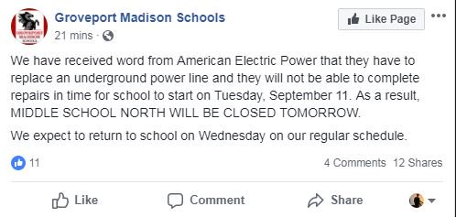

Figure1: a school was to shut down due to a power disrupting.

As we previously mentioned in case of power failure from the utility, buildings depend on the backup power system for both safety and the public health as well as the protection of business facilities which will be an awful disaster if it is suddenly lost due to a power outage. Unexpected crisis usually disrupts the power to hundreds thousands of business and people. Many facilities such as air ports, hospitals, data centers, gas stations, water and sewage facilities, transportation and communication systems need some kind of alternative power to eventually save lives during the case of disasters. The power disrupt to a business facility can cause a significant economic impact, the longer the business in the most need of power, the greater the economic losses, when these unexpected disasters occur, the backup power system provides a source in order to support the equipment loads through uninterruptible power supplies, generators or even battery storage system.

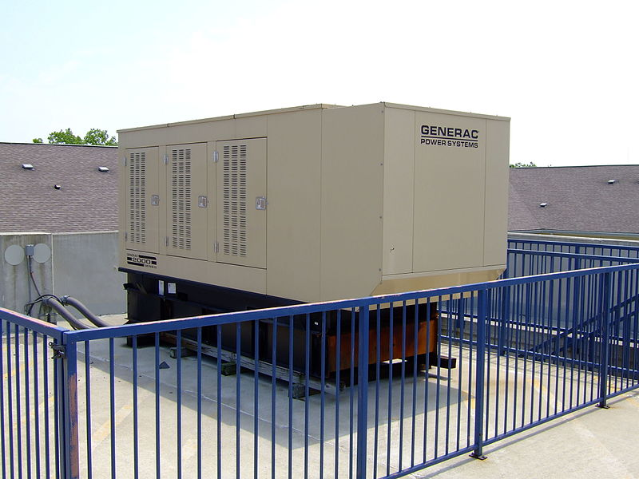

Fig:2 a backup generator for a large apartment building

Now allow me to give you a glimpse about the battery-stored backup power, what is it, and how does it work, it is simply allows you to go on operating lights, refrigerators and many other appliances, fans and communicating during a power disrupt. This system can be connected to renewable sources of energy like the small-scale wind generators and solar panels in order to help the batteries to be charged for a long time during an emergency case, you also have the ability to recharge too many of these battery systems with diesel generators. The time length you need to draw electricity from the batteries you have depends on the battery bank size, the emergency battery backup power of mobile phones can power lights and phones for a relative small period of time for example (700-1500 watt hours), the prewired solar powered battery can supply more power for a long periods of time for example (5000-10000 watt hours). Also the solar power can supply a small part of daily primary power besides backup power in case of emergency, the solar modules and panels are usually installed on the home and work facilities roofs, those solar panels are composed of photovoltaic cells, which can transfer the sunlight into direct current power, then a converter is used to convert it into alternating current power or electrical standard current that we usually use it in our homes or offices.by using solar power we can recharge the battery system, while solar panels are generating during the whole day, any spare energy by the home or office can be stored for use at nights, rainy days or even power outages.

Now we also have an important alternative backup power option and it is the wind power, a very scale wind electric system like the institutional or residential can give a hand to the homeowners or business owners and help the local facilities to get their own energy for onsite use, the small wind turbine can generate energy by the help of wind when the moving air pushes the turbines to rotate, many of the small wind turbines seem to be miniaturized version of the large three bladed turbines utility scale, but we have too many other models have the ability to differ in appearance, the wind electric systems are not used in a wide scale by the public compare to the solar powered systems as too many municipalities do not involve the small wind systems in municipal zoning codes, and that possibly makes installing and permitting the system so costly and difficult.

Another type of the alternative backup power options and it is fuel cells; the fuel cells have the same function such as batteries and can supply the trucks, buses and cars with power, as well as laptops, computers and cell phones and any portable devices, those fuel cells can also supply facilities and buildings with backup power, nowadays the fuel cells are probably fueled with natural gas, they are too much expensive, in the year 2005 the most deployed fuel cells that are used in a wide scale cost approximately 4,500$ per KW, on the contrary a diesel generator used to cost 800$ to 1,500$ per KW. The hydrogen can be used as a fuel to the fuel cells backup power, it can also be supplied and provided in the tanks that will be replaced later after emptiness, a smarter solution would be for the fuel cells to provide its own hydrogen through an electrolysis operation during periods when the electricity is there, and the fuel cell is motionless. A mixture of fuel cell and electrolyzer is possibly referring to as a variable fuel cell, the backup power supply systems generate power at the time the primary power source is stopped. Emergency power generators, telecommunication, information technology services, for all of those applications, the pressurized hydrogen is the most used and applied type of fuel cell, we have too many fuel options just like liquefied hydrogen, compressed hydrogen, natural gas, propane and others. An electrolyzer system is a great choice for the backup power applications because it can give hydrogen if it is requested, the electrolyzer could be powered by the solar panels electricity, wind source, nuclear source or local grid electricity, the fuel cells in the hybrid energy systems can be connected to condensers, photovoltaics, batteries or the wind turbines that are responsible of generating electricity to the primary or the secondary, the fuel cells that are used for the stationary power applications, backup, portable, automotive have been shown. For the fuel cells to be sold at suitable prices, there should be sufficient production of volume in an attempt to drive down the costs, and that’s mean that there must be a large market to satisfy the enough amount of thousands or tens of thousands of units per year and that’s at minimum, however the automotive market has the spare promise of high volume with tens of millions of units per year, the market of backup power is offering a great opportunity for fuel cell trading in its own rights.