C:\Users\مصطفى\Desktop\CY-Near-East-University.jpg

**NEAR EAST UNIVERSITY**

**Faculty of Engineering**

**Department of Electrical and Electronic Engineering**

**ULTRASONIC RADAR SYSTEM**

**Graduation Project Report**

**EE402**

**Student:**

**Lorraine T. Majo (20146348)**

**Mostafa M. Zhlawi (20146266)**

**Mohammad I. Al Zaben (20168007)**

**Oluwakayode O.Abayomi (20144115)**

**Amr B. Elhennaey (20173638)**

**Munir A. Irshed (20174897)**

**Supervisor: Assist. Prof. Dr. Umar Özgünalp**

**Nicosia – 2019**

**ACKNOWLEDGMENT**

We thank GOD who guide us to this success.

We thank our parents for their prayer to GOD to protect and help us.

Six student we meet in Cyprus in near east university coming from different countries speak different languages with different ages some of us 30 years old someone else 22 years .some one of us graduate in four years someone eight years someone nine years.

So we should thank our university for this chance.

We thank our doctors for their effort in technical and guided us to reach our goals.

We thank Dr. Umar Özgünalp our Supervisor in graduation project which help us to write report, doing poster and collect our project.

We thank Assist. Prof. Dr. Ali Serener which help us in EE401 project design 1, he give us a lot of information about the project, guide us to preparing to start working on the project.

Our friend that we meet them in this university and doing a hard work together we thank them for all moment that we spent together.

**i**

**TABLE OF CONTENT**

**ACKNOWLEDGMENT………………………………….………………..i**

**Table of Content……………………………………………………………ii**

**Table of Figure……………………………………………….…………….iii**

**List of Table…………………………………………………..…………….v**

**ABSTRACT…………………………………………………..……….……1**

**1. INTRODUCTION……………………………….………………..……..1**

1.1: AIMS AND GOALS…………………………………………………2

1.2: DIFFICULTIES…………………………………………….………..3

1.3: PROJECTS CONTRIBUTION……………………………….…..…4

1.4: BUDGET…………………………………………………………….6

1.5: TIMELINE…………………………………………………………..8

### 2. LITERATURE REVIEW AND THEORIES USED………….…….…9

2.1: LITERATURE REVIEW……………………………………..………9

2.2: THEORIES USED……………………………………………………11

2.2.1: Raspberry Pi 3 Model B……………………………....……………12

2.2.2: ARDUINO……………………………………………………….…13

2.2.3: ULTRASONIC SENSOR…………………………..………………14

2.2.4: SERVO MOTOR………………………………………………..…18

2.2.5: WEBCAM……………………………………………..………...…20

2.2.6: MONITOR ……………………………………………………….…21

2.2.7: THE WEBSITE………………………………………………..……21

2.2.8: APPLICATION ON SMARTPHONE……………………..….……22

2.2.9: BREADBOARD………………………………………………..……23

2.2.10 POWER PARTS……………………………………………….……24

**3. WORK DONE AND SYSTEM MODEL……………………………….28**

3.1: SYSTEM MODEL AND EXPLAIN…………………………………28

3.2: WORK DONE……………………………………………………..…30

3.2.1: POWER SECTION ……………………………………….………30

3.2.2: PARTS NEED SOFTWARE ………………………………………36

3.2.3: PERFORMANCE TESTING FOR POWER PART…………….….46

ii

**4. CONCLUSION…………………………………………………………..47**

**REFERENCE……………………………………………………...……….48**

**APPENDIX………………………………………………..………….…….50**

iii

**TABLE OF FIGURE**

Figure 1.1: Gantt chart timeline……………………….………..……………8

Figure 2.1: raspberry pi 3 model b……………….…………………….……12

Figure 2.2: Arduino r 3………………………………………………………13

Figure 2.3: Ultrasonic Sensor HC-SR04……………………….……………14

Figure 2.4: sound wave …………………………………………………...…15

Figure 2.5: ultrasonic radar second task …………………….………………16

Figure 2.6: its tower 9 grams……………………………………………...…16

Figure 2.7: pulse that controls servo motor to rotate. ……………….………17

Figure 2.8: web cam…………………………………………………………18

Figure 2.9: small monitor……………………………………………………20

Figure 2.10: tumbler logo ………………………………………………..……21

Figure 2.11: tumbler application for smartphone…………....………………22

Figure 2.12: Breadboard…………………………………………………….…23

Figure 2.13: solar panel…………………………………………………..……24

Figure 2.14: battery 12 v……………………………………….……………25

Figure 2.15: charge controller…………………………………….……………26

Figure 2.16: Step down transformer………………………………….…………27

Figure 3.1: the electromagnetic spectrum……………………………………28

Figure 3.2: shows the transformer that using in the circuit. …………………31

Figure 3.3: shows the circuit of the full-bridge rectifier………………….…33

Figure 3.4: shows the idea of getting a smooth voltage………………….….34

Figure 3.5: regulator to give a fixed output voltage………………………….34

Figure 3.6: regulator to using a fixed output voltage………………………….…35

Figure 3.7: connect with the project……………………………………….…39

Figure 3.8: tumbler website…………………………………………………...41

Figure 3.9: tumbler smartphone application………………………….………43

iv

**LIST OF TABLE**

Table 1.1: Table for Budget………………………………………………….6

**ABSTRACT**

As the world continues to develop in many areas such as military, private and governmental properties, homes and other industries need for security is increasing. In previous years people have used methods such security dogs, human security, electric fencing etc. These methods which are more costly and less reliable had to be improved.

Radar is a system that uses electromagnetic waves to determine speed range and angle of both moving and stationary objects. Instead of electronics waves, we use ultrasonic waves hence it is called ultrasonic radar system. Radar has been in use for quite a long time and continues to grow

**1: INTRODUCTION**

While these words are written, the huge progress and development are going so fast trying to find the most comfortable ways for the humans on this earth. These ways include the type of saving that enables everyone's needs to be guaranteed and how to use technology to feel more secure. So the topic of our proposal will be about ultrasonic radar and how it effects on people's lives.

Human labour has been used to watch over prohibited areas to avoid trespassers (animals, human or objects).However, over large areas, human labour can be expensive, less effective and sometimes not reliable as humans are prone to errors

Well, ultrasonic radar is an electronic device that uses the electromagnetic waves to measure the distance between the bodies in the surrounding area and gives an alert to the user to be attentive to what is going on.

The system uses ultrasonic waves to detect objects, in this case, unauthorized access by animals, human or simply objects. It gives details about the targeted object, the range, direction, speed, photo of the intruder. It then alerts the responsible authorities through an alarm or LCD display.

Details of intrusion photo of intruder, date and time of intrusion as well as the coordinates of each intrusion are recorded on an online event log. The intrusion history is kept for analysis so as to see how the intruder gained access and to fix the vulnerability allowed the intrusion.

The most important component is the ultrasonic sensor which works by sending waves using a transmitter and receives it using a receiver. This type of sensors has improved in the last few years in a new way that helped to increase the number of application that can use this device.

The design on the ultrasonic radar for object detection system uses ultrasonic waves to detect distance, angle, and position on both moving and fixed objects. The system monitors a limited area of about up to the 40cm non-contact distance, which alerts authorities by a buzzer as the alarm and details about the intruder are then displayed on the monitor.

The system is basically an Arduino-Uno circuit that is connected to an ultrasonic sensor which is on a servo motor which controls the movement of the ultrasonic sensor. The sensors send high-frequency waves (50 kHz-60 kHz) and receive the echo.The sensors determine the distance by calculating the time interval between sending the signal and receiving the echo. Our project has been advanced by adding a camera which can take a photo or video and send it to the user regardless of how far the user is. This type of projects has been used widely in many aspects of the individual's life or the industrial fields also in the military uses to detect the enemy's weapons.

**1.1: AIMS AND GOALS**

The main goal of this project is to design and build a reliable ultrasonic radar surveillance system that detects and report unauthorized access by objects, human beings or animals. By making use of ultrasonic sensors that have a coverage of 180 degrees, when an intrusion is detected, a photo of the trespasser, angle and specific coordinates of the position of the intruder are then sent to the responsible authority's screen. An online log of events that contains further details of the intrusions is recorded for further analysis so as to prevent further intrusions.

. The system should perform at high speed thus it should respond fast by reducing stage delays and optimize the microcontroller's software code. Reduce the number of components that can be so it is as minimum as possible yet accurate. The whole system should occupy the minimum area. It should consume minimum power for the overall system

The system should be run and tested on a small area. Have the system on the lowest cost budget as possible thus the system should be cost-effective. So there are many tasks to apply to build this project. To assemble this project, the tasks were divided into 6 different parts which are as follows

1. Overall circuit design and analysis.
2. Servo motor and ultrasonic module control.
3. Camera control for taking a snapshot of the intruder and video streaming to a screen.
4. Power supply to the system. The primary source of power supply will be the mains. In the case of mains failure, the system should continue its operation from solar panels for a backup time of 2 hours.
5. Sending photo and location information of the intruder to a mobile phone.
6. Online event log (e.g. time, date, coordinates, photo) of intrusion history. The log should be able to show the last 200 intrusions.

These previous tasks by adding together will help to finish this project with the high result and by doing it in the high performance as possible.

**1.2: DIFFICULTIES**

Whenever you are creating or designing something in life, nothing will be perfect at the beginning. You will always face troubles and difficulties. The major difficulty that can be faced when planning and designing this project is that we are not 100 % sure that the plan is going to work out properly.

The aim is to create a perfect surveillance device however will face some hiccups here and there. First off this is a group task hence different members have different schedules making it more difficult for each one to complete their task as we are all depending on each other’s task to complete our individual tasks.

The ultrasonic sensor uses sound waves to determine the distance, the speed of sound determines the accuracy but it is affected by temperature and relative humidity of the air. Although sensors work in most conditions, extreme conditions such as water and built up dirt can result in incorrect readings

Most of the components needed for the system are not available in North Cyprus meaning they have to be imported from other countries, this is an issue as it is going to take time for the products to be shipped in and there are high risks of delay of arrival of the components. And in worst scenarios, the products can get lost causing more delay and expenses. As a group project of different individuals in cooperating everyone’s views was a challenge and having everyone cooperate such as when we held meetings for discussion and putting together the project was hectic as each one would submit components in their own time.

Being not familiar with this area, most of the work done depended on intense research and analysis of previous work done by others on this particular system. So much time was consumed trying to study and analyse the materials and writings so as to choose the best fit for an improved outcome.

Our greatest challenge was to program the system as we had little knowledge about programming and its languages, this took us time to learn and how to pick the best programming language that is suitable for the Arduino or the raspberry pi that it's going to use as a microcontroller for the project. The website design also requires coding, is not well versed in coding this will be challenging.

Some components gave errors, others were faulty and as a result, we had to buy extra components, as being an online purchase the process was frustrating as they would not respond and others were reluctantly resulting in delays. The most difficult stage when assembling any project is how to make the parts to interact with each other in the project and make a good combination between each element.

Beside that how to keep balance between the function of the sensor and the function of the camera that has to rotate between the angles o and 180 to take a photo or a video to send it to the user or the website In this case the power supply system has to work all the time without any interrupting to give the best results.

**1.3: PROJECTS CONTRIBUTION**

Safety and security have been our primary concern since ages. For the past years, different control systems have been designed to prevent access to unauthorized users to private property. Since the existence of radio detection and ranging many developments have been made and its use has spread to navigation and positioning, target detection and tracking for example in wildlife researches and energy optimization.

The ultrasonic Radar system has a lot of benefits to society. In each and every society there are people who break into other people's homes stealing their property. This system helps to reduce cases of theft it peoples home and commercial places like industries as it alarms if there is an intrusion into space. As it captures the image of the intrusion it makes it easy for the authorities to track the culprits. This creates a crime-free environment.

In the design of this project, we are going to include online event as mentioned before which will be the database to store previous events of intrusion are kept on an online website, this helps to analyse how where and when the intrusion occurs there by taking necessary steps to improve the system. This system is environmentally friendly as sensors are easy to use and not dangerous to use during an operation to the nearby object. The Ultrasonic Radar project will not occupy a lot of space as it relatively small.

Driving these days is now not as easy as many cars drive side by side heading in the same direction and changing lanes it's not an easy thing especially in this situation. Cars do have mirrors but mirrors have a portion of the area which they do not cover which is known as the blind spot. With the application of ultrasonic radar, it makes it easy for drivers to know if there another car beside enhancing them to make better decisions and focusing more forward.

Currently, ultrasonic radar systems are used in vehicles as the safety system to reduce accidents such as collisions. As the population is increasing day by day the traffic density is increasing mostly in the urban areas and parking is becoming trick and doing a small error of being in contact with another parked car or a hidden object can result in unwanted expenses. So the good news is that this can be avoided by implementing Ultrasonic radar system by using ultrasonic parking assistance which actually cost little than repairing an accident damaged car. This is really a great feature as the sensors monitor the vehicle’s surroundings which act in an emergency.

With this self-driving vehicles that are not only going to be make traveling comfortable but also provides safety for both passenger and the vehicle. It's a low-cost security system compared to having humans physically guarding and watchdogs as the components are affordable, it offers 24/7 service hence it is more reliable. It can dictate many intrusions at the same time, unlike human labor.This technology can be applied to various areas like measuring wind speed, control tank fullness as well as speed through air and water.

This project as mentioned before focuses on Arduino based ultrasonic radar which is more economical compared to other systems as it drastically reduces power consumption hence makes it a cheaper and an effective contactless surveillance system. Having a rise in the rate of crime and insecurity, there is a need for the design of a system that will take adequate measures, this project is going to meet these demands by the use of physical components like and Ultrasonic sensor that are highly accurate when operating.

There are many contributions from using this type of projects by using it improve the quality of security in the people’s life or in the industrial field also in the disabilities’ people life by adding some helping to make their life easier by designing some robots based on the idea of using the ultrasonic sensor radar to be like an assistant also for the elder people that they are living alone to introduce some help for them.

Another one by using it decrease the number of accidents on the high ways by observing the high-speed cars that pass the allowed speed by recognizing the plats to put a fine on them to keep other's people life safe. In the military services, it helps to improve the defenses for the army by catching the intruding aircraft or rockets through the civilian casualties also that helps to save a lot of lives from killing.

Another one that we can add here the amazing effort that has started in the agriculture field by using the ultrasonic sensor to work as a spray the crops during the time of growing. In the industrial field like the heavy machine factories, it has used for the controlling of

The system is environmental friendly they do not pose harm to a nearby object, people or equipment.It is user-friendly one does not have to have complicated knowledge to use this system.

Due to the high frequency, high, penetrating power and sensitivity. The system proves to be the most accurate method compared to other methods of measuring the distance to parallel surfaces and thickness of objects. It can capture a lot of invasions simultaneously as it has no downtime and processes the captured data at the same time.

The system proves to be more efficient as it is not affected by the transparency or the color of the object so they don't affect the readings of the sensors as the ultrasonic sensor reflects the sound off of objects.The other benefit is that they can operate in dark places. The ultrasonic radar is not affected by dirt, dust or areas with high moisture content which makes it easy to be used in almost every environment.

This ultrasonic radar system is going to have a backup solution so that if there is a power cut of the mains power supply the system will continue to work without stopping since it is designed including an uninterrupted power supply data will be collected continuously without stopping so no information is going to miss. Hence all the data analysis will be accurate.

**1.4: BUDGET**

The table below shows the budget for the whole project. The table clearly states the name of each item and a brief description of the specific type of the item and the quantity of each item needed and the total cost.

Table 1.1: Table for Budget [2]

|  |  |  |  |  |  |
| --- | --- | --- | --- | --- | --- |
| No | Item | Explanations | Quantity | Cost per item | Total cost |
| 1 | Raspberry pi3 | Microcontroller | 1 | 55.5$ | 55.5$ |
| 2 | Solar panels  20*20 cm | Charge battery  To save power as  A spare source | 2 | 17$ | 34$ |
| 3 | Battery | Save the power  Come from solar  Panels 5v | 4 | 6$ | 24$ |
| 4 | Cables | Make  Connections  between parts | 13 | 1.5$ | 19.5$ |
| 5 | Diodes | For making a bridge rectifier | 4 | 0.5$ | 2$ |
| 6 | Resistances | For bridge and  transformer | 20 | 0.25$ | 5$ |
| 7 | Capacitors | For transformer  And make balance | 8 | 1$ | 8$ |
| 8 | Inductances | For transformer | 5 | 0.4$ | 2$ |
| 9 | Ultrasonic  sensor | To collect the distance | 1 | 20$ | 20$ |
| 10 | webcam | For taking photo and steaming | 1 | 10$ | 10$ |
| 11 | Servo motor | For rotate the parts | 1 | 7$ | 7$ |
| 12 | Monitor | For shows the photo and streaming | 1 | 60$ | 60$ |
| 13 | Arduino | For help raspberry pi and control servo and ultrasonic | 1 | 20$ | 20$ |
| 14 | SD card | For raspberry pi | 1 | 10$ | 10$ |
| 15 | Keyboard | For control the raspberry | 1 | 5$ | 5$ |
| 16 | Mouse | For control the raspberry | 1 | 3$ | 3$ |
| 17 | Transformer | 220 V input  24, 20, 18 output | 1 | $15 | $15 |
| 18 | Charger controller battery | For control charging the battery | 1 | $20 | $20 |
| 19 | Relay | 20 DC, and up  to 5A | 4 | $1 | $4 |
| 20 | Voltage Regulation | For regulation the value | 2 | $1 | $2 |
| 21 | Buck converter | 6V, 3A | 1 | $7 | $7 |
| 22 | Breadboard | To connect the parts | 2 | $4 | $8 |
| Total |  |  |  |  | $333 |

From the table above we can see that a total of twenty-two items were purchased to build this project. The most expensive item was the monitor which cost $ 60 followed by the Raspberry Pi which cost $ 5 less. From the table we can see that this project was assembled from a lot of different components in which the total cost amounted to $ 333. All these prices are quoted from robotisation an electronic equipment shop based in Turkey.

**1.5: TIMELINE**

The figure below shows the Gantt chart which gives some details on how the planning and assembly of the project were done in reference with time.

Figure 1.1 Gantt chart timeline

Figure 1.5 above show the date and the number of days that each and every task took to execute or complete. From the chart, we can see that to design and assemble this project fourteen different tasks were carried out. The first task started on the 15th of April and the last task was done in the month of December. Most tasks took a few days to complete but some other tasks needed a lot of attention and massive research had to be done so they took so long to complete which are writing the proposal, choosing and ordering parts, modeling the ultrasonic radar and assembling the project. The shortest and the most enjoyed task was a presentation which lasted less than two hours.

### 2: LITERATURE REVIEW AND THEORIES USED:

### This section will be talking about, the start of making radar and it's developed and will provide some example in this period of time, to give the reader the principle of how the radar working and its importance in our life.

### This project is an electronic device which is Discovering and locating objects and the part which is responsible the ultrasonic sensor it sends special waves and then receives and analyzes the wave after it has been bounced from the target and the ultrasonic sensor is placed above the servo motor which makes it rotate about 180 degrees.

### Raspberry Pi is controlling the servo motor and the ultrasonic to send the information about the object (distance and angle) to the website and application. There is also a camera sends the photo of the object to the website and all of this part connected by Breadboard and Jump Wires.

**2.1: LITERATURE REVIEW:**

The radar become very important at this time and that because all of this technology around the world, of course, this technology need radar to make the work done for example the plane one of the most important transportation on the world that without radar it cannot work, also space vehicles which are need radar to decide its way to move, so all of this show that how is the world need radar.

There are many scientists but the most famous one was the Scottish physicist Robert Watson Watt (1892 – 1973). Through World War I, Watson worked for the most important meteorological office in the United Kingdom and used radio waves to predict the future coming storms[3].In World War II Watson realizes and help Arnold Wilkins in developing the radar, to use this technology to detect enemy planes coming, the team developed a wide and complicated network of radar detectors on the ground that had been located on the border of Britain from both east and south and had the radar line of defense this is the major credit in the war against German planes and has played an important role in the victory for Britain. So that put the Developed countries In a competition to try to develop the radar especially from world war 2 after the radar concept has been adopted by the United States of America which is one of the first countries who developed the radar and work on it.

Example of radar use in this modern period:

Nowadays one of the example for radar and sensor using it in the car, most of the cars have sensors to help the driver in parking, its useful because it let the driver know the distance from the wall or sidewalk when parking anything behind the car, it is not all about that also it make the dream become true to make a car or vehicle drive and get to its destination without a driver, for example TSLA American company [4], achieved it which already made a car that drives automatically to any location depending on the location of the user by only press one button, this type of car use the sensor information to make move without any accident and its use GPS.

Another example the airplanes, this transportation also need radar in another word the radar is the most important part in the airplanes, the airplanes need it to land and takeoff also because most of the airplanes landing and takeoff automatically. The airplane use the information of the location and the weather state whether it is raining or there is a storm furthermore if the airplane would be landing on a moving target, all of this information that the airplane needs it, it will be taken from the radar and the sensors.[5]

Last and not least country used the radar in Military at ground and in the sky and underwater, because the new weapons use GPS to detect the enemy and communicate with the team and the airplane also use radar to choose target and watch the enemy, under water the submarine which also needs the radar because underwater there is no vision and also its need to use GPS.

**2.2: THEORIES USED:**

This section will be talking about each part that used in the project.

But in webcam section, there are extra details because of it the most important part in this project after raspberry pi.

About how the parts work with each other and how it will program it will be on the next part, which calls (work done).

Parts:

1. Raspberry pi 3
2. Ardunio
3. Webcam
4. Servo motor
5. Ultrasonic sensor
6. Monitor
7. The web site
8. The application on a smartphone
9. Breadboard and jump wire.
10. Power parts.

.

**2.2.1: Raspberry Pi 3 Model B:**

Raspberry Pi it's (technical part) in the same size of the small card, it's like a small computer, the idea coming from bcc micro 1981, and the idea also to produce something in low price to help and upgrade programming skills and understand the program part in an easy way. And because it's small and easy to buy it, the programmer and beginner used it and it's become famous.

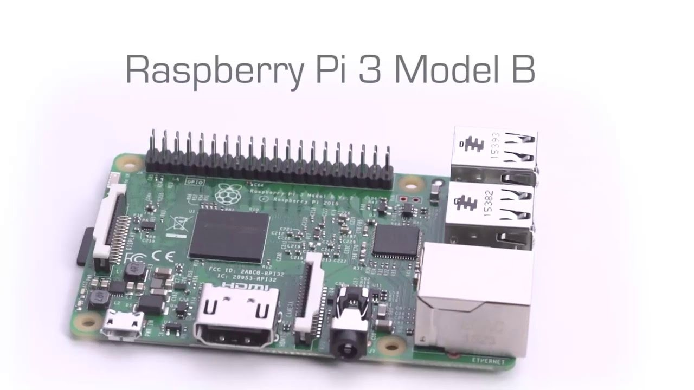

Figure 2.1 raspberry pi 3 model b.

**the Main idea of this part :**

it's like a brain for this project, the programmer writes code to program the raspberry pi to control the part so it's like the brain, it gives order to ultrasonic to send information after detect any object in the range of the radar and the camera take photo for the object and send it to the application on smartphone and website.

**Raspberry pi 3 model b:**

Because it has wireless part and Bluetooth and has a separate memory location and high-speed core.

**Description:**

It has **BCM2837 (**Processor) and quad-core Arm, 64 bit, And 1.3 Gigi hertz, one Gigabit Ram, 400 Mega HZ video core, power supply (2.5) A, and **Bluetooth.**

**Types of Raspberry Pi Models:**

* Raspberry Pi 1 many model (A,A+,B,B+)
* Raspberry Pi Zero and Zero W
* Raspberry Pi 2
* Raspberry Pi 3 and model B

Raspberry Pi 3 model b which used in this project.

**2.2.2: ARDUINO:**

It's a company which makes electrons project. It has a microcontroller and a software that runs on PC, It’s used to control the project by writing and uploading code to the Arduino. Arduino is designed and developed by Arduino.cc the board has many digital and analogy input and output pins which are can be connected to the circuits.

It is been programmed by connected to the computer and using the application to assigned the code and downloaded to the Arduino [6]

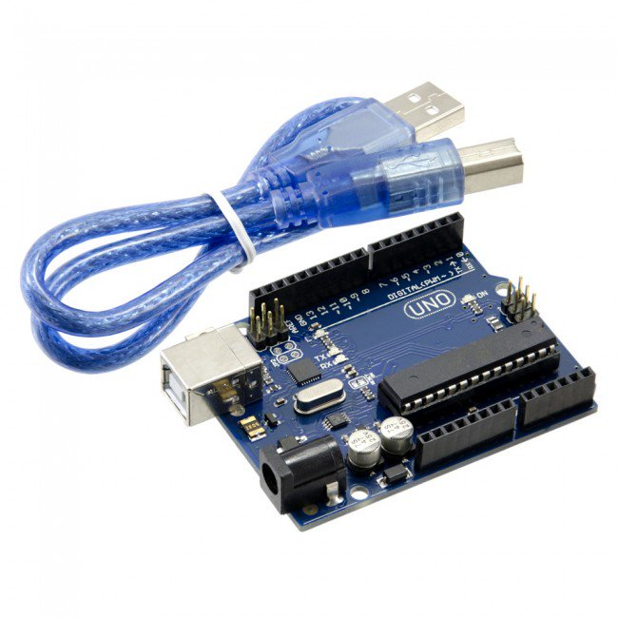

Figure 2.2. Arduino r 3

Figure 2.2.2 shows the Arduino which have 14 digital signal pin and 6 Analogy signal pin and a USB connection and more, it also needs a 5-volt power supply to start up.

**The Main idea of this part :**

The main idea for the Audrina is to help the raspberry pi in this project by making the Servo motor rotates 180 degrees and make the ultrasonic sensor send the information about distance and angle of the object to the website and more than this. By programming the Arduino, the program code can be written in C/C++ language.

We use this partbecause it is very simple to use for beginners and flexible to use by advanced users. The users can run it by Windows and Mac.

Doctors and researchers in the university need it to design a simple program in physics and chemistry, and its cheap also.[7]

**Type of Arduino:**

There are many types of Arduino like Arduino Due, Arduino Mega, Arduino Leonardo, Red Board, LilyPad Arduino, and Arduino.

**2.2.3: ULTRASONIC SENSOR:**

Ultrasonic sensor is a device to measure the distance and the angle for an object by using sound wave , by sending sound wave at a specific frequency and proccing that wave which is back after bounce the object , by measure the time for generated wave and bouncing back after touch the object , the sensor determine the time between sending the wave and return back on other hand the sensors can find the distance by know how long the sound wave takes to back after sending using **Equation d = v × t .**

The speed of the sound wave the sensor can calculate in different conditions, by knowing and accounting temperature, humidity and pressure (source). detect an object also depends on the movement of the object, if the object did not move in the (flat) surface the sound wave maybe will not return to the sensor.

The ultrasonic sensor is the same idea as the SONAR.

The figure below shows the type of ultrasonic that will be using for the project ultrasonic sonic radar which will be Ultrasonic Sensor HC-SR04.

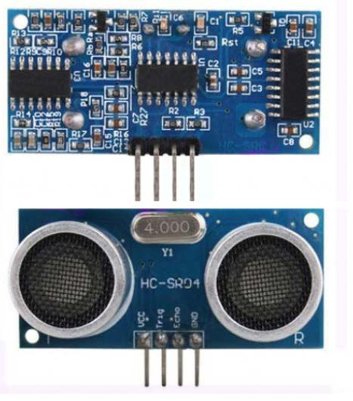

Figure 2.3 Ultrasonic Sensor HC-SR04

The figure below explain the idea of ultrasonic [8].

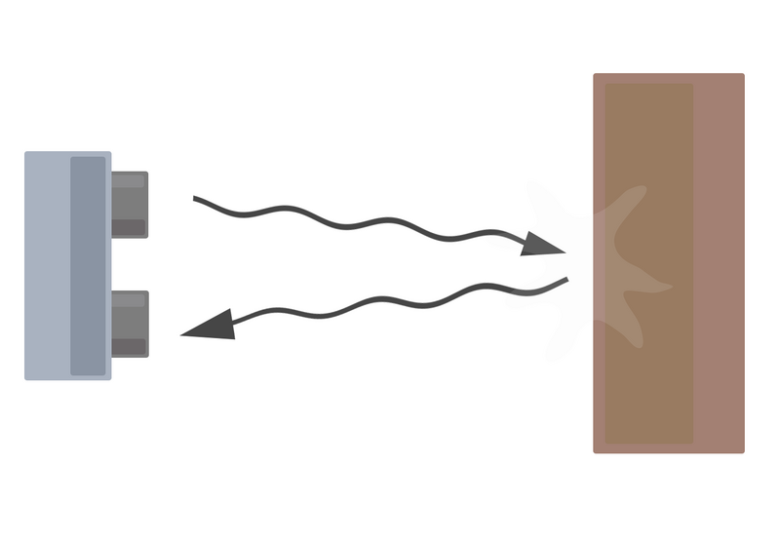

Figure 2.4 sound wave send and (reflect and back)

Figure 2.2.4 shows the idea of the ultrasonic sensor to find the distance and the angle for the object.

**Ultrasonic Sensor Pins:**

First, pin Vcc: Vcc pin it gives power to the sensor, with +5 volt.

Second pin: Trigger, Trigger pin is Input pin which it should be kept high for 10 us to initialize measurement by sending US wave.

Third pin: Echo, Echo pin is Output pin which goes high for a period of time which will be equal to the time taken for the US wave to return back to the sensor.

Fourth pin: Ground, This pin is connected to the Ground of the system

**The ultrasonic sensor HC-SR04 Specifications [9]:**

● Power Supply: + 5 Volt

● Quiescent Current: <2 mill ampere

● Working current: 14.9 mill ampere

● Effectual Angle less than 16 degree

● Ranging Distance: 2­500 centimetre

● Resolution: 0.29 centimetre

● Angle: 29 degree

● Input Pulse width: 10 (microsecond)

● Dimension: 46 x 21x 14 (millimetre)

● Weight: 11 gram.

The figure below shows the ultrasonic radar second task Servo motor and ultrasonic module control all part connected together.

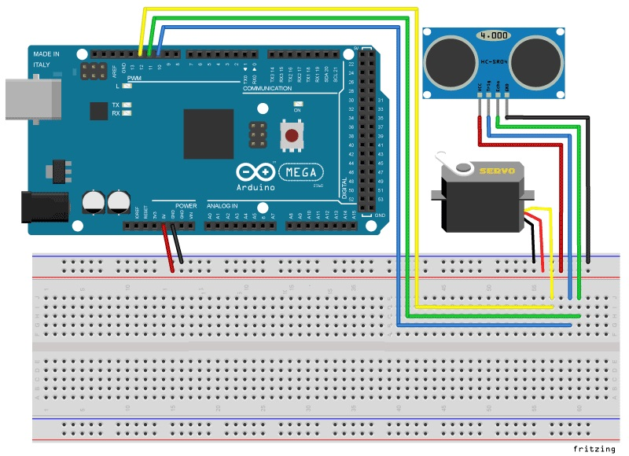

Figure 2.5 ultrasonic radar second task Servo motor and ultrasonic module control.

Figure 2.2.5 shows the second task in this project Servo motor and ultrasonic module control connected together by breadboard and jump wire, the ultrasonic sensor above the servo motor and its connection to the Arduino Uno to programming and take input power supply.

**2.2.4: SERVO MOTOR:**

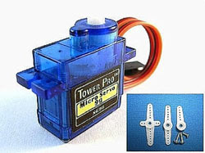

2.6: its tower 9 grams

Figure 2.2.6 shows servo motor tower 9 grams.

**The main idea** of using servo motor in this project is to rotate the ultrasonic sensor and the camera 180 degree which is above of the servo motor.

**Controlling the servo motor:**

Servo takes order from a (series of pulses), which is sent from the computer. A pulse is a moving from low voltage to large voltage and its stays large for a short time, and then it's back to low voltage in servos, low is considered to be ground or 0 volts and large is the power supply voltage the figure below shows it. Most of the servos work in a between 4.5 - 6.5 volt, so they can easily be connected and take supply from the computer [10].

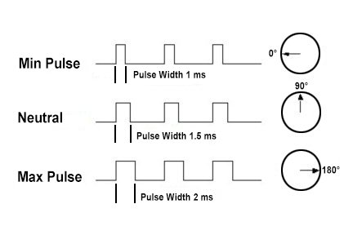

Figure 2.7: pulse that controls servo motor to rotate.

Figure 2.2.7 shows the pulse that already explained which is controlling the servo motor to rotate 90 degrees or 180 degrees and rotate back.

We use servo motor tower 9 gramsbecause it’s cheap and small and not heavy and it gives high output. the servo motor can rotate about 180 degrees, the user can programming the servo motor to rotate 180 degrees and stop when the sensor detected something easily, so it doesn't need a programmer to do this.

**Types of servo motors:**

There are many sizes of Servo Motors and any type of positional rotation, linear and continuous rotation.

**Specifications:**

The servo motor tower 9 grams has three legs (pins):

First, pin its brown which is used to connect the servo to the Arduino ground (-).

The second pin which is red it’s connected to the Arduino to give power supply 5 Volte (+) for the servo motor.[11]

The third pin which is yellow it's connected to the Arduino to any digital pin to send and receive signal [9].

**2.2.5: WEBCAM:**

Webcam: it's a video camera for streaming the image live and its connection to computer, laptop, and raspberry pi .it can capture a photo by taking orders from raspberry pi, it can be connected to the website, the video stream can be saved, and is connected by a USB cable.

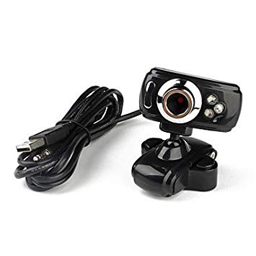

Figure 2.8 webcam

 We use webcambecause it’s cheap and simple to program and need small voltage.

First and after collecting all components together with wires to allow us to send and receive signals between the elements and thus controlling them. After that, we are going to use the microprocessor to control all of these elements to do exactly what we need to do. First set up the motor to and power it and code it in a way that it will loop in a 180 degree angle, on that motor we are going to set up the Ultrasonic module and wire it as well, the module will start sending and receiving the pulses or waves, with parameters set the Ultrasonic module will measure the distance as it is turning on the motor – using the time it takes for the waves to be sent and received – thus determining if there is an intruder in the vicinity. After that whenever there is an intrusion detected the Pi camera will turn on and capture images, these images will be saved on the microprocessor alongside other information need to be delivered to the mobile phone.

As for the Pictures and Information sending to a mobile phone and website, there is a lot of different ways that we can accomplish that and we will try to go through one or two of these methods and explain them.

Let us walk back a bit and focus on a few things that we will need to obtain the data from so it can be sent.

When the Ultrasonic Module detects an intrusion few things will happen, first we will have the angle of the motor registered and also the distance that the module calculated of the wave that was reflected off of the object after that we are going have the camera turn on and take a photo and save it in a pre-determined file path.

Now that we have the information and data that we need we can get into the methods we want to use to send them to the phone. One of the methods that we can use is an Email method, basically we take this info and have them saved as a text file and then script a code to take this 2 file (the text file plus the picture was taken) attach them to an Email and send them to an assigned E-mail address which will be accessed from the mobile phone itself. This may seem to be a very simple method that we can use but it is not practical for two reasons:

1- It will be very annoying to receive so many E-mails and

2- It will take some time to upload the files to the E-mail attachments.

The other method that can be used is also a simple one but very practical. Since our system is an IP system that will be connected to the internet through Wi-Fi or Ethernet we can have the pictures taken to be saved to a cloud and after that have the other info sent through an E-mail or other simple methods for text transmission.

The message will be a warning that a movement was detected and it may also contain the basic info of the location of the object detected.

One last thing would be alerting the person paired with the system whenever an intrusion occurs. Obviously the faster the person is alerted the better to allow him to act accordingly or alert the police, this most likely will prove to be difficult as we don't have a plan set yet, as of now we will be using the text file E-mail as the notification also the E-mail will mention that pictures were uploaded to the cloud, so the person can go check them and acquire them if they are needed as evidence.

Other methods can be done as well, such as Bluetooth connection but these type of connection are very limited when it comes to range and speed so we much rather use the IP system and send all of these info through the Web.

**2.2.6: MONITOR:**

It is an output device which shows the information in graphic form. The monitor consist of the casing, power supply, circuitry, and display device.

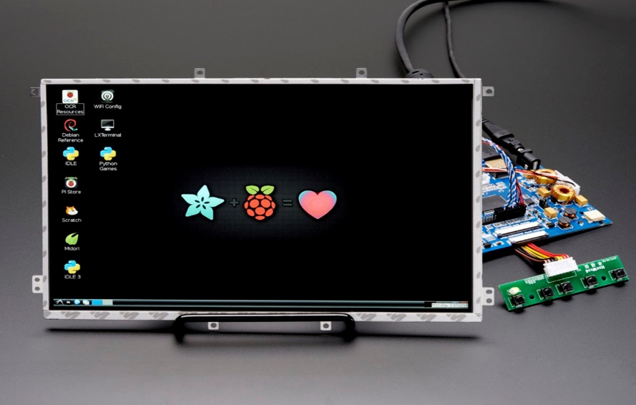

Figure 2.9 small monitor same that will used in the project

**The Main of using this part:**

The main idea in this part that to shows the camera screen 24 /7 and shows the photo that has been taken with the camera, so it shows the streaming and the photo.

**Type of MONITORS?**

* Pc monitors come in two different type:
* LCD: liquid crystal display (flatter type)
* CRT: cathode ray tube. (traditional type)

**2.2.7: THE WEBSITE:**

For the ultrasonic radar project, there is no need to make own website, the best option in this situation is to make a (blog) on TUMBLER website, it's like a page on Facebook and Instagram.



Figure 2.10 tumbler logo (website and phone application)

TUMBLER is a free website to make (blog), and it’s easy to connect with the project. so BLOG is like a small or simple website, and that's what the project needs, website receive photo and video .it’s easily to connect with it from any pc or laptop .as said before it's like a page on Instagram just make an account on TUMBLER and make a blog and connect the project with it.

This website connects with the project, by connecting the IP address for the raspberry pi with the website, which creates a possibility to upload the photos and the videos to the website.

**Steps to make a blog on Tumbler:**

1. Create an account on (tumbler).
2. Press login into tumbler web site.
3. Create a blog
4. After creating the blog you can choose a theme, name, and color for your blog.
5. Connect you're (blog) with your project.

**2.2.8: APPLICATION ON SMARTPHONE:**

The fifth tasks in this project is about making application on the smartphone to receive the photo ,same website part in this project no need to make own application, tumbler company gives an option that let you make a website blog and you can open from the phone also, same idea for the Facebook (account).

So no need to create an application on play store (for Android) or in-app store (for iPhone).

So TUMBLER application let the user access to the blog that has been created by the user to upload and receive the photos and the videos.



## Figure 2.11 tumbler application for smartphone

**Steps to make tumbler application:**

Same way of the last part and then login in from the phone, and search for the BLOG and make LIKE on the page and make it favourite to see.

If the project takes a photo the user will see a notification on his phone that the project detect an object.

**2.2.9: BREADBOARD:**

It's a board (Baltic) it is used to make an electrical circuit, the electrical technician can use it to connect the resistance or diode…etc., and connect it together easily any way or any design, and this breadboard can be connected with a power source.

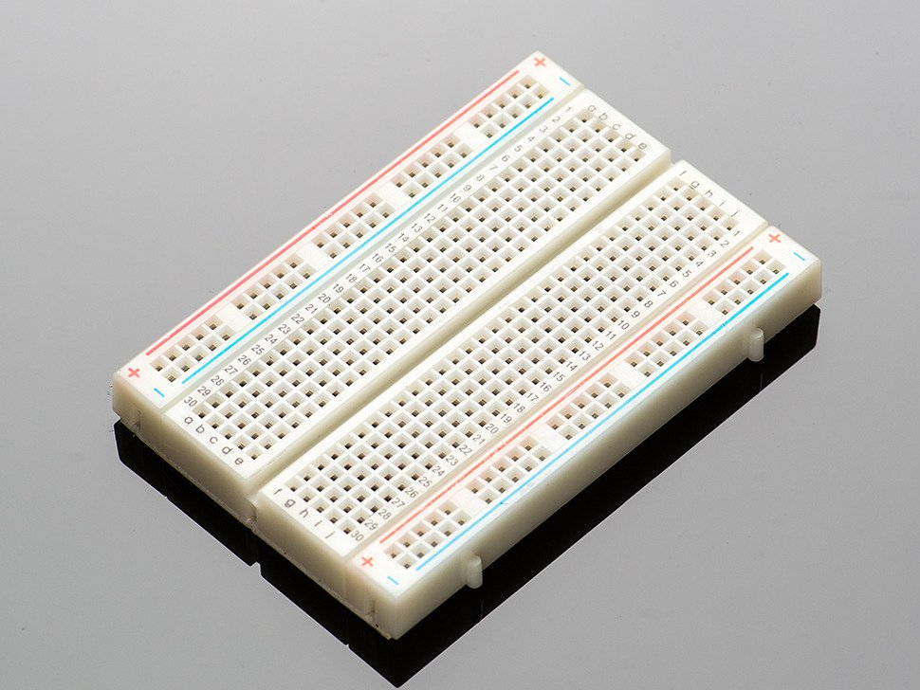

Figure 2.12 breadboard

**Type of bread board:**

### Holes in the top and bottom 4 rows

### Holes in the center section

## Half & Half+

## Mini

## Tiny

## BB-301

**2.2.10: POWER parts:**

**SOLAR PANEL:**

The idea of this part is to convert the heat coming from the sun into a valuable energy that is greater more than 10 times of the whole planet needs of energy.

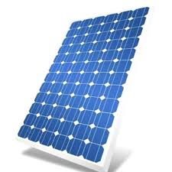

Figure 2.13 solar panel

**The main idea of the solar panel:**

The main idea is to use sunshine and change it to electrical power, the solar panel used the sunshine to protect the power, it is used some different technique to change the intensity of the sunshine, the intensity of the sunshine effect on the electronics atoms which are in the panels, and somehow connect the panels with charge controller and battery, so the battery will charge from it by controlling of charge controller.

## **Applications of solar panel:**

* [Photovoltaic power stations](https://en.wikipedia.org/wiki/Photovoltaic_power_station)
* [Rooftop solar PV](https://en.wikipedia.org/wiki/Rooftop_solar_PV) systems
* [Standalone PV systems](https://en.wikipedia.org/wiki/PV_system#Standalone)
* [Solar hybrid power systems](https://en.wikipedia.org/wiki/Solar_hybrid_power_systems)
* [Concentrated photovoltaic](https://en.wikipedia.org/wiki/Concentrated_photovoltaics)
* [Solar planes](https://en.wikipedia.org/wiki/Solar_plane)
* [Solar-pumped lasers](https://en.wikipedia.org/wiki/Solar-pumped_laser)
* [Solar vehicles](https://en.wikipedia.org/wiki/Solar_vehicle)
* [Solar panels on spacecraft’s](https://en.wikipedia.org/wiki/Solar_panels_on_spacecraft) and [space stations](https://en.wikipedia.org/wiki/Space_station)

**Type of solar panel:**

There are many types of solar panels that are using already in the field. The most common one that is using a lot and we have used it too is the" Monocrystal silicon" solar panel.

But there are other types like

* -Polycrystalline Solar Panels (Poly-SI)
* -Thin-Film Solar Cells (TFSC)
* -Amorphous Silicon Solar Cell (A-Si)
* -Biohybrid Solar Cell

**BATTERY:**

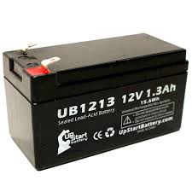

Figure 2.14 battery 12 v

We use the battery in this project because part of this project is to use the solar panel, and solar panel in this project need to save the electrical charge inside the battery, so it cannot gives the power directly to the project.

## **Common Battery Types:**

* Lead Acid.
* Lithium Ion.
* Nickel Metal Hydride (NiMH).

## **Lithium-ion battery advantages:**

1. High energy density:
2. Self-discharge:
3. No requirement for priming:
4. Low maintenance:
5. Variety of types available:

## **Lithium-ion battery disadvantages:**

1. Protection required:
2. Aging:
3. Transportation:
4. Cost:
5. Immature technology:

**CHARGE CONTROLLER:**

It’s an important part that we have used to keep the buttery from the overcharging because of the output coming from the solar panel has to be more than 12v almost 17v to 19v. We need these extra voltages because if we depend on just only expecting 12v from the solar panel it will ruin the buttery as a result from the cool or the cloudy weather and that will not be helpful to the make the buttery get charged. So we are using a charge controller to keep the buttery from the overcharging and try to extend the expecting life for it. The most butteries need almost 14v to 14.5v to get fully charged.

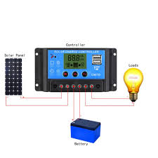

Figure 2.15 charge controller

**The main idea of this part** is to control the power which charge the battery, so its control the power because it's organized the battery charging.

**TRANSFORMER (STEP DOWN)**

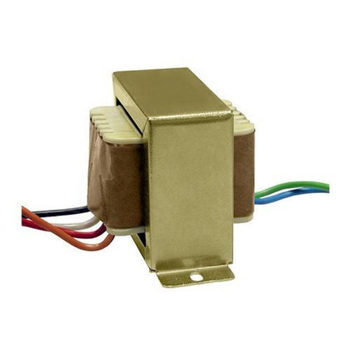

2.16 Step down transformer

Because the project needs to take direct power, and direct power is (220 v) and the project needs 5 v to work, so the transformer will change the power 220 V to 5 V.

**Type of transformer:**

* [Step up and Step down Transformer](https://circuitglobe.com/types-of-transformer.html#StepupandStepdownTransformer)
* [Power Transformer](https://circuitglobe.com/types-of-transformer.html#PowerTransformer)
* [Distribution Transformer](https://circuitglobe.com/types-of-transformer.html#DistributionTransformer)
* [Uses of Distribution Transformer](https://circuitglobe.com/types-of-transformer.html#UsesofDistributionTransformer)
* [Instrument Transformer](https://circuitglobe.com/types-of-transformer.html#InstrumentTransformer)
* [Current Transformer](https://circuitglobe.com/types-of-transformer.html#CurrentTransformer)
* [Potential Transformer](https://circuitglobe.com/types-of-transformer.html#PotentialTransformer)
* [Single Phase Transformer](https://circuitglobe.com/types-of-transformer.html#SinglePhaseTransformer)
* [Three Phase Transformer](https://circuitglobe.com/types-of-transformer.html#ThreePhaseTransformer)

**3: SYSTEM MODEL & WORK DONE:**

**3.1: SYSTEM MODEL AND EXPLAIN:**

Camera

Servo motor

Ultrasonic sensor

Source

Solar panel

**Arduino**

Monitor

**Raspberry pi 3**

Sending information

Web site

Mobile

Figure 3.1 system model flow chart

**EXPLAIN SYSTEM MODEL:**

Figure 3.1 shows the system model for the project which shows the connection between each part in the project.

The brain for the project is raspberry pi 3 which control the Arduino and give power 5 volt, and collect the information from Arduino which is distance and angle about the object .Arduino control servo motor and ultrasonic sensor and give them power 5 volt and collect the distance from ultrasonic and the angle from servo motor.

Servo motor rotate the ultrasonic sensor and camera 150 degree and know angle for the object, the ultrasonic sensor which responsible to collect the distance for the object.

The camera is connect with raspberry pi 3 which give for it the power and control it take photo for the object.

Raspberry pi3 after collect all information about the object (distance, angle, photo, time and date) its send the information to TMBLER which is application can be download in smart phone and can open on pc.

The monitor to shows the Rasbian and can open Tumbler website to see the information about the object that sent already.

The source as show in figure 3.1.1 its direct source and solar panel source, solar panel source will be explain in the next part, the relay it’s for change the power line which connect with the project between solar panel and direct source to make sure that the project work, will be the direct line is main source and panel source is second source.

**3.2: WORK DONE:**

This part will be explained in two section:

1. Power section and introduction to the second section.

2. Software section which includes the part that needs software to work.

**3.2.1: POWER SECTION:**

In this part of the report, we will discuss the types of sources that will be used to supply the whole project.

Firstly it has to be from the main source because it’s a constant and fixed source we have to consider in our project because of its permanent for all time. This type of sources divided into many values for example 220 v,110v and 380v depend on the purpose we choose the value of it but in this project, the 220v will be used because it’s the value that is using here in this country.

To avoid any type of interruption we have used another type of source to provide the project with power and this source will be the solar panel system.

In the first part that has used the main source, we have used a step-down transformer to decrease the voltage from 220v to 12v to be suitable for using with the circuits and by adding another regulator after this step to give a fixed voltage to supply the full bridge circuit to give DC voltage after converting it from AC voltage.

After getting this power from the previous circuit we have connected it to a relay that works as a switch between the two sources that we have if there is any interruption to the main source system.

In the second source, we have connected a solar panel with a charge controller then to the battery the charge controller also is connecting to relay to work if there is any problem or interruption happened to the main source to convert it to the solar system the buttery gives us 12v then it has connected to a buck converter to give 5v to supply the raspberry pi 3 circuit that it works as a brain for the whole project.

After the previous introduction about the main type of sources that provide the project with power, we will discuss the main idea that the project will follow to operate.

The ultrasonic radar mainly depends on the ultrasonic sensor that uses a lot of radio frequencies to apply the process of transmitting and receiving these frequencies to figure out if there is anybody interrupts these frequencies and sends alert about what was found to the user.

The ultrasonic radar is using a transmitter is to send the waves and after that, the receiver will detect it and analysis to give the information that has found.

The radar system has a lot of values of frequencies that are using already, begin from the small frequencies until the high of it like the ultraviolet region.

The value of frequencies that are using are difference depend on the purpose and the practical implementation. Most of the radar systems are using the microwave signals because it could arrange in many bands depends on the area, distance, security and the purpose absolutely.

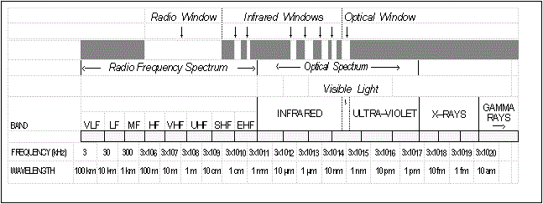

Figure 3.2 the electromagnetic spectrum

The previous figure shows us the electromagnetic spectrum that divides the areas of this spectrum depends on the type of wavelength and name of the name of it. Depends on the wavelength of the long wavelengths correspond to the radio frequency spectrum, the intermediate wavelength shows the infrared and millimetre radiation, the short wavelength to the ultraviolet and visible light. Generally, there are no basic bands in the electromagnetic spectrums that are using in the radar frequencies. Radar also could be any device that detects and locates an object by using electromagnetic energy. The essential principals of radars are the same at any frequency. In practice, most of the radars are operating between 400MHz and 36 GHz, however, if there any exceptions. The Earth's atmosphere and ionosphere are the bands that occupy by the spectrum**.**

**Radar frequency selection**

Depends on the application you can select the best frequency for this operation. The choice of frequency depends on many several factors, for example, physical size, transmitted power, antenna bandwidth, and atmospheric attenuation.

**Physical size:**

The physical size depends on the wavelengths and the frequencies. At lower frequencies, it will be longer wavelengths. In this situation, the hardware size will be bigger and heavy. At the higher frequencies when the wavelengths become shorter, the radars could be smaller and you can put it in just a package.

**Transmitted power:**

The value of frequency that has picked effect on the amount of power that the radar could send because of the size of the hardware device. The voltage gradient is one the most affected parameters on the level of power that the radar could be transmitted. In the case when the wavelength value is approached to be in meters then the radar could transmit megawatts of average power but in the case when the wavelength value is approached to be in millimetres-waves radar could be limited to a few hundred watts of average power.

**Bandwidth:**

In this case, if we consider this parameter at higher frequencies the size of the antenna will be smaller but if the frequencies become lower the size of the antenna must be bigger to detect the narrow beams.

**Atmospheric attenuation:**

The absorption and scattered are the main reasons to make the attenuation. Basically, the absorption is because of the water vapour and oxygen. The scattering is because of the liquid hydrometers. The last two parameters increase with frequency. Above about 10 GHz it becomes more important but below about 100 MHz atmospheric attenuation becomes negligible.

**PRINCIPAL OF OPERATION:**

**Steps to convert from the 220v AC into 5v DC:**

Because of that, approximately the whole appliances that we are using in our normal life require a power supply. In general, we are using AC supply to let them work but this power has to change to be suitable for our appliances. For this purpose, we have to convert it to the desired voltage range to provide them.

Many of power electronics devices are using for that like a transformer, DC to DC converter and many other devices.

The way that we followed to get the voltage from the first source.

**First step: step down the voltage level:**

In our project, we are going to use the step-down transformer to convert the 220v AC into 12v (RMS) the root main square value that gives approximately 17v for the peak value.

In this transformer, there are two windings primary and secondary, the primary is designed to have many numbers of turns to carry high voltage power with a low value of a current, and the secondary is designed to have a low number of turns to carry low voltage power and high amount of current.

Also, we could say that the transformer is working depends on the principle of Frady's law that using electromagnetic induction.

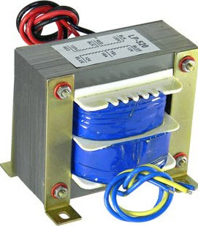

Figure 3.3 shows the transformer that using in the circuit.

**Second step: convert the AC voltage into DC voltage**

In this step, the 12v RMS (17v peak) that we got had to convert from the AC power value into a DC power value to be suitable to convert to 5v. To achieve this value we have to use a rectifier circuit to do this job.

Basically, the rectifier circuit consists of four diodes connected together to give this combination. We number these diodes by numbers from 1 to 4 considering that the input voltage value is being as positive and negative cycle we could say that the D1 and D3 are going to work in the negative cycle and the D2 and D4 are going to work in the positive cycle. After this operation the voltage that we got it wasn't pure and it had some ripples. Also, we could say that there was some voltage drop coming from the diodes in each cycle (2*0.7) gives 1.4v lost, therefore the peak voltage is going to affected ( from 17v to 15v ) approximately.

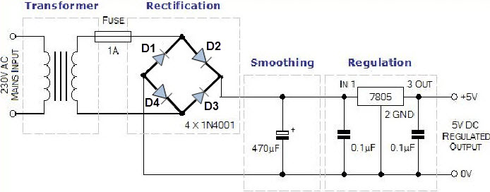

Figure 3.4 shows the circuit of the full-bridge rectifier

**Third step: Smoothing the ripples using a filter (capacitors)**

The 15v DC voltage that we got it still has some ripples we need to convert it into a pure voltage. The idea behind that choice is that the capacitor is like a storage device working in the charging and discharging period that is helpful in reducing the number of ripples in the DC voltage getting from the rectifier circuit.



Figure 3.5 shows the idea of getting a smooth voltage.

**Fourth step: Using a voltage regulator to get 5v DC from 12v DC**

To regulate the 15v DC or making a step down for it we could use a step-down converter called a Voltage Regulator IC7805. The first two digits here "78" relate to a positive voltage getting from this converter and the last two digits " 05"relate to the amount of voltage getting this converter too.

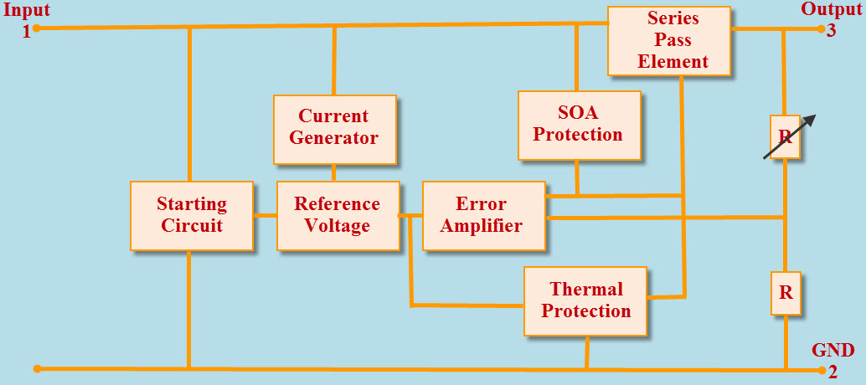

Figure 3.6 shows the idea of using a regulator to give a fixed output voltage.

In the previous part, we have talked about the way that we have used to convert the AC to DC to be suitable for the load.

**3.2: PART NEED SOFTWARE:**

**CONTROLLING THE SERVO MOTOR AND ULTRASONIC RADAR**

The figure below shows connections of the project. All pins from the Arduino is connected and moved to the breadboard for easy setup. The Arduino Uno comprises of multiple pins of which a few will be used to connect the servo motor and ultrasonic sensor. Both the sensor and servo motor are attached together since it will be the most part under constant movement, extra measures are applied so both elements stay in place. Fig 3.5 shows a model.

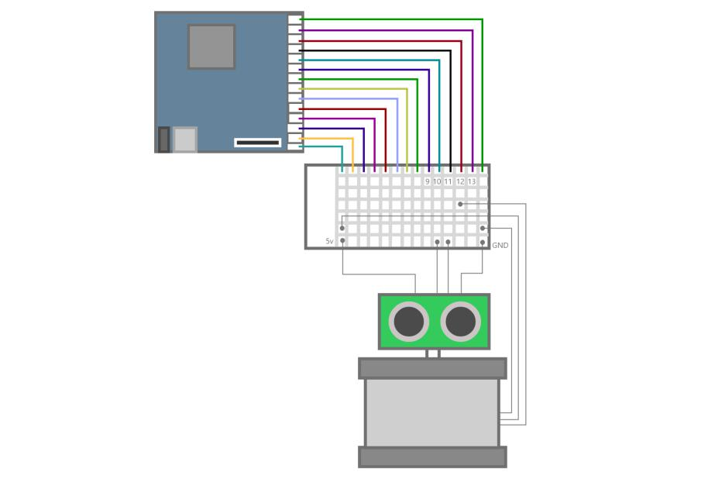

Figure 3.5 show the connection for servo and sensor with the Arduino

**SETUP AND WORK DONE**

Below are few guidelines to setting up and building the radar scanner

**INSTALLING ARDUINO IDE TO YOUR COMPUTER:**

Before beginning building the project, we need to have a compiler environment for writing codes into the Arduino board. This method requires a pc and an up-to-date Arduino side. If you do not have that installed it is the best time to set up the program on your laptop or pc. When that is done, we can move on to the next phase.

**SETTING UP THE PINS FOR THE ARDUINO:**

When it comes to the pins to choose for communication, people often get confused or are indecisive of which to use. For the purpose of this project and after multiple online types of research, the best pin to use will be from pin 9 to 13. This will ensure we can compile and get a minimum error, or those pins will be easy to debug.

**CONNECTING THE PROJECT TO BREADBOARD:**

This part requires an extra attention and care as not to be confused on the wiring. Any wrong connections can lead to either skin burn or circuit damage.

We start with the ultrasonic sensor. As explained earlier, it comprises of 4 pins which are Vcc, ground, trigger and echo. Also as explained, it uses the trigger and echo pin to determine the distance travelled.

So, these 2 pins are the most important, so we connect the trigger pin to pin 10 and echo pin to pin 11 in the Arduino. Then connect both ground and Vcc to a common connection. We create a bridge for the voltage and ground coming from the Arduino so both the sensor and servo motor can receive the same power from the source.

Next, we move on to the servo motor. The servo motor comprises 3 cables which are Vcc, ground, and signal. Because a motor only requires a single command, it is designed to have a single signal cable which is responsible for communicating to the Arduino board. Connect both its Vcc and ground to the common cable which supplies voltages to the ultrasonic sensor. Then the signal cable of the servo motor is connected to pin 12 in the Arduino board. The pin 12 will be used to control the servo motor in the code. When everything is set up nicely, we move on to writing program to control the project.

**WRITING A PROGRAMME TO CONTROL THE PROJECT**

Before we begin, we make sure the Arduino software is up to date. Failure to do this might lead to compilation error. After the idea is installed and updated, we can now move to install the library for the servo motor. This will library is responsible for controlling the servo motor so it is important to have it in the code. Next, is to also install a library for the ultrasonic sensor. As explained earlier, this is also responsible for controlling the ultrasonic sensor.

Then we call pin 10 and 11 and assign them to triggers and echo and also initialize them. We create two constant variables which are duration and distance. These variables are responsible for measuring and calculating the distance difference between objects and also how long it takes for the sensor to meet a target or obstruction. The setup method in the code is to initialize all variables created. In our case, trigger, echo, buzzer, and servo variables are initialized.

We move on to the void loop on the next method. Since this method is designed to run repeatedly, it is perfect to run the servo continuously without obstruction. To listen for a command from i2c communication from the raspberry pi, we need to assign another variable and set it to 0. The loop is designed to begin scanning or operation if the value of the variable becomes greater than or equal to 1. By encapsulating the for loop inside that condition, we have control on when the servo can start operating.

Then we continue and add a for loop to beginning calculating distance and turning the servo motor. The angle for the servo is set from 15 to 165-degree range for building purposes, however, the range can be adjusted later when everything is moving smoothly. Next, we write a conditional statement, on the ultrasonic sensor range, if the distance of scan falls below 40cm, we do another additional operation as a subroutine.

Because Arduino is designed to run continuously, we have to add additional steps to stop both servo motor and ultrasonic sensor. Within this timeframe, the Arduino sends data to the pi. In other to achieve this, we write a line of code to detach the servo motor i.e. to lower the voltage for the servo motor low enough to make it stop moving. For the ultrasonic sensor, we simply block or stop the pin from sending voltage to it.

When that is done, an empty for loop is design preventing the Arduino from moving to the next line of code. We assign the condition to only move if it receives a value greater than 5. While the Arduino is in wait, we send the angle or position of the servo motor and distance of the ultrasonic sensor to a command line window. By doing this, since the raspberry pi is also connected to the Arduino and can send and receive information via i2c communication, it is possible to for the raspberry to receive the content sent from the Arduino. Assuming the raspberry pi receives this information and sends a value to begin the Arduino. Just before it begins scanning, the command line is cleared and memory is freed to listen to the new value. This operation runs continuously until the Arduino cannot receive any value telling it to continue.

**CAMERA CONTROL FOR TAKING SNAPSHOT AND VIDEO STREAMING**

**WORK DONE AND SETUP**

For simplicity purposes, a custom LCD display is used for portability and less power consumption. An HDMI cable is connected from the display to the raspberry pi. A power adapter is also present, providing the screen with 12v and 1A. While 5v and 2A are provided for the raspberry pi. An external USB extension is connected from the raspberry pi that feeds the Camera as well as other components like mouse and keyboard for controlling the project. Fig below shows the complete connection of the parts.

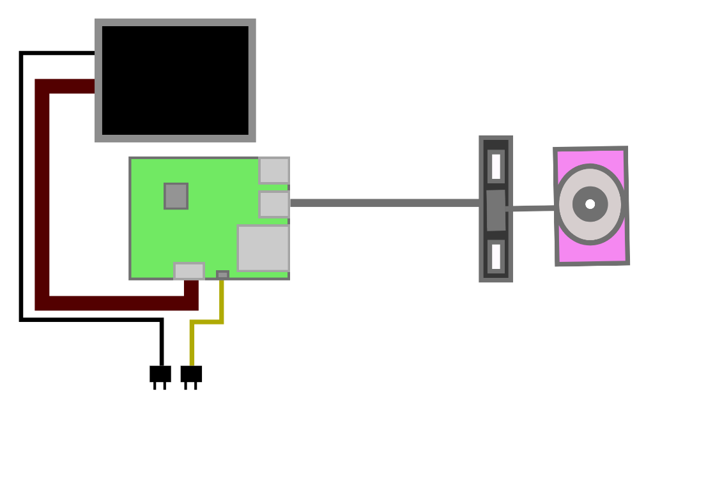

Figure 3.6: connect with the project

Setting up and configuring the project is relatively easy. But one should be careful so as not to confuse or damage any part.

## **SETTING UP WEBCAM:**

Fswebcam is a simple but effective program for controlling and taking both images and live video streaming. It has the capability of capturing images from different sources and performing manipulation on the targeted image. As known to other programs, it can save in multiple formats like JPEG or PNG. These formats can be transferred to sudo using format pattern of Filename “-”. The resulting output if then been formatted as STRFTIME.\

To install the program on your raspberry pi, go to the command prompt on the terminal window. When there, first write the line ‘ sudo apt-get update’. This line will search on the web online and find the newest version of your operating system to make sure you are up to date and all your libraries are current. Then write ‘sudo apt-get upgrade’ to upgrade all your libraries if they are not updated yet. When all requests are complete, write ‘sudo apt-get install webcam’, this line will install the latest version of the program to your raspberry pi system.

## CONFIGURATION OF THE FSWEBCAM

Fswebcam comes with many options for working with or setting up your images as well as other extra features which we will look into.

**GENERAL OPTIONS OR CHOICES:**

**Help**: Open your command prompt and write nano fswebcam, then write the command help for the list of options or features the library offers

**Config**: This option is responsible for loading options from a file. Also, it has the option or can load more than one config file. Its limitation is the inability to load or to be used from within a configuration file.

**Quiet**: For cases where you may be working with multiple commands at a time, checking the command prompt for every action may be clustered or excessive usage of memory, the command --quiet helps in minimizing them thereby making them run in the background. Also, it can help in hiding messages

**Verbose**: This helps in printing extra information during image captures. For cases like debugging or program freezing, it is an excellent tool of choice.

**Version:** uncertain or unrecognizable errors may occur which most of them comes from outdated libraries or version. You can check which version is currently running on your machine by writing this command.

**Loop:** This is used to capture more than one image continuously. By default, the library is set to capture an image at a time. This command comes in handy when you want to capture multiple images for streaming.

**Offset**: As explained earlier in loop operation, this will help in setting time intervals between each loop operation. It can take any value from negative to a positive number.

**Log**: Either for debugging purposes, keeping log helps in tacking your code operation and finding any errors when arises. It keeps the history of all your activities been executed.

**GMT**: The library also comes with its custom time format. Using this line of command is choosing a GMT time zone format instead of local time zone when formatting a text using strftime.

**Device**: This command sets options or choice of device or camera to operate on. In some cases, we often have more than one camera installed in the machine. Also, several sources of the module include:

* V4L2 – Capturing images from a device that supports a v4l2 format
* V4l1 – Capturing images from a device that supports a v4l1 format.
* RAW – Responsible for reading images or files directly from a device or source.
* FILE – Responsible for capturing images in form or JPEG or PNG from a file.
* TEST – Responsible for drawing objects on the images or file.

**Input:** Used to set the inputs to make use of. By default, it is set to zero 0, but this can be changed to 1 or more.

**List-inputs**: To show all the number of devices currently available in your ports or device.

**Frequency**: You can set the frequency of your selected tuner or input. Depending on your input, it can be read as KHZ or MHZ.

**Palette**: this line of command is responsible for specifying image formats. When set to default, it automatically chooses the best format depending on certain criteria. Supported formats include: JPEG, MJPEG, S561, RGB32, RGB24, BGR32, BGR24, YUYV, UYVY, YUV420P, BAYER, SGBRG8, SGRBG8, SGRBG8, RGB555, Y16, GREY.

Resolution: This line of command is responsible for setting image resolution of either the source of the device. While the most device can capture at the desired resolution, the resolution may differ is the source or device is incapable of capturing in that specific frame resolution. The default resolution is set to 324x288. This default resolution is compatible with all devices

**To capture** an image, navigate to the command line and type os.system('fswebcam -r 320x240 -S 3 --jpeg 50 --save /home/pi/Desktop/radar/start/image'+str(count)+'.jpg').

**SENDING PHOTO AND LOCATION COORDINATE TO A MOBILE DEVICE**

Getting the content from a raspberry pi into a mobile device works similarly to the webpage. Since the content is shared for both webpage and mobile device, similar setup will be done. Fig below shows a complete connection from a raspberry pi to a mobile device. Content is sent through API, HTTP as we will be looking in details.

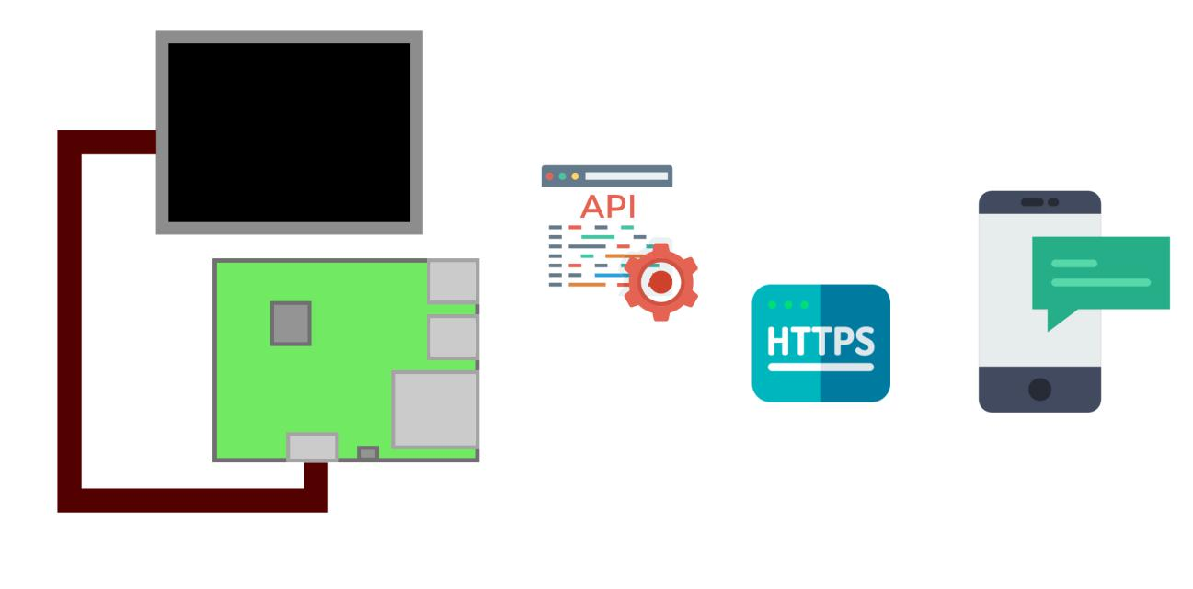

Figure 3.7 tumbler website

**WORK DONE AND SETUP :**

in the terminal window on your machine, install Tumblr by writing the command sudo apt-get install by Tumblr to fetch the latest version from its repository. Also, sudo apt-get updates to update all your libraries in your system. To upgrade files that are out of date, write the command sudo apt-get upgrade to set all libraries to date.

**JSONP**

JsonP or JSON with padding is a form of a get-request element used to fetch data from servers which are been hosted in a different domain. We use this to parse a request from Tumblr in order to be able to either read or write data files. An HTML serves as a messenger where it translates or executes content which is served from foreign origins. This is essential to our project as services which are replying or serving data in pure JSON cannot share its resources across the domain. For instance, an example of a foreign domain may be served as follows http://tumblr.com/user/photo which is been returned as a JSON format in which by description, does not tally with JavaScript object initializer. While standard json might display its URL like<Script type = "application/javascript” _src = http://tumblr.com/user/photo > </Script>, any attempts to use this in its pure form will cause an error in javascript format. The browser will download each script, since json view contents in form of a block, it will treat the script as a part of the item whereby misinterpreting the raw JSON file.

When data is been passed and shown as in the form of JsonP, it returns a usual javascript code but this time, a wrapped payload surrounds the script and it is then been interpreted by the browser, in this way, a function been fed to a javascript environment can now be manipulated in any form like the JsonP data making request calls possible.

The function is responsible for calling the parse response thus the name JsonP, “P” _for padding. For this function to work properly, a server must submit result in the form of JsonP format And since JsonP does not work with JSON format, the invocation that the function sends back and its payload received must be organized and accepted to both server and client.

**SECURITY CONCERNS**

Injecting or wrapping an existing javascript function into any content works well for our project but it raises security issues. The ability to rewrite any script exposes it to vulnerabilities, for instance, if an attacker has that privileges and the access to inject an additional script to our existing code, then that code can retrieve or download additional javascript from domains bypassing terms and conditions or strong policies protecting it. An effort has been taken as a measure to prevent such acts. Browsers will be able to force or push an emphasis on scripts requesting access with a MIME type like "Application/JSON-p". Failure to comply or parse, the browser can throw an error to the user or preferably, ignore the whole response altogether.

**SETTING UP TUMBLR API**

We need to get an authorization key from Tumblr website to be able to talk to their application program interface (API). Without this, we cannot post to their database. When we have successfully created an been given the key, we also request for consumer secret, consumer key, client secret, and client key. These keys are needed to read as well as write data and post them to their database. After those are gotten, we begin to write a python script to hold this information and then request them within our code whenever we need them. It is important to separate the sensitive information from the rest of the code so as not to lose them to unauthorized person. After the python script is created, we must add this in the main program that runs our code. It needs to be the first line of code to be executed to enable Tumblr grant us access. After that is done, other codes can run depending on what the task may be.

**SENDING PHOTO AND LOCATION TO WEBPAGE**

Communicating or setting a connection between a raspberry pi and the web is not always easy and sometimes you constantly have to change your code due to constant library update which can lead to incompatibility issues. In this part, we will only focus on the specific area that is required to run it without worrying about said issues. Below is a complete diagram showing how the project communicates to the web. An LCD is connected to the raspberry pi and both elements are supplied with their designated

voltages.

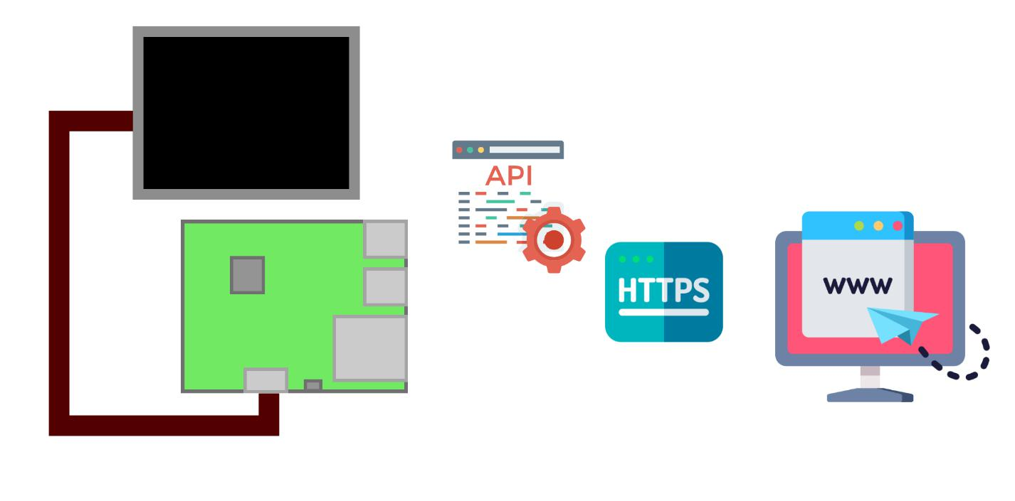

Figure 3.2.8 tumbler smart phone application

**WORK DONE AND PROJECT SETUP**

Getting to this point, we should be getting data from the Arduino like the angle and distance. These data are been processed and is been split into parts and the camera has triggered an image is captured and everything is ready for sending to the web.

**APPLICATION PROGRAM INTERFACE (API) SETUP AND CONFIGURATION**

Tumblr has support for APIs that can send or organize data in form of or in the oEmbed standard. It helps in sorting out data and makes it easy to be called by other sites or applications.

oEmbed is a format that has the ability to show contents in form of an embedded pattern to deliver to third party websites. What this means is it gives the website the ability to embed media content such as videos or photos when any client request or post a link to its origin without parsing the origin directly his specification is broken into three parts which are configuration, client request, and provider response. The concept of an embed system is fairly easy. This exchange occurs between a service provider and a client. When a client wishes to show a third-party resource or embedded representation of their website and its media contents such as audio, photos or videos. A service provider is responsible for implementing the oEmbed which then allows the client to fetch the desired content.

**CONFIGURATION**

In order for configuration to occur, the providers must specify either a single or multiple URL schemes as well as multiple API endpoints. The URL schemes come with a description of which services may have already been embedded, that is an embedded representation. The endpoints from those APIs describes or shows the client where they can request representations for the URLs. For example, in our case, the URL scheme will be in form of <https://tumblr.com/user/photos>, and the endpoint will be something like <https://tumblr.com/services/oembed/>.

**CONSUMER REQUEST**

When a client makes a request, the data been sent to its end point is usually in form of HTTP GET requests, where all its arguments sent are in form of query parameters and also URL encoded. The following specification is part or an example of a query parameter:

1. URL: Ability to receive or to retrieve embedded information. This is an essential tool.

2. Max width: This describes the maximum width of most embedded sources. But in some cases, it only applies to some resource's types. In the case for supported types, the following parameters must be respected by its providers.

3.Max height: This describes the maximum height of most embedded sources. But in some cases, it is only applicable to some resource’s types. In cases for supported types, the following parameters must be respected by its providers.

4. Format: This is a pattern of the request form. When specification in how it should be is not given, the provider can return any response in a valid format. But when a specification is given, then the provider must return the data accordingly. Cases, where the client has an error or provider, is unable to read the client requests, an error response is sent.

The output from the request will be in form of:

<https://tumblr.com/services/oembed?url=http%3A//tumblr.com/user/photos/>. There are two choices

for providers when it comes to specifying endpoint URL. Rather than parameters in form of queries,

Providers can also choose to have it in the form directly from its endpoint URL. For example, in our case, it will look like this <https://tumblr.com/user/photo>for the URL scheme and <https://tumber.com/services/oem.xml>for XML endpoints and

<https://tumblr.com/services/oembed/json>for JSON endpoint API. In this case, however, parameters for a format is not necessary or needed and thus can be ignored.

**3.3: PERFORMANCE TESTING FOR POWER PART:**

The first part that we had to test in the project it was the power supply part to be sure about if there is a power connection to those other parts to start our performance testing.

We did many researchers to find the suitable one for this application. We started by using the transformer as a step-down then we follow it by a full-bridge to convert the output "Ac" that coming from the step-down operation to a Dc voltage. Then we used filters to supply some smooth voltage and follow it by using a regulator to fix the output voltage to connect to the load of the circuit. In the first part, the transformer that we have used it gives 17v to the system to avoid any problem of lacking in the desired voltage we need. After checking the getting voltage from the step-down transformer we put the full-bridge circuit by using silicon diodes and by considering that the voltage drop coming from this types of diodes will be almost 0.7v we actually lost approximately (2*0.7v) voltage drop for the diodes connected for each negative and positive cycle. Therefore, the peak voltage after the full-bridge rectifier circuit was almost 15v dc. Then we added a filter circuit to smooth the output to remove the ripples After that, a regulator has added to give a fixed output voltage to connect it directly to supply the other parts in the project. Also, there is another source and it is the solar power system by connecting a battery that is charging by connecting to a charge controller that is trying to keep it from the overcharging. By taking a direct line from the buttery to the other parts we couldn't make direct because of the getting value wasn't fixed as we supposed so it had to use a regulator to give a constant voltage to keep the other parts form any damaging but another problem had appeared and it was coming from the regulator because it started to be very hot because of the voltage going through it so we had to use a heat sink to avoid this increase in the temperature. Then it became works perfectly but it happened after many numbers of trails to get the desired values. Finally, we could say that the operation of testing has taken a lot of time because of the variety of values that we got changed from time to time because of the concept of tolerance that exists in the whole electronics components also the losses of wires and temperature effects.

**4. CONCLUSION**

The main idea behind this project or design it was to find a better way to exist more secure and safety for people's life. This idea had obtained by using a sensor to detect any interruption during a certain distance. This sensor is working by detecting in almost more than 3 meters away from it and giving an alert for the user. This alert is connected to a camera that is recording and taking a picture for an intruder in a certain area. Also, another feature was added to the project by sending the recorded videos and pictures to a website the user could get in form any place to give more trust to the user. The feature of using a servo motor carrying the sensor added more flexibility to the sensor to move and detect in any angle between 0 and 180. One of the most important parts in this project that it works as a brain for the whole project is the Raspberry Pi which controls all parts. Also, there were two types of sources were used in this project to keep the project works with any interruption, the main source (220v) and a solar system. The main power supply in this project will be the main source (220v) and the solar system will work if there is any interruption happened to the main source by using a battery charges from the charge controller (to keep the battery from the overcharging) that is connected directly to the solar panel(the source of power). Also, it was written the raspberry pi has carried all set of programming codes and instructions which has used the python language as a programming language which works by distributing the tasks to the other parts of the project. Also, it has used to control the servo motor and the camera too. After that, we still have the ultrasonic sensor to detect any intruders and measure these objectives in a certain surrounding distance. Finally, after introducing the whole process of creating this project we hope it will be a reason to enhance the quality and the idea of using this type of product in the manufacturing field.

**REFERENCES**

[1] MWRF," radar grows military tool" [online] Available:http://www.mwrf.com/systems/radar-grows-military-tool-everyday-use/[Accessed: 1 May 2018].

[2] EBAY, “ultrasonic sensor radar"[online]Available:https://www.ebay.com/sch/i.html?_from=R40&_trksid=m570.l1313&_nkw=ultrasonic+sensor+radar&_sacat=0/[Accessed: 4 May 2018].

[3] MADEHOW, "Sir Robert Watson Watt" [online] Available:http://www.madehow.com/inventorbios/67/Sir-Robert-Watson-Watt.html/ [Accessed: 6 May 2018].

[4] TESLA, "smart car" [online] Available: https://www.tesla.com/model3/[Accessed:8May 2018].

[5] CIMMS, “detection and tracking airplanes” [online] Available:http://cimms.ou.edu/~slana/paper/techniques_for_detection_and_tracking_airplanes_using_WSR88D.pdf [Accessed: 11 May 2018].

[6] ARDUINO.CC, “Arduino Guide"[online]Available:https://www.arduino.cc/en/Guide/Introduction/[Accessed:13 May 2018].

[7] ELPROCUS, “elprocus" [online] Available:https://www.elprocus.com/different-types-of-arduino-boards/[Accessed: 15 May 2018].

[8] JAMEC O, “how servo motors work."[Online]Available:https://www.jameco.com/jameco/workshop/howitworks/how-servo-motors-work.html/[Accessed: 17 May 2018].

[9] RAPIRO, “servo motors specifications"[online] Available:http://www.rapiro.com/servo-motors-specifications/[Accessed: 20 May 2018].

[10] YouTube, "ultrasonic sensor" [online]Available:https://www.youtube.com/watch?v=1jGvzNrtF24/[Accessed:23 May 2018].

[11] COMPONENTS, “ultrasonic sensor working” [online] Available:https://components101.com/ultrasonic-sensor-working-pinout-datasheet/ [Accessed: 24 May 2018].

[12] Turnkey digital,” Migatroncrop”, 2015, “<https://www.migatron.com/ultrasonic-detections-and-control-applications/> **“,** Accessed: December 2018.

[13] Pepperl-fuchs, 2018, “<https://www.pepperl-fuchs.com/global/en/4507.htm?searchterm=ultrasonic+radar&start=0&rows=5&search=&modifier=beginswith> “, Accessed: December 2018.

[14] Plcdev, 2018, “<http://www.plcdev.com/how_plcs_work> “, Accessed: December 2018.

[15] [Werner Wiesbeck](https://ieeexplore.ieee.org/author/37281044700) , Leen Sit, “IEEE”, 2014, “<http://ieeexplore.ieee.org/document/7060395> “, Accessed: December 2018.

[16 Elprocus, 2018, “ <https://www.elprocus.com/ultrasonic-detection-basics-application/> “, Accessed: December 2018.

[17] Allaboutcircuits, 2018, “<https://www.allaboutcircuits.com/textbook/digital/chpt-6/programmable-logic-controllers-plc/> “, Accessed: December 2018.

[19] Radio Astronomy, 2nd Ed, Cygnus-Quasar Books, John D. Krau, 1986, chp 3.

[20] Elprocus, 2018, “<https://www.elprocus.com/steps-to-convert-the-230v-ac-to-5v-dc/> Accessed: December 2018.

**APPENDIX**

**Python Code for the Raspberry pi:**

import serial

import time

import os

import pytumblr

from tumblr_keys import

import RPi.GPIO as GPIO

arduino = serial.Serial("/dev/ttyUSB0")

arduino.baudrate = 9600

GPIO.setwarnings(False)

GPIO.setmode(GPIO.BCM)

GPIO.setup(4, GPIO.OUT)

client = pytumblr.TumblrRestClient(

consumer_key,

consumer_secret,

token_key,

token_secret

time.sleep(3)

arduino.write('1')

def arduinoWake():

arduino.write('5')

time.sleep(1)

arduino.write('5')

def ledBlinkOn():

GPIO.output(4, True)

def ledBlinkOff():

GPIO.output(4, False)

def scan():

count = 0

max = 6

while (count < max

data1 = arduino.readline()

pieces = data1.split(".")

old_angle = 0

angle = pieces[0]

distance = pieces[1]

if old_angle != angle:

#os.system('fswebcam -r 320x240 -S 3 --jpeg 50 --save /home/pi/Desktop/radar/start/image'+str(count)+'.jpg')

if count == 0:

ledBlinkOn()

zero_angle = angle

zero_distance = distance

old_angle = angle

os.system('fswebcam -r 320x240 -S 3 --jpeg 50 --save /home/pi/Desktop/radar/start/image'+str(0)+'.jpg')

time.sleep(0.5)

#client.create_photo('ultrasonicradar402', state="published", tags=["ANGLE = "+ zero_angle +"deg", "DISTANCE =" + zero_distance + "cm"], data="image"+str(0)+".jpg")

arduinoWake()#to wake up the arduino

count = count + 1

ledBlinkOff()

else:

continue

break

if count == 1:

ledBlinkOn()

one_angle = angle

one_distance = distance

old_angle = angle

os.system('fswebcam -r 320x240 -S 3 --jpeg 50 --save /home/pi/Desktop/radar/start/image'+str(1)+'.jpg')

time.sleep(0.5)

#client.create_photo('ultrasonicradar402', state="published", tags=["ANGLE = "+ one_angle +"deg", "DISTANCE =" + one_distance + "cm"], data="image"+str(1)+".jpg")

arduinoWake

count = count + 1

ledBlinkOff()

if count == max:

count = 0

else:

continue

break

if count == 2:

ledBlinkOn()

two_angle = angle

two_distance = distance

old_angle = angle

os.system('fswebcam -r 320x240 -S 3 --jpeg 50 --save /home/pi/Desktop/radar/start/image'+str(2)+'.jpg')

time.sleep(0.5)

#client.create_photo('ultrasonicradar402', state="published", tags=["ANGLE = "+ two_angle +"deg", "DISTANCE =" + two_distance + "cm"], data="image"+str(2)+".jpg")

arduinoWake()

count = count + 1

ledBlinkOff()

if count == max:

count = 0

if count == 3:

ledBlinkOn()

three_angle = angle

three_distance = distance

old_angle = angle

os.system('fswebcam -r 320x240 -S 3 --jpeg 50 --save /home/pi/Desktop/radar/start/image'+str(3)+'.jpg')

time.sleep(0.5)

#client.create_photo('ultrasonicradar402', state="published", tags=["ANGLE = "+ three_angle +"deg", "DISTANCE =" + three_distance + "cm"], data="image"+str(3)+".jpg")

arduinoWake()#to wake up the arduino

count = count + 1

ledBlinkOff()

if count == max:

count = 0

else:

continue

break

if count == 4:

ledBlinkOn()

four_angle = angle

four_distance = distance

old_angle = angle

os.system('fswebcam -r 320x240 -S 3 --jpeg 50 --save /home/pi/Desktop/radar/start/image'+str(4)+'.jpg')

time.sleep(0.5)

#client.create_photo('ultrasonicradar402', state="published", tags=["ANGLE = "+ four_angle +"deg", "DISTANCE =" + four_distance + "cm"], data="image"+str(4)+".jpg")

arduinoWake()

count = count + 1

ledBlinkOff()

if count == max:

count = 0

else:

continue

break

if count == 5:

ledBlinkOn()

five_angle = angle

five_distance = distance

old_angle = angle

os.system('fswebcam -r 320x240 -S 3 --jpeg 50 --save /home/pi/Desktop/radar/start/image'+str(5)+'.jpg')

time.sleep(0.5)

#client.create_photo('ultrasonicradar402', state="published", tags=["ANGLE = "+ five_angle +"deg", "DISTANCE =" + five_distance + "cm"], data="image"+str(5)+".jpg")

arduinoWake()#to wake up the arduino

ledBlinkOff()

if count == max:

count = 0

break

count = 0 #Resetting the loop back to beginning

**Arduino Code**

#include <Servo.h>

//Defining designated pins for controlling the ultrasonic radar.

int echoPin = 11;

int trigPin = 10;

long duration;

int distance;

Servo myServo

const int buzzer = 9;

int usbRead = 0;

void setup() {

pinMode(trigPin, OUTPUT);

pinMode(echoPin, INPUT);

pinMode(buzzer, OUTPUT);

Serial.begin(9600);

myServo.attach(12);

usbRead = Serial.read() - '0';

while(usbRead == 1)

for(int i=15;i<=165;i++)

distance = calculateDistance

if(distance < 40)

tone(buzzer, 1000);

delay(1000);

noTone(buzzer);

delay(1000);

myServo.detach();

Serial.print(i)

Serial.print(".");

Serial.println(distance);

Serial.flush();

Serial.end();

Serial.begin(9600);

while (Serial.available() == 0);

Serial.flush();

Serial.end();

Serial.begin(9600);

myServo.attach(12);

usbRead = 1;//changes the condition to 1. loop condition wil be satisfied

myServo.write(i);

delay(30);

for(int i=165;i>15;i--){

distance = calculateDistance();

if(distance < 40)

tone(buzzer, 1000);

delay(1000);

noTone(buzzer);

delay(1000);

myServo.detach();

Serial.print(i);

Serial.print(".");

Serial.println(distance);

Serial.flush();

Serial.end();

Serial.begin(9600);

while (Serial.available() == 0);

Serial.flush();

Serial.end();

Serial.begin(9600);

myServo.attach(12);

usbRead = 1;

myServo.write(i);

usbRead = 1;

delay(30);

usbRead = 1;

end of 'if usbRead ==1'

delayMicroseconds(2);

digitalWrite(trigPin, LOW);

duration = pulseIn(echoPin, HIGH);

time in microseconds

distance= duration*0.034/2;

return distance;