11/5/2020

Asem Abdou (20193554)

Instructor: Assist. Prof. Dr. Parvaneh Esmaili

Emergency Backup System

Project Block Diagram

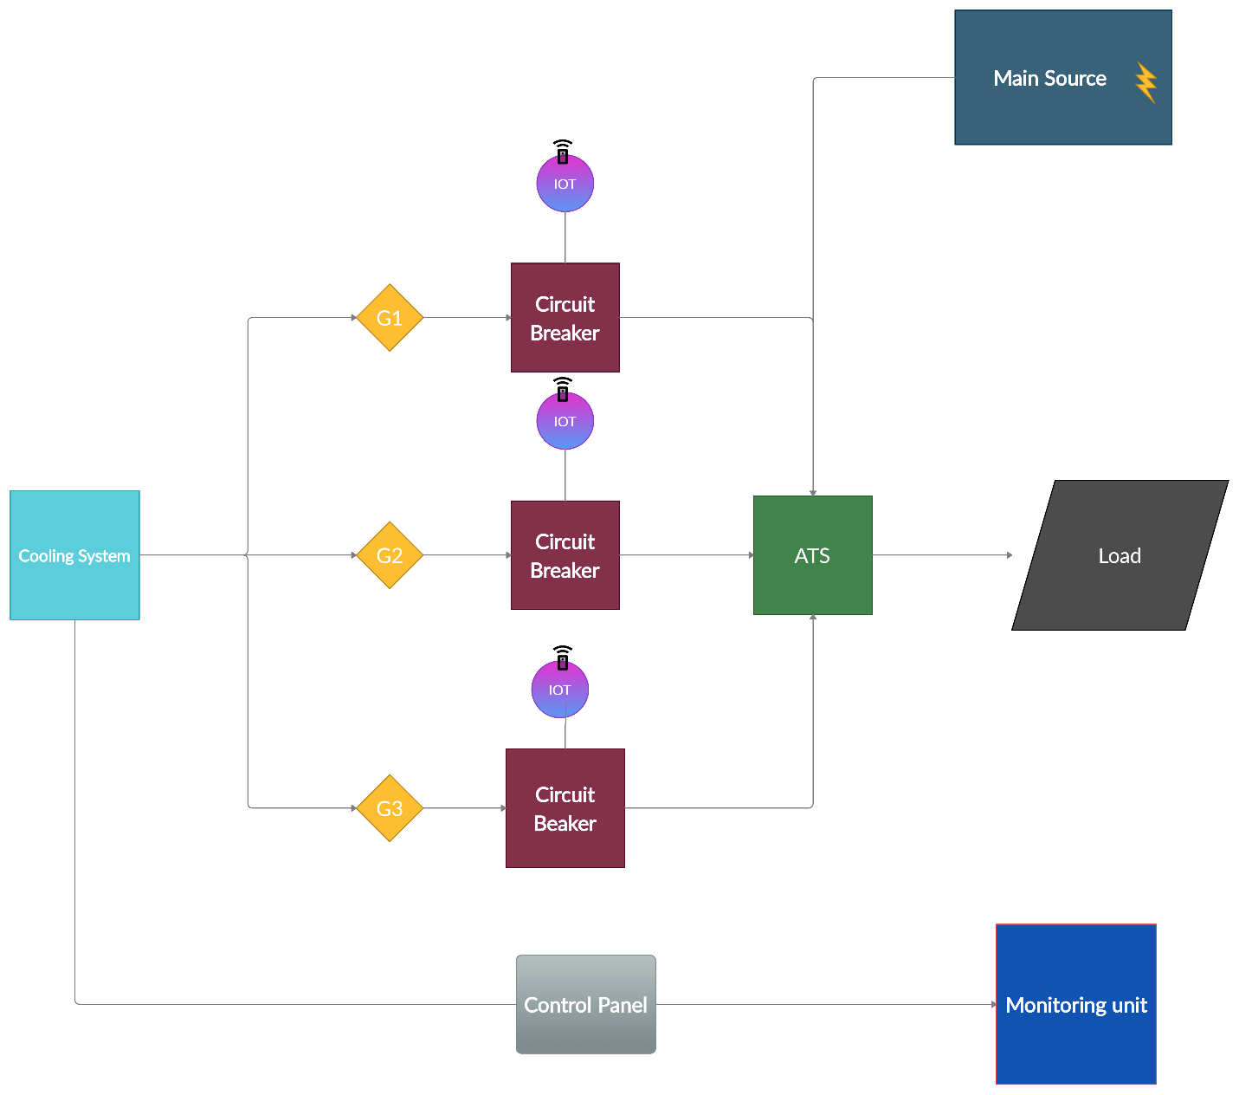

**Cooling System: Used in Task 6**

It will make the generators work alternatively to get the most out of the whole backup system by applying a cool period of 8 hours for each generator and this results in more efficiency in the whole system.

**The three Generators: Used in all tasks and specially Task 1**

The main power suppliers in the backup system each of which has a 600 KW capacity.

**Circuit Breakers: Used in Task 2 and 3**

It is a protective device and essential component in the safety circuits and it controls the flow of the current through the system just like a fuse.

It breaks the circuit in case there is any fault conditions like short circuit and overload which is required in our system to apply the load balancing.

**The IOT section: Used in Task 5**

Together with the circuit breaker we can operate the circuit breaker automatically or manually by a remote control which is required in our system to control in normal and faulty conditions.

**The monitoring unit and control panel: Used in Task 5**

and by connecting a monitoring unit to the control panel we can monitor changes being happen in the system from faults to operating and idle conditions.

**The Automatic transfer Switch (ATS): Used in Task 3 and 4**

It automatically transfers a power supply from its primary source to a backup source if there is any failure or outage in the primary source.

It is an essential component in backup systems as it can be used to start up local diesel generators to run the facility until the main source is restored.

**The Main Source: Used in all tasks and specially task 4**

It is the electricity being supplied directly to the facility coming from a distribution transformer or power stations.

**The Load: Used in All tasks but specially in Task 2**

It is the facility, but so far, we are going to represent it in our system as motors.