

**Digital lab 1**

**Experiment 3:**

**inverter gate**

**Ali bsharat**

**Asem diab**

**Malek Abu Jumah**

**Dr. Muhannad Al-Jabi**

**Abstract**

**What did we do?**

In this experiment we constructed small digital circuits to investigate the logic of some common gates, such as open collector inverter and Schmitt trigger inverter.

**How did we do it?**

We connect the Open Collector inverter gate with multi-meter and power supply by board and wires without resistor then we change the input and read the output voltage then we connect the circuit with resistor and read the output voltage again we change the input and read the output voltage .

We connect Schmitt Trigger gate with multi-meter and power supply by board and wires we increase the input from 0 to 5 in step of 0.2 volt and record the output and decrease the input from 5 to 0 on step of 0.2 volt and record the output.

**What did we find?**

Open collecter inverter gate consist of transistor will work properly if we connected the resistor to its output and the output in Schmitt trigger gates retains its value until the input changes

**Introduction**

We do this experiment to become familiar with open collecter gates and to understand the meaning and importance of Schmitt trigger levels for digital gates

**Tools and equipment**

We will use TTL IC’s such as:

1. 74LS05 open collector inverter gate

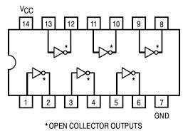

1. 74LS14Schmitt trigger inverter gate
2. Different Wires.
3. Power Supply.
4. Resistors.
5. Digital multi-meter.
6. Bread board

# Procedure

**Part 1: Open collector gates:-**

1-Obtainan an open Collector inverter, e.g. 74LS05 or 74LS06.

2- Connect VCC and GND to the IC.

U4A

74

LS

05

1

2

3- Connect the inverter input to GND and record the output.

1. Connect the inverter input to VCC and record the output.
2. Connect a 1K ohm resistor from the output to VCC.

VCC (5V)

U4A

74

LS

05

1

2

R2

1

k

Vin

Vout

1. Repeat 3 and 4.

Now he circuit is on because the resistor help the circuit to connected with VCC and to be on.

1. What symbol is used for Open Collector gates?

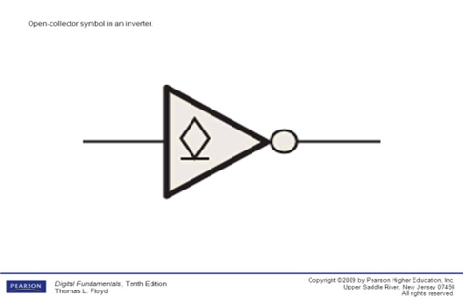

*** We found the output voltage and the corresponding logic for each case without resistor.

|  |  |  |
| --- | --- | --- |
| Input | Output Voltage | Logical output |
| 0 | 0.320v | 0 |
| 1 | 0.243v | 0 |

Table 1

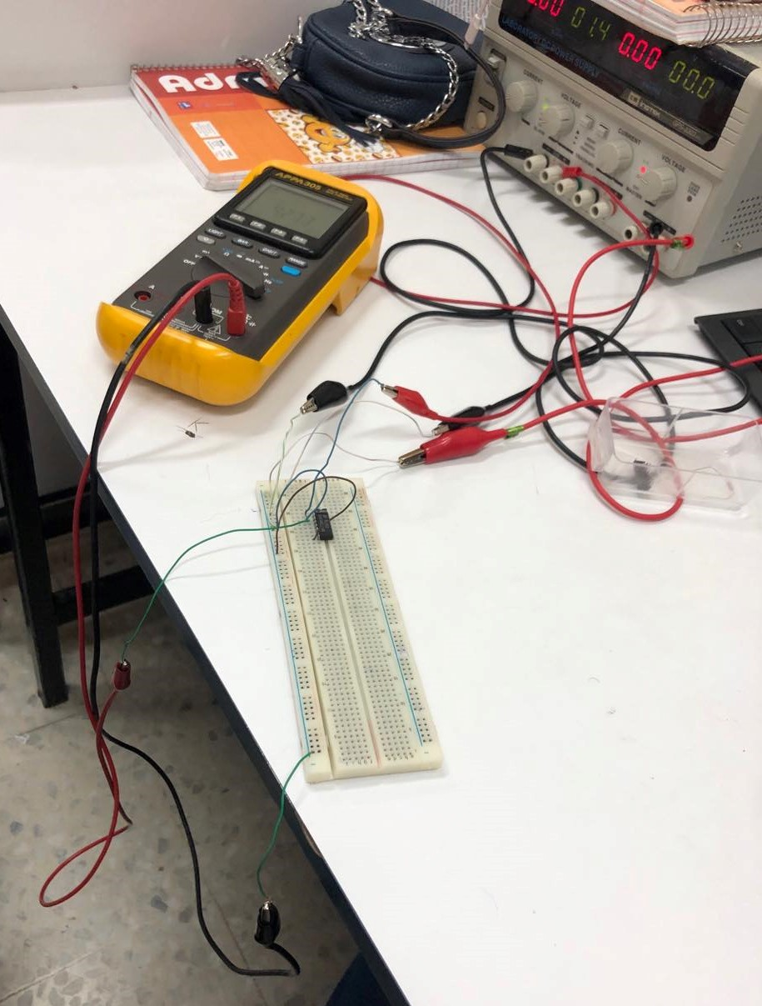

*** Then we found the output voltage and the corresponding logic for each case with resistor.

|  |  |  |
| --- | --- | --- |
| Input | Output Voltage | Logical output |
| 0 | 4v | 1 |
| 1 | 0.502v | 0 |

Table 2

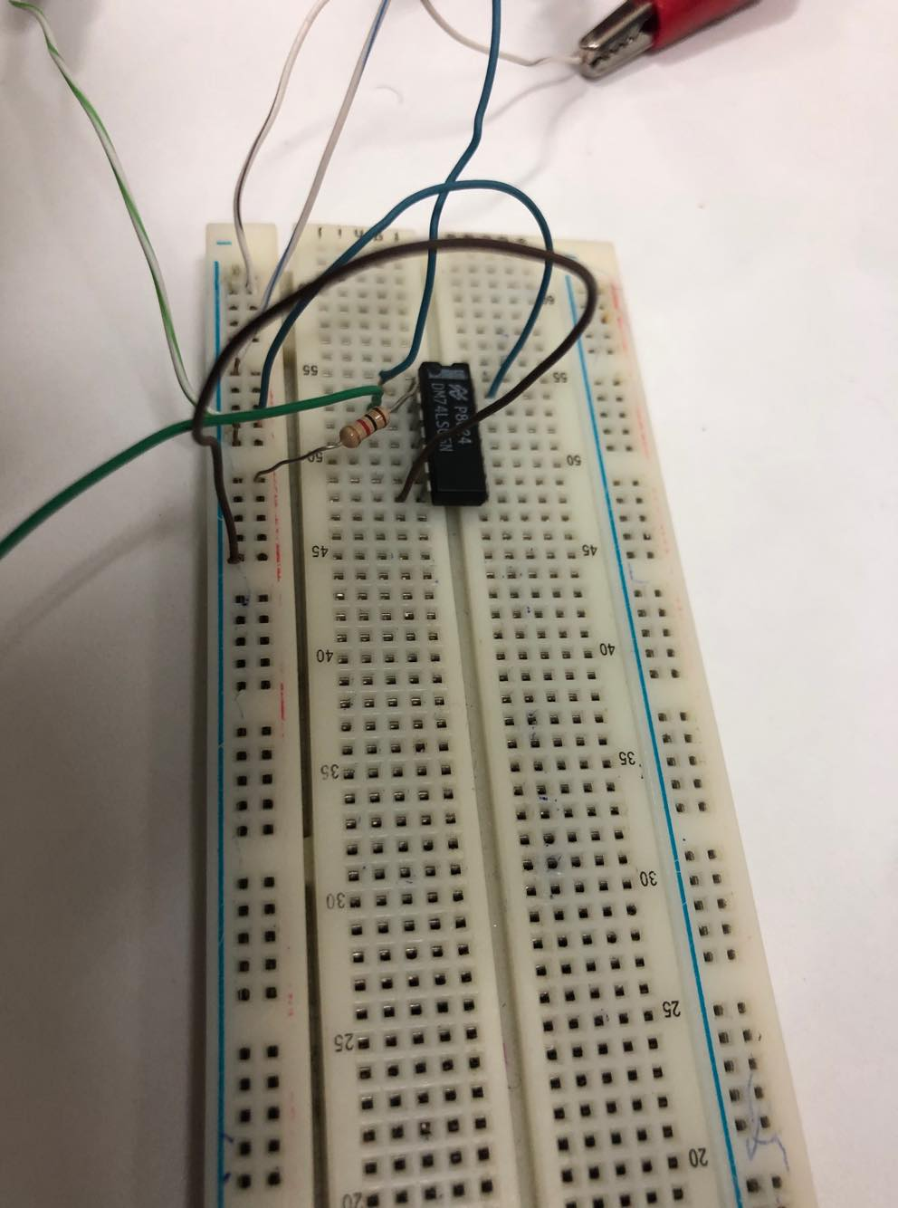

**Part 2: Schmitt Trigger Gates: -**

1. Obtain a Schmitt trigger inverter e.g.74LS14
2. Connect the circuit as shown below.
3. Increase the input from 0 to 5 in steps of 0.2 volt. You may increase or decrease the step as appropriate.
4. Recordthe input and the output.
5. Decrease the output from 5 to 0 in steps of 0.2 volt.
6. Record the input.
7. Plot Vout versus Vin.
8. Notice that there are two breakpoints **VT+** and **VT‐**.What are they?

**VT+** =1.2

**VT‐** = 1.4

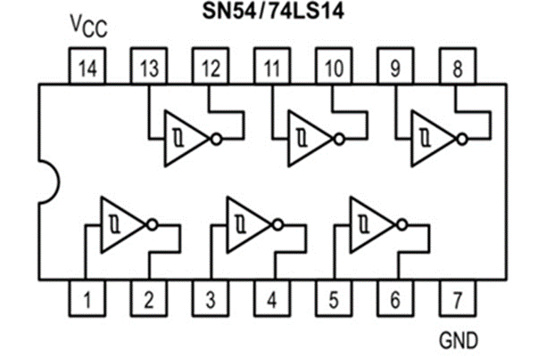

|  |  |
| --- | --- |
| Vin | Vout |
| 4.0 | 0.2710v |
| 3.8 | 0.2641v |
| 3.6 | 0.2654v |
| 3.4 | 0.2127v |
| 3.2 | 0.2010 v |
| 3.0 | 0.1958v |
| 2.8 | 0.1926v |
| 2.6 | 0.1949v |
| 2.4 | 0.1948v |
| 2.2 | 0.1943v |
| 2.0 | 0.1993v |
| 1.8 | 0.1843v |
| 1.6 | 0.1821v |
| 1.4 | 0.1814v |
| 1.2 | 4.201v |
| 1.0 | 4.212v |
| 0.8 | 4.241 v |
| 0.6 | 4.250v |
| 0.4 | 4.261v |
| 0.2 | 4.270v |
| 0.0 | 4.271v |

**Results:**

|  |  |
| --- | --- |
| Vin | Vout |
| 0.0 | 4.27 v |
| 0.2 | 4.273 v |
| 0.4 | 4.276 v |
| 0.6 | 4.284v |
| 0.8 | 4.287v |
| 1.0 | 4.29v |
| 1.2 | 4.92v |
| 1.4 | 0.18v |
| 1.6 | 0.182v |
| 1.8 | 0.1843v |
| 2.0 | 0.1993v |
| 2.2 | 0.1943v |
| 2.4 | 0.1948 v |
| 2.6 | 0.1951v |
| 2.8 | 0.1961 v |
| 3.0 | 0.2130v |
| 3.2 | 0.221 v |
| 3.4 | 0.2267v |
| 3.6 | 0.2364v |
| 3.8 | 0.2453v |
| 4.0 | 0.2682v |

**Table1 Table 2**

Table1

Table2

**Discussion**

**Why we use the resistor with the open collector ?**

To collect the lost voltage and give us a full voltage because without a resistor the output voltage wouldn’t be accurate

**Why we use Schmitt trigger ?**

To remove the distraction and restore the shape of digital signal

**Conclusion**

We learned about open collector and how it works.

We learned that open collector inverter gate that consists of transistor will work properly if we connect a resistor to its output.

We also learned about Schmitt trigger and determined the breakpoints (VT+ and VT-).