**Jordan University of Science and Technology**

**Computer Information Systems**

**CIS441 – Winter2024 Final project**

1. In our project we used the Blueprint to figure out the main idea to construct the network for the university.
2. The idea was based on dividing the Blueprint into 6 Sectors, so we can create sub networks in the university Then connect the sub networks into main router, so the sectors can communicate with each other.

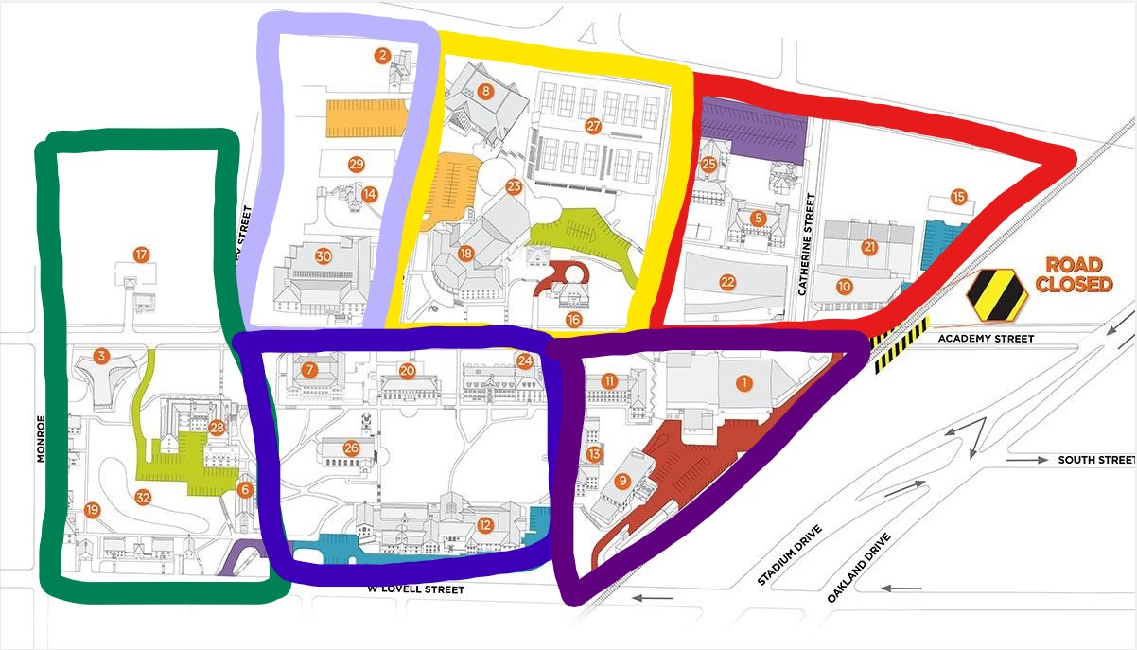

1. Every sector has a core router connected to the main router of all of the sub-networks.
2. Under every router in every sector a multi-layer switch connects all buildings with each other in the sector.
3. Multi-layer switches are used because they have a good processing power. and capable of providing many 1 Gbit/s ports.
4. Every building in every sector has a different **VLAN**. To reduce the load on the DHCP servers and to use class ‘C’ subnet mask efficiently to handle a 100% growth at the network in the future.

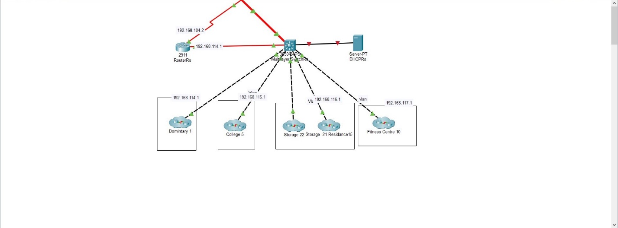

1. large buildings have a core switch that connects to a switch in each floor of that building.

8-We used the hierarchical model with a combination of star and bus topologies to create a loop within sectors.

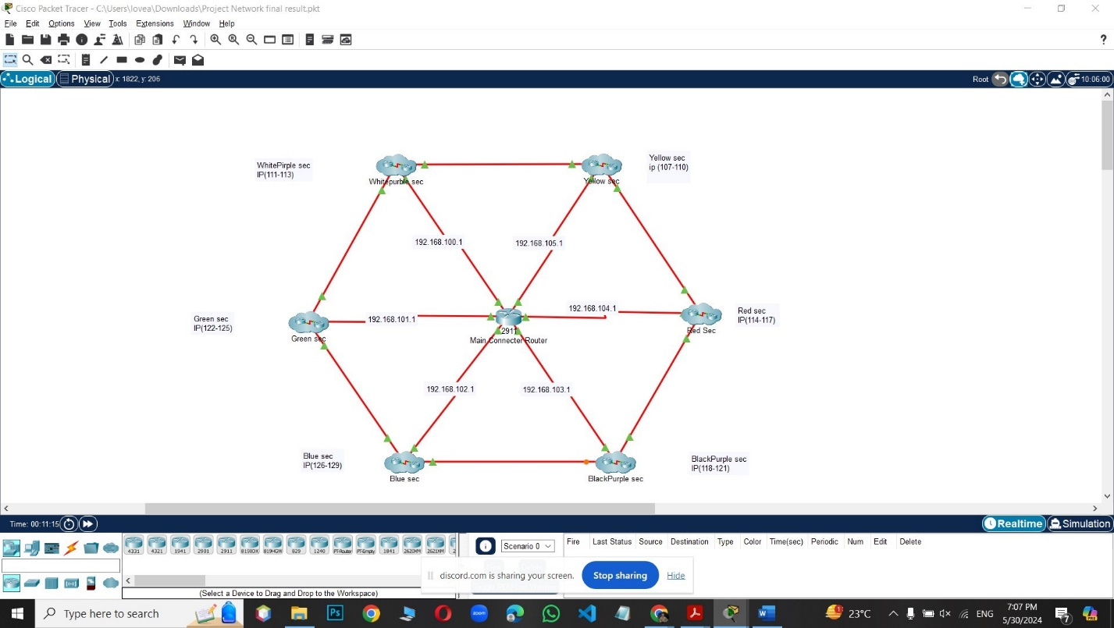

9 – Added access points with a coverage range of ( 250m – 80m ), to provide cameras and students with wireless connection at all places.**

10- We used “Just” as SSID and “Just1234” as Password as wireless network credentials.

11- We used Fiber cables to connect large distant buildings and MLS (to Routers and loops).

12- We used serial cables to connect routers

13 -We used UTP cables to connect PCs and other devices with switches.

**VLANS Configuration**

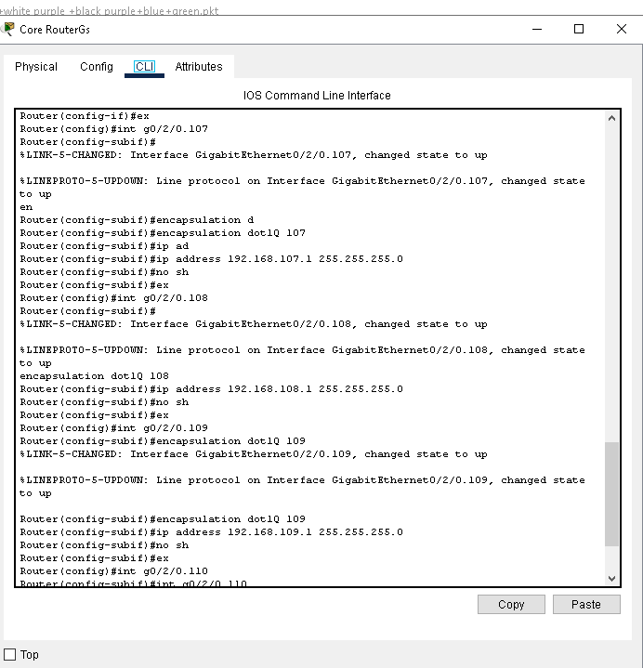

We configured the VLANs on the router using the CLI and assigned them Class C IP addresses.

**Create Pools**

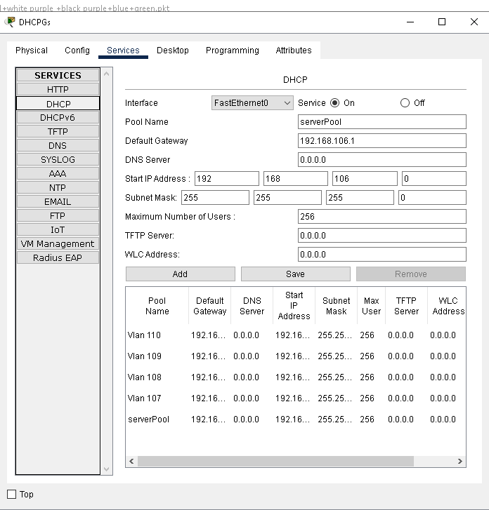

We create pools for each VLAN we use.

**IP Helper Address(VLANS)**

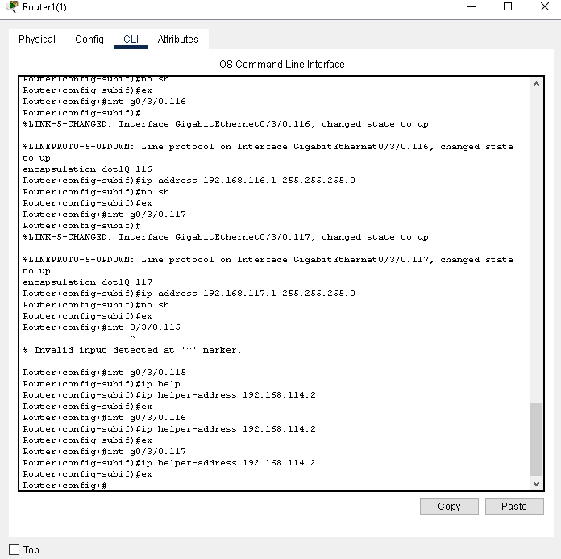

We assign an IP Helper address for DHCP to each VLAN using the CLI.

|  |  |  |  |  |  |  |  |
| --- | --- | --- | --- | --- | --- | --- | --- |
| **Section** | **Yellow** | **WhitePurple** | **Red** | **BlackPurple** | **Blue** | **Green** | **Total** |
| **Routers** | 1 | 1 | 1 | 1 | 1 | 1 | 6 |
| **MLSs** | 1 | 1 | 1 | 1 | 1 | 1 | 6 |
| **Switchs** | 31 | 10 | 16 | 18 | 20 | 22 | 117 |
| **PCs** | 284 | 80 | 130 | 180 | 156 | 138 | 968 |
| **AccessPoints** | 6 | 3 | 5 | 4 | 5 | 5 | 28 |
| **Cameras** | 22 | 12 | 17 | 18 | 18 | 27 | 114 |
| **DHCP** | 1 | 1 | 1 | 1 | 1 | 1 | 6 |
| **Totlal** | 345 | 108 | 171 | 223 | 202 | 195 | 1244 |
| **DHCP Pools** | 107-110 | 111-113 | 114-117 | 118-121 | 126-129 | 122-125 | 100-129 (including static IPs Devices) |