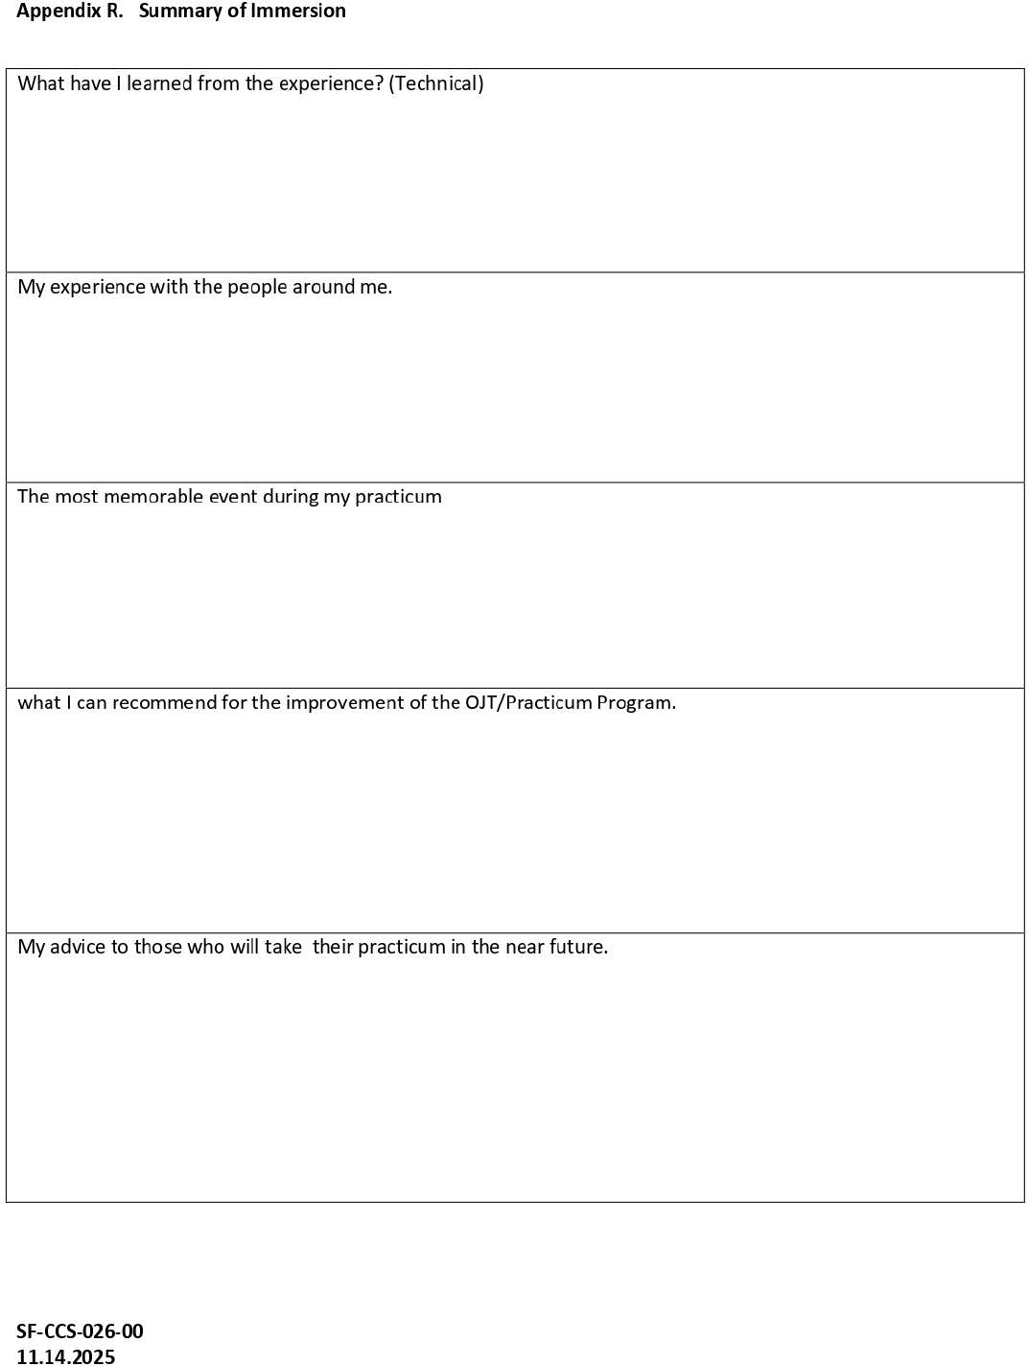
My advice is to keep learning and practicing. Be patient when fixing errors because coding takes time. Always ask questions if you are confused, listen to feedback, and do your best in every task.
I recommend giving trainees clear tasks and examples before they start working. It would also help if trainees receive feedback after each task so they can know what to improve. More hands-on activities would also help students learn faster.
The most memorable event during my practicum was when I finished improving a page in the system. I felt proud because I could see my changes working on the screen, and I knew that my work helped make the system better.
My experience with the people around me was good. They were helpful and guided me when I needed help. I learned how to communicate better, ask questions, accept feedback, and work with other people on a project.
I learned how to create and improve the design of a website or system. I learned how to use HTML, CSS, JavaScript, and React to build pages and make them work properly. I also learned how to fix layout problems, improve buttons and forms, and make the system easier for users to use.

