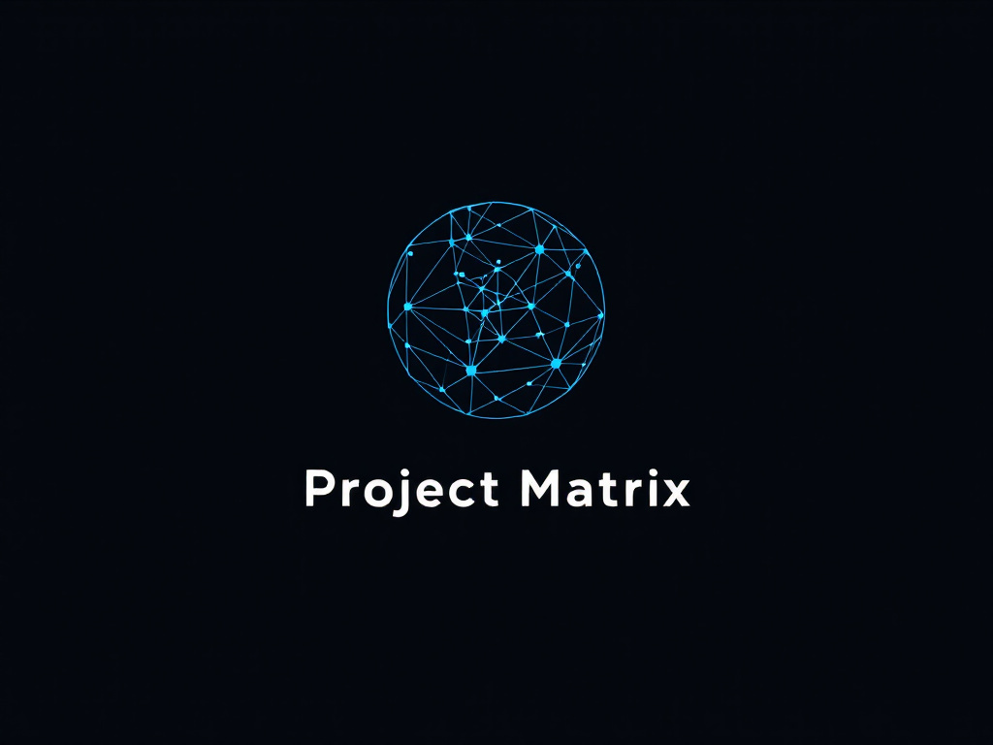
PROJECT MATRIX
U S E R G U I D E
The offline, single-file tool for R&D portfolio
and workforce management

Version | 2.0 · July 2026
Author | Benoit Tani
Copyright | © 2026 Benoit Tani — All rights reserved
Applies to | matrix.html (single-file build)

Table of Contents

1. Introduction

1.1 What is Project Matrix?
Project Matrix is a 100% local, single-file HTML application for Chapter Leaders, R&D Managers and Workforce Planners. It brings project prioritization, resource allocation, skills-risk analysis, cross-functional alignment and an in-browser AI advisor into one tool that runs entirely from a single matrix.html file — no server, no account, no internet connection required after download.
→ Privacy-first by design
Every byte of your data — people, projects, photos, financials, even the AI conversation — stays inside your browser on your own device. Nothing is uploaded, and the app keeps working offline once the file is on disk.

Key capabilities
- Prioritize R&D initiatives on a customizable impact / effort / visibility / enabler matrix.
- Plan resources — allocate engineers to projects across months and track cost in €.
- Visualize the org — reporting lines, headcount and span-of-control in an interactive org chart.
- Manage talent — nine-box, DISC profiles, skills matrix and single-point-of-failure (SPOF) risk.
- Align the offer — a cross-functional charter with financials (NPV / IRR / break-even), a trade-off decision triangle, design-to-cost and channel mix.
- Get insights — people analytics, portfolio analytics and cross-layer portfolio economics.
- Ask the AI advisor — a private, in-browser LLM that reasons over your data.

1.2 Why use Project Matrix?
Challenge | How Project Matrix helps
Too many competing projects | A visual matrix with switchable Y-axis (Impact / Visibility / Enabler) and tactical-intent grouping
Limited engineers, many demands | Month-by-month allocation with FTE tracking and over-allocation warnings
Key-person risk | Skill-risk tab flags SPOFs (skills held by only one person)
Functions pulling in different directions | A charter that detects conflicts between must-have demands and the project's trade-off stance
Decisions without numbers | Financials, portfolio analytics and economics with € / ROI / NPV / break-even
Confidentiality | 100% local — no data leaves the device
Working offline | One self-contained HTML file

1.3 Who it is for
- R&D & Chapter leaders — prioritize, staff, and align initiatives with strategy.
- Workforce / HR planners — spot skill gaps, plan succession and headcount.
- Product & offer managers — weigh cost vs. time vs. features and shape the go-to-market.
- Finance & controlling — track ROI, NPV and project cost.
- Consultants & analysts — build decks and synopses for stakeholders.

1.4 System requirements
Requirement | Details
Operating system | Windows 10/11, macOS 10.15+, or a modern Linux distribution
Browser | Chrome or Edge recommended; Firefox / Safari for core features
Memory | 4 GB RAM minimum; 8 GB+ recommended when using the AI advisor
GPU (AI only) | A WebGPU-capable GPU is required for the AI advisor (see section 5)
Storage | A few MB for the app; 1–2 GB per AI model, cached by the browser on first use

2. Getting Started

2.1 Installation — there is none
Project Matrix is a single file. There is nothing to install and no admin rights are needed.
- Get the file. Download matrix.html from the GitHub Releases page (the dist/ build).
- Open it. Double-click matrix.html to open it in your default browser.
- Optional — run a local server. If a browser blocks local-file features, serve the folder instead:
python -m http.server 8000
then open http://localhost:8000/matrix.html. The VS Code “Live Server” extension works too.
⚠ Keep the file in one place
Photos and other browser-stored data are tied to the exact file location (origin). If you move or rename matrix.html later, the app opens but its photo store looks empty — a recovery prompt appears. Decide on a home for the file before adding photos, and use Backup (section 8) to move data between locations.

2.2 First run
On the very first launch a welcome screen asks you to choose the view the app opens on. Pick Roster (recommended — start from the team) or Portfolio Matrix (start from project prioritization). You can change this any time in Settings › Default landing view.

2.3 Create your first project
- Open OFFER MNGT › Portfolio matrix from the navigation rail.
- Click + PROJECT on the matrix toolbar.
- Fill in the details and click ADD:
Field | Meaning
Name | Project title, e.g. “Next-Gen HVAC Controller”
X position (Effort) | Horizontal axis, 0–10 (renameable)
Impact / Visibility / Enabler | Score on each Y-axis dimension, 0–10
Section | Grouping bucket, e.g. Hardware / Software
Sector / Domain | Market segment, e.g. HVAC, Power
Tactical intent | Strategic posture: Defend, Grow, Adapt or Diversify
Revenue impact (M€) | Expected revenue in millions of euros
Color | Bubble color on the matrix

2.4 Add your first team member
- Go to TEAM › Roster.
- Click + ENGINEER.
- Enter name, role, skills, group, monthly cost and start date; optionally add a photo (stored locally). Click SAVE.
→ Two ways to add people
A real engineer counts toward cost and utilization. A “planning resource” (a placeholder for a role you haven't hired yet) lets you plan future demand — it only counts toward cost if you tick “include in cost”.

3. Navigation & Interface

3.1 The navigation rail
A persistent left rail is the single entry point to everything. It is grouped into domains (which set the visible view) and a utility foot (one-shot actions). Hover the collapsed rail to expand it; click the pin to lock it open.
Domain | Views it contains
TEAM | Roster · Org chart
OFFER MNGT | Portfolio matrix · Financials analysis · Trade-off decision · Channel mix · Design to cost · Project brief
PLAN | Resource plan · Timeline · Backlog & planner
SKILLS | Skills matrix · Skill risk (SPOF) · Heatmap
TALENT | Nine-box · DISC · Team profiles · Development
INSIGHTS | Portfolio analytics · Portfolio economics · People analytics · Summary · Cost dashboard · Compare
The utility foot holds the fire-and-forget actions: Snapshots, Backup, Restore, AI advisor, Settings and Help. These never change which view you are on.
→ The Matrix is no longer the “home” screen
In earlier versions the impact/effort matrix was the front door. It is now one view under OFFER MNGT (carrying a “was home” badge). The app opens on your chosen landing view instead — Roster by default.

Rail preferences
- Auto-hide — collapse the rail when the pointer leaves it (Settings).
- Collapsed width — adjustable 48–96 px (Settings; default 58 px).
- Pin — lock the rail open so labels stay visible.

3.2 The top bar
- Breadcrumb — the current Domain › View, e.g. PLAN › Resource plan.
- Storage health — how full the browser’s local storage is.
- Auto-save status — shows that changes are being saved automatically.

3.3 Overlays, panels and modals
Type | Examples | Behaviour
Overlay (full) | Help, Summary, Compare, Resource plan | Fills the screen beside the rail; close with Esc or ✕
Panel (rail-inset) | Financials analysis, Trade-off decision, Channel mix | Opens inset from the rail; close with ✕
Modal (dialog) | Add project, Settings | Centered dialog; close with ✕ or Cancel

4. Core Features

4.1 Roster (TEAM)
The Roster is the team overview: every engineer and planning resource as a card with role, group, skills and photo. It is the recommended landing view and the source of truth for who exists in the tool. Add people here with + ENGINEER; click a card to open the full ID card (skills, cost, dates, DISC, nine-box, development).

4.2 Portfolio Matrix (OFFER MNGT)
Plot projects as bubbles to compare them at a glance.

Axes
- X-axis — Effort by default (0–10), renameable, with adjustable min/max and Linear/Log scaling.
- Y-axis — switch between Impact, Visibility and Enabler using the toolbar buttons (or the 1 / 2 / 3 keys).

Drawing & annotation
Annotate the matrix for reviews with select/move, lines, dashed lines, arrows and text labels. Group projects by tactical intent (Defend / Grow / Adapt / Diversify) to read the portfolio’s strategic balance.

4.3 Resource Plan (PLAN)
The Resource plan is where you allocate people to projects over time and watch the cost. A shared From / To period at the top drives every tab — change it once and all figures re-scale to those months.

What to watch
- Allocation — set each person’s FTE on each project, month by month. Over-allocation (>1.0 FTE) is flagged.
- Cost by project — the uncapped share each project bears. If someone is spread across two projects, both carry their share — that is the over-allocation signal, not an error.
- Team cost — cost per person, capped at 1.0 FTE, so Team cost = allocated + unallocated.
→ Two deliberate cost lenses
“Cost by project” is uncapped (it can exceed one salary when someone is over-allocated). “Team cost” caps each person at 1.0 FTE. They answer different questions — don't try to reconcile them into a single number.
Status letters matter for cost: m/r (medical / resigned) = 0 cost and 0 FTE, p (PTO) = full cost and 1.0 FTE, a number = that fraction. Vacancies (planned roles) do count toward forecast spend.

4.4 Org Chart (TEAM)
- Hierarchy — people appear as nodes in a reporting tree.
- Drag-and-drop — re-parent a node to reshape the org.
- KPI overlays — optionally show span of control, tenure and headcount.
- Export — save the chart as a high-resolution PNG.

4.5 Skills, Risk & Talent (SKILLS / TALENT)

Skill risk — single points of failure
The Skill risk tab flags SPOFs: skills held by only one person. Typical coding — red for a single holder, amber for thin coverage, green for healthy. Use it to target cross-training and hiring before a key person becomes a bottleneck.
⛔ Address SPOFs early
A skill with a single holder is a project risk waiting to happen. Cross-train or hire before that person is unavailable, not after.

Nine-box & DISC
Under TALENT, plot people on a nine-box (performance × potential, with per-year history and trajectory) and capture DISC behavioural profiles. Team profiles and Development round out succession and growth planning.

Skills matrix & heatmap
The Skills matrix records who has which skill and at what level; the Heatmap turns that into a coverage view across the team.

5. AI Advisor
The AI advisor is a private, in-browser assistant that reasons over your Project Matrix data. It runs a quantized language model entirely on your machine using WebLLM + WebGPU — there is no backend, no API key, and no data ever leaves the browser.

5.1 Requirements
- Browser: Chrome or Edge (best support); a WebGPU-capable GPU is required.
- VRAM: ~4 GB for a small model (e.g. Llama 3.2 1B); more for larger models.
- First use: the model weights (1–2 GB) stream from a public source once, then the browser caches them so later use works offline.
→ How loading works
Nothing is bundled into matrix.html — the AI library and model weights are fetched on demand and cached. The model is never loaded automatically on start (it's heavy); you trigger it, and a pre-flight check tests your GPU before any large download. A stall watchdog offers a “reload to resume from cache” hint if a download hangs.

5.2 Using the advisor
- Click AI advisor in the rail’s utility foot; load the model when prompted.
- Choose a scope — tick the specific people and/or projects to focus on (a live token estimate shows the budget). Focusing on one person is far cheaper and sharper than sending the whole org.
- Type your question and press Enter. Replies stream in token by token.
Example questions: “Who can replace Alice on Project X?” · “What are our biggest skill gaps?” · “Which projects are over-allocated?”
⚠ If the GPU drops out
On some Windows/NVIDIA setups a long generation can trip the GPU driver (“device removed”). The advisor saves the conversation and offers a “Reload page” banner to recover. If it recurs, prefer a smaller model (Llama 3.2 1B), update your GPU driver, and fully restart the browser.

6. Offer Management Modules
These OFFER MNGT views turn a project into a cross-functional, financially grounded case. They all read and write the same charter that lives on the project, so everything flows through save, backup and snapshots automatically. All money is in euros.

6.1 Financials Analysis (the Charter)
A per-project artifact that aligns the five functions — Strategy, R&D, Offer Management, Procurement and Industrialization — on shared priorities. It has three tabs:
- Overview — business case, priority, status and expected revenue.
- Demands — each function’s alignment (1–10) and its list of demands, tagged as must-have or not, on a dimension (features / time / product cost / project cost).
- Financials — investment, cash flows and unit economics driving NPV, IRR, break-even and margin, with SVG curves.
→ Conflict detection is the point
When a function marks a demand “must-have” on a dimension the project has chosen to sacrifice, that's a conflict — highlighted in red on the board, the decision panel, the deck and the synopsis. It makes the classic failure visible before it happens.
Export as a 5-slide deck or a one-page synopsis (copy as Markdown, or Print/PDF).

6.2 Trade-off Decision
A configurable trade-off triangle. For the four dimensions (features, time, product cost, project cost) you set a stance — prioritize, balance or sacrifice — and the triangle plots three of them, with a weighted marker pulled toward what you prioritize. Add up to two named comparison scenarios side by side, plus explicit non-negotiables and flexibilities. An alignment radar and the live conflict list sit alongside.

6.3 Design-to-Cost
Bring cost into the design conversation early.
- Target-cost cascade — break the unit cost into subsystems (with optional BOM items and include/exclude toggles) against the allowable envelope (price − target margin). Toggling a part off is instant scenario analysis.
- Cost-down waterfall — levers (idea / committed / realized) step the current cost down toward the target.
- Design guidelines — do/don’t rules generated from the trade-off stances, plus conflicts as hard constraints.
- Competition analysis — up to five competitors plus “Us”, comparing cost, margin and brand premium.
- Loop-closer — push the rolled-up cost back into the financials with one click.

6.4 Channel Mix
A per-project go-to-market synoptic: Company/Project → Channels → Segments, with arrow thickness proportional to each channel’s share. Choose what the share means with basis: revenue (splits expected revenue into € per channel), volume (splits units) or emphasis (weighting only). A live summary checks the shares against 100% and shows a share-weighted blended margin.

7. Insights & Analytics
The INSIGHTS domain has three read-only analytics views. None of them ever change your data.

7.1 People Analytics
A story/dimension engine over the team — headcount, cost, skills, tenure and talent distributions — to answer “what does the workforce look like?”

7.2 Portfolio Analytics
- Spend-map treemap — project cost or revenue by area, optionally nested by tactical intent; color encodes ROI rank.
- Cost-over-time burn — monthly and cumulative cost with break-even.
- Distribution — histogram of project metrics (impact / visibility / enabler) with Gaussian / Pareto overlays.
- Channel-mix rollup — the portfolio’s revenue by channel.

7.3 Portfolio Economics
The cross-layer view: it joins value (charter financials), cost (allocations + design-to-cost), route-to-market (channels) and decision (conflicts + alignment) into one place. It computes risk-adjusted NPV, a profitability index, channel/segment concentration, a pool-level mix-shift what-if, and — on demand — a trajectory over snapshots so you can see how the portfolio’s economics have moved over time.

8. Data Management

8.1 Where your data lives
Project Matrix stores everything locally, across a few browser stores:
Store | Holds
Main state (localStorage) | Engineers, projects, allocations, matrix layout and UI settings
Photos (IndexedDB) | Compressed engineer photos, kept out of the main state
Talent (IndexedDB) | Nine-box and DISC placements
Snapshots (IndexedDB) | Time-travel copies of your data

8.2 Auto-save
Auto-save is on by default — changes are written to local storage continuously, and the top bar confirms it. There is no “document” to lose; reopening the same matrix.html restores your latest state.

8.3 Snapshots (time-travel)
A snapshot captures the current state so you can return to it later — ideal before a big reorganization or an experiment. Snapshots live inside the current dataset (they share the live photo store), so they are for intra-dataset time-travel, not for moving data between machines. Use them freely; they don’t touch your photos.

8.4 Backup & restore
- Open Backup in the rail’s utility foot.
- Click Export full backup — a single JSON file (including photos) downloads.
- To restore, open Restore and select a backup file.
⚠ Restoring replaces everything
A full-backup restore is a dataset swap: it replaces all current data, including photos, with the backup's. A safety snapshot is taken automatically first. Use full backups — not snapshots — to move your data to another computer or file location.

9. Settings & Customization
Open Settings from the rail’s utility foot.
Setting | What it does | Default
Language | Interface language: English, French or Chinese (reloads the app) | English
Default landing view | The view the app opens on | Roster
Auto-hide nav rail | Collapse the rail when the pointer leaves it | Off
Collapsed rail width | Width of the collapsed rail, 48–96 px | 58 px
Charter picker mode | How you pick a project for the charter panels: card hub or dropdown | Hub
→ Language is a device preference, not data
Your chosen language is stored separately from your project data. A French user's backup opens exactly the same for a colleague working in English or Chinese — only the interface chrome changes, never the stored content.

Interface accent colors
The app’s interface uses a lime accent (#c8f135) and a teal secondary (#5be5c8) on a dark background, with red (#f14335) for danger and amber (#f1a435) for warnings.

10. Keyboard Shortcuts
Press ? at any time to open the in-app Help panel with the full, current shortcut reference. Common ones:
Key | Action
? | Open the Help panel
Esc | Close the open panel, overlay or modal
1 / 2 / 3 | Matrix Y-axis: Impact / Visibility / Enabler
+ PROJECT | Add a project (Matrix toolbar)
+ ENGINEER | Add a team member (Roster)

11. Troubleshooting
Symptom | Likely cause | What to do
App won’t open / features blocked | Browser restricting local files | Serve the folder (python -m http.server) or use Live Server
AI advisor unavailable | No WebGPU support | Use Chrome/Edge on a WebGPU-capable GPU; check chrome://gpu
Model download stalls | Network hiccup or a hung shard | Click Reload in the stall hint to resume from cache
“Device lost / removed” during AI | GPU driver reset (TDR) | Reload the page, pick a smaller model, update the driver, restart the browser
Photos look missing | matrix.html was moved or renamed | Use the recovery prompt, or restore a full backup at the new location

12. Frequently Asked Questions
Q. Who owns Project Matrix, and can I share it?
A. Project Matrix is proprietary software — © 2026 Benoit Tani, all rights reserved. It is not open source. Please do not copy, redistribute or modify the application without the author's written permission.
Q. Does it need an internet connection?
A. No. After you have the file (and, for AI, the one-time model download), it works fully offline.
Q. Is my data private?
A. Yes. Everything — including the AI — runs locally in your browser. No data is uploaded.
Q. How do I move my data to another computer?
A. Export a full backup (JSON) and restore it on the other machine. Snapshots stay with their dataset and are not meant for transfer.
Q. Which browser should I use?
A. Chrome or Edge for the full experience, especially the AI advisor. Firefox and Safari run the core features.
Q. Can several people share one file?
A. Project Matrix is a single-user local tool. Share by exporting a backup or a charter deck/synopsis; there are no accounts or approvals.

Appendix A — Quick-Start Checklist
☐ Download matrix.html and open it in Chrome or Edge.
☐ Choose a landing view (Roster recommended).
☐ Add a few projects on the Portfolio matrix.
☐ Add your engineers and planning resources in Roster.
☐ Allocate people to projects in the Resource plan and set the From/To period.
☐ Check Skill risk for SPOFs.
☐ Fill a project’s Financials analysis and Trade-off decision.
☐ Try the AI advisor (if your GPU supports WebGPU).
☐ Export a full backup.

Appendix B — Glossary
Term | Definition
FTE | Full-Time Equivalent; 1.0 = 100% of a person’s time
SPOF | Single Point of Failure; a skill held by only one person
Nine-box | A 3×3 grid plotting people by performance and potential
DISC | A behavioural profile (Dominance, Influence, Steadiness, Conscientiousness)
Tactical intent | A project’s strategic posture: Defend, Grow, Adapt or Diversify
NPV / IRR | Net Present Value / Internal Rate of Return — discounted-cash-flow metrics
Charter | The cross-functional project artifact aligning the five functions
Snapshot | A time-travel copy of your data within the current dataset
WebGPU | The browser graphics API the in-browser AI runs on

Appendix C — Best Practices

For R&D & chapter leaders
- Start on the matrix — agree priorities visually before staffing.
- Staff early — allocate in the Resource plan before a project kicks off, and watch over-allocation.
- Review SPOFs regularly — make Skill risk a standing agenda item.
- Charter the big bets — use Financials analysis + Trade-off decision to surface conflicts before commitment.
- Back up before big changes — snapshot for quick undo, full backup to move or archive.

Support, License & Revisions

Getting help
- Issues: github.com/Asepsie/Matrix/issues
- Discussions: github.com/Asepsie/Matrix/discussions

Copyright & license
© 2026 Benoit Tani. All rights reserved. Project Matrix — its source code, design and this documentation — is proprietary. No part may be copied, distributed, modified, decompiled or used to create derivative works without the prior written permission of the author.
The application runs entirely on your own device and stores no data externally; using it locally does not transfer any ownership or rights in the software.

Revision history
Milestone | Date | Highlights
Current build | July 2026 | Persistent navigation rail; AI advisor; charter (financials + trade-off); design-to-cost; channel mix; portfolio analytics & economics; EN/FR/ZH localization.
Initial build | June 2026 | First working build — core portfolio matrix, roster, resource plan and org chart.

Project Matrix User Guide · Version 2.0 · July 2026 · © 2026 Benoit Tani. All rights reserved.

