ADRIAN TURION |  | Avenue de Sainte-Clotilde 9  1205 Geneva, Switzerland | 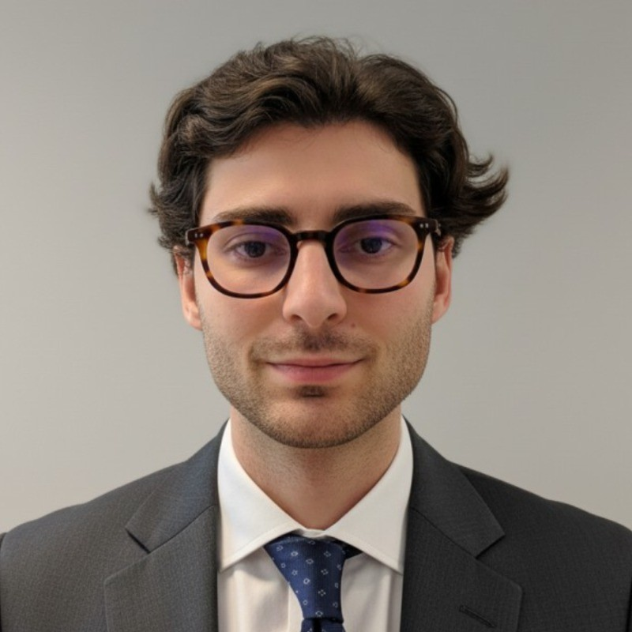
turionadrian@gmail.com | Swiss national | 10.11.2000 |  | +41 77 262 37 96
INTRODUCTION
Finance graduate with hands-on deal-making experience across multiple concurrent mandates. Entrepreneurial mindset combined with strong analytical and data analysis skills, thriving in fast-paced, high-stakes environments. Eager to apply commercial aptitude and resilience to Glencore's dynamic trading operations.
WORK EXPERIENCE
Auraïa Capital Advisory – Small & Mid Cap Cross-border M&A Boutique  Mergers & Acquisitions Analyst (Converted internship into full-time position) |  | Geneva, Switzerland  Aug 2024 – Current
- Staffed on 7 live mandates (sell-side, buy-side, debt advisory) across healthcare, tech, and life sciences with deal values ranging from EUR 5M to EUR 50M, managing multiple concurrent priorities under tight deadlines
- End-to-end execution exposure in a lean 3-person deal team (sourcing, valuation, due diligence, negotiations, closing), demonstrating individual responsibility and ownership from day one
- Conducted comprehensive industry research and identified strategic buyers for cross-border deals spanning Europe, US, and Asia, leveraging AI-driven tools to streamline buyer sourcing and reduce research time by 90%

RC Group – Currently under LBO with Crédit Mutuel Equity  Mergers & Acquisitions Intern |  | Paris, France  Feb 2024 – Aug 2024
- Worked directly with the CEO of Healthcare and Retail divisions on evaluating multiple acquisition targets in France and Belgium, preparing investment memos including market analysis, and financial projections for 3 potential acquisitions

Europ Assistance – Subsidiary of Generali Insurance  Financial Analyst Intern |  | Geneva, Switzerland  Apr 2024 – Aug 2024
- Built automated financial dashboards in Excel and PowerBI to track KPIs and performed variance analysis on monthly P&L results for a CHF 50M+ revenue subsidiary, improving financial reporting efficiency through data-driven automation

LEADERSHIP
- Founded and developed Screeny.ai, an AI-driven software for investment banks to identify strategic acquirers. Adopted by 3 advisory firms, reducing buyer search time from 10h+ to 20min through automation and applied AI
- Led business development at AIESEC, sourcing corporate leads and negotiating partnerships. Closed 3 key deals generating CHF 60K annual revenue and increasing volunteer placements by 40%, demonstrating commercial acumen and resilience
- Founded a second-hand luxury sneaker business using upcycled materials, managing supplier relations in China, product development, and marketing. Achieved profitability within 6 months with 150% sales growth in first year
EDUCATION
HEC Lausanne  Master of Science in Finance |  | Lausanne, Switzerland  2021 – 2024
- Cumulative GPA: 5.2/6.0 (Top 15% of the class cohort)
- Exchange programs at Waseda University (Tokyo, Japan) and Maastricht University (Maastricht, Netherlands)
- Relevant Coursework: Risk Management, Derivatives, Data Science for Finance, Quantitative Asset and Risk Management
- Thesis Topic: Synergies Analysis of the Merger between American Airlines & US Airways

Bachelor of Science in Management |  | 2018 – 2021
- Cumulative GPA: 4.7/6.0

Scientific Baccalaureate with Highest Honors (16.6/20) |  | Aix-en-Provence, France
ADDITIONAL INFORMATION
Languages:  Computer:  Certifications:  Interests:  References: | French (Native, C2), Spanish (Native, C2), English (Fluent, C1), German (Business proficient, B2-C1)  Financial Modeling: Excel, Bloomberg Terminal, Capital IQ, PowerBI | Data Science: Python, SQL, R  Candidate for the CFA Level I exam – November 2025 session  Geopolitics, Badminton (Provence regional finalist), Gym, Real use cases of Artificial Intelligence  Guillaume Arnaldez – Ex-Director at Auraïa Capital Advisory, guillaume.arnaldez@auraia.ch  Sacha Caravatti – CFO at Europ Assistance Switzerland, scaravatti@europ-assistance.ch

