ADRIAN TURION |  | Avenue de Sainte-Clotilde 9  1205 Geneva, Switzerland | 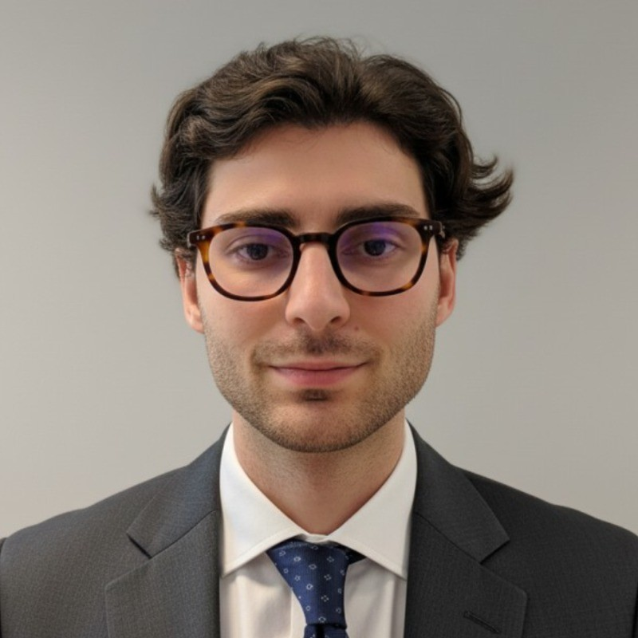
turionadrian@gmail.com | Swiss national | 10.11.2000 |  | +41 77 262 37 96
INTRODUCTION
Finance graduate with hands-on transaction exposure across healthcare, technology, and life sciences sectors. Demonstrated innate curiosity through entrepreneurial ventures and cross-functional projects spanning M&A, FP&A, and technical innovation. Proven ability to work on transactions from day one, developing technical skills and business knowledge in dynamic team environments. Eager to bring analytical mindset and eagerness to learn to Macquarie's Commodities and Global Markets Graduate Programme.
WORK EXPERIENCE
Auraïa Capital Advisory – Small & Mid Cap Cross-border M&A Boutique  Mergers & Acquisitions Analyst (Converted internship into full-time position) |  | Geneva, Switzerland  Aug 2024 – Current
- Staffed on 7 live mandates (sell-side, buy-side, debt advisory) across healthcare, tech, and life sciences sectors with deal values ranging from EUR 5M to EUR 50M, working on transactions from day one in a lean 3-person team
- Built detailed financial models (LBO, DCF, trading comps, precedent transactions) and prepared client presentations for Board meetings and investor pitches, developing technical skills through hands-on deal execution
- End-to-end execution exposure in a dynamic deal team managing sourcing, valuation, due diligence, negotiations, and closing, demonstrating innate curiosity across diverse sectors and transaction types

RC Group – Currently under LBO with Crédit Mutuel Equity  Mergers & Acquisitions Intern |  | Paris, France  Feb 2024 – Aug 2024
- Worked directly with CEO of Healthcare and Retail divisions on evaluating multiple acquisition targets in France and Belgium, preparing investment memos with market analysis, competitive positioning, and financial projections for 3 potential acquisitions (EUR 10M-30M targets)

Europ Assistance – Subsidiary of Generali Insurance  Financial Analyst Intern |  | Geneva, Switzerland  Apr 2023 – Aug 2023
- Built automated financial dashboards in Excel and PowerBI for CHF 50M+ subsidiary, performed variance analysis on monthly P&L results, and prepared Board presentations on financial performance, developing technical skills critical for business knowledge

LEADERSHIP
- Founded and developed Screeny.ai, an AI-driven buyer sourcing tool for investment banks, leading full-stack development and sales outreach; tool adopted by 3 firms, reducing buyer research time by ~90% (10h+ to 20min), demonstrating innovative approach to challenging the status quo
- Finalist in 2024 McKinsey & Company Business Case, presenting data-driven predictive model to executives; showcased analytical thinking and innate curiosity in problem-solving with potential CHF 200K revenue impact
- Led post-COVID financial recovery for AIESEC by sourcing corporate leads and negotiating partnerships; closed 3 deals generating CHF 60K annual revenue through resilience and collaborative teamwork
EDUCATION
HEC Lausanne  Master of Science in Finance |  | Lausanne, Switzerland  2021 – 2024
- Cumulative GPA: 5.2/6.0 (Top 15% of the class cohort)
- Exchange programs at Waseda University (Tokyo, Japan) and Maastricht University (Maastricht, Netherlands)
- Relevant Coursework: Derivatives, Fixed Income and Credit Risk, Data Science for Finance, Quantitative Asset and Risk Management
- Thesis Topic: Synergies Analysis of the Merger between American Airlines & US Airways

Bachelor of Science in Management |  | 2018 – 2021
- Cumulative GPA: 4.7/6.0

Scientific Baccalaureate with Highest Honors (16.6/20) |  | Aix-en-Provence, France
ADDITIONAL INFORMATION
Languages:  Computer:  Certifications:  Interests:  References: | French (Native, C2), Spanish (Native, C2), English (Fluent, C1), German (Business proficient, B2-C1)  Excel, PowerBI, Python, SQL, Bloomberg Terminal, Capital IQ  Candidate for the CFA Level I exam – November 2025 session  Geopolitics, Badminton (Provence regional finalist), Gym, Real use cases of Artificial Intelligence  Guillaume Arnaldez – Ex-Director at Auraïa Capital Advisory, guillaume.arnaldez@auraia.ch  Sacha Caravatti – CFO at Europ Assistance Switzerland, scaravatti@europ-assistance.ch

