ADRIAN TURION |  | Avenue de Sainte-Clotilde 9  1205 Geneva, Switzerland | 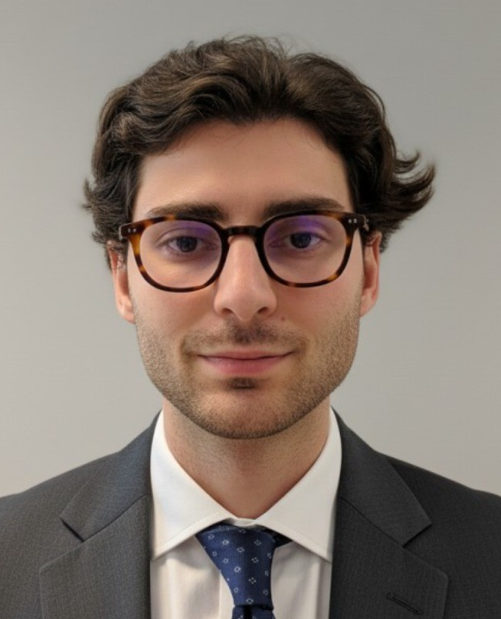
turionadrian@gmail.com | Swiss national | 10.11.2000 |  | +41 77 262 37 96
INTRODUCTION
Finance graduate with hands-on transaction exposure across healthcare, technology, and life sciences sectors. Demonstrated innate curiosity through entrepreneurial ventures and cross-functional projects spanning M&A, FP&A, and technical innovation. Eager to bring analytical mindset and eagerness to learn to Macquarie's Commodities and Global Markets Graduate Programme.
WORK EXPERIENCE
Auraïa Capital Advisory – Small & Mid Cap Cross-border M&A Boutique  Mergers & Acquisitions Analyst (Converted internship into full-time position) |  | Geneva, Switzerland  Aug 2024 – Current
- Staffed on 7 live mandates (sell-side, buy-side, debt advisory) across healthcare, tech, and life sciences sectors with deal values ranging from EUR 5M to EUR 50M, working on transactions from day one in a lean 3-person team
- Built detailed financial models (LBO, DCF, trading comps, precedent transactions) and prepared client presentations for Board meetings and investor pitches, developing technical skills through hands-on deal execution
- End-to-end execution exposure in a dynamic deal team managing sourcing, valuation, due diligence, negotiations, and closing, demonstrating innate curiosity across diverse sectors and transaction types

RC Group – Currently under LBO with Crédit Mutuel Equity  Mergers & Acquisitions Intern |  | Paris, France  Feb 2024 – Aug 2024
- Worked directly with CEO of Healthcare and Retail divisions on evaluating multiple acquisition targets in France and Belgium, preparing investment memos with market analysis and financial projections for 3 potential acquisitions (EUR 10M-30M targets)

Europ Assistance – Subsidiary of Generali Insurance  Financial Analyst Intern |  | Geneva, Switzerland  Apr 2023 – Aug 2023
- Built automated financial dashboards in Excel and PowerBI for CHF 50M+ subsidiary, performed variance analysis on monthly P&L results, and prepared Board presentations on financial performance, developing technical skills critical for business knowledge

LEADERSHIP
- Founded and developed Screeny.ai, an AI-driven buyer sourcing tool for investment banks, leading full-stack development and sales outreach; tool adopted by 3 firms, reducing buyer research time by ~90% (10h+ to 20min)
- Finalist in 2024 McKinsey & Company Business Case, presenting data-driven predictive model to executives; showcased analytical thinking and innate curiosity in problem-solving with potential CHF 200K revenue impact
- Led post-COVID financial recovery for AIESEC by sourcing corporate leads and negotiating partnerships; closed 3 deals generating CHF 60K annual revenue through resilience and collaborative teamwork
EDUCATION
HEC Lausanne  Master of Science in Finance |  | Lausanne, Switzerland  2021 – 2024
- Cumulative GPA: 5.2/6.0 (Top 15% of the class cohort)
- Exchange programs at Waseda University (Tokyo, Japan) and Maastricht University (Maastricht, Netherlands)
- Relevant Coursework: Derivatives, Fixed Income and Credit Risk, Data Science for Finance, Quantitative Asset Management
- Thesis Topic: Synergies Analysis of the Merger between American Airlines & US Airways

Bachelor of Science in Management |  | 2018 – 2021
- Cumulative GPA: 4.7/6.0

Scientific Baccalaureate with Highest Honors (16.6/20) |  | Aix-en-Provence, France
ADDITIONAL INFORMATION
Languages:  Computer:  Certifications:  Interests:  References: | French (Native, C2), Spanish (Native, C2), English (Fluent, C1), German (Business proficient, B2-C1)  Excel, PowerBI, Python, SQL, Bloomberg Terminal, Capital IQ  Candidate for the CFA Level I exam – November 2025 session  Geopolitics, Badminton (Provence regional finalist), Gym, Real use cases of Artificial Intelligence  Guillaume Arnaldez – Ex-Director at Auraïa Capital Advisory, guillaume.arnaldez@auraia.ch  Sacha Caravatti – CFO at Europ Assistance Switzerland, scaravatti@europ-assistance.ch

