ADRIAN TURION |  | Avenue de Sainte-Clotilde 9  1205 Geneva, Switzerland | 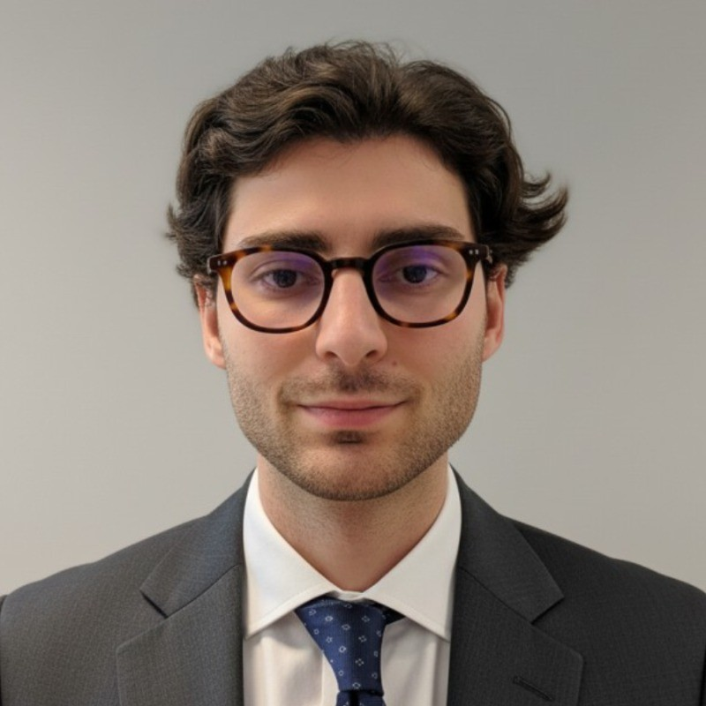
turionadrian@gmail.com | Swiss national | 10.11.2000 |  | +41 77 262 37 96
INTRODUCTION
Finance graduate with M&A execution experience across 7 concurrent mandates under tight deadlines. Demonstrated commercial aptitude through deal-making and entrepreneurial ventures, combined with strong data analysis skills (Python, Excel). Proven resilience managing high-stakes transactions with individual responsibility. Ready to bring this mindset to Glencore's trading floor.
WORK EXPERIENCE
Auraïa Capital Advisory – Small & Mid Cap Cross-border M&A Boutique  Mergers & Acquisitions Analyst (Converted internship into full-time position) |  | Geneva, Switzerland  Aug 2024 – Current
- Managed end-to-end execution on 7 concurrent mandates (EUR 5M–50M) across healthcare, technology, and life sciences sectors, handling valuation, buyer sourcing, and deal coordination under tight deadlines in a lean 3-person team
- Built financial models (LBO, DCF, comps) and performed data analysis to identify strategic buyers across Europe, US, and Asia, coordinating logistical and financial execution from marketing materials to closing
- Sole analyst entrusted with individual responsibility for data room management, client presentations, and relationship coordination with advisors across multiple live transactions simultaneously

RC Group – Currently under LBO with Crédit Mutuel Equity  Mergers & Acquisitions Intern |  | Paris, France  Feb 2024 – Aug 2024
- Worked directly with CEO on acquisition targets in France and Belgium, preparing investment memos with market analysis and financial projections (EUR 10M–30M targets), demonstrating commercial aptitude in evaluating strategic opportunities

Europ Assistance – Subsidiary of Generali Insurance  Financial Analyst Intern |  | Geneva, Switzerland  Apr 2023 – Aug 2023
- Built automated financial dashboards (Excel, PowerBI) for CHF 50M+ subsidiary, performing data analysis on monthly P&L variance and developing cost allocation models with accuracy critical for Board presentations

LEADERSHIP
- Founded and developed Screeny.ai, an AI-driven buyer sourcing tool for investment banks, leading full-stack development and sales outreach; tool adopted by 3 firms, reducing buyer research time by ~90% (10h+ to 20min)
- Led post-COVID financial recovery for AIESEC by sourcing corporate leads and negotiating partnerships; closed 3 deals generating CHF 60K annual revenue through resilience and strong communication skills
- Manage personal investment portfolio using options strategies (Cash Secured Puts, Covered Calls), executing disciplined trades with 45-day expiries to generate CHF 5K+ annual premiums while managing risk
EDUCATION
HEC Lausanne  Master of Science in Finance |  | Lausanne, Switzerland  2021 – 2024
- Cumulative GPA: 5.2/6.0 (Top 15% of the class cohort)
- Exchange programs at Waseda University (Tokyo, Japan) and Maastricht University (Maastricht, Netherlands)
- Relevant Coursework: Data Science for Finance, Derivatives, Corporate Governance and M&A, Quantitative Asset and Risk Management
- Thesis Topic: Synergies Analysis of the Merger between American Airlines & US Airways

Bachelor of Science in Management |  | 2018 – 2021
- Cumulative GPA: 4.7/6.0

Scientific Baccalaureate with Highest Honors (16.6/20) |  | Aix-en-Provence, France
ADDITIONAL INFORMATION
Languages:  Computer:  Certifications:  Interests:  References: | French (Native, C2), Spanish (Native, C2), English (Fluent, C1), German (Business proficient, B2-C1)  Excel, Bloomberg Terminal, Python, SQL, PowerBI, Capital IQ  Candidate for the CFA Level I exam – November 2025 session  Geopolitics, Badminton (Provence regional finalist), Gym, Real use cases of Artificial Intelligence  Guillaume Arnaldez – Ex-Director at Auraïa Capital Advisory, guillaume.arnaldez@auraia.ch  Sacha Caravatti – CFO at Europ Assistance Switzerland, scaravatti@europ-assistance.ch

