SOFTWARE DESIGN DESCRIPTION
IEEE 1016 Conformant
Module 3
Generate PDF Reports and Display Them on the React Frontend
Document Control

Field | Detail
Document Title | SDD — Module 3: PDF Report Generation & React Display
Version | 1.0
Status | Draft for Review
Date | June 29, 2026
Prepared By | Kirtika (2023A7PS0219U)
Reviewed By | [Reviewer Name]
Standard | IEEE Std 1016 — Software Design Descriptions

Table of Contents
(If entries appear blank, right-click the table and choose “Update Field”, or it will populate automatically when the document opens in Word.)

1. Introduction

1.1 Purpose
This Software Design Description (SDD) specifies the design of Module 3 of the system, which is responsible for generating PDF reports on the server and presenting those reports to end users inside a React-based web frontend. The document translates the module's functional and non-functional requirements into a concrete software design that developers can implement, testers can verify against, and reviewers can evaluate.
The intended audience includes software developers, the technical lead, quality-assurance engineers, and project stakeholders who need to understand how report generation and rendering are realized within the overall application.

1.2 Scope
Module 3 covers the complete path of a report from request to display. Its responsibilities are:
- Accepting a report request from the React frontend through a REST API endpoint.
- Retrieving the underlying data from the application database.
- Binding that data into a report template and generating a well-formatted PDF document on the server.
- Persisting the generated PDF to file/object storage and returning a reference (URL) to the client.
- Rendering the PDF inside the React application and offering view, download, and print actions.
Out of scope: authentication mechanics (provided by a shared security module), the creation of the source business data, and long-term archival policy. These are referenced where they interface with Module 3 but are designed elsewhere.

1.3 Definitions, Acronyms, and Abbreviations
Term | Definition
SDD | Software Design Description
PDF | Portable Document Format
API | Application Programming Interface
REST | Representational State Transfer
DTO | Data Transfer Object — structured payload exchanged between layers
SPA | Single Page Application (the React frontend)
Template Engine | Component that merges data with an HTML/markup template
Object Storage | Storage service for binary files (e.g., S3-compatible)

1.4 References
- IEEE Std 1016 — IEEE Standard for Information Technology — Software Design Descriptions.
- Software Requirements Specification (SRS), Module 3 section.
- React documentation — https://react.dev.
- react-pdf library documentation — https://github.com/wojtekmaj/react-pdf.
- Puppeteer / wkhtmltopdf documentation for HTML-to-PDF conversion.

1.5 Overview
The remainder of this document is organized as follows. Section 2 describes the module and its context. Section 3 presents the system architecture and technology stack. Section 4 defines the data design. Section 5 details the behavioral and process flow with flowcharts. Section 6 decomposes the backend and frontend components. Section 7 specifies the API and user interface. Section 8 addresses error handling, and Section 9 covers non-functional design considerations. Section 10 provides a requirements traceability matrix.

2. Module Overview

2.1 Module Description
Module 3 is a vertical slice that spans the frontend and backend tiers of the application. On the backend, it exposes a report-generation service that converts structured business data into a styled PDF document. On the frontend, it provides a dashboard where the user requests a report, waits for generation, and then views the resulting PDF inline with options to download or print.
The module is designed to be data-source agnostic: any report type can be supported by supplying a corresponding template and a query, without changing the generation pipeline itself.

2.2 Module Context
The diagram in Section 3.1 shows where Module 3 sits relative to neighboring modules. It consumes data prepared by the data-management modules, relies on the shared authentication module for access control, and produces artifacts (PDF files and their URLs) that are stored and surfaced to the user.

2.3 Design Objectives
Objective | Description
Correctness | Generated PDFs faithfully reflect the underlying data and the agreed layout.
Separation of concerns | Data retrieval, templating, PDF rendering, storage, and display are isolated.
Reusability | New report types are added via templates without pipeline changes.
Responsiveness | The frontend remains usable while generation runs asynchronously.
Resilience | Failures at any stage produce clear, recoverable error states.

2.4 Assumptions and Dependencies
- A shared authentication/authorization module issues and validates tokens used by Module 3.
- A relational (or equivalent) database holds the data that reports are built from.
- An HTML-to-PDF engine (Puppeteer or wkhtmltopdf) is available in the backend runtime.
- File/object storage is reachable and the backend has credentials to write and read PDFs.
- The frontend is a React SPA capable of embedding a PDF viewer such as react-pdf.

3. System Architecture

3.1 Architectural Design
Module 3 follows a layered architecture. The presentation layer (React) communicates only with the application layer (REST API), which delegates work to the business/service layer, which in turn interacts with the data and storage layer. This keeps responsibilities cleanly separated and the data flow unidirectional and predictable.
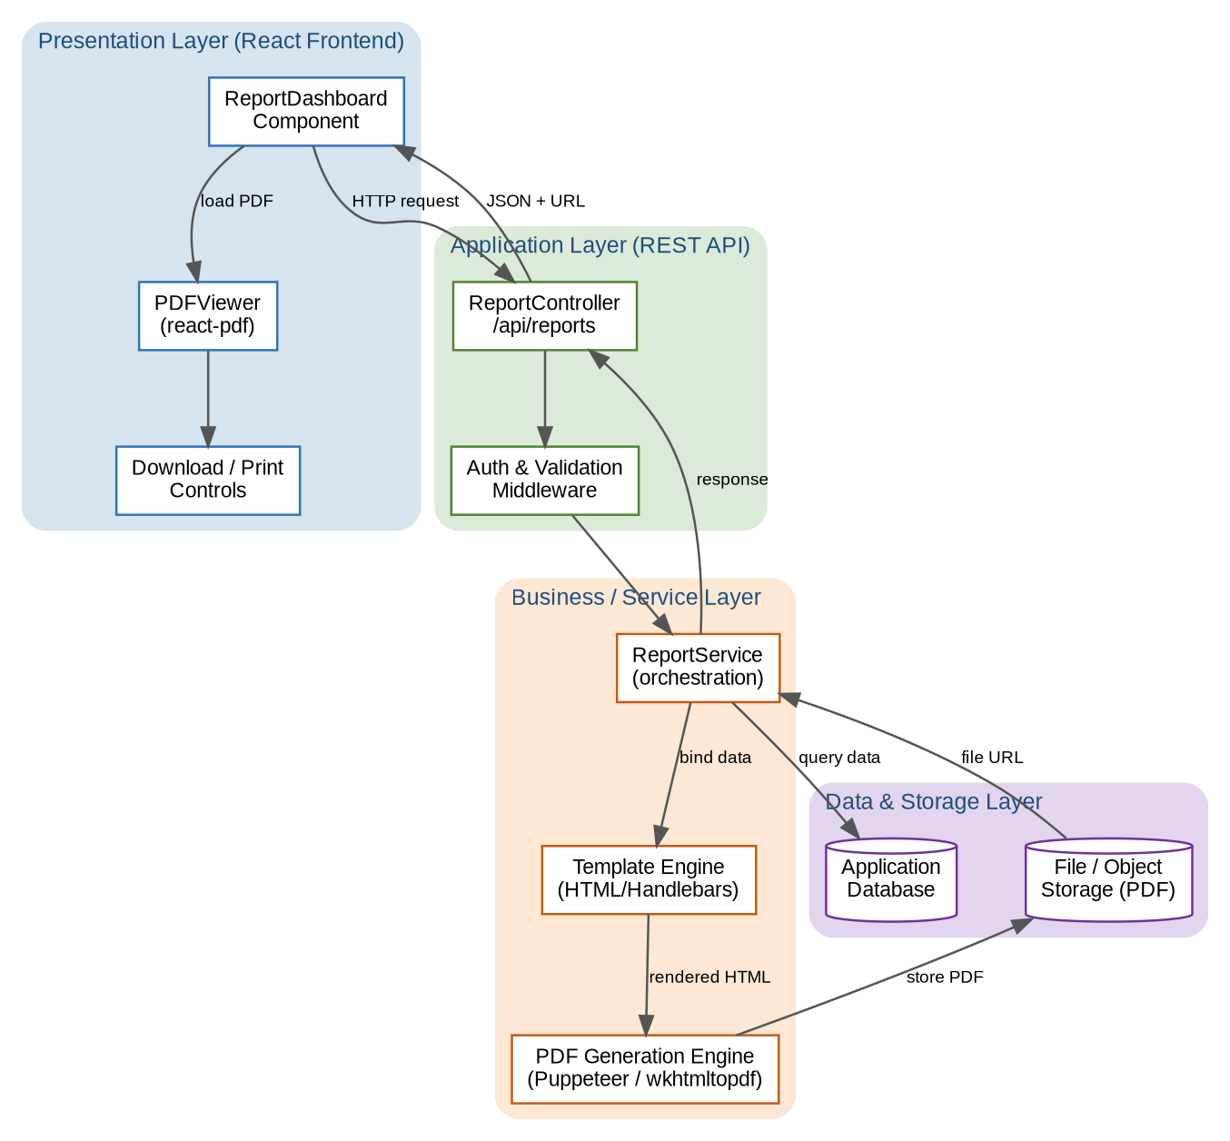
Figure 1 — Layered architecture of Module 3

3.2 Technology Stack
Layer | Technology | Responsibility
Presentation | React, react-pdf | Request reports and render/download PDFs
Application (API) | Node.js / Express (or equivalent) | Expose REST endpoints, auth, validation
Service | Report Service + Template Engine | Orchestrate data binding and rendering
PDF Generation | Puppeteer / wkhtmltopdf | Convert rendered HTML into a PDF
Data | Relational database | Provide source data for reports
Storage | Object/file storage | Persist generated PDF artifacts

3.3 Component Decomposition
The module decomposes into the following primary components, each detailed in Section 6:
- ReportController — REST entry point that receives requests and returns responses.
- ReportService — orchestrates the generation workflow end to end.
- TemplateEngine — merges report data into an HTML template.
- PDFEngine — converts the rendered HTML into a PDF binary.
- StorageAdapter — writes the PDF to storage and returns its URL.
- ReportDashboard (React) — UI for requesting and listing reports.
- PDFViewer (React) — embeds and renders the PDF with download/print controls.

4. Data Design

4.1 Data Description
Three principal data structures move through the module: the inbound report request, the data set retrieved for the report, and the outbound report response carrying the PDF reference. These are exchanged as JSON DTOs between layers.

4.2 Data Dictionary

4.2.1 ReportRequest (client → API)
Field | Type | Required | Description
reportType | string | Yes | Identifier of the report template to use
parameters | object | No | Filters such as date range, entity IDs
format | string | No | Output format; defaults to "pdf"

4.2.2 ReportResponse (API → client)
Field | Type | Description
reportId | string | Unique identifier of the generated report
url | string | Accessible URL of the stored PDF
status | string | SUCCESS, PENDING, or FAILED
generatedAt | datetime | Timestamp of generation
metadata | object | Page count, size, report title, parameters echoed back

4.2.3 ReportRecord (persisted metadata)
Field | Type | Description
id | UUID | Primary key
reportType | string | Template used
filePath | string | Storage key/path of the PDF
requestedBy | string | User identifier
createdAt | datetime | Creation time
status | string | Lifecycle status of the report

5. Process Flow and Behavioral Design

5.1 PDF Generation Process Flow
The flowchart below shows the full control flow from the user's request to the final display, including the decision points where validation, data availability, and generation success are checked. Each failure branch returns a specific, client-meaningful error and terminates the flow gracefully.
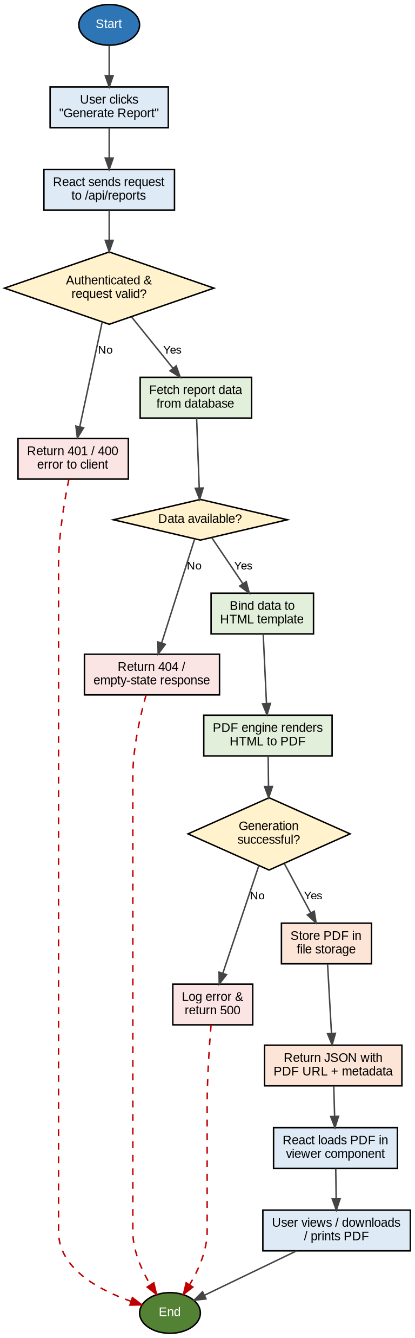
Figure 2 — PDF report generation process flowchart

5.2 Sequence of Operations
The sequence below traces the messages exchanged between the participating components for a successful generation. Solid steps represent forward calls; the returning steps carry results back up the stack until the PDF is displayed to the user.
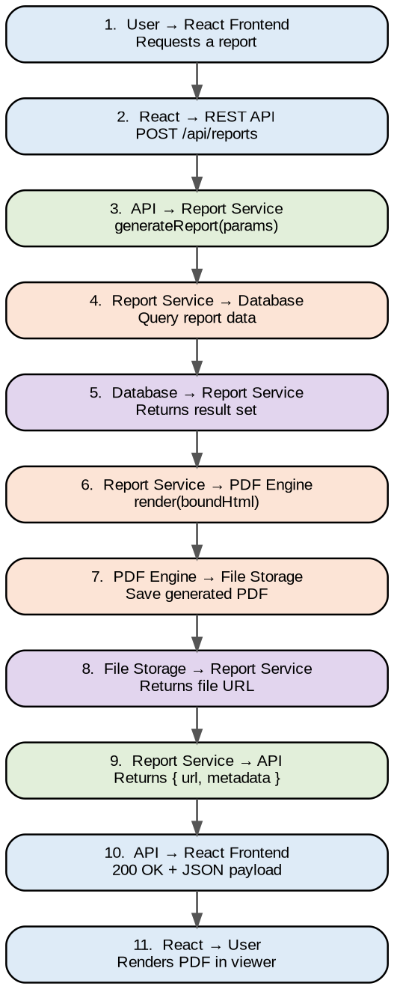
Figure 3 — Component interaction sequence

6. Component Design

6.1 Backend Components

6.1.1 ReportController
Responsibility: expose the REST endpoint, validate the incoming ReportRequest, invoke ReportService, and shape the HTTP response. It does not contain business logic.
Operation | Signature | Description
createReport | POST /api/reports | Validates request, calls service, returns ReportResponse
getReport | GET /api/reports/{id} | Returns metadata/URL for a previously generated report

6.1.2 ReportService
Responsibility: orchestrate the workflow — fetch data, invoke the template engine, call the PDF engine, persist the file, and assemble the response. It is the single place that knows the full sequence.
- fetchData(request) — retrieves the data set for the requested report type.
- bindTemplate(data) — delegates to TemplateEngine to produce HTML.
- generatePdf(html) — delegates to PDFEngine to produce the PDF binary.
- persist(pdf) — delegates to StorageAdapter and returns the URL.

6.1.3 TemplateEngine
Responsibility: merge the data set into a pre-defined HTML/Handlebars template, producing print-ready markup with the correct headers, tables, and styling. Templates are versioned and selected by reportType.

6.1.4 PDFEngine
Responsibility: convert rendered HTML into a PDF using a headless browser (Puppeteer) or wkhtmltopdf. It applies page size, margins, headers/footers, and pagination, and returns the binary buffer.

6.1.5 StorageAdapter
Responsibility: write the PDF buffer to object/file storage under a deterministic key, set access controls, and return a retrievable URL. It abstracts the concrete storage provider behind a stable interface.

6.2 Frontend Components

6.2.1 ReportDashboard
Responsibility: render the form/controls for choosing a report and its parameters, trigger the API request, manage loading and error UI state, and list previously generated reports.

6.2.2 PDFViewer
Responsibility: receive the PDF URL, load and render the document using react-pdf, support page navigation and zoom, and expose download and print actions. It also handles loading and load-error states.
State | Trigger | UI Behavior
idle | No report requested | Show form / empty state
loading | Request in flight | Show spinner, disable submit
success | URL received | Render PDF + download/print
error | API or load failure | Show error message + retry

7. Interface Design

7.1 API Interface
The module exposes a small, RESTful surface. All requests and responses use JSON, and all endpoints require a valid authentication token.
Method | Endpoint | Request Body | Success | Description
POST | /api/reports | ReportRequest | 200 / 201 | Generate a report and return its URL
GET | /api/reports/{id} | — | 200 | Fetch metadata/URL of a report
GET | /api/reports | — | 200 | List the user's reports

Representative success response (HTTP 200):
{ "reportId": "a1b2c3", "status": "SUCCESS", "url": "https://storage/.../a1b2c3.pdf", "generatedAt": "2026-06-29T10:00:00Z", "metadata": { "pages": 4, "title": "Monthly Summary" } }

7.2 User Interface Design
The user-facing flow is intentionally simple:
- The user opens the report dashboard and selects a report type and parameters.
- On submit, a loading indicator appears while the backend generates the PDF.
- On success, the PDF renders inline in the viewer with download and print buttons.
- On failure, a clear error message is shown with the option to retry.

8. Error Handling and Edge Cases
Each stage of the pipeline maps a failure to a specific, actionable outcome so that both the system and the user can respond appropriately.
Condition | HTTP / State | Handling
Missing/invalid token | 401 Unauthorized | Reject before processing; prompt re-authentication
Malformed request body | 400 Bad Request | Return validation errors listing offending fields
No data for parameters | 404 / empty state | Return empty-state response; UI shows "no data"
PDF engine failure | 500 Internal Error | Log with correlation ID; UI offers retry
Storage write failure | 500 Internal Error | Retry with backoff; surface failure if persistent
Viewer load failure | Frontend error | Show fallback download link and error notice

All backend errors are logged with a correlation ID that is also returned to the client, enabling end-to-end traceability during support and debugging.

9. Design Considerations (Non-Functional)

9.1 Performance
- Generation runs asynchronously where reports are large, so the UI never blocks.
- Generated PDFs are cached/stored so identical requests can be served without regeneration.
- Database queries for report data are indexed and parameter-bounded.

9.2 Security
- Every endpoint requires authentication; report URLs are access-controlled or time-limited.
- Input parameters are validated and sanitized before use in queries or templates.
- Template rendering avoids injecting untrusted markup that could affect output.

9.3 Scalability and Maintainability
- The PDF engine can run as a pooled or separate worker to handle load independently.
- New report types are added by registering a template and query — no pipeline change.
- The storage provider is abstracted, so it can be swapped without touching the service.

9.4 Reliability
- Transient failures (storage, engine) use bounded retries with backoff.
- Each report's lifecycle status is persisted, allowing recovery and auditing.

10. Requirements Traceability Matrix
The matrix links each functional requirement of Module 3 to the design elements that satisfy it, supporting verification and impact analysis.
Req ID | Requirement | Design Element(s) | Section
FR-3.1 | Accept report requests via API | ReportController | 6.1.1, 7.1
FR-3.2 | Retrieve report data | ReportService.fetchData | 6.1.2
FR-3.3 | Generate a formatted PDF | TemplateEngine, PDFEngine | 6.1.3, 6.1.4
FR-3.4 | Store PDF and return URL | StorageAdapter | 6.1.5, 4.2.2
FR-3.5 | Display PDF in React frontend | PDFViewer | 6.2.2
FR-3.6 | Allow download and print | PDFViewer controls | 6.2.2, 7.2
FR-3.7 | Handle errors gracefully | Error handling design | 8

— End of Software Design Description —

