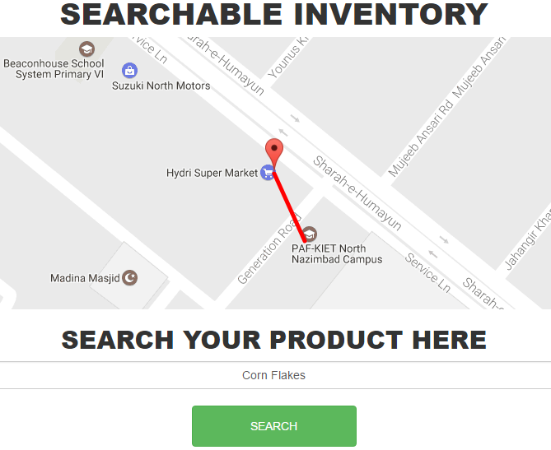

**Geo-Fence**

**Online Searchable Inventory**

MEMBERS

MuHAmmad umer

asfa akhter

izma khalid qureshi

asad raza

* What is your Product/Service?

Name of Our Project is Searchable Inventory. In This project we are putting the inventory of Stores on maps so the user (Internet Consumer) can easily find their desire product in nearest shops and get directions to the store.

* Who is your Customer?

Our Customers are the Internet Consumers i-e smart phones user’s and consumers, shops and marts with automated and updated inventory.

* How will you earn Money?

We will add subscription charges after three months on web and mobile application and 1 month free trail for stores and marts. we will get some amount of profit on sold product from the shops Revenue.

# Principal Of Effectuation Related to Our Project…

**Bird in Hand**

On very first step we only have Smartphone’s in our hands with an idea, so we just put together and make things possible try to shape up things.

**Affordable Loss**

We all ready know that in the beginning we have to invest our time, money and resources, we already calculated some loss for incoming situation.

**Lemonade**

Our job is to upload only exists inventories on our websites but if our customer don't have computerized inventory we will entertain them to have one.

**Patchwork Quilt**

We can also use help from off shelf product in our product, i-e designing of our product from third party.

**Facebook responce**

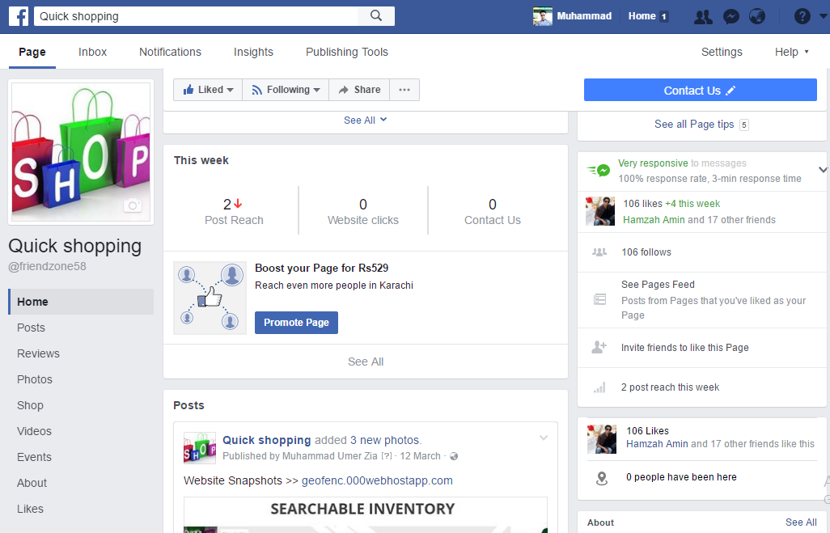

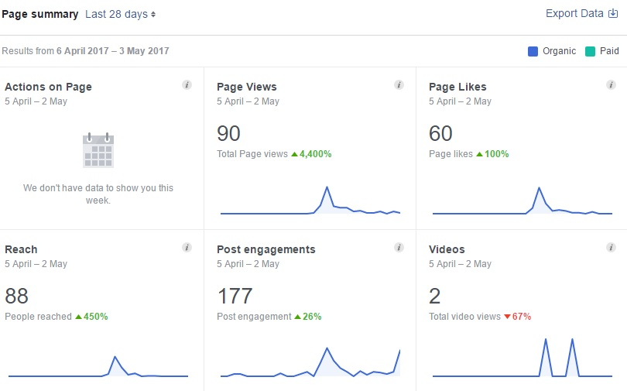

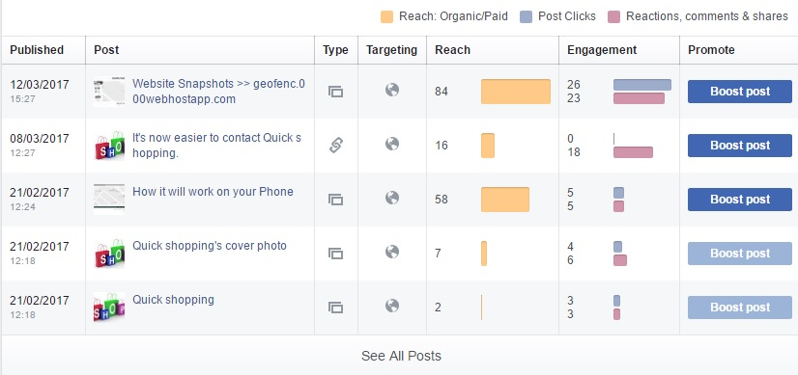

**Some Snap Shots of our Project**

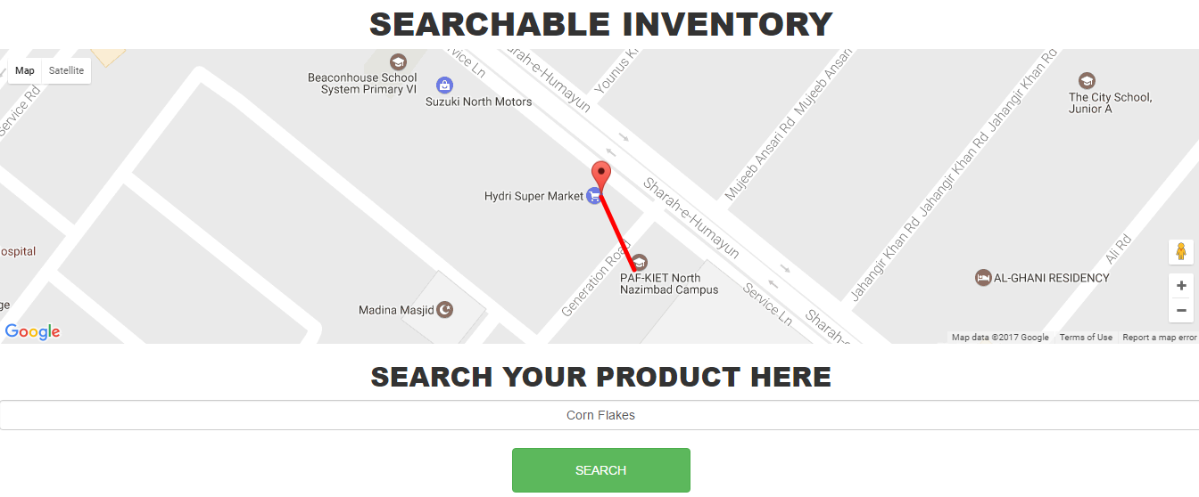

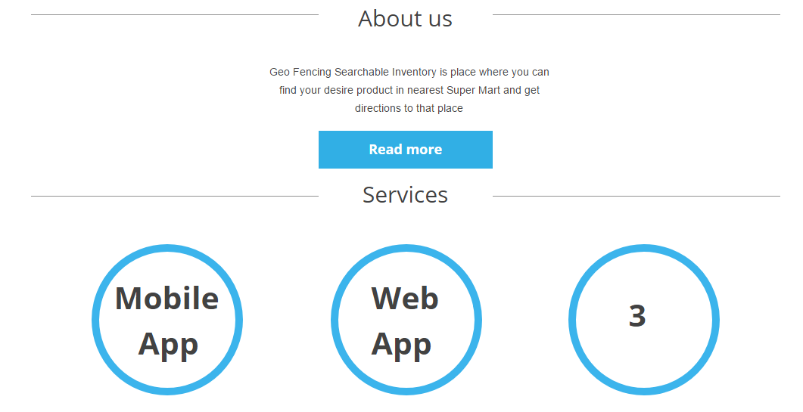

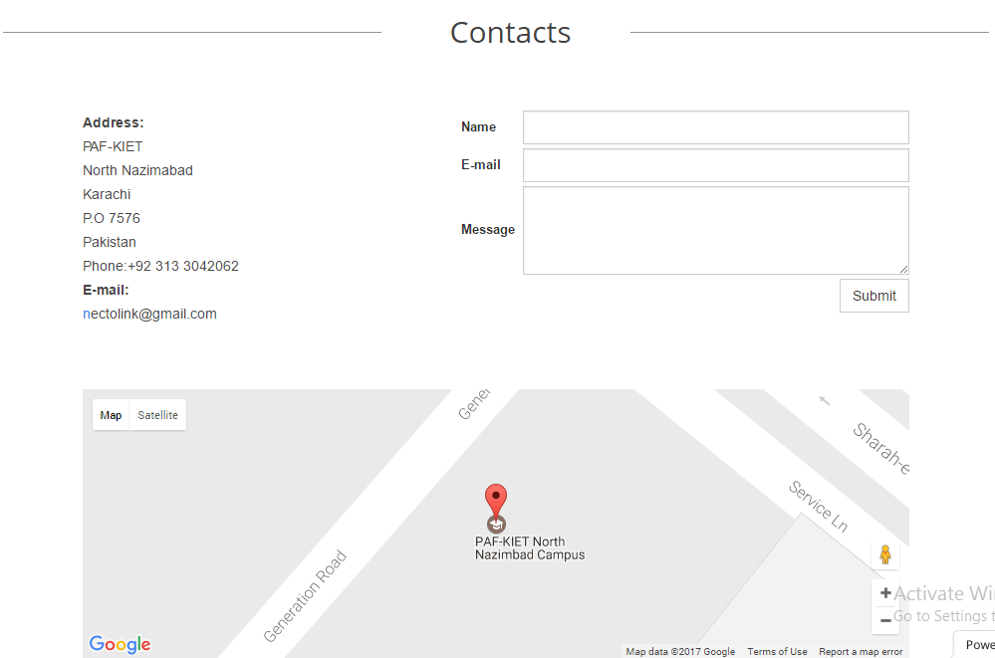

**Business Model Canvas**

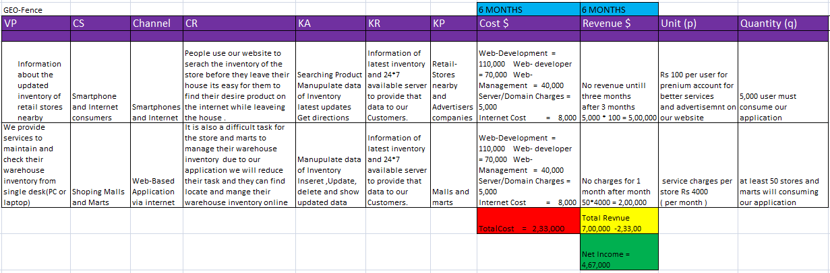

**Future plan and procedings…..**

As we know that technology is increasing day by day so there is no way that technology involved apps or service will fail the best example is Uber and careem we are working on the site to make it better and after that we have plans for IOS and ANDROID app for that project.