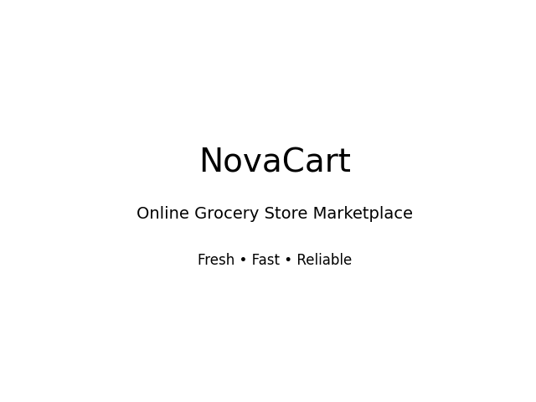

Project Proposal: NovaCart – Online Grocery Store

1. Executive Summary
NovaCart is a modern online grocery store designed to provide customers with fresh, high-quality groceries delivered directly to their doorstep. The platform aims to digitize traditional grocery shopping by offering a seamless, user-friendly, and secure e-commerce experience.

2. Project Objectives
• Develop a fully functional e-commerce grocery platform.
• Provide secure online ordering and payment system.
• Enable real-time inventory management.
• Ensure fast and reliable home delivery services.
• Create a scalable and secure system using modern technologies.

3. Project Scope
The project includes website design, backend development, database integration, payment gateway setup, order management system, admin dashboard, and marketing implementation.

4. Product Categories
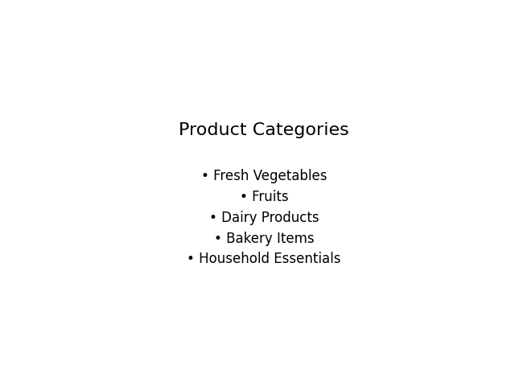

5. Technology Stack (MERN)
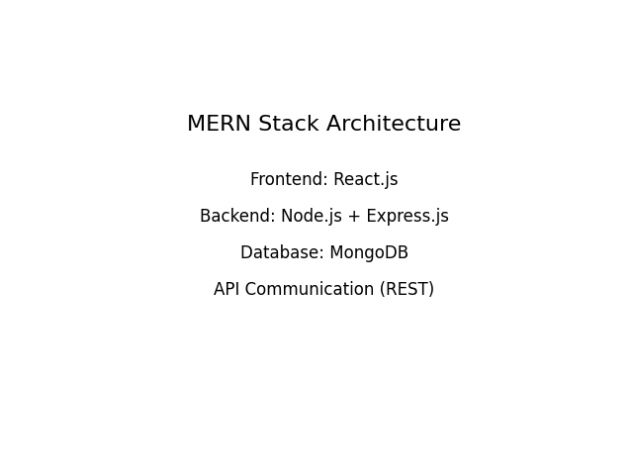
Frontend: React.js (Responsive UI Development)
Backend: Node.js with Express.js (RESTful APIs)
Database: MongoDB (NoSQL Database)
Authentication: JWT (JSON Web Tokens)
Payment Integration: Stripe / PayPal
Hosting: AWS / Vercel / Render
Version Control: Git & GitHub

6. Key Features
• User Registration & Login System
• Smart Search & Category Filtering
• Shopping Cart & Wishlist
• Secure Checkout & Online Payments
• Order Tracking System
• Admin Dashboard for Inventory & Orders
• Customer Reviews & Ratings

7. Project Timeline (6 Months)
Month 1: Requirement Analysis & UI/UX Design
Month 2-3: Frontend & Backend Development
Month 4: Database & Payment Integration
Month 5: Testing & Security Implementation
Month 6: Deployment & Launch

8. Estimated Budget
The estimated budget will cover development costs, hosting, domain registration, payment gateway charges, marketing campaigns, and maintenance expenses.

9. Conclusion
NovaCart aims to revolutionize grocery shopping by combining convenience, technology, and reliability. By leveraging the MERN stack and secure payment integration, the platform will provide a scalable, efficient, and customer-focused solution.

