Software Design Specifications

e-Medicare

Version: 1.0

Project Team | 22K-4626 Asfandyar Khanzada  22K-4231 Munnazzar Shahzad
Submission Date | 9th May 2025

Document History

Version | Name of Person | Date | Description of change
0.1 | Munnazzar Shahzad | 05-May-2025 | Document Created
0.2 | Asfandyar Khanzada | 06-May-2025 | Added System Architecture
0.3 |  | 07-May-2025
  Munnazzar Shahzad
  Added Database Design & Diagrams
1.0 |  | 09-May-2025
  Munnazzar & Asfandyar
  Finalized for submission

Distribution List

Name | Role
Ms. Romasha Khurshid | Supervisor

Document Sign-Off
Version | Sign-off Authority | Project Role | Signature | Sign-off Date

Document Information

Category | Information
Customer | FAST-NU
Project | e-Medicare
Document | Software Design Specification
Document Version | 1.0
Status | Draft
Author(s) | Munnazzar Shahzad, Asfandyar Khanzada
Approver(s)
Issue Date | 09-May-2025
Document Location
Distribution | Advisor, Project Coordinator

Definition of Terms, Acronyms and Abbreviations
[This section should provide the definitions of all terms, acronyms, and abbreviations required to interpret the terms used in the document properly. ]

Term | Description
HMS | Hospital Management System
DD | Design Specification
ICU | Intensive Care Unit
CRUD | Create, Read, Update, Delete (DB operations)
SPA | Single Page Application (React-based frontend)
DFD | Data Flow Diagram

Table of Contents
1 Introduction 7
1.1 Purpose of Document 7
1.2 Intended Audience 7
1.3 Document Convention 7
1.4 Project Overview 7
1.5 Scope 7
2 Design Considerations 8
2.1 Assumptions and Dependencies 8
2.2 Risks and Volatile Areas 8
3 System Architecture 9
3.1 System Level Architecture 9
3.2 Software Architecture 9
4 Detailed System Design 10
4.1 Database Design 10
4.1.1 ER Diagram 10
4.1.2 Data Dictionary 10
4.1.2.2 Patients 11
4.1.2.3 Doctor 12
4.1.2.3 Nurses 12
4.1.2.3 Rooms 12
4.1.2.3 Formula 13
4.1.2.3 Medicine 13
4.1.2.3 Dosage 13
4.1.2.3 DosageTimes 13

4.2 Application Design 15
4.2.1 Sequence Diagram 15
4.2.2 Activity Diagram 15
6 References 17
7 Appendices 18

Introduction

Purpose of Document
The purpose of this document is to outline the Software Design Specification (SDS) for the ICU Hospital Management System. This system is aimed at improving ICU operations by automating and streamlining patient care tasks, enhancing staff communication.

Intended Audience
This document is intended for the development team, project supervisor and evaluators, and any stakeholder involved in the design, development, and deployment of the system.

Document Convention
[Describe the font and font size that this document will be using]

Project Overview
The ICU Hospital Management System is designed to automate key ICU operations such as patient admission, doctor and room assignment, and dosage management. The system promotes role-based access control for doctors, nurses, and admins with task associated with their roles respectively.

Scope
The ICU Hospital Management System focuses on streamlining and automating ICU operations for enhancing efficiency, including doctor assignment, patient record management, room allocation, medication prescription, and dosage administration. It is a web-based Node application with a React frontend, Express.js backend, and PostgreSQL database.

Design Considerations
This section outlines key design-related issues that must be considered to ensure a robust and scalable system. It addresses the underlying assumptions, dependencies, and potential risk factors that may influence or constrain the software design process. These considerations lay the foundation for selecting appropriate design strategies, technologies, and architectural patterns.

Assumptions and Dependencies
- It is assumed that all users (doctors, nurses, administrators) will have access to modern web browsers and reliable internet connectivity.
- Node.js and PostgreSQL will be supported in the deployment environment, either on-premises or via a cloud-based infrastructure.
- An up-to-date list of the staff schedules, patient records and inventory would be provided for system initialization.
- The system depends on timely and accurate input from staff, especially for dosage logging and inventory updates.
- Integration with biometric or IoT-based monitoring systems is currently out of scope but may be considered for future releases.

Risks and Volatile Areas
- Healthcare data compliance laws (e.g., HIPAA, GDPR equivalents) may evolve, requiring design changes in data encryption, storage, and access protocols.
- Frameworks like React and Node.js are rapidly evolving. Architectural adjustments might be required due to dependency updates or deprecations.
- Medical staff may resist shifting from manual systems to digital platforms, which might require design changes to simplify onboarding and usage.
- High patient intake in peak ICU periods could expose design weaknesses in system scalability or performance bottlenecks.

System Architecture

System Level Architecture
The system follows a client-server architecture, structured into three major components:
- Frontend: React (JavaScript-based SPA)
- Backend: Node.js with Express
- Database: PostgreSQL

Software Architecture
The software architecture follows a 3-tier layered architecture, consisting of:
- User Interface Layer:
This layer includes all React-based frontend components. It is responsible for:
  - Taking user input
  - Representing data fetched from backend
  - Handling navigation and routing within the app
  - Displaying alerts, forms and role-based dashboards
- Middle Tier (Application Logic Layer)
This includes the Node.js/Express server:
  - Receives HTTP requests from frontend
  - Processes business logic (e.g., assigning rooms or doctors, validating medication schedules)
  - Handles authentication using JWT and role-based access control
- Data Access Layer
The backend accesses the PostgreSQL database through this layer:
  - Executes SQL queries
  - Performs CRUD operations on patient, doctor, medication, and room data
  - Maintains transactional integrity and performs validation

Detailed System Design
The detailed design of the e-Medicare covers database schema, application logic, and user interfaces that together fulfill the system’s objectives. This section includes class relationships, the logical data model (ER diagram), and a comprehensive data dictionary for the system's main entities.

Database Design

ER Diagram
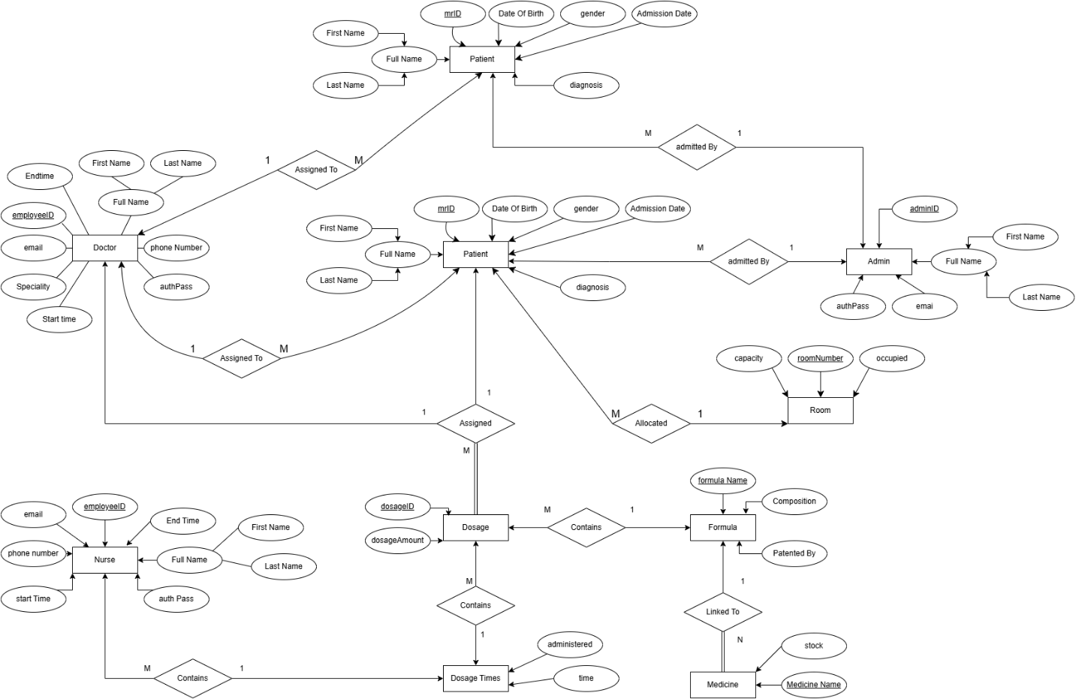

Data Dictionary

Admins
Used in patient admission and record authorization.

Column Name | Description | Type | Length | Nullable | Default Value | Key Type
adminID | Unique identifier | bigint | - | No | NEXTVAL('employeeIDGenerator') | PK
firstName | Admin’s first name | text | - | No | -
lastName | Admin’s last name | text | - | No | -
email | Admin’s email | text | - | No | -
authPassword | Hashed password | text | - | No | -

Patients
Used for ICU record management, room and doctor assignment.

Column Name | Description | Type | Length | Nullable | Default Value | Key Type
mrID | Medical record ID | bigint | - | No | Auto-generated | PK
firstName | Patient’s first name | text | - | No | -
lastName | Patient’s last name | text | - | No | -
gender | Gender | text | - | Yes | -
dateOfBirth | DOB | timestamp | - | Yes | -
admissionDate | Date of admission | timestamp | - | No | -
roomNumber | Assigned room | bigint | - | Yes | - | FK
doctorID | Assigned doctor | bigint | - | Yes | - | FK
adminID | Registered by admin | bigint | - | Yes | - | FK
diagnosis | Medical diagnosis | text | - | Yes | -
.

Doctor
Holds doctor information, availability, and credentials.

Column Name | Description | Type | Length | Nullable | Default Value | Key Type
employeeID | Unique doctor ID | bigint | - | No | NEXTVAL('employeeIDGenerator') | PK
firstName | Doctor’s first name | varchar | 255 | No | -
lastName | Doctor’s last name | varchar | 255 | No | -
email | Doctor’s email | text | - | Yes | -
phoneNumber | Contact number | varchar | 255 | No | -
speciality | Doctor’s specialty | text | - | No | -
startTime | Shift start time | time | - | No | -
endTime | Shift end time | time | - | No | -
authPassword | Login password | text | - | No | -

Nurses
Stores nurse credentials and scheduling details.

Column Name | Description | Type | Length | Nullable | Default Value | Key Type
employeeID | Unique nurse ID | bigint | - | No | NEXTVAL('employeeIDGenerator') | PK
firstName | Nurse’s first name | varchar | 255 | No | -
lastName | Nurse’s last name | varchar | 255 | No | -
email | Nurse’s email | text | - | Yes | -
phoneNumber | Contact number | varchar | 255 | No | -
startTime | Shift start time | time | - | No | -
endTime | Shift end time | time | - | No | -
authPassword | Login password | text | - | No | -

Rooms
Manages ICU room capacities and occupancy status.

Column Name | Description | Type | Length | Nullable | Default Value | Key Type
roomNumber | Room identifier | bigint | - | No | Auto-generated | PK
capacity | Room capacity | integer | - | No | -
occupied | Number of occupied beds | integer | - | Yes | 0

Formula
Defines medical formulas used in treatments.

Column Name | Description | Type | Length | Nullable | Default Value | Key Type
formulaName | Formula name | text | - | No | - | PK
composition | Ingredients/Composition | text | - | No | -
patentedBy | Organization holding patent | text | - | No | -

Medicine
Tracks medication stock and their formulas.

Column Name | Description | Type | Length | Nullable | Default Value | Key Type
medicineName | Medicine name | text | - | No | - | PK
stock | Available stock | integer | - | No | -
formulaName | Formula reference | text | - | Yes | - | FK

Dosage
Stores patient-specific dosage information.

Column Name | Description | Type | Length | Nullable | Default Value | Key Type
dosageID | Dosage ID | bigint | - | No | Auto-generated | PK
dosage_amount | Amount to administer | text | - | Yes | -
patientmrID | Related patient ID | bigint | - | Yes | - | FK
formulaName | Formula used | text | - | Yes | -

DosageTimes
Tracks when and by whom dosages were administered.

Column Name | Description | Type | Length | Nullable | Default Value | Key Type
dosageID | Dosage reference | bigint | - | No | - | FK (PK)
time | Scheduled time | time | - | No | - | PK
administered | Whether it was administered | boolean | - | Yes | false
nurseID | Nurse responsible | bigint | - | Yes | null | FK

Application Design
This section provides a detailed view of how the system components interact over time to perform user actions, with a focus on system behavior and logic. It includes sequence diagrams and activity diagrams with parameter flows.

Sequence Diagram
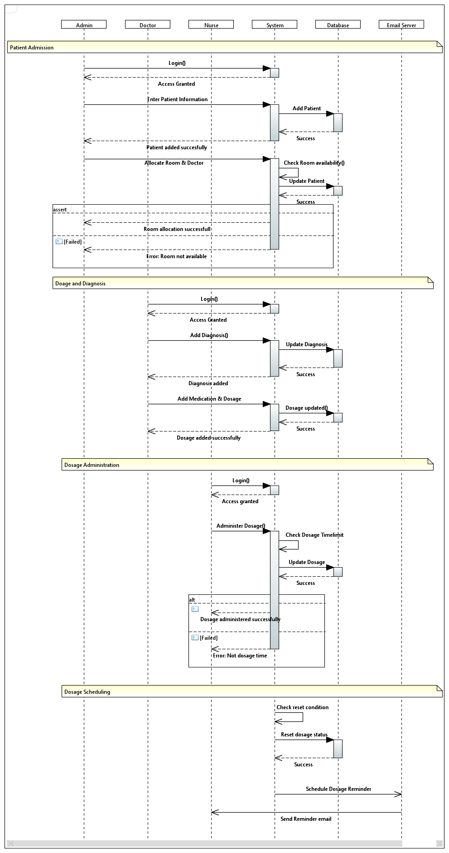

Activity Diagram

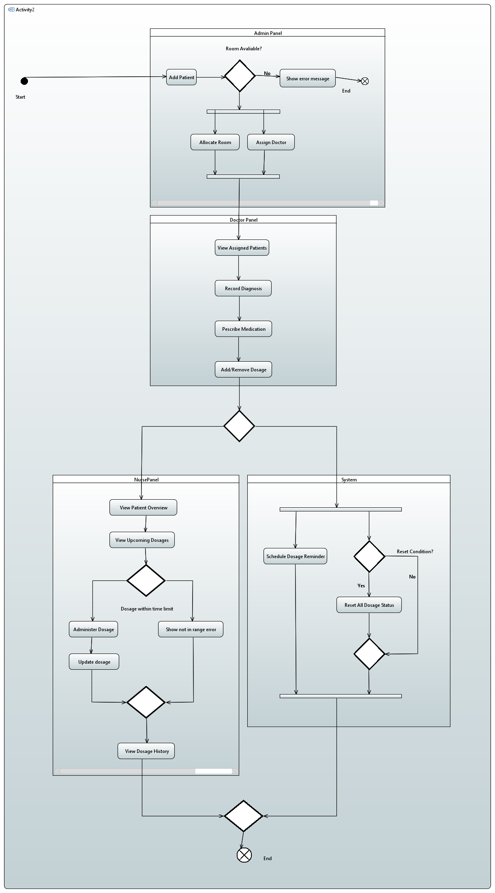

References
  - @google/generative-ai
Library for accessing Google's Generative AI APIs.
Documentation

  - bcrypt
Library for hashing passwords.
Documentation

  - cors
Middleware for enabling Cross-Origin Resource Sharing in Express apps.

  - dotenv
Loads environment variables from a .env file into process.env.
Documentation

  - express
Fast, unopinionated, minimalist web framework for Node.js.
Documentation

  - jsonwebtoken
Implementation of JSON Web Tokens for authentication and authorization.
Documentation

  - node-schedule
A cron-like and not-cron-like job scheduler for Node.
Documentation

  - nodemailer
Module to send emails from Node.js.

  - nodemon
Utility that monitors for changes in files and restarts your app automatically.
Documentation

  - pg
PostgreSQL client for Node.js.
Documentation

  - chai
BDD / TDD assertion library for Node and the browser.
Documentation

  - mocha
JavaScript test framework for Node.js programs.
Documentation

  - supertest
Super-agent driven library for testing HTTP servers.
Documentation

