 | Assignment No. 02  Semester: Fall 2023  Web Design and Development CS506 | Total Marks: 20  Due Date: 12-Jan, 2024
Instructions:
Please read the following instructions carefully before submitting assignment. It should be clear that your assignment will not get any credit if:

- The assignment is submitted after due date.
- The submitted assignment does not open or file is corrupt.
- Assignment is copied (partial or full) from any source (websites, forums, students, etc.) Strict action will be taken in this regard.

Note (Submission Instruction):
You are required to submit only .doc or .docx word file. No need to send complete project code, just send the code of processRequest() method of each Servlet. Details are given in the assignment description.

Objectives:
The objective of this assignment is to provide hands-on experience of Java Programming concepts including:
  - Servlet Basics
  - Process Request
  - Member Functions and main function

For any assignment related query, contact at CS506@vu.edu.pk

Covered Lectures: Assignment No.2 is from 26-37 lectures.

Problem Statement: Marks 20
In this assignment, you will create two Java Servlets to perform basic banking transactions. The first Servlet will simulate a deposit or withdrawal operation, and the second Servlet will calculate the account balance after the transaction.

1. Transaction Servlet:
- Create a Servlet named TransactionServlet.
- Design an HTML form that allows the user to enter their initial account balance, specify whether they want to make a deposit or withdrawal, and enter the transaction amount.
- Perform the deposit or withdrawal operation based on the user's input.
- Store the updated account balance as an attribute in the request.
- Forward the request to BalanceServlet (using the Request Dispatcher method).
2. Balance Servlet:
- Create a Servlet named BalanceServlet.
- Retrieve the updated account balance from the request attribute set by TransactionServlet.
- Calculate the new account balance after the transaction.
- Display the new balance on the web page, along with a message indicating whether the transaction was successful.

Note: No need to send complete code, just send the code of processRequest() method of each Servlet. Details are given below:
Solution Sample:
FirstServlet (TransactionServlet) processRequest() method:
protected void processRequest(HttpServletRequest request, HttpServletResponse response) throws ServletException, IOException {
// code…..
……..
}

SecondServlet (BalanceServlet) processRequest() method:
protected void processRequest(HttpServletRequest request, HttpServletResponse response) throws ServletException, IOException {
// code…..
……..
}

Just for your detailed understanding about the assignment. See below attached screenshots.
Sample Screenshot No1:
Initial view, Transaction type “Withdrawal”.
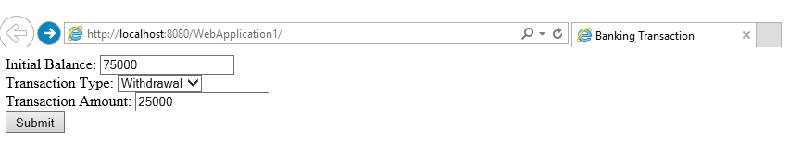

Sample Screenshot No2:
Result after clicking on submit button.
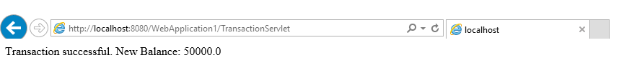

Sample Screenshot No3:
Initial view, Transaction type “Deposit”.
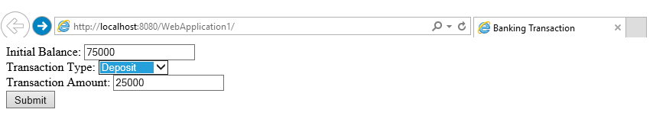
Sample Screenshot No4:
Result after clicking on submit button.
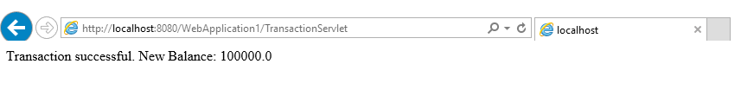

BEST OF LUCK

