 | Assignment No. 01  Semester: Fall 2023  CS506 - Web Design and Development | Total Marks: 20  Due Date: 13-NOV-2023
Instructions:

Please read the following instructions carefully before submitting assignment. It should be clear that your assignment will not get any credit if:

- The assignment is submitted after due date.
- The submitted assignment does not open or file is corrupt.
- Assignment is copied (partial or full) from any source (websites, forums, students, etc.) Strict action will be taken in this regard.

Objectives:
The objective of this assignment is to provide hands-on experience of Java Programming concepts including:
  - Classes and Objects
  - Default Constructors
  - Member Functions and main function

For any assignment related query, contact at CS506@vu.edu.pk

Software (s) Used to develop Assignment
Note:
- Use Notepad or Notepad++ for coding and JDK package for java source code compilation and running.
- Submit a single AvgMarksCalc.java file including both classes(Vehicle and AvgMarksCalc) in one file (No multiple or zip files allowed).

Covered Lectures: Lecture number 1-9 are covered in this assignment.

A video tutorial of JDK installation and configuration is given in course download section
Link: https://vulms.vu.edu.pk/Courses/CS506/Downloads/JDK_Installation.mp4

Problem Statement: Marks 20
You are required to write a Java program which stores student information, calculate their average marks and print them on the console. The program contains two classes: Student and AvgMarksCalc. The Student class contains two data members (student id, it’s marks in 4 subjects), a default constructor which initialize data members, setter and getter functions, Average marks calculator function which calculates student average marks by adding marks in all subjects divided by total number of subject and print it on console and last one is display student information function will print student id and it’s grades in different subjects on console. In AvgMarksCalc class you have to create student object by explicit default constructor and store your VU student id and 4 random subject marks (e.g. 98.0, 55.0, 65.0, 78.0) in the object using setter functions after that print student object info using display student information function displayStdInfo() and average grade using Average grade calculator function avgMarks() of student class. All necessary details of class, data members, constructor, setter function, getter functions and other member functions are given below.

Details: (AvgGradeCalc.java file contains)
- Student class:
Data Members: stdId, sbjGrades[] (stdId is String type and sbjGrades is an array of double)
Explicit Default Constructor: Student()
Setter Functions: setStdId(…), setSbjMarks(…)
Getter Functions: getStdId(), getSbjMarks()
Average Marks Calculator function: avgMarks()
Display Function: displayStdInfo()

- AvgMarksCalc class:
Main Method: public String void main(String args[])

Output of the Program: (Data is just a demo you will input your own data for creating objects)
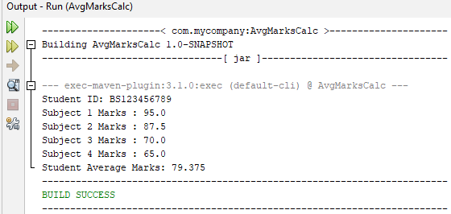

BEST OF LUCK

