**Happy Meal**

**Design Document**

**Version 1.0**



**Group Id: F2302B53C0** (BC200203944)

**Supervisor Name:** Maham Murtaza Khan

**Revision History**

|  |  |  |  |
| --- | --- | --- | --- |
| **Date (dd/mm/yyyy)** | **Version** | **Description** | **Author** |
| 18/01/2024 | 1.0 | Software Requirements Specification, also known as SRS, is the term used to describe an in-depth description of a software production to be developed. It’s considered one of the initial stages of the software development lifecycle. In SRS document we prepared scope of the project we also define the use case diagram to demonstrate the actors of a system. We also create project plan and discuss the development methodologies in an SRS document. | BC200203944 |
|  |  |  |  |
|  |  |  |  |
|  |  |  |  |

**Table of Contents**

1. Introduction of Design Document
2. Entity Relationship Diagram (ERD)
3. Sequence Diagrams
4. Architecture Design Diagram
5. Class Diagram
6. Database Design
7. Interface Design
8. Test Cases

1. **Introduction of Design Document**

“Good design does not call attention to itself, but good designers use the principles of document design to make sure their layouts look pleasing and attractive. The principles of document design are **balance, proportion, order, contrast, similarity, and unity**. “Design documentation is important because it **tells the story of why and how a product or project was designed**. It helps everyone involved understand what was done and why, so that the final result is the best it can be. Having design documentation also makes it easier to fix and update things later on. A ***Design Document*** is also known as a technical specification is a description of how you plan to solve a problem. A design document is the most useful tool for making sure the right work gets done. The Software Design Document is a document to provide documentation which will be used to aid in software development by providing the details for how the software should be built. Documentation **helps you organize and deliver your thoughts to stakeholders, which in turn helps them understand how your design decisions will satisfy the user needs and their own business objectives**. Designers need to find a sweet spot between business goals and user needs.

1. **Entity Relationship Diagram (ERD)**

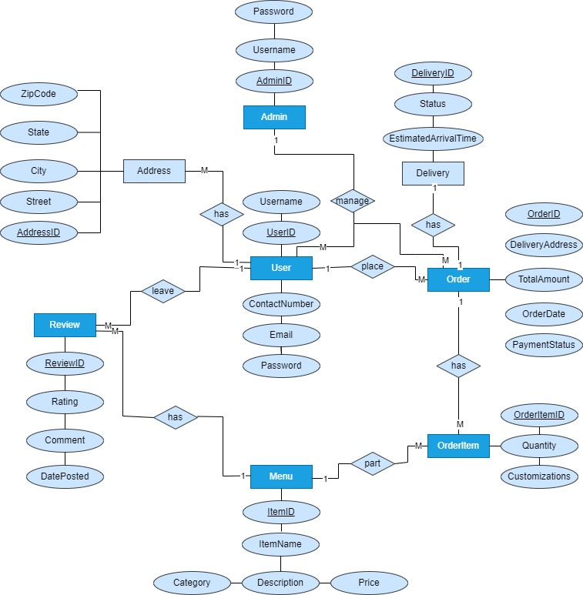

**3**. **Sequence Diagrams**

**(i)**

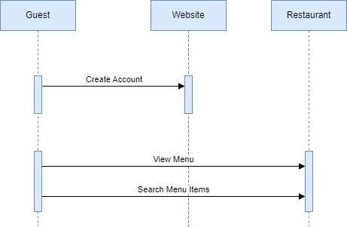

**(ii)**

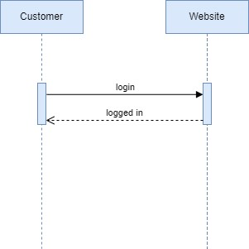

**(iii)**

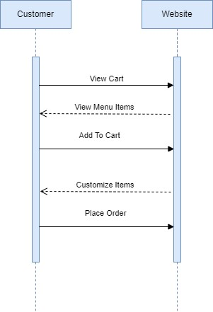

**(iv)**

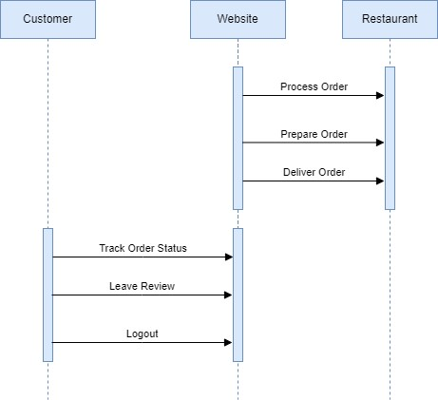

1. **Architecture Design Diagram**

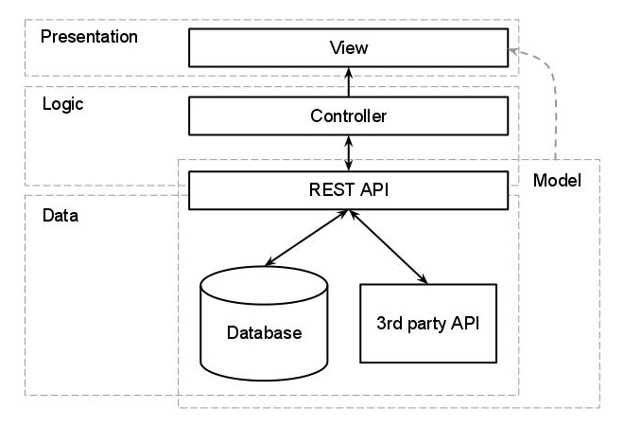

1. **Class Diagram**

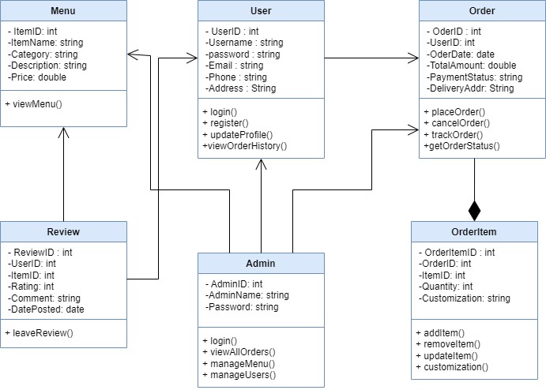

1. **Database Design**

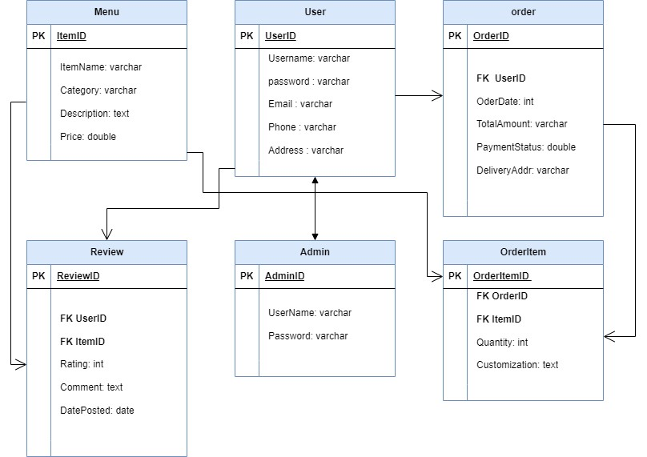

1. **Interface Design**

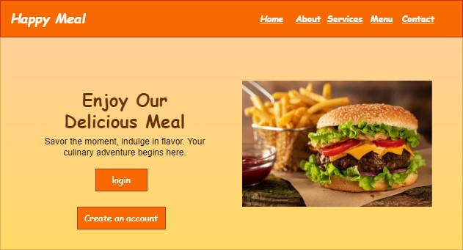

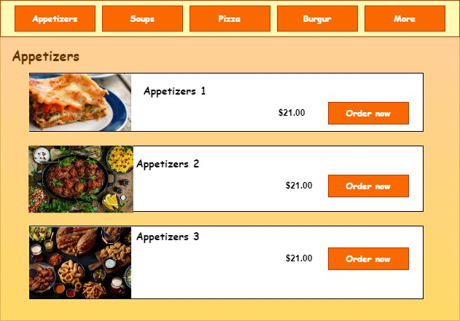

1. **Test Cases**

**Test case title: Create Account**

|  |  |
| --- | --- |
| **Precondition** | Internet connection should be available.  You must open Happy Meal Website |
| **Action** | Create an account |
| **Expected Result** | 1. If entered data is correct then the account will be created. 2. If entered data is incorrect then the account will not be created. |
| **Test Result** | Successful |
| **Test by** | BC200203944 |

**Test case title: View Menu**

|  |  |
| --- | --- |
| **Precondition** | Internet connection should be available.  You must open Happy Meal Website |
| **Action** | 1. After creating an account. 2. The guest will view the menu. |
| **Expected Result** | 1. If entered data is correct then the guest will view the menu. 2. If entered data is incorrect then the guest will not be able to view the menu. |
| **Test Result** | Successful |
| **Test by** | BC200203944 |

**Test case title: Search Menu Items**

|  |  |
| --- | --- |
| **Precondition** | Internet connection should be available.  You must open Happy Meal Website |
| **Action** | 1. After creating an account. 2. The guest will view the menu items. |
| **Expected Result** | 1. If the entered data is correct then the guest will be able to view the menu items. 2. If entered data is incorrect then the guest will not be able to view the menu items. |
| **Test Result** | Successful |
| **Test by** | BC200203944 |

**Test case title: login/logout**

|  |  |
| --- | --- |
| **Precondition** | Internet connection should be available.  You must open the Happy Meal Website. |
| **Action** | 1. Customer will click on log in. 2. The customer will enter their information such as name, email and phone etc. 3. After the procedure customer will logout to website. |
| **Expected Result** | 1. If entered data is correct then the customer is logged in to the website. 2. If entered data is incorrect then the customer is not logged in to the website. |
| **Test Result** | Successful |
| **Test by** | BC200203944 |

**Test case title: View Cart**

|  |  |
| --- | --- |
| **Precondition** | Internet connection should be available.  You must open Happy Meal Website |
| **Action** | 1.Customer will click on log in.  2.The customer will enter their information such as name, email and phone etc.   1. After this the customer will view the cart. |
| **Expected Result** | 1.May be customer will not be able to login.  2.May be customer will be able to login. |
| **Test Result** | Successful |
| **Test by** | BC200203944 |

**Test case title: Add to Cart**

|  |  |
| --- | --- |
| **Precondition** | Internet connection should be available.  You must open Happy Meal Website |
| **Action** | 1.Customer will click on log in.  2.The customer will enter their information such as name, email and phone etc.  3.After this the customer will view the cart.  4. The customer will add meal items to cart. |
| **Expected Result** | 1.May be customer will not be able to login.  2.May the items are not available now. |
| **Test Result** | Successful |
| **Test by** | BC200203944 |

**Test case title: Place Order**

|  |  |
| --- | --- |
| **Precondition** | Internet connection should be available.  You must open Happy Meal Website |
| **Action** | 1.Customer will click on log in.  2.The customer will enter their information such as name, email and phone etc.  3.After this the customer will view the cart.  4. The customer will add meal items to cart.  5. And place the order. |
| **Expected Result** | 1.May be customer will not be able to login.  2.Payment issues. |
| **Test Result** | Successful |
| **Test by** | BC200203944 |

**Test case title: Customize Order**

|  |  |
| --- | --- |
| **Precondition** | Internet connection should be available.  You must open Happy Meal Website |
| **Action** | 1.Customer will click on log in.  2.The customer will enter their information such as name, email and phone etc.  3.After this the customer will view the cart.  4. The customer will add meal items to cart.  5. And place the order.  6. The customer will customize the order. |
| **Expected Result** | 1.May be customer will not be able to login.  2.Payment issues.  3. The order he wants to customize with is not available. |
| **Test Result** | Successful |
| **Test by** | BC200203944 |

**Test case title: Leave review**

|  |  |
| --- | --- |
| **Precondition** | Internet connection should be available.  You must open Happy Meal Website |
| **Action** | 1.Customer will click on log in.  2.The customer will enter their information such as name, email and phone etc.  3.After this the customer will view the cart.  4. The customer will add meal items to cart.  5. And place the order.  6. The customer will customize the order.  7. Customer will give the review. |
| **Expected Result** | 1.May be customer will not be able to login.  2. May the entered information is not correct. |
| **Test Result** | Successful |
| **Test by** | BC200203944 |