|  |  |  |
| --- | --- | --- |
| nsu-logo  **North South University**  Department of Electrical & Computer Engineering    **LAB REPORT**  **Computer Organization and Architecture Lab**  Experiment Number: **Lab -** **#02**   |  | | --- | | Experiment Name: **Design of a 2-bit Arithmetic unit** |     Experiment Date: 03-11-2021  Report Submission Date: 09-11-2021  Section: **02** | |
| Student Name: **Asfaria Islam Chowdhury** | Score |
| Student ID: **1931741642** |  |
| Remarks: |

**Objectives**

Here, a two bit arithmetic unit is being used, which is part of an arithmetic logic unit. The ALU here performs addition, addition with a carry, subtraction, and subtraction with a borrow on the two bit inputs A=A1A0 and B=B1B0; and transfer, increment and decrement on A=A1A0.

The description of each one of these microoperations is as follows:

1. Addition: A and B are added via two full adders, with a carry out.
2. Addition with a carry: Same as addition, but with a carry in of 1 into a full adder. The output is the summation of A+B+1, and Cout is displayed.
3. Subtraction: B is first 1’s complemented, and then Cin is passed into FA as 1, hence making B into 2’s complement. B is then added to A.
4. Subtraction with a borrow: B is only 1’s complemented, i.e. Cin=0. Then, B is added to A.
5. Transfer: Whatever is the input of A is the output.
6. Increment: Increase A by 1.
7. Decrement: Decrease A by 1.

In the experiment, it is demonstrated that via selection bits into multiplexers and Cin in FA, the ALU determines which of the seven microoperations should take place, i.e. more than one microoperation out of the seven listed cannot take place simultaneously.

**List of Equipments**

1. Trainer board
2. IC 7404 - NOT, IC 7483 – 4-bit full adder, IC 74F153 – 4x1 Dual MUX
3. Wires for connection

**Theory**

There are two multiplexers in the dual MUX IC. In the *Circuit Diagram* section, they are labelled as MUX0 and MUX1, for the 0th and 1st bits of A and B respectively.

Each MUX has the following input pins (input pin no’s as per *Circuit Diagram* section):

1. 0th pin – B
2. 1st pin – B’s 1 complement (via B NOT). This step is useful for both subtraction and subtraction with borrow.
3. 2nd pin – connected to 0
4. 3rd pin – connected to 1

There are two selection pins, S0 and S1. The table below summarizes how S works.

|  |  |  |
| --- | --- | --- |
| **S1** | **S0** | **Output** |
| 0 | 0 | B |
| 0 | 1 | B NOT (1’s complement) |
| 1 | 0 | 0 |
| 1 | 1 | 1 |

Addition

When S=00, B is output of MUX. Both B and A are connected to FA, with Cin=0. A0 and B0 are added in FA0, and Cout of FA0 is the Cin of FA1. Here, Cout of FA0 is added to A1 and B1, and the final carry out of the addition is displayed, along with D0=A0+B0 and D1=A1+B1+(Cout of FA0).

Addition with Carry

S=00, output of MUX = B. Cin=1 for FA0. The 0th output, D0=A0+B0+1, is displayed. The Cout of FA0 is connected to Cin of FA1. The 1st output, D1=A1+B1+(Cout of FA0), is displayed, along with Cout of the entire addition.

Subtraction

S=01, output of MUX is 1’s complement of B. Cin=1 for FA0. In FA0, the output D0 is A0+(B0’+1), where B0’ is 1’s complement, and (B0’+1) is 2’s complement. The Cout goes to FA1 as Cin, and the output is D1=A1+B1’+(Cout of FA0). The final carry out is also displayed.

Subtraction with Borrow

S=01, output of MUX is 1’s complement of B. Cin=0 for FA0. In FA0, the output D0 is A0+B0’, where B0’ is 1’s complement. The Cout goes to FA1 as Cin, and the output is D1=A1+B1’+(Cout of FA0). The final carry out is also displayed.

The reason why Cin=0 is that B borrows from A, rather than taking an external 1. The following diagram explains this, along with comparing with decimal subtraction with borrow:

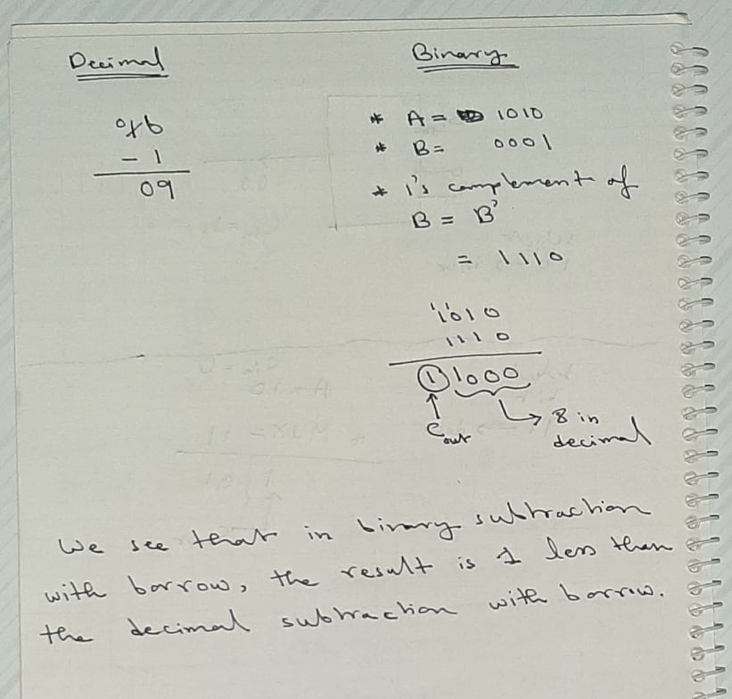

Transfer A

S=10, the output of MUX is 0. 0 is added with A to output A.

S=11, the output of MUX is 1. Cin=1. These two 1’s cancel out each other (as shown in the diagram below), so the output of FAs is A1A0.

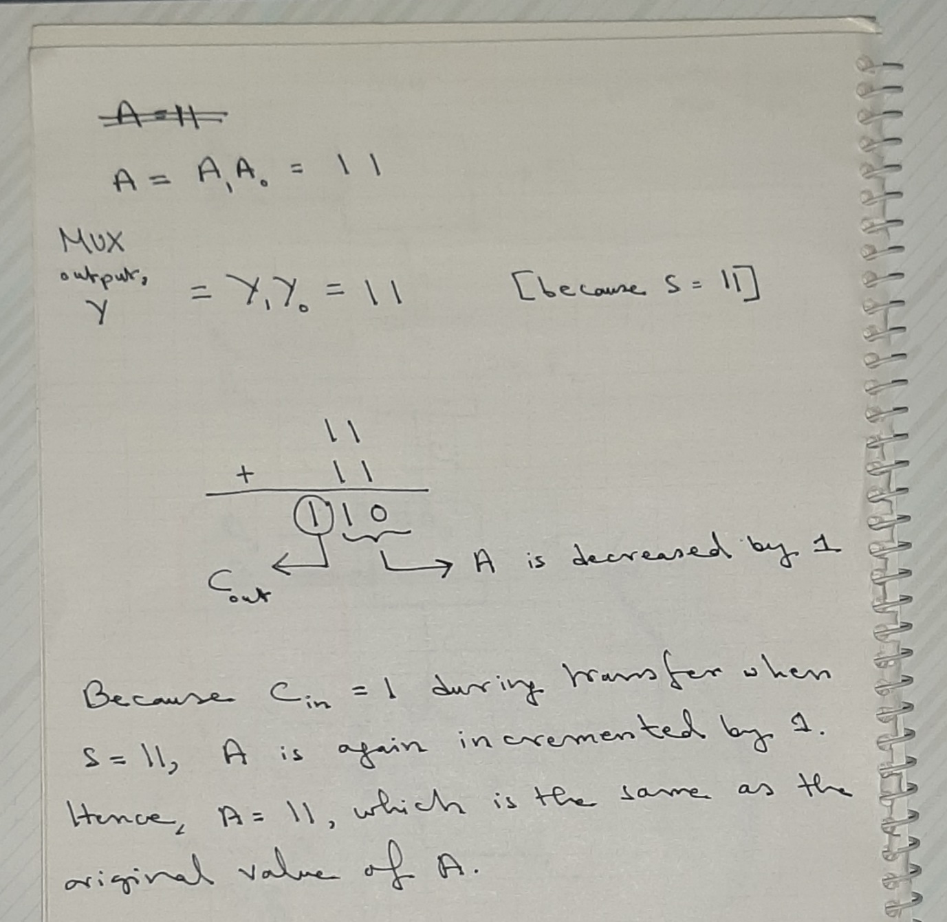

Increment A

S=10, the output of MUX is 0. Cin is 1. A+0+1=A+1, so A is incremented by 1.

Decrement A

S=11, output of MUX is 1. This is added to A and Cin, which is 0. The following diagram explains what happens:

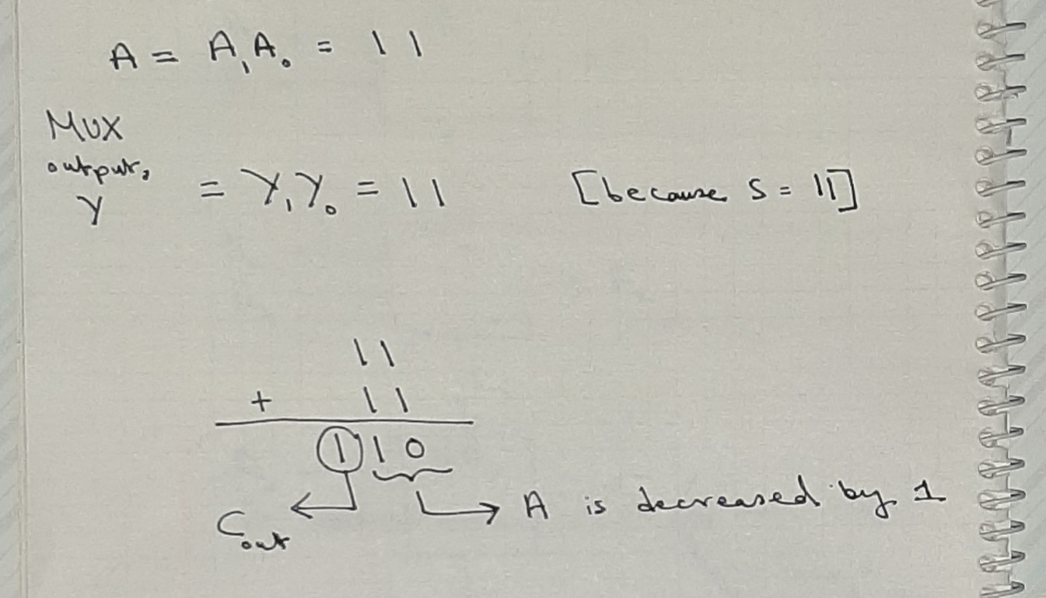

Cout is a signed bit. If Cout=1, the output D is positive. If Cout=0, the output D is negative.

**Circuit Diagram**

Here, the simulation is for S=11, Cin=1, A=00, and B=00.

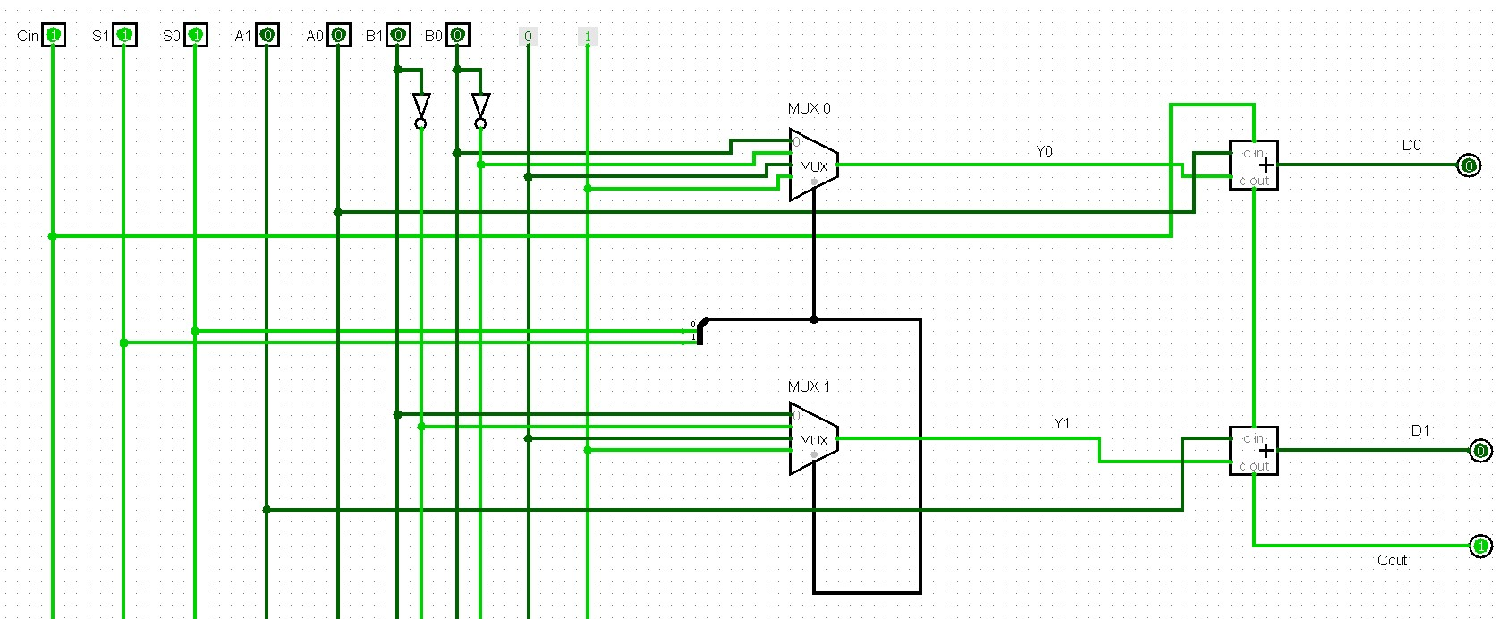

**Function Table**

|  |  |  |  |  |  |  |  |  |  |  |
| --- | --- | --- | --- | --- | --- | --- | --- | --- | --- | --- |
| **S1** | **S0** | **Cin** | **A1** | **A0** | **B1** | **B0** | **D1** | **D0** | **Cout** | **Microoperation** |
| 0 | 0 | 0 | 0 | 0 | 0 | 1 | 0 | 1 | 0 | Add |
| 0 | 0 | 1 | 0 | 1 | 0 | 1 | 1 | 1 | 0 | Add with carry |
| 0 | 1 | 0 | 1 | 0 | 0 | 0 | 0 | 1 | 1 | Subtract with borrow |
| 0 | 1 | 1 | 1 | 1 | 1 | 1 | 0 | 0 | 1 | Subtract |
| 1 | 0 | 0 | 1 | 1 | 0 | 1 | 1 | 1 | 0 | Transfer A |
| 1 | 0 | 1 | 0 | 0 | 1 | 0 | 0 | 1 | 0 | Increment A |
| 1 | 1 | 0 | 1 | 1 | 0 | 0 | 1 | 0 | 1 | Decrement A |
| 1 | 1 | 1 | 0 | 0 | 0 | 0 | 0 | 0 | 1 | Transfer A |

**Discussion**

At first, each equipment is discussed in details. The trainer board has the following features:

1. An on/off button
2. Vcc comes from 5V, and ground from GND
3. 16 input switches
4. The outputs are displayed by connecting the output pins of ICs to the output LED pins via wires.
5. A breadboard is located in the middle. The horizontal red line is the plus connection or Vcc connection. The horizontal blue line is the minus connection or ground. A, B, C, D, and E are vertically connected. There are 16 pins or rails for them.
6. ICs are connected to the breadboard.
7. Pulse switches – A’ and B’ give a negative phase, and A and B give a positive phase.

Secondly, ICs are discussed. Here are the pin numbers for IC 74F153, and a short description of each pin in the dual MUX:

1. Pins 1 and 15 are enable keys for Mux A and Mux B respectively.
2. The 2nd pin is S1, and the 14th pin is S0. S1 is the most significant select bit (MSB), and S0 is the least significant bit (LSB).
3. MUX A input pins (from pin no. 3 till 6) are as follows: 3rd pin is for 4th input bit or I3a … 6th pin is for 1st input or I0a. The output is 7th pin.
4. The 8th pin is GND, or 0 volts.
5. The 16th pin is Vcc, or 5V.
6. Mux B input pins (from pin no. 13 till 10) are as follows: 13th pin is for 4th input bit or I3b … 10th pin is for 1st input or I0b. The output is 9th pin.

The dual MUX already allows for both MUXs to have same select bit. However, if two separate MUXs were used, we would short the select bits.

IC 7404, hex inverters, have a total of 6 NOT gates. Vcc is in 14th pin, and GND at 7th. The input-output pairs are as follows:

1. Input – 13th pin, Output – 12th pin
2. Input – 11th pin, Output – 10th pin
3. Input – 9th pin, Output – 8th pin
4. Input – 1st pin, Output – 2nd pin
5. Input – 3rd pin, Output – 4th pin
6. Input – 5th pin, Output – 6th pin

IC74283 is a 4-bit full adder. There are 4 FAs here. The pins are described as follows:

1. FA1: pin 1 – summation of A1 and B1 or ∑1, pin 2 - B1, pin 3 - A1
2. FA0: pin 4 –∑0, pin 5 – A0, pin 6 – B0
3. FA2: pin 15 – B2, pin 14 – A2, pin 13 – ∑2
4. FA3: pin 12 – A3, pin 11 – B3, pin 10 – ∑3
5. Pin 16 – Vcc, pin 8 – GND
6. Pin 7 – Cin, pin 9 - Cout

The following block diagram shows how the 4 FAs connect with each other and work:

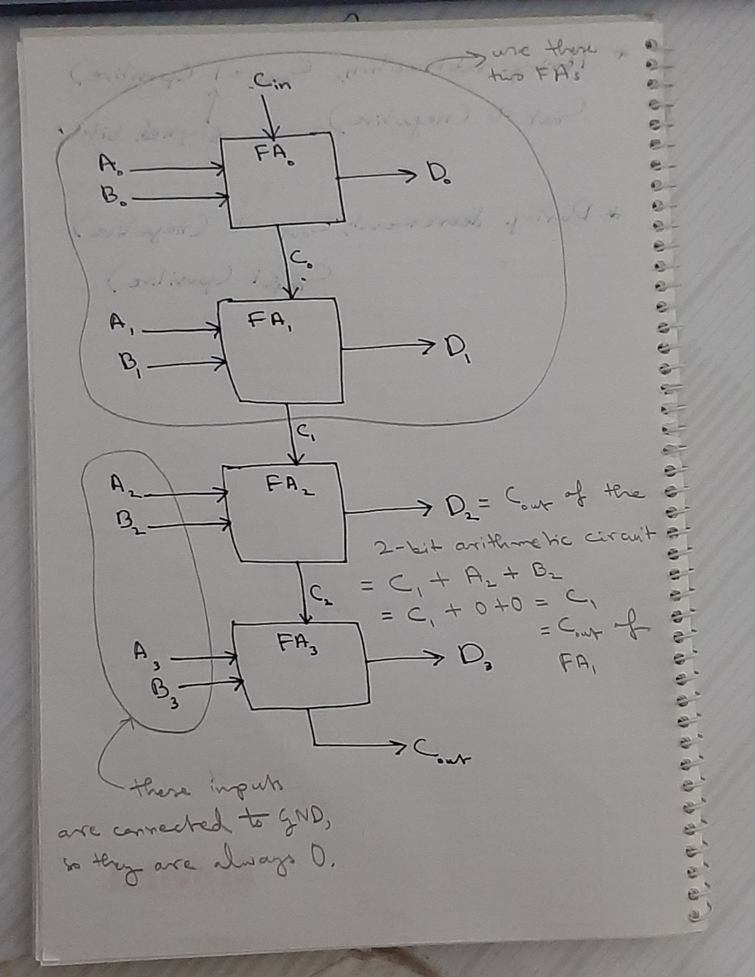

Before the experiment even starts, the equipment must be checked to see if there are any troubles. The trainer board needs to be checked to see if 5V and ground are working properly or not. The power on trainer board is turned on. Next, the 5V supply is connected to breadboard first. A separate wire from here is then going into an output LED pin. LED turns on.

The GND is not working in the video, so an alternative has been used. The wire is connected to the 0-15V, and the knob is turned to 0V.

The input switches are checked to see if they are properly working or not. The input switch pin is connected to an output pin via a wire. The input switch is turned on to see if the output LED turns on. If the same input switch shows output for all other output pins except a particular output pin, that output pin is not properly working. Hence, this technique can be used to check whether input and output pins are working properly at the same time.

After checking all the equipment, the equipment is now being set up. The Vcc is connected to the positive pin in the breadboard, and the 0-15V is connected to the minus pin.

The ICs are placed on the breadboard. The Vccs on the IC pins are connected to 5V, and GND to the 0-15V. Then, the input switches and other connections are as follows:

1. Cin is the 1st input switch pin on the trainer board, connected to the 7th pin to the FA IC.
2. S1 and S0 are 2nd and 3rd input switch pins on the trainer board, connected to 2nd and 14th pins of MUX IC respectively.
3. A1 and A0 are 4th and 5th input switch pins on the trainer board are connected to 3rd and 5th pins of FA IC respectively.
4. B1 and B0 are 6th and 7th input switch pins on the trainer board are connected to 10th and 6th pins of MUX IC respectively. From the MUX IC, these inputs are connected to 3rd and 1st pins of NOT IC. The 4th and 2nd output pins are connected to 11th and 5th pins of MUX IC.
5. The GND is connected to the following pins (for constant 0):
6. 12th and 4th pins on MUX IC
7. Pins 11, 12, 14, 15 on FA IC
8. The 5V is connected to these pins (for constant 1): 13th and 3rd pins on MUX IC.
9. 9th and 7th pins are Y0 and Y1 respectively, the output pins on MUX IC. These are connected to the FA IC to 2nd and 6th pins of FA IC.
10. The outputs D0, D1, and Cout are from 4th, 1st, and 13th pins respectively, which are connected each to output LED pins 1, 2, 3.

Different input switch pins are turned on and off according to the function table, and the values are recorded onto the table.

Whenever Cout=1, the output LED is on in the 3rd pin, and the output D is positive because the signed bit indicates a positive number. Whenever Cout=0, the output LED is off in the 3rd pin, and the output D is negative because the signed bit indicates a negative number.

An example would be the simulation shown in the *Circuit Diagram* section, for S=11 (turned on 2nd and 3rd input switch pins), Cin=1 (turned on 1st input switch pin), A=00 (turned off 4th and 5th input switch pins), and B=00 (turned off 6th and 7th input switch pins). D0=0 (output LED 1 is off), D1=0 (output LED 2 is off), and Cout=1 (output LED 3 is on).The signed bit indicates that D is positive.