**Objectives**

Our objective is to design a 20 bit ISA which can solve problems such as addition, shifting, comparism, branch, etc.

**Types of Operations**

1. R-type: ADD, AND, SUB, SLL, SLT
2. I-type: ADDi, LW, SW
3. J-type: BEQ, JMP

**Control Table**

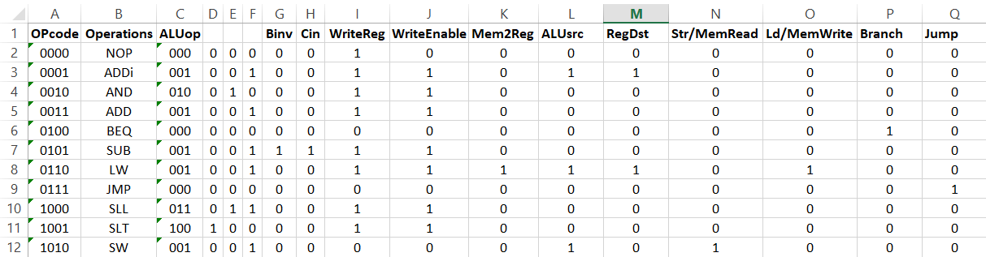

**Instruction Format**

Immediate/R3 (5 bits) R2 (5 bits) R1 (5 bits) Opcode (5 bits)

Since there are 4-bit select keys to choose specific registers and decoder output in control unit, these 5 bits are bit-extended to 4 bits.

**Circuit of Register File**

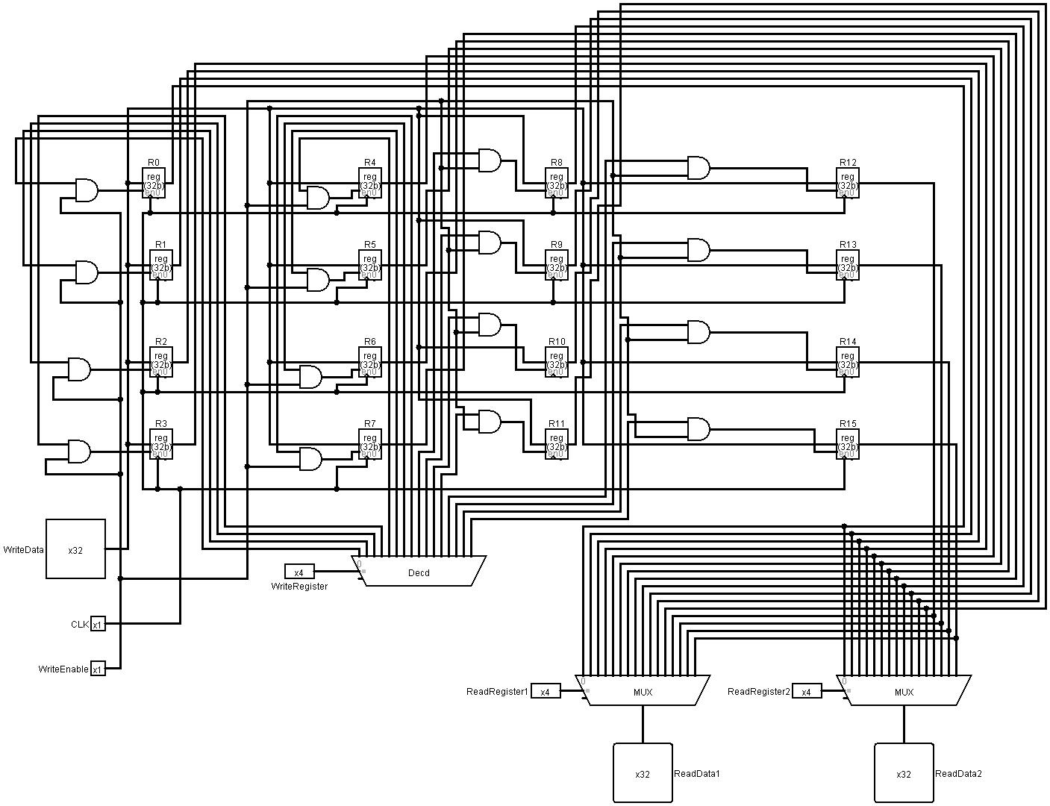

**Subcircuit of Register File**

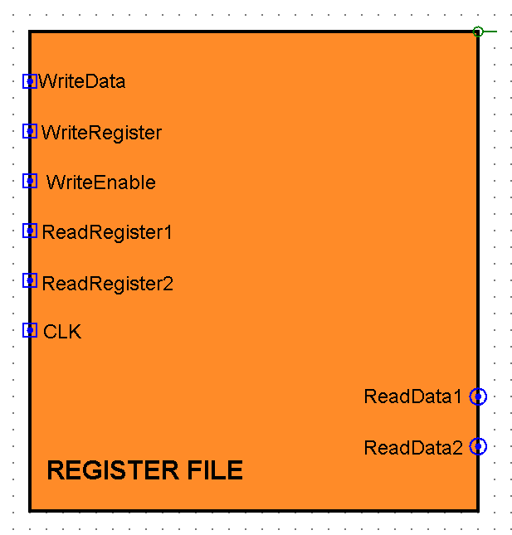

**Circuit of ALU**

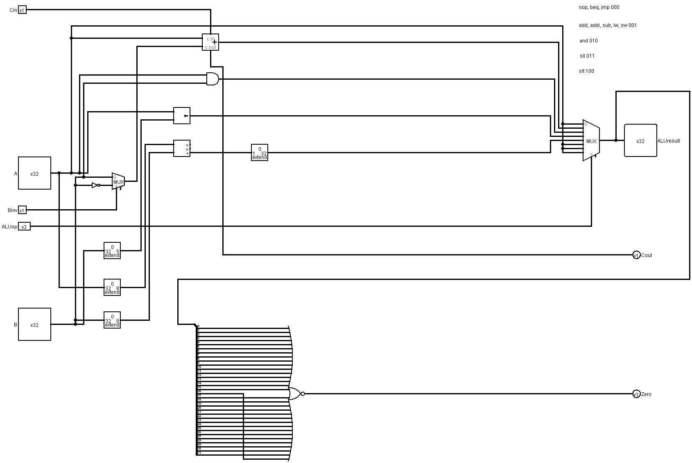

**Subcircuit of ALU**

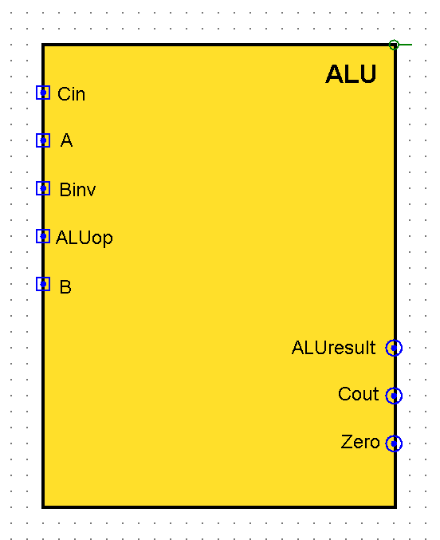

**Circuit of Control Unit**

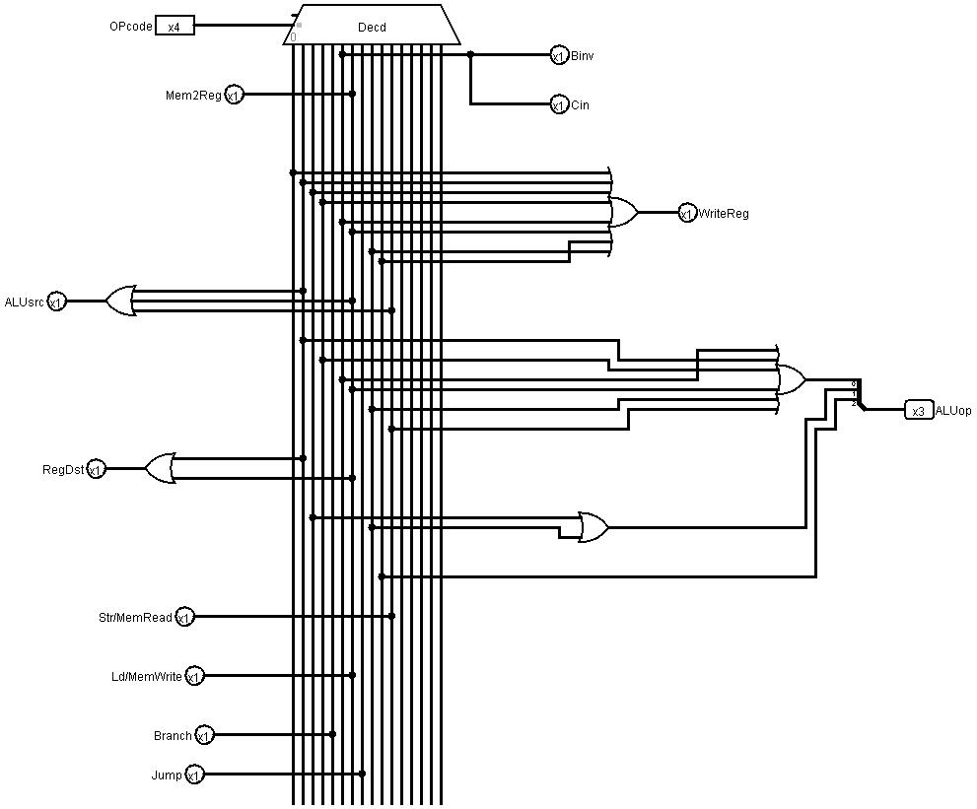

**Sub-circuit of Control Unit**

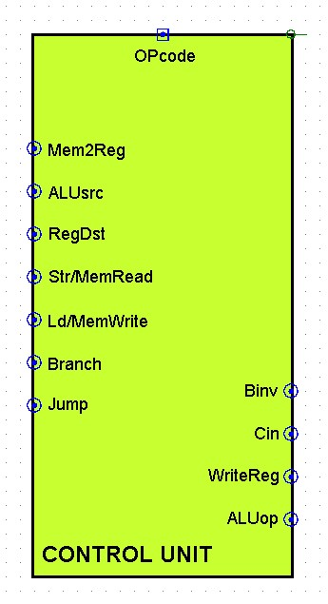

**Circuit of Datapath**

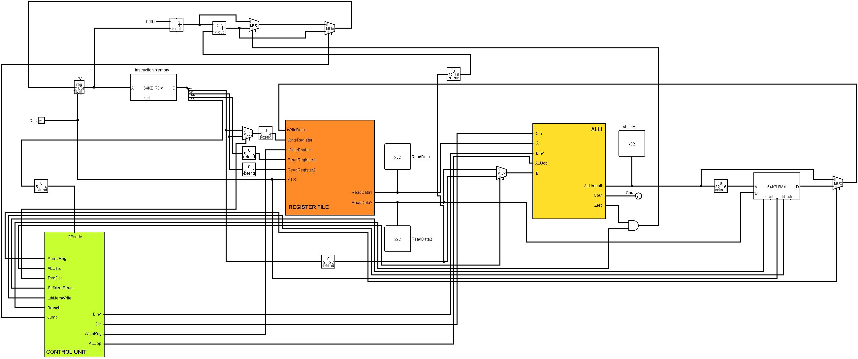

**Limitations**

1. The second input of shift is 5 bits, whereas Read Data 2 is 32 bits. Although bit-extender is used, a better alternative is to build a separate shifting sub-circuit, so that more bits can be shifted.
2. Both inputs of the comparator device is 8 bits, whereas Read Data 1 and Read Data 2 are 32 bits. If the 9th bit or later causes one of them to not be same/less than/greater than, then it will not be detected in comparator. To overcome this limitation, a separate 32 bit comparator sub-circuit can be built.