# HackNSU Season 3

# Team Details

Team Name: Orbit

University: North South University

# Selected Scope

Remote Health Care

# Problem Description

During COVID 19 pandemic, a lot of non-COVID patients end up contracting Corona virus during their hospital visits. It is also risky to collect and touch the physical hard copy of the medical reports. Furthermore, both practitioners and patients are confused with how to use this new tech (telemedicine). During huge surges of COVID across the globe, it is seen that there are shortages of critical resources such as oxygen cylinders, Azithmycin, and other key lifesaving drugs. People with weaker immune system, such as old people, are prone to COVID 19. It is also seen that people with genetic diseases, such as asthma, or with other problems such as a history of having heart attacks, are also more prone to COVID 19. Although it is generally appreciated that ex-COVID patients’ plasma is valuable because it contains antibodies critical to fight COVID, the problem lies in the fact that there needs to be a certain amount of time spent on the ‘search’ for such a donor (in case the person has not donated yet). Even buying medicine in a shop with no social distancing is problematic too. Also, if a household contains only elderly people or all sick patients, it becomes difficult for any one of them to commute to a medicine shop.

# 

# Brief Description of Our Solution

Hospital visits should only be done when absolutely needed, such as when undergoing a surgery. If the visit just requires talking to the doctor, it can be done virtually to prevent COVID 19 spreading to non-COVID patients. The medical reports can be available digitally, instead of going to the hospital to collect them. A home delivery service of the medicine purchased can also help spread less COVID in an otherwise crowded medicine shop with no social distancing. This also helps the elderly or very severely ill people, and they no longer have to commute.

Guidelines on how to use the remote healthcare platform will be written down in an FAQ section, such as how to place an appointment with the doctor, etc.

Limited medical resources during huge surges of COVID 19 caused doctors to use an idea called *likelihood of recovery*. However, the term *likelihood of recovery* is a vague term, hence we mathematically quantified it as *risk factor*.

At first, let us explain the ‘already existing’ concept of *likelihood of recovery* that doctors are currently using (ONLY during huge surges of Corona, NOT throughout the pandemic). For example, there are only 10 Azythmycin tablets available (these oversimplified small numbers are used for easy explanation). However, the number of COVID patients who need the Azythmycin are 55. No matter how much we try, due to huge shortage of medicine and pharmacies manufacturing at full capacity, the number of tablets does not increase beyond 10. In that case, doctors are left with only one option – choose the ‘optimal’ patients out of the 55 who are allowed to consume the tablets. But how can choosing be done? That choosing is currently done in a highly manual, repetitive process – the doctor checks each individual patient’s records and tries to understand whose *likelihood of recovery* is the most. For instance, if a patient has asthma, versus a patient without asthma, the *likelihood of recovery* is more for the patient without asthma. So, the crucial medicine will be given to the healthier patient (without asthma) since the medicine is less likely to be ‘wasted’.

Now, imagine this same process be repeated for 5000 patients. The doctors go through this stressful work of understanding *likelihood of recovery* for all these 5000 patients (this technique is currently used ONLY during huge surges of Corona, NOT throughout the pandemic). Instead of performing this by a human, our Java app can calculate the risk factor, and arrange the patient IDs in an ascending sorted list, so that doctors can instantly find out who is at lowest risk factor, and hence who gets the crucial medical resource allocation first.

After patients successfully recover from COVID, they can mark themselves as ‘I am a plasma donor’. Anyone who needs a plasma donor for obtaining the very special COVID antibodies can just look up for the available list of plasma donors.

Dedicated care is provided to patients who are grouped as COVID category. There is also a non-COVID category. Also, patients are divided into vaccinated and non-vaccinated categories.

## Impact

For village areas, it is crucial that they get good quality services from hospitals located in urban areas through remote health care, because rural hospitals have poor quality. Also, a villager can travel back to their hometown immediately after doing a medical test and view results online instead of physically travelling to the city hospital. The physical medical reports can be contagious and not touching them during the pandemic would be a better option.

Hospitals will be less crowded, and this will allow people to stand a few feet apart from each other in the hospital during absolutely necessary visits (social distance). The same is applicable for the medicine shop. Also, the elderly and sick will no longer have to travel to the medicine shop if they can access a virtual shop.

Risk factor calculation will significantly save more lives that would have otherwise been neglected (due to shortage of resources during COVID surges).

Finding plasma donors fast is key to help a critical patient recover, who could die any moment without the necessary COVID antibodies.

Knowing how many people are vaccinated in a specific region will help in understanding vaccine distribution.

## Full description of our solution

### Features of our solution:

1. Simple Registration and Login
2. Information of patients (with NID)
3. Health history
4. Vaccine information
5. User Dashboard
6. Booking for doctor appointment
7. Video Conferencing
8. Emergency service
9. View medical test result online
10. Calculate each patient’s risk factor
11. Look for plasma donors
12. Online medicine shopping

### System Architecture:

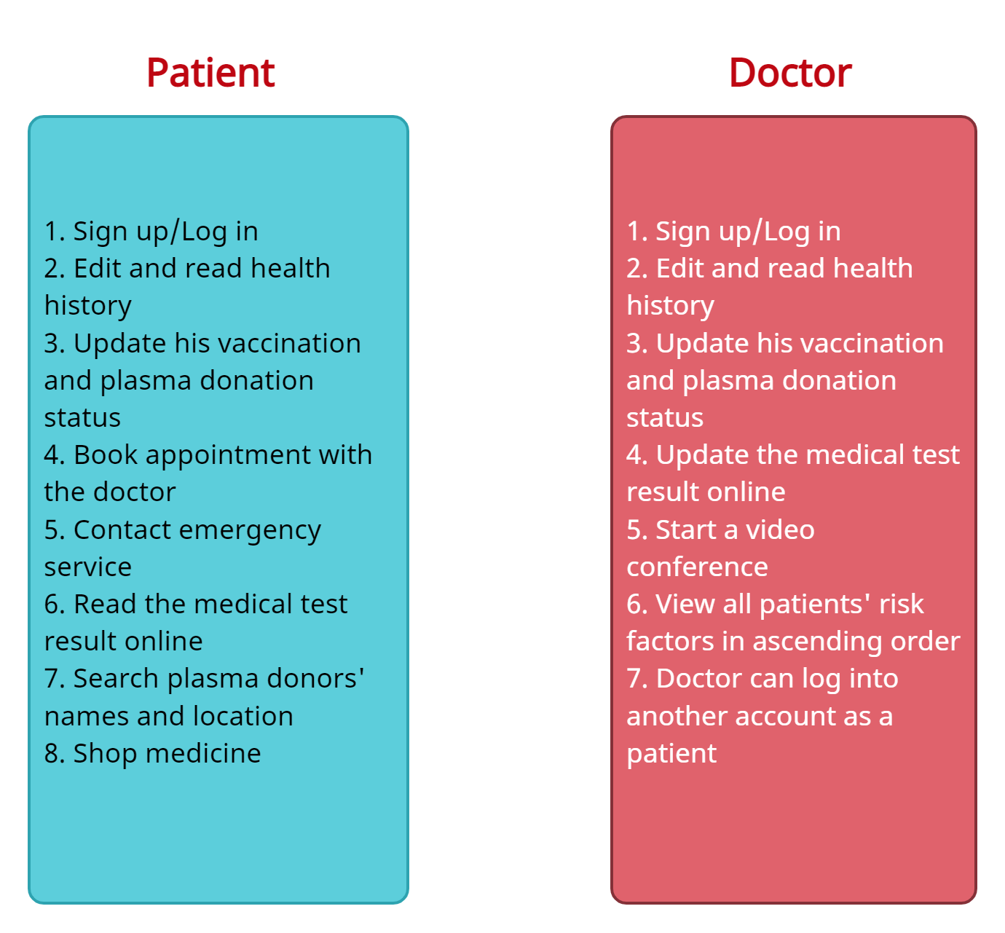

### Tools and Technologies you are going to use:

1. Java OOPS and data structure
2. JavaFX

### Description of our prototype:

Our prototype is a desktop application. The patient can write about their health history. From here, risk factor is calculated as follows:

Risk factor = summation of the number of factors associated with slow recovery

For example, if someone has asthma and is middle-aged, he has two factors, so the risk factor = 2. Another person, who has only asthma, has a risk factor of only 1.

All these risk factors are calculated and inserted into our sorted data structure to list patients in ascending order.

### Conclusion:

Our project shows the considerable impact of the COVID 19 in rural area, as well as urban area. Rural people in our country are very nervous and lack knowledge of COVID 19. The vaccination status that is visible in our app, as well as plasma donation, is an important step towards creating health awareness among the rural community – since they are reluctant to take vaccines or try plasma treatment.