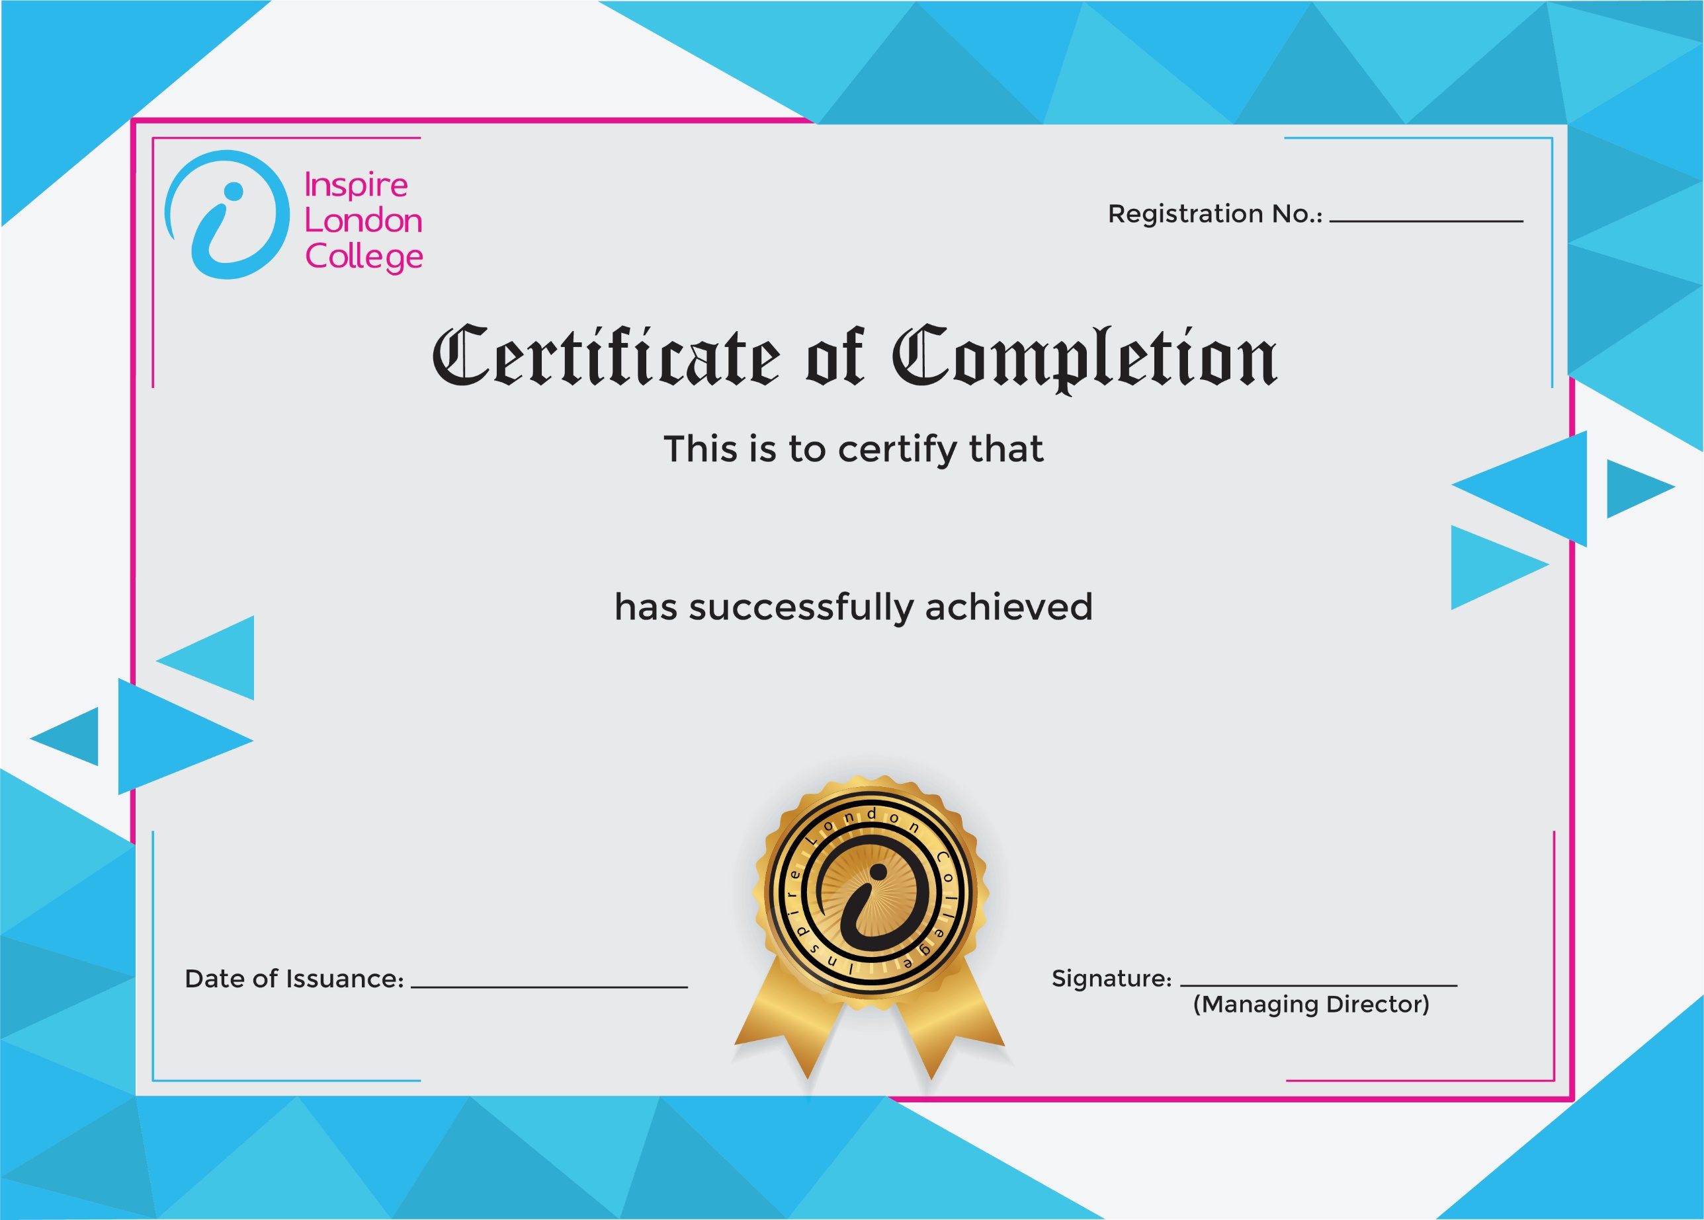
ILC50043



Certificate in Business Succession Planning
26th December 2025
Asfand

