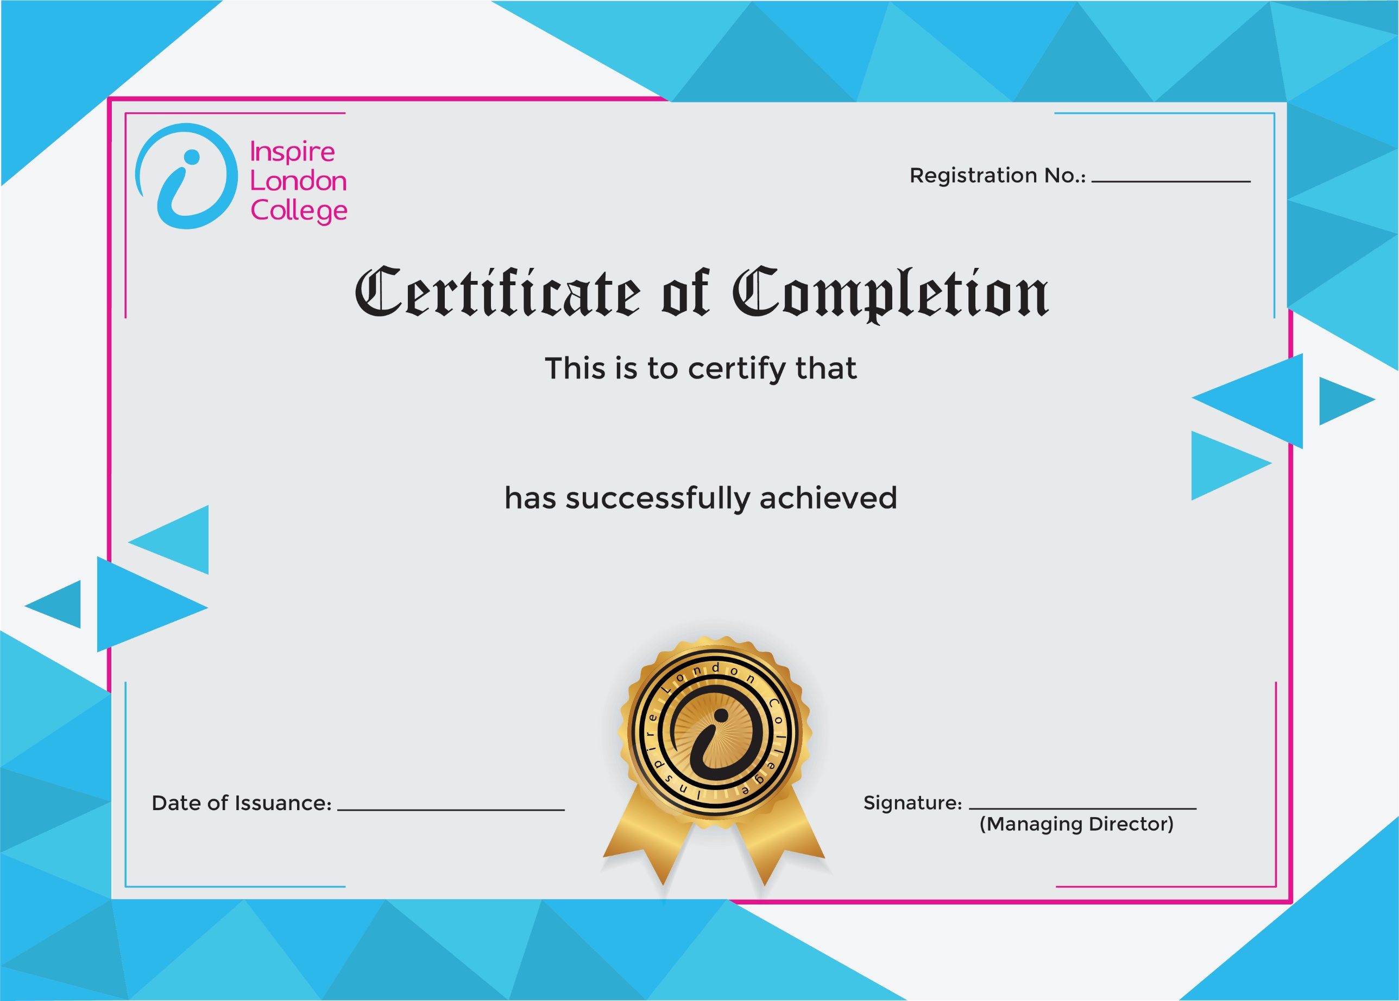
ILC50045

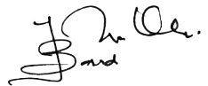

Certificate in Accountability in the Workplace
26th December 2025
Asfand

