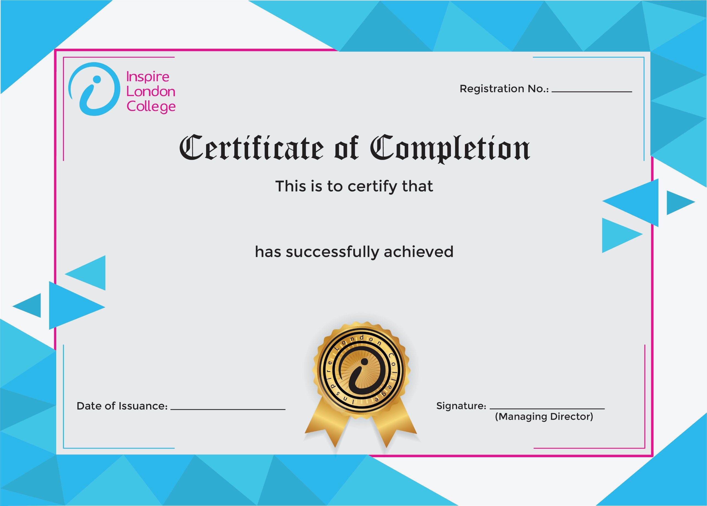
ILC50046

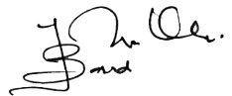

Certificate in Asbestos Awareness
26th December 2025
Asfand

