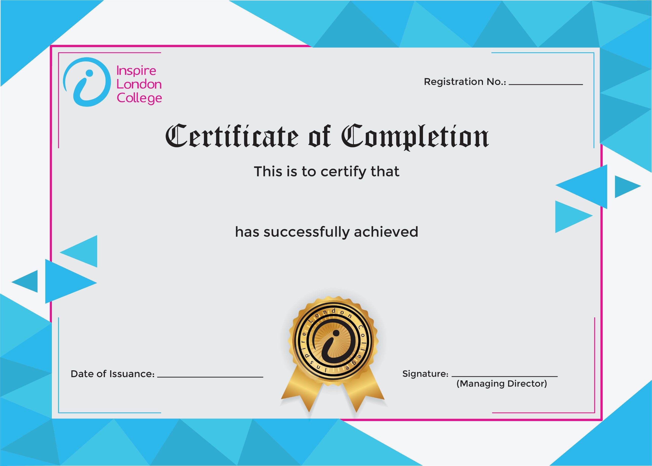
ILC50046

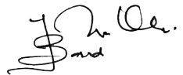
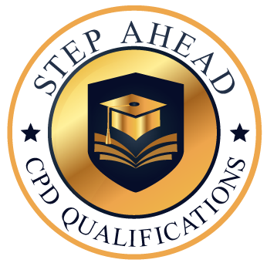
Certificate in Asbestos Awareness
29th December 2025
Asfand yar

