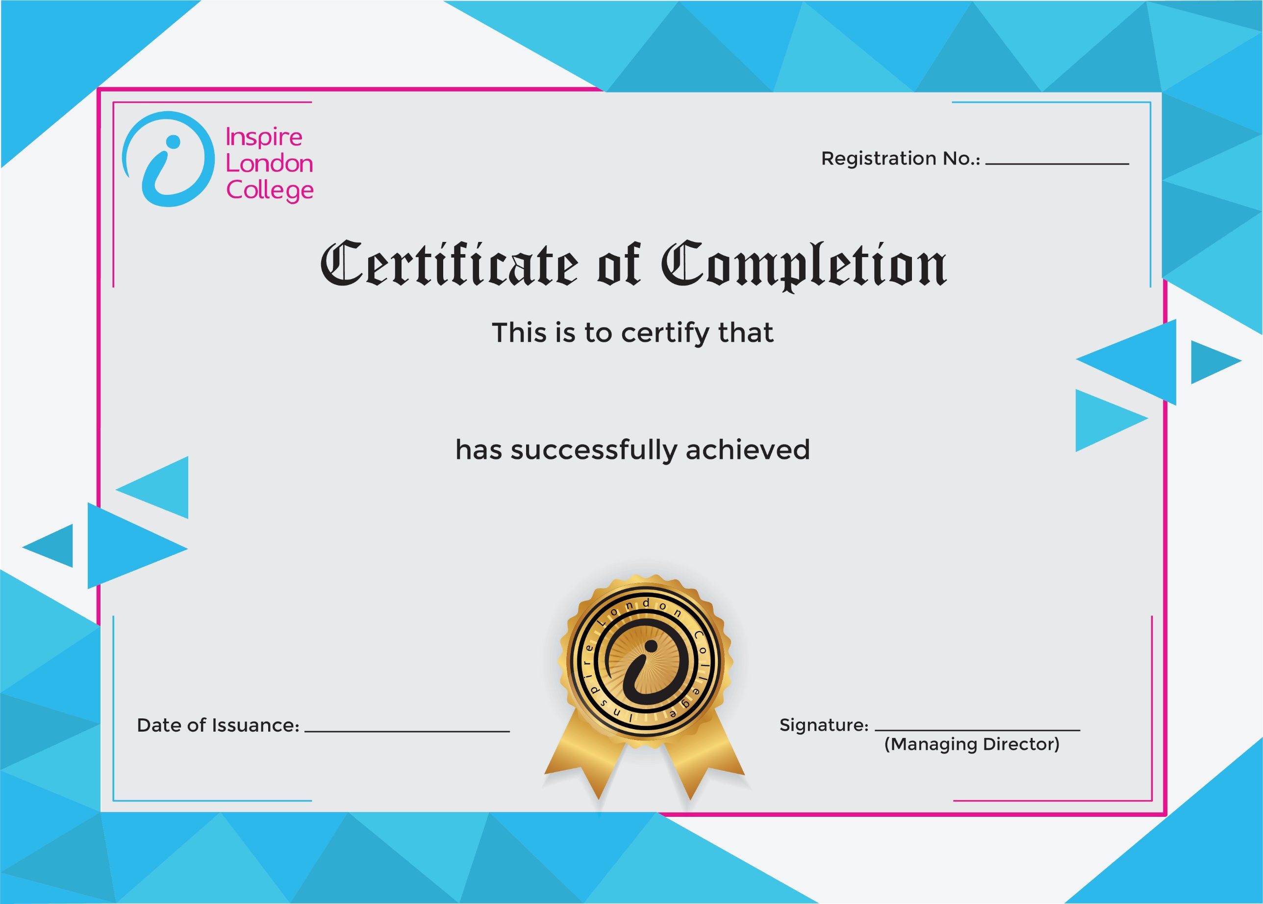
ILC50047

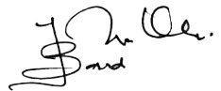
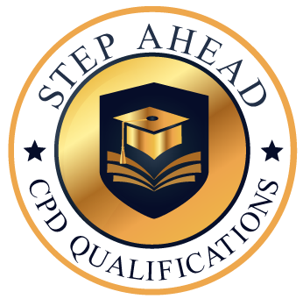
Certificate in Collaborative Business Writing
12th January 2026
Sanwal Iqbal

