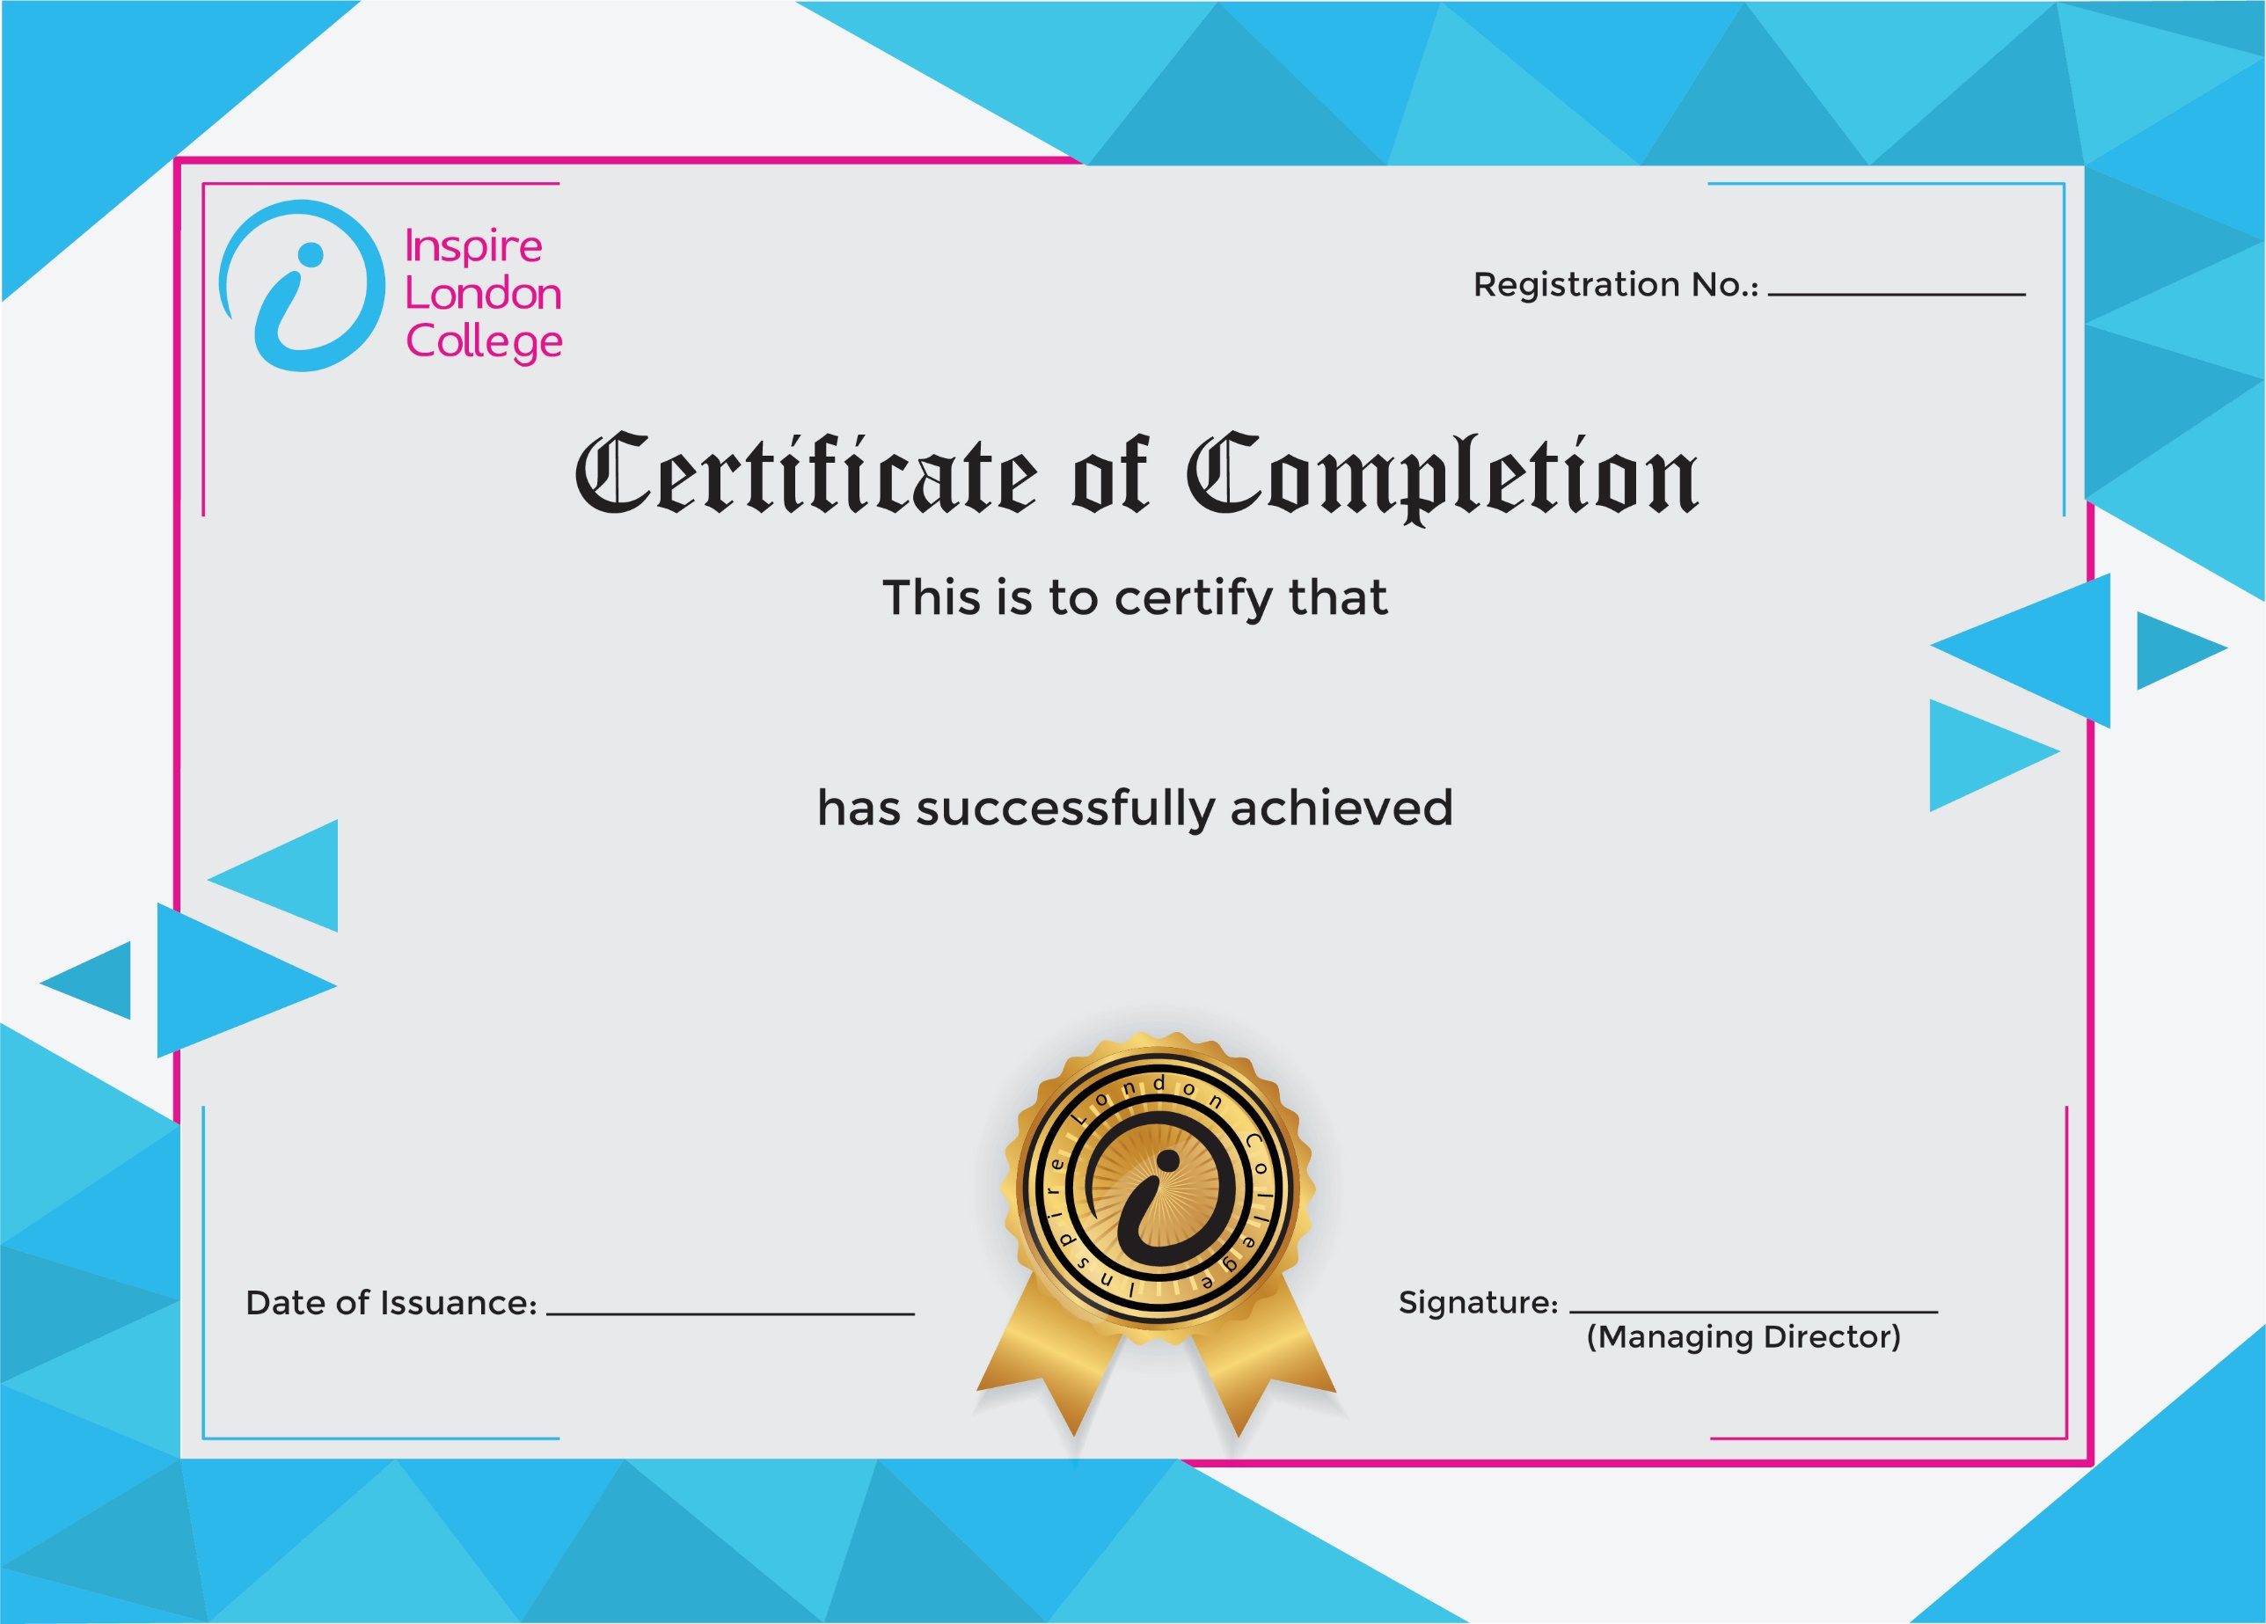
ILC50048

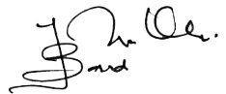
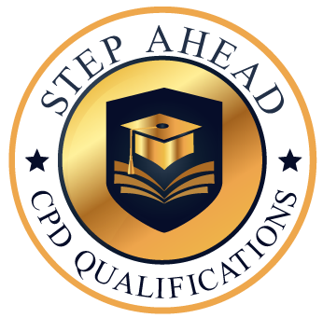
Level 5 Diploma in Administrative Secretary and Personal Assistant
13th January 2026
Ahmed

