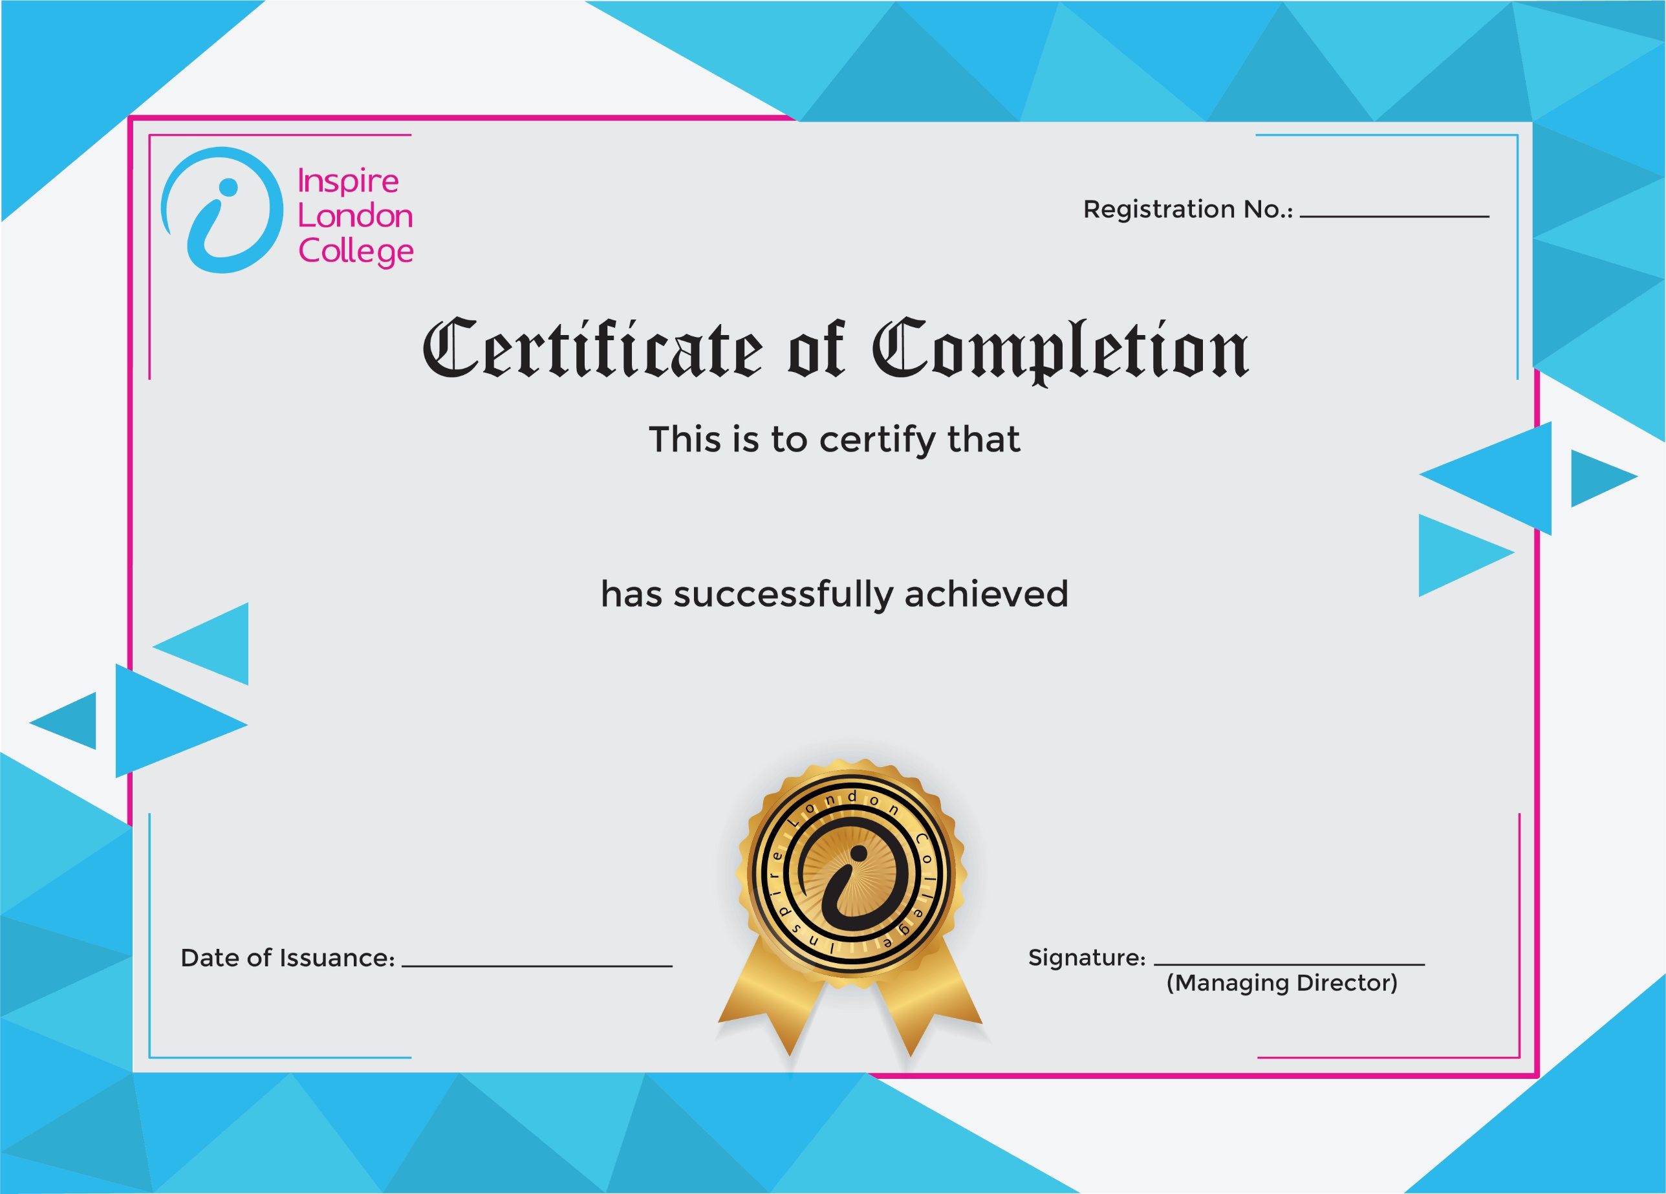
ILC50049

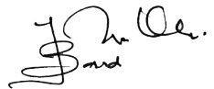
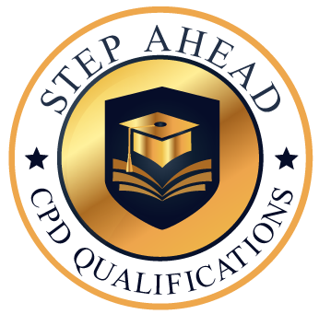
Level 7 Diploma in Admin, Secretarial & PA
13th January 2026
Ahmed Khan

