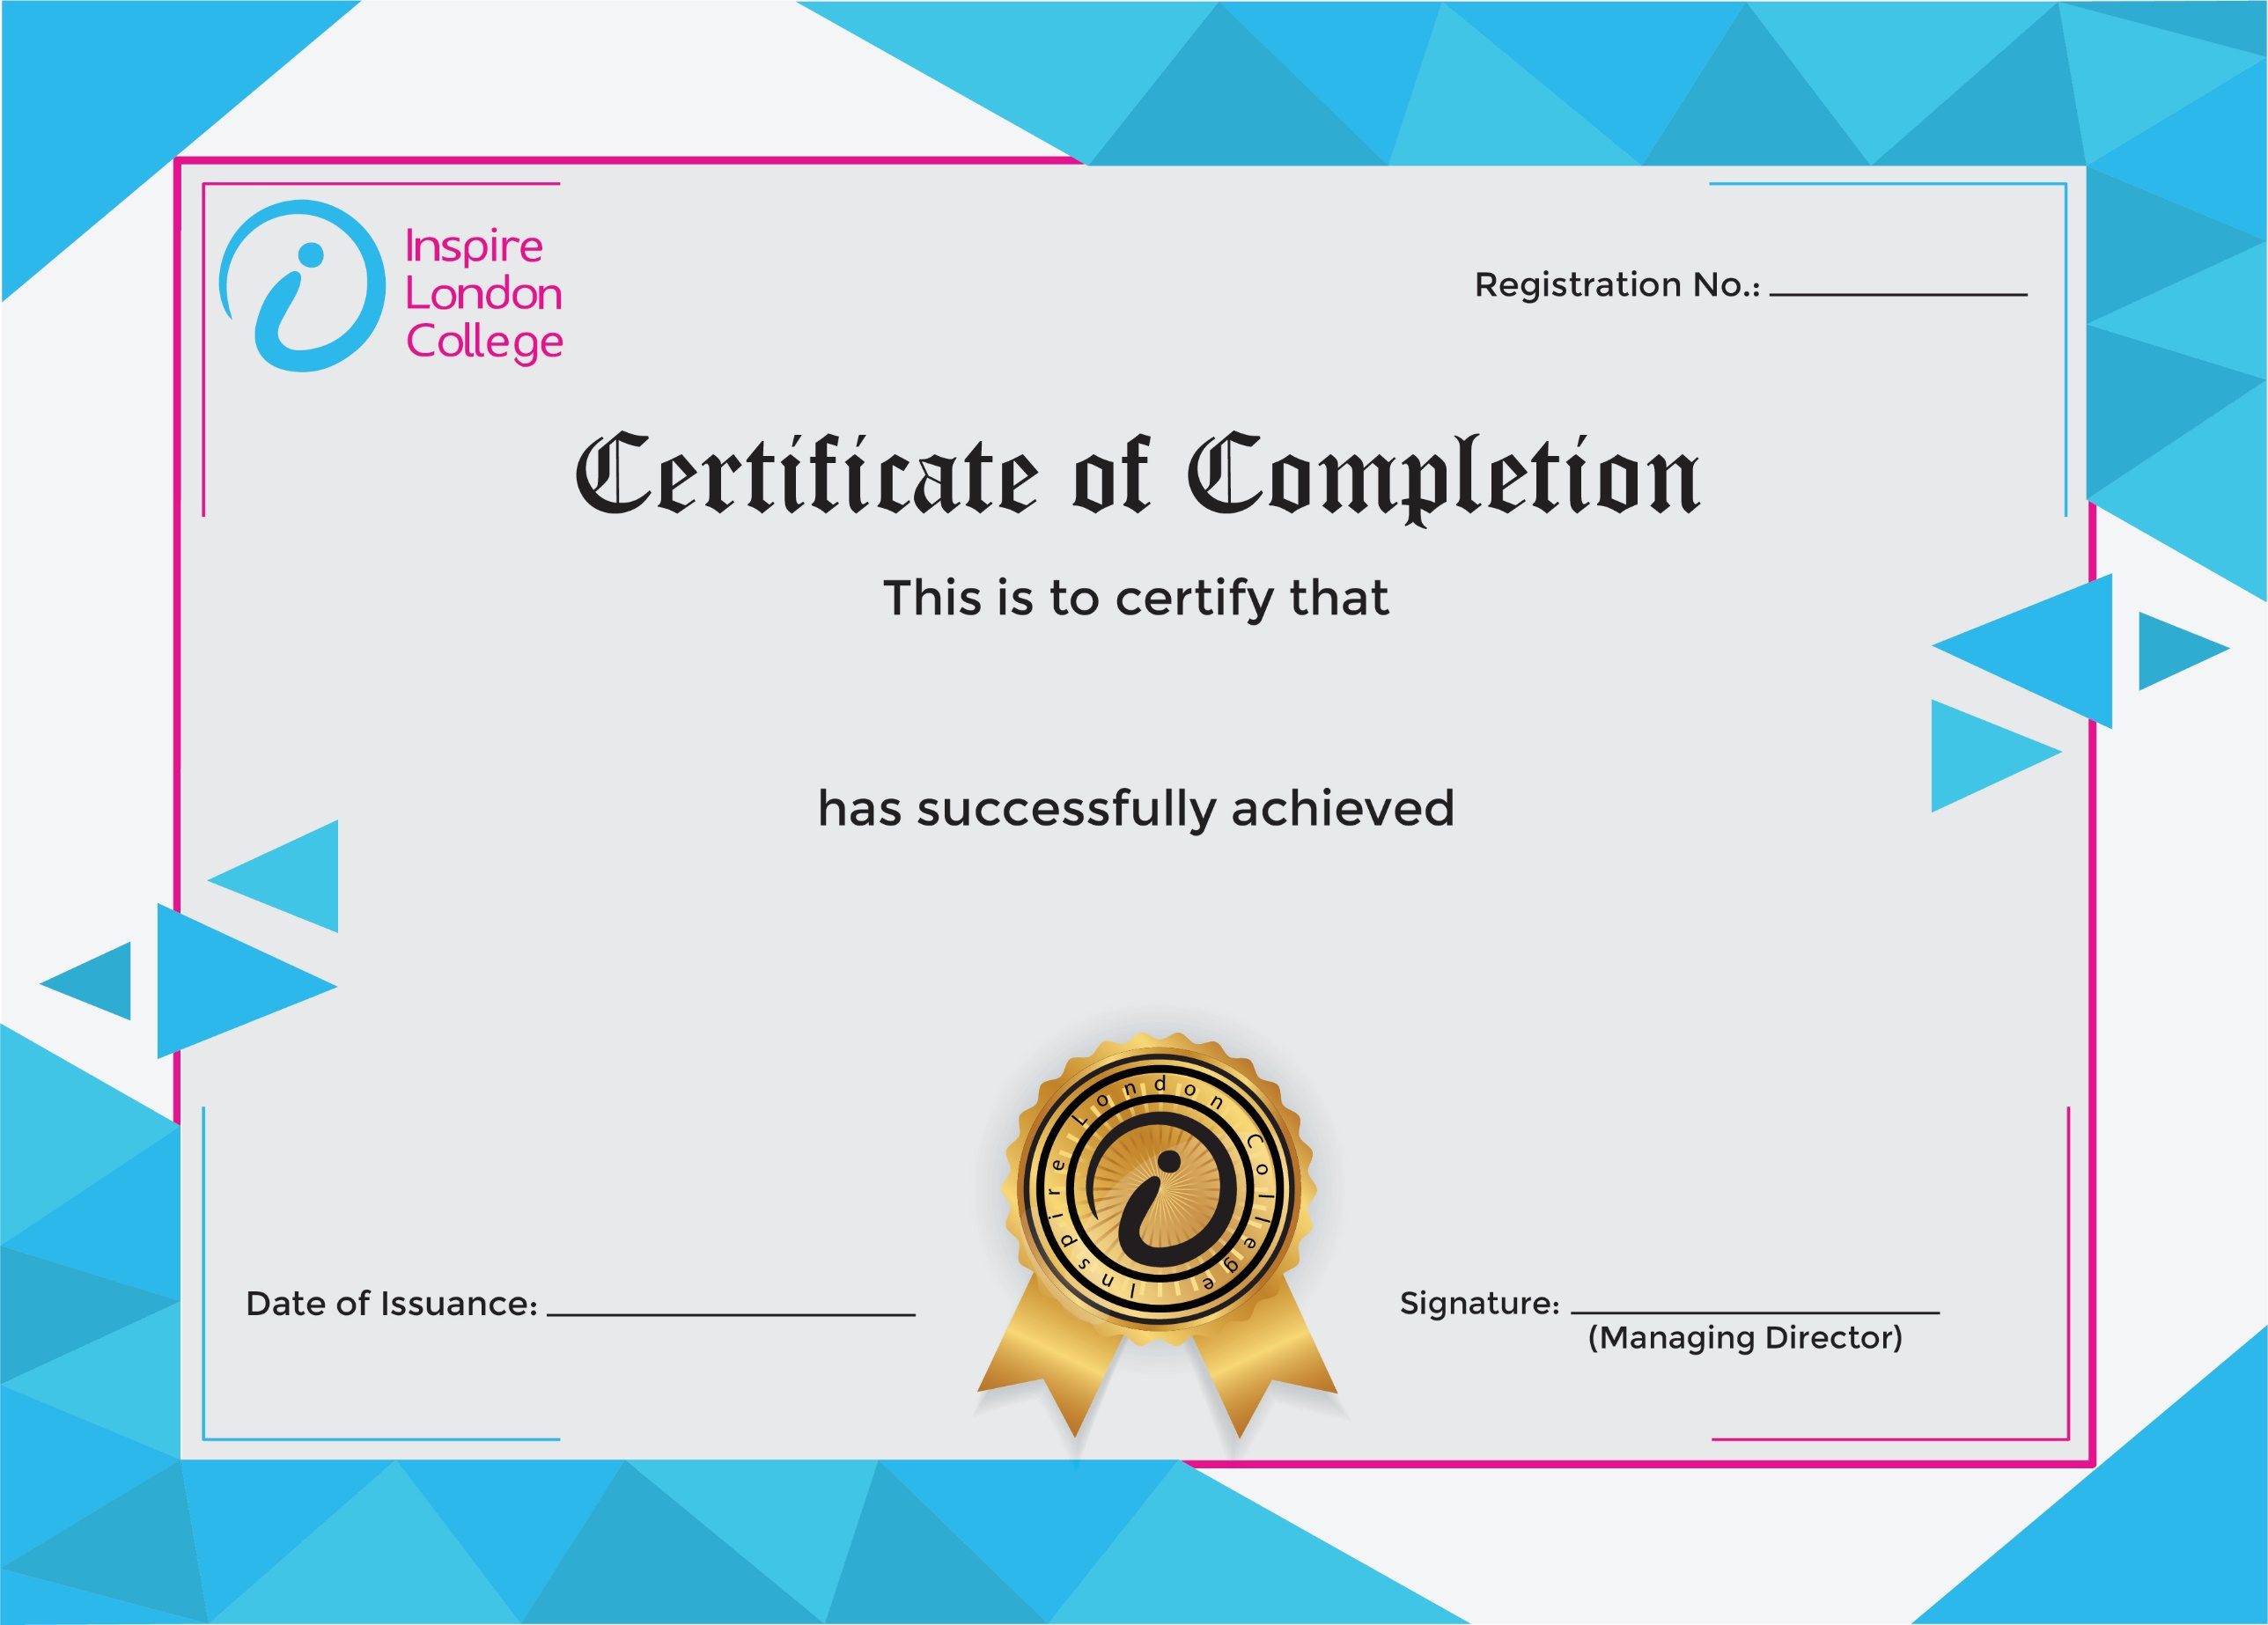
ILC50057

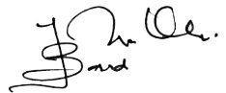
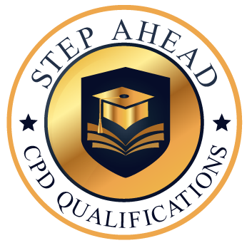
Level 7 Diploma in Admin, Secretarial & PA
13th January 2026
Ahmed Khan

