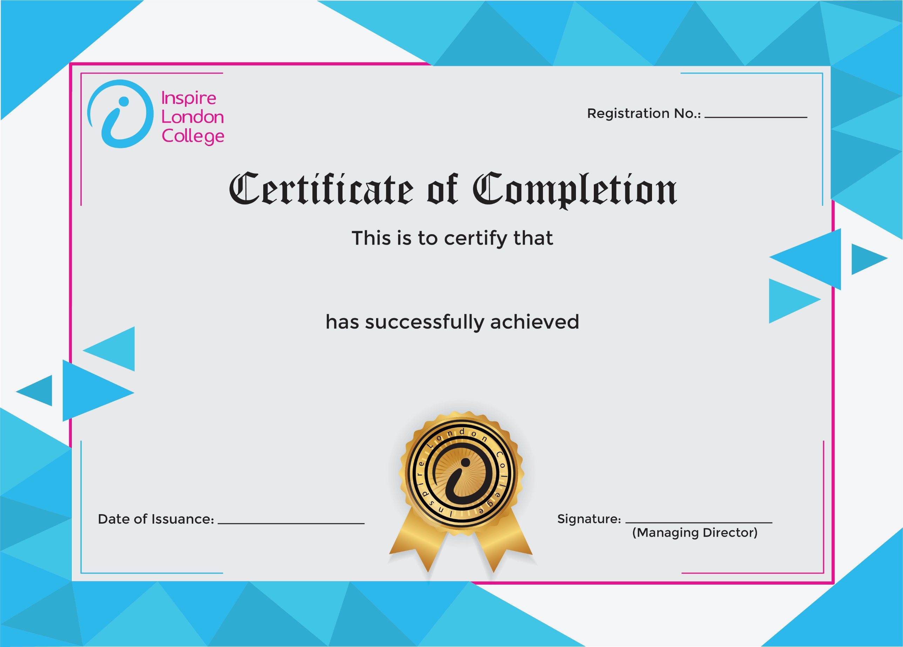
ILC50051

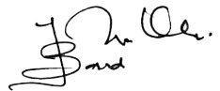
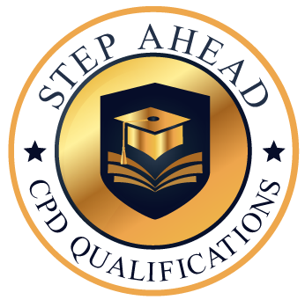
Level 5 Diploma in Administrative Skills
14th January 2026
Ahmed Khan

