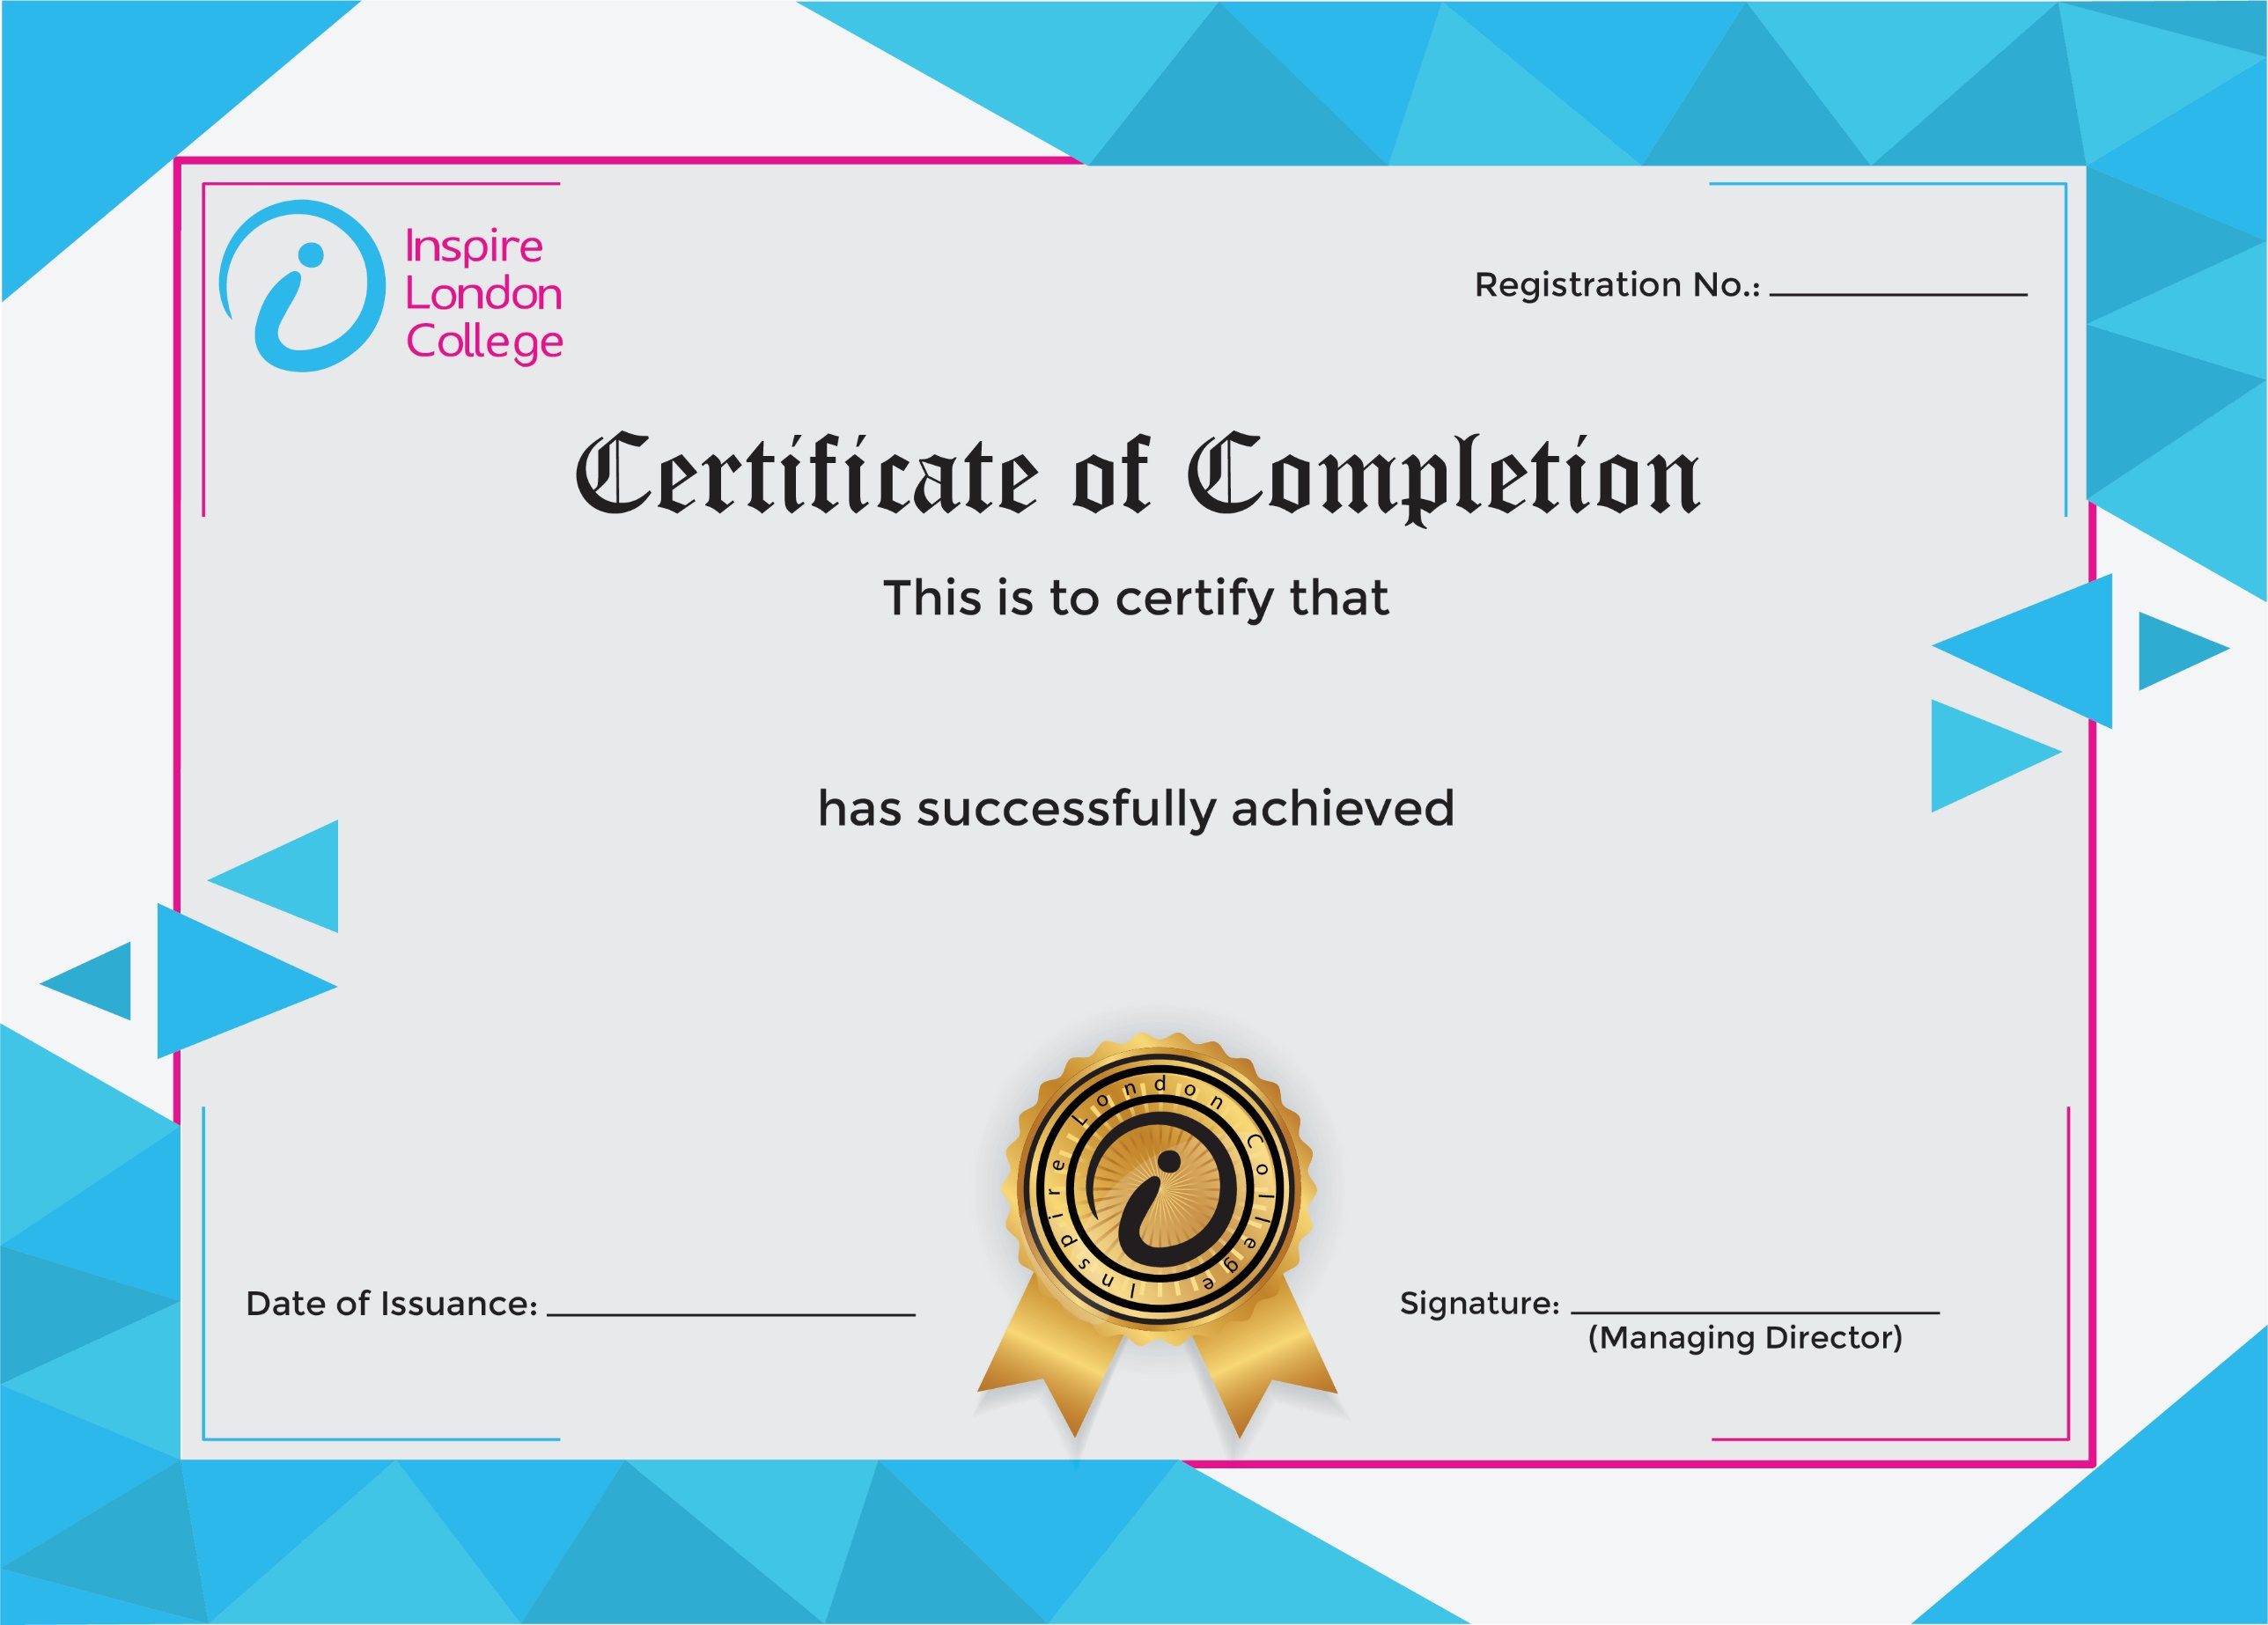
ILC50052

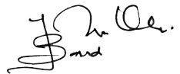
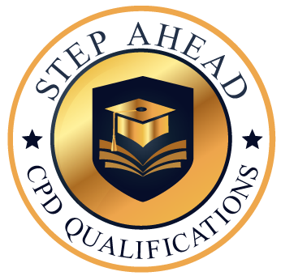
Level 5 Diploma in Administrative Secretary and Personal Assistant
15th January 2026
Nimra Anwar

