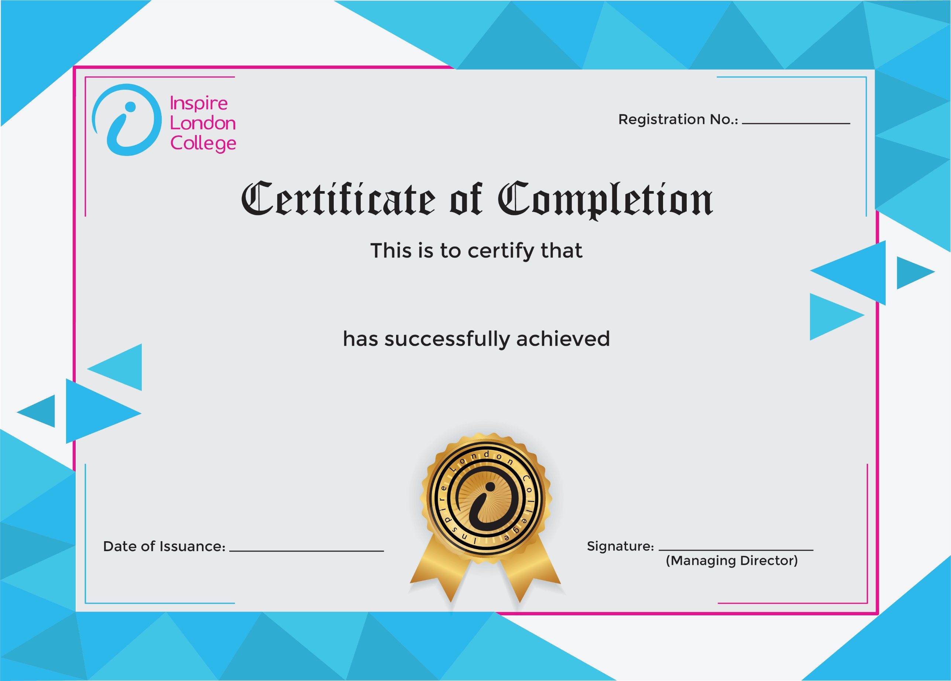
ILC50059

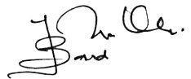
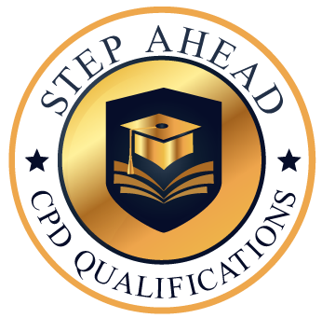
Level 5 Diploma in Administrative Secretary and Personal Assistant
15th January 2026
Zunaira Anwar

