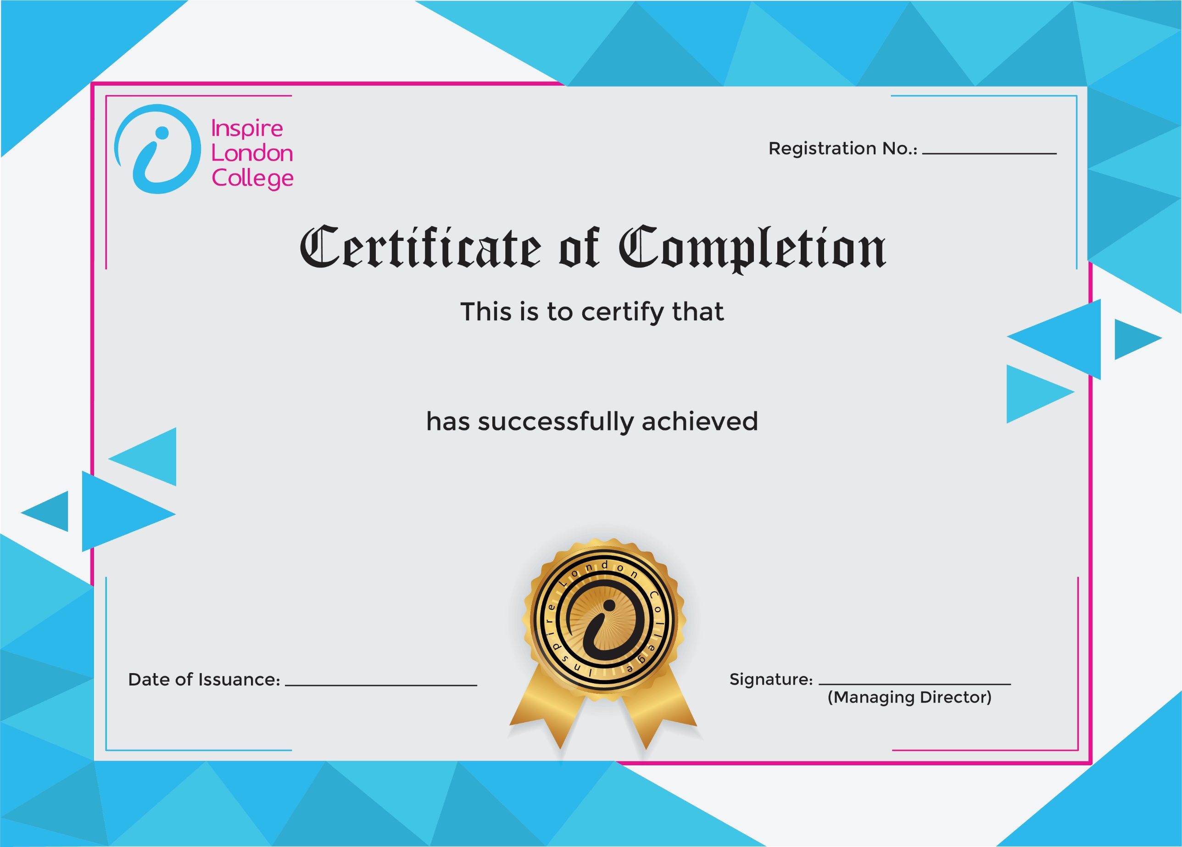
ILC50067

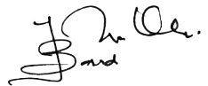
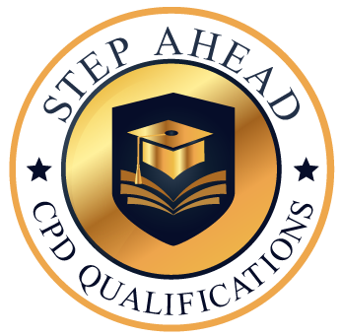
Certificate in Digital Citizenship
31st January 2026
Ahmed Khan

