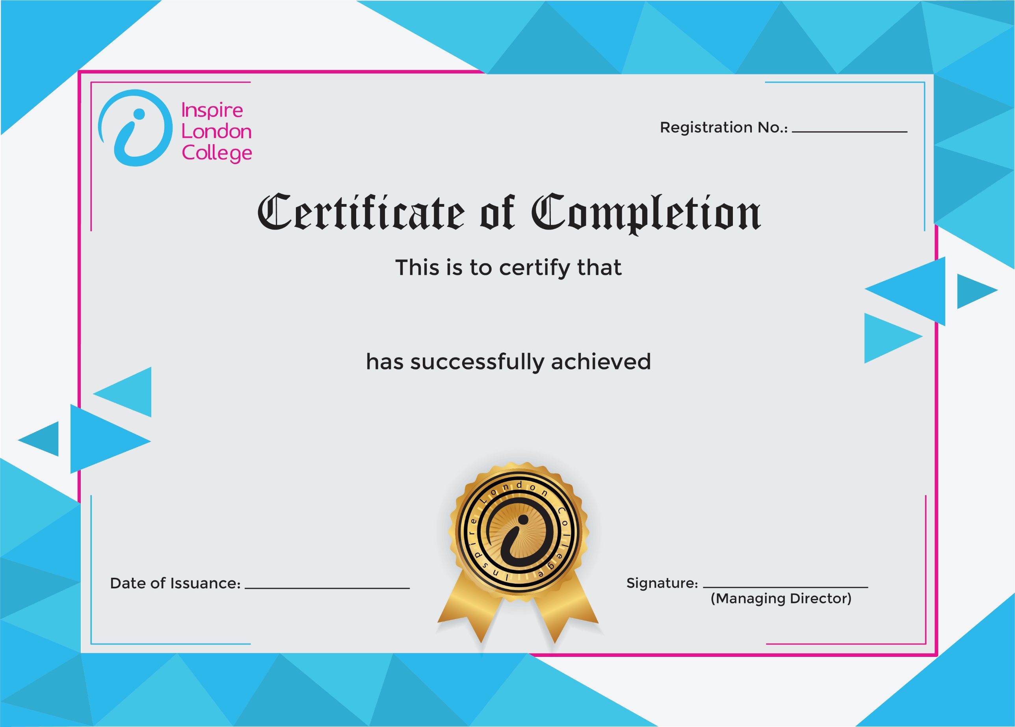
ILC50087

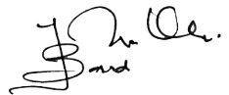
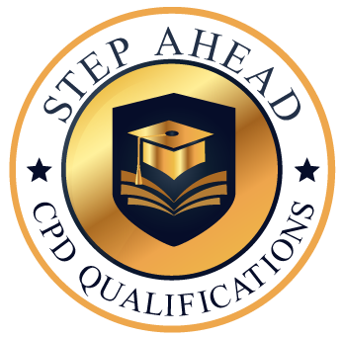
Certificate in Fire Safety
31st January 2026
Ahmed Khan

