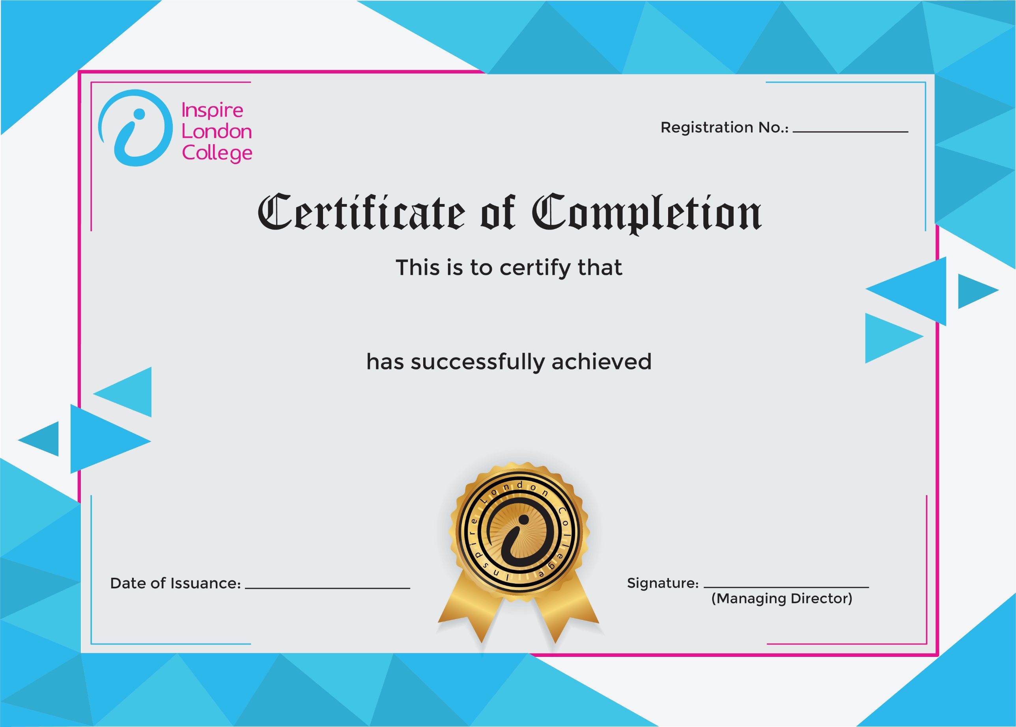
ILC50091

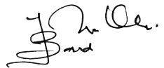
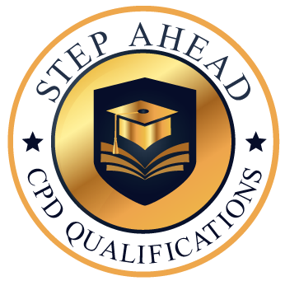
Level 5 Diploma in Customer Service
4th February 2026
Ahmed Khan

